# The AGI Race

# OpenAI vs Anthropic in the Battle for Artificial General Intelligence

### **WARNING: This content was generated using Generative AI. While efforts have been made to ensure accuracy and coherence, readers should approach the material with critical thinking and verify important information from authoritative sources.**

# Table of Contents

**Introduction: The High Stakes of AGI** **5**

Defining AGI and Its Potential Impact 5

What is Artificial General Intelligence? 5

The transformative potential of AGI 8

Risks and opportunities of AGI development 10

The Key Players: OpenAI and Anthropic 14

Origins and missions 14

Key figures and leadership 17

Philosophical approaches to AGI 20

**Technical Innovations and AI Breakthroughs** **23**

OpenAI’s Technical Advancements 23

GPT series and language models 23

DALL-E and multimodal AI 26

Reinforcement learning and robotics 28

Anthropic’s Technical Approach 32

Constitutional AI and alignment 32

Large language model innovations 35

Scaling laws and efficiency breakthroughs 37

Comparative Analysis of Technical Capabilities 41

Benchmarking performance 41

Unique strengths and weaknesses 44

Potential for AGI breakthrough 47

**Business Strategies and Funding Models** **51**

OpenAI’s Evolution and Business Model 51

From non-profit to ‘capped-profit’ 51

Partnerships and revenue streams 54

Investment and valuation 57

Anthropic’s Approach to Funding and Growth 60

Venture capital and strategic investments 60

Research-focused business model 63

Long-term sustainability plans 66

Comparative Business Analysis 68

Market positioning and competitive advantage 68

Scalability and growth potential 71

Financial sustainability in the AGI race 75

**Ethical Approaches and Safety Considerations** **78**

OpenAI’s Ethical Framework 78

Commitment to beneficial AGI 78

Transparency and research sharing 81

Safety measures and control mechanisms 84

Anthropic’s Ethics-First Approach 87

Constitutional AI principles 87

Alignment and value learning 90

Long-term safety considerations 93

Comparative Ethics and Safety Analysis 96

Robustness of safety measures 96

Potential risks and mitigation strategies 99

Public perception and trust 102

**Societal and Economic Impacts** **105**

Potential Transformations from OpenAI’s Technology 105

Labour market disruptions 105

Economic productivity gains 109

Societal adaptation challenges 112

Anthropic’s Vision for AGI Integration 115

Aligned AI in society 115

Economic democratisation potential 118

Long-term human-AI coexistence 121

Comparative Impact Analysis 125

Short-term vs long-term effects 125

Global implications and inequalities 128

Potential scenarios for AGI deployment 132

**The Role of Policy and Regulation** **135**

Current Regulatory Landscape 135

AI governance frameworks 135

International cooperation and competition 138

Challenges in regulating AGI development 141

OpenAI and Anthropic’s Regulatory Engagement 145

Policy advocacy and influence 145

Compliance strategies 148

Collaboration with regulators 151

Future of AGI Regulation 154

Potential regulatory scenarios 154

Impact on AGI development timelines 157

Balancing innovation and safety 160

**Conclusion: The Future of AGI and Human Civilisation** **163**

Assessing the Likelihood of AGI Supremacy 163

Evaluating OpenAI and Anthropic’s positions 163

Wild cards and unknown factors 167

Potential for collaboration or convergence 170

Implications for Humanity 173

Preparing for an AGI future 173

Ethical considerations for society 175

The role of public engagement and understanding 178

# Introduction: The High Stakes of AGI

## Defining AGI and Its Potential Impact

### What is Artificial General Intelligence?

As we embark on this exploration of the AGI race between OpenAI and Anthropic, it is crucial to establish a clear understanding of Artificial General Intelligence (AGI) and its profound implications for humanity. This section will delve into the concept of AGI, its transformative potential, and the associated risks and opportunities that make this technological pursuit so pivotal for our future.

Artificial General Intelligence represents a paradigm shift in the field of artificial intelligence, moving beyond narrow, task-specific AI to create systems capable of human-level cognition across a wide range of domains. Unlike current AI systems that excel in specific areas but lack broader understanding, AGI aims to replicate the flexibility, adaptability, and general problem-solving capabilities of human intelligence.

AGI is not merely an incremental improvement in AI capabilities, but a fundamental leap towards machines that can think, reason, and learn in ways that are indistinguishable from human cognition.

To fully grasp the concept of AGI, it is essential to understand its key characteristics:

* General problem-solving: AGI systems would be capable of solving novel problems across diverse domains without specific prior training.
* Transfer learning: The ability to apply knowledge and skills learned in one context to entirely new situations.
* Abstract reasoning: Capacity for conceptual thinking, understanding complex relationships, and forming high-level abstractions.
* Natural language understanding: Comprehensive grasp of human language, including nuances, context, and implicit meanings.
* Self-awareness and consciousness: While debated, some definitions of AGI include a level of self-awareness or consciousness similar to human cognition.
* Adaptability and learning: Rapid acquisition of new knowledge and skills without extensive reprogramming or retraining.

The development of AGI holds transformative potential across virtually every aspect of human society. Its impact could be likened to the advent of electricity or the internet, but potentially far more profound and rapid in its effects. Some key areas where AGI could drive revolutionary change include:

* Scientific research and discovery: AGI could accelerate breakthroughs in fields such as medicine, physics, and climate science, potentially solving long-standing challenges like cancer or fusion energy.
* Economic productivity: Automation and optimisation driven by AGI could lead to unprecedented economic growth and efficiency gains across industries.
* Education and skill development: Personalised learning experiences and rapid knowledge dissemination could revolutionise education and workforce training.
* Healthcare: AGI could enable precise diagnostics, personalised treatment plans, and rapid drug discovery, potentially extending human lifespans and quality of life.
* Environmental management: Complex climate models and resource optimisation powered by AGI could help address global challenges like climate change and resource scarcity.
* Governance and decision-making: AGI could enhance policy-making processes, offering data-driven insights and predictive modelling for complex societal issues.

However, the development of AGI also presents significant risks and challenges that must be carefully considered and addressed:

* Existential risk: The potential for AGI to surpass human intelligence rapidly (often referred to as an ‘intelligence explosion’) could pose existential risks if not properly aligned with human values and goals.
* Economic disruption: Widespread automation enabled by AGI could lead to significant job displacement and economic inequality if not managed carefully.
* Privacy and security concerns: AGI systems with access to vast amounts of data and advanced analytical capabilities could pose unprecedented threats to individual privacy and national security.
* Ethical dilemmas: The development of AGI raises complex ethical questions about consciousness, rights, and the moral status of artificial entities.
* Control and alignment: Ensuring that AGI systems remain under human control and aligned with human values is a critical challenge that requires robust technical and governance solutions.
* Unintended consequences: The complexity of AGI systems may lead to unforeseen and potentially harmful outcomes that are difficult to predict or mitigate.

The race to develop AGI is not merely a technological competition, but a pivotal moment in human history that will shape the future of our species and our planet.

As we examine the competition between OpenAI and Anthropic in the subsequent chapters, it is crucial to keep in mind the enormous stakes involved in AGI development. The approaches, ethical considerations, and safety measures employed by these organisations will play a significant role in determining whether AGI becomes a transformative force for good or a potential threat to humanity.

The following sections will delve deeper into the specific strategies, technologies, and philosophies of OpenAI and Anthropic, providing a comprehensive analysis of their respective approaches to this monumental challenge. By understanding the nuances of their efforts, we can better appreciate the complexities of the AGI race and its implications for our collective future.

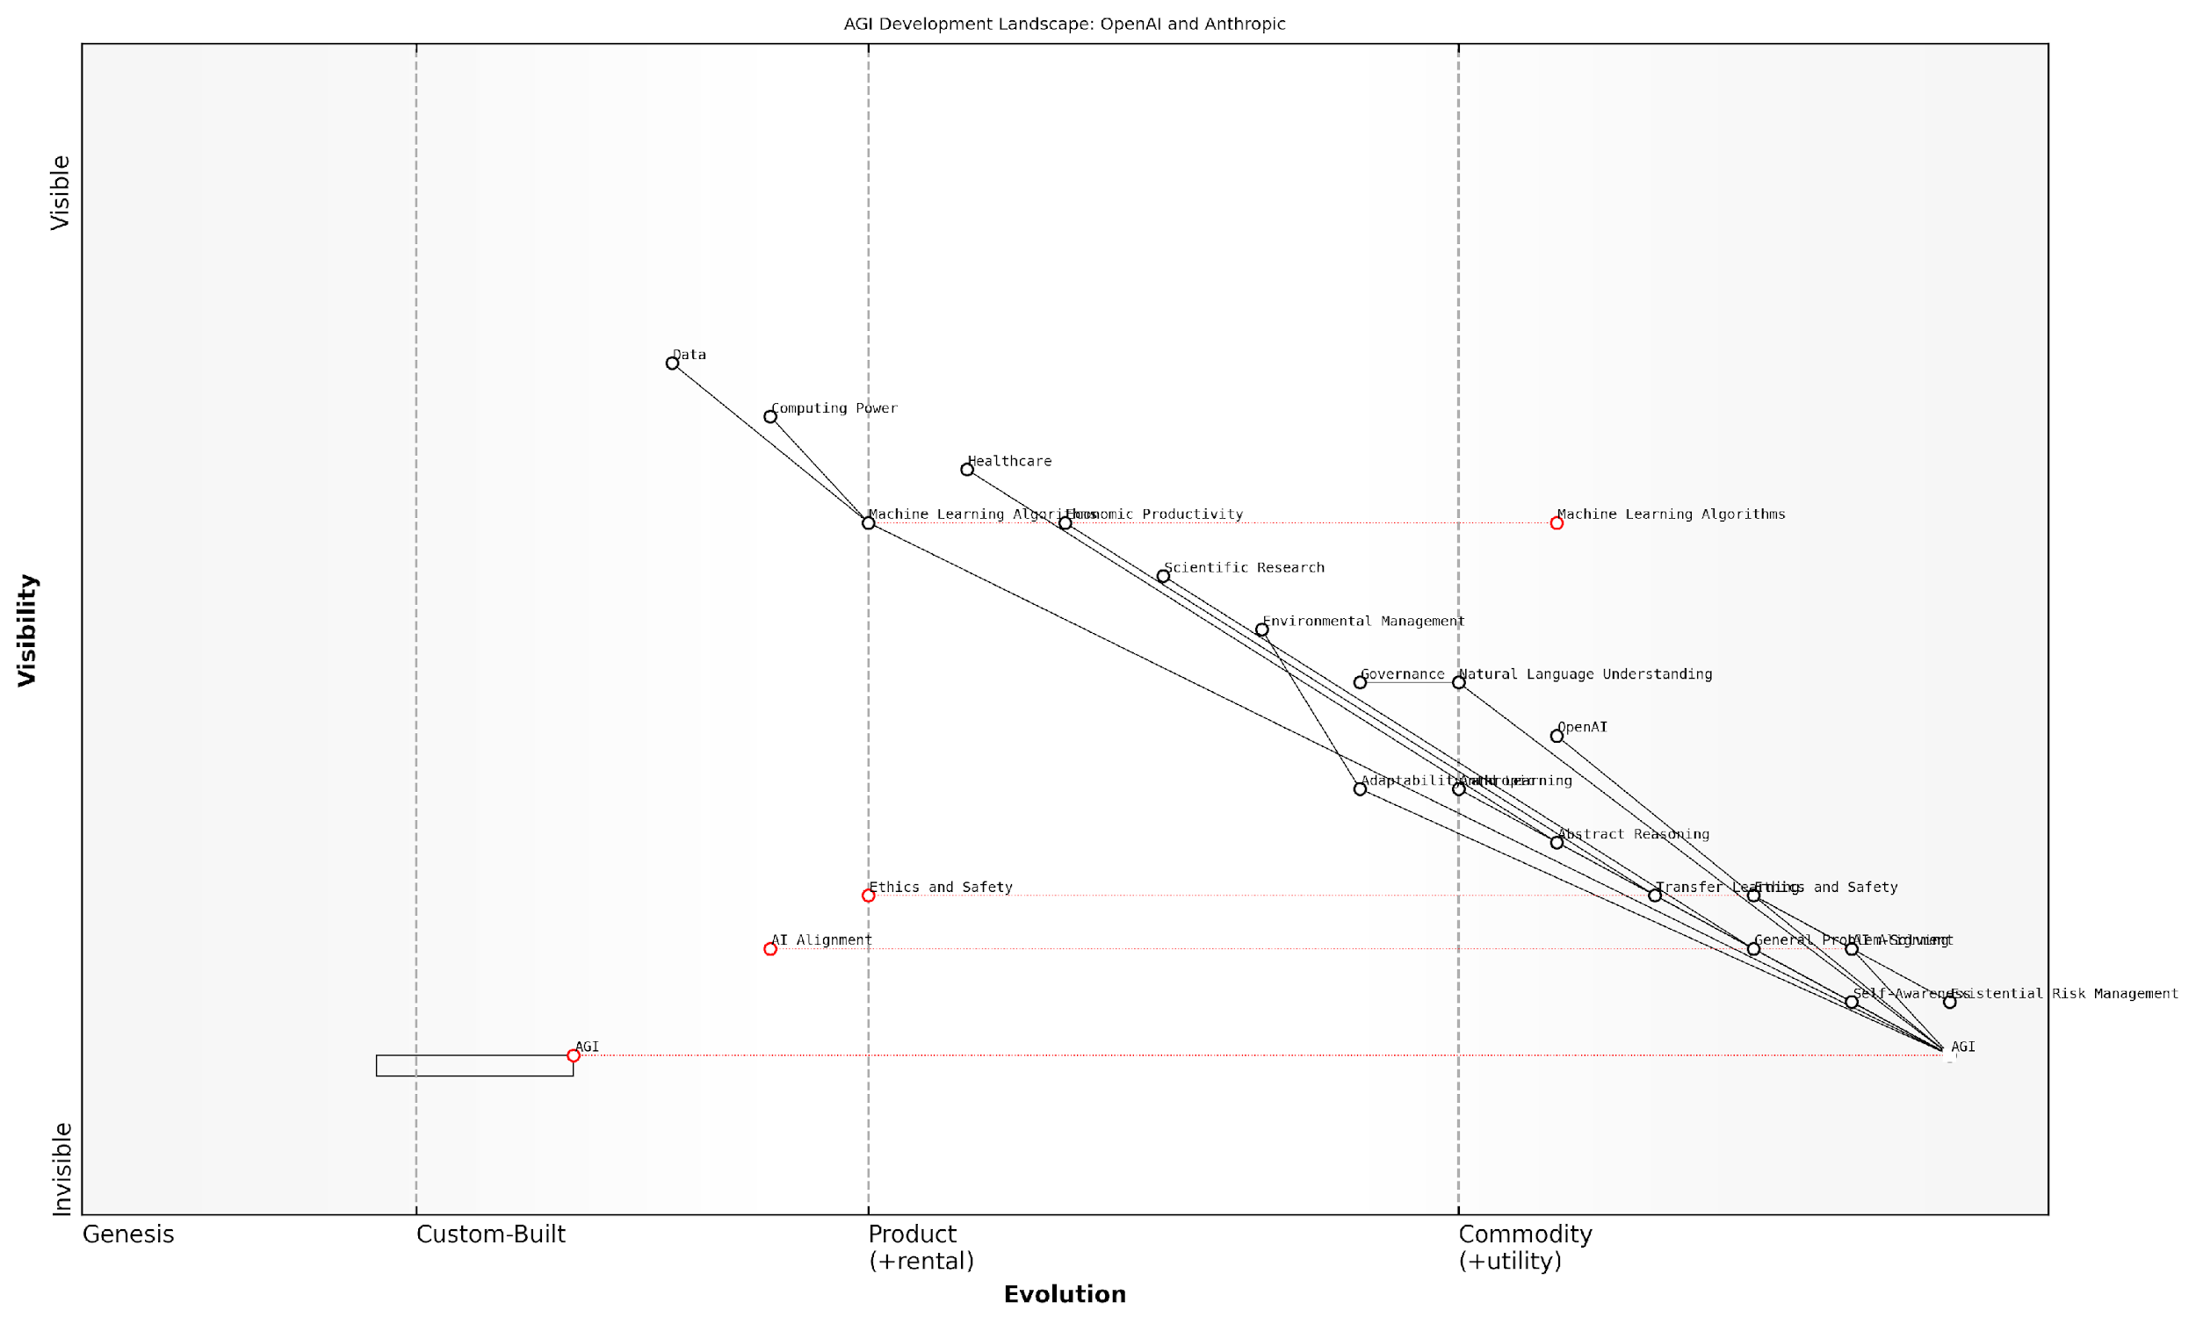

*Draft Wardley Map: [Insert Wardley Map: What is Artificial General Intelligence?]*

[Edit this draft Wardley Map](https://create.wardleymaps.ai/#clone:7ca727cb5a03c7035e)

Wardley Map Assessment

The AGI Development Landscape, as represented by this Wardley Map, showcases a field on the cusp of transformative breakthroughs. The positioning of AGI, AI Alignment, and Ethics/Safety as high-value, low-evolution components underscores both the immense potential and significant challenges ahead. OpenAI and Anthropic are well-positioned to lead this development, but success will require not just technical innovation, but also careful navigation of ethical, safety, and governance challenges. The critical path to AGI runs through AI Alignment and Ethics/Safety, making these areas as important as core technical capabilities. As the field evolves rapidly, maintaining a balance between competitive advancement and responsible development will be crucial. The potential impacts across various domains (healthcare, environment, governance) highlight the transformative potential of AGI, but also the need for a holistic, society-wide approach to its development and deployment. Strategic focus should be on accelerating progress in AI Alignment and Ethics/Safety while continuing to push the boundaries of core AGI capabilities, all within a framework of robust risk management and governance.

[View full Wardley Map report](http://markdown_wardley_map_reports/wardley_map_report_01_What_is_Artificial_General_Intelligence?.md)

### The transformative potential of AGI

Artificial General Intelligence (AGI) stands as the pinnacle of AI development, representing a system capable of matching or surpassing human cognitive abilities across a wide range of tasks. As we delve into the transformative potential of AGI, it is crucial to understand that we are not merely discussing incremental improvements to existing AI systems, but rather a paradigm shift that could fundamentally alter the course of human civilisation.

The race between OpenAI and Anthropic to develop AGI is not just a technological competition; it is a contest that will shape the future of humanity. The transformative potential of AGI extends far beyond the realm of computing, touching every aspect of our lives and society. To fully grasp the implications of this development, we must examine its potential impacts across various domains.

Economic Transformation:

* Unprecedented productivity gains: AGI could optimise complex systems and processes at a scale and speed unattainable by human cognition alone, potentially leading to exponential economic growth.
* Labour market disruption: Entire industries may be revolutionised or rendered obsolete, necessitating a fundamental rethinking of work, education, and social safety nets.
* Innovation acceleration: AGI could dramatically speed up scientific research and technological development, potentially solving long-standing challenges in fields such as energy production, healthcare, and space exploration.

Societal Impact:

* Governance and decision-making: AGI could provide unparalleled insights for policymakers, potentially leading to more effective and data-driven governance.
* Education revolution: Personalised learning experiences tailored to individual needs could become the norm, potentially democratising access to high-quality education.
* Healthcare advancements: AGI could accelerate drug discovery, enhance diagnostic accuracy, and enable personalised treatment plans, potentially extending human lifespans and quality of life.

Existential Considerations:

* Superintelligence scenario: AGI could potentially lead to an intelligence explosion, resulting in a superintelligent system that far surpasses human cognitive abilities.
* Existential risk: Misaligned or uncontrolled AGI could pose an existential threat to humanity, underscoring the critical importance of robust safety measures and ethical frameworks.
* Human-AI coexistence: Successfully developed AGI could become a partner in solving global challenges, potentially ushering in an era of unprecedented human flourishing.

The development of AGI represents the most significant inflection point in human history. Its potential to solve our greatest challenges is matched only by the risks it poses if developed without adequate safeguards and ethical considerations.

The transformative potential of AGI extends to the very fabric of our reality, potentially altering our understanding of consciousness, intelligence, and our place in the universe. As we stand on the precipice of this technological revolution, the approaches taken by OpenAI and Anthropic in their pursuit of AGI will have far-reaching consequences.

OpenAI’s iterative approach, exemplified by their GPT series, has demonstrated the power of large language models and their potential applications across various domains. Their focus on scaling and pushing the boundaries of AI capabilities has yielded impressive results, but also raised concerns about the potential for misuse and unintended consequences.

Anthropic, on the other hand, has placed a strong emphasis on AI alignment and safety from the outset. Their constitutional AI approach seeks to embed ethical considerations and human values directly into the foundation of their AI systems. This focus on ‘getting it right’ from the start could potentially lead to more robust and trustworthy AGI systems, albeit potentially at the cost of development speed.

The contrasting approaches of these two leading organisations in the AGI race highlight the complex trade-offs and considerations at play. The winner of this race will not necessarily be the first to achieve AGI, but rather the one that develops AGI in a manner that maximises its transformative potential while minimising existential risks.

As we progress through this book, we will delve deeper into the specific strategies, technologies, and ethical frameworks employed by OpenAI and Anthropic in their pursuit of AGI. By understanding the nuances of their approaches, we can better anticipate the potential outcomes and prepare for a future where the transformative potential of AGI becomes a reality.

The race to develop AGI is not merely about technological supremacy; it is about shaping the trajectory of human civilisation. The decisions made today by organisations like OpenAI and Anthropic will echo through the annals of history, potentially defining the very nature of our species’ future.

In the subsequent chapters, we will explore the technical innovations, business strategies, ethical considerations, and potential societal impacts that characterise the AGI race between OpenAI and Anthropic. By gaining a comprehensive understanding of these factors, readers will be better equipped to navigate the complex landscape of AGI development and its implications for our collective future.

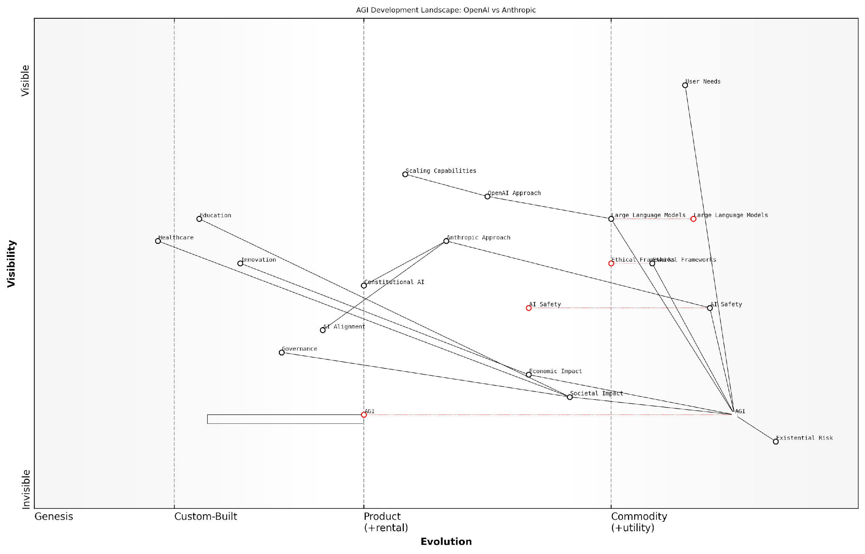

*Draft Wardley Map: [Insert Wardley Map: The transformative potential of AGI]*

[Edit this draft Wardley Map](https://create.wardleymaps.ai/#clone:2a581ac0a7d772d971)

Wardley Map Assessment

The map reveals a critical juncture in AGI development, with immense potential balanced against significant risks. The divergent approaches of OpenAI and Anthropic highlight the need for a balanced strategy that combines rapid capability scaling with robust safety measures and ethical considerations. Success in AGI development will require unprecedented collaboration, foresight, and adaptive governance to harness its transformative potential while mitigating existential risks. The strategic focus should be on advancing AI alignment, establishing flexible yet robust ethical frameworks, and creating adaptive governance structures, all while continuing to push the boundaries of AI capabilities.

[View full Wardley Map report](http://markdown_wardley_map_reports/wardley_map_report_02_The_transformative_potential_of_AGI.md)

### Risks and opportunities of AGI development

As we stand on the precipice of a potential artificial general intelligence (AGI) breakthrough, it is crucial to thoroughly examine the risks and opportunities that such a development presents. The race between OpenAI and Anthropic to achieve AGI is not merely a technological competition; it is a high-stakes endeavour that could fundamentally reshape human civilisation. This section delves into the multifaceted implications of AGI development, exploring both the transformative potential and the existential risks that accompany this pursuit.

To fully appreciate the gravity of AGI development, we must first consider its unprecedented capabilities. Unlike narrow AI systems designed for specific tasks, AGI would possess human-like cognitive abilities across a broad spectrum of domains. This general intelligence could potentially surpass human capabilities in areas such as scientific research, problem-solving, and decision-making, leading to rapid advancements in fields ranging from medicine to space exploration.

AGI represents the holy grail of artificial intelligence research. Its potential to solve complex global challenges is unparalleled, but so too are the risks if not developed and deployed with the utmost care and foresight.

Let us examine the key opportunities and risks associated with AGI development:

* Opportunities:
  + Accelerated scientific breakthroughs
  + Enhanced problem-solving capabilities for global challenges
  + Unprecedented economic growth and productivity
  + Personalised education and healthcare
  + Advanced space exploration and colonisation
* Risks:
  + Existential threat to humanity if misaligned
  + Massive job displacement and economic disruption
  + Potential for misuse in warfare or surveillance
  + Exacerbation of global inequalities
  + Loss of human agency and decision-making autonomy

One of the most significant opportunities presented by AGI is its potential to accelerate scientific breakthroughs. With its ability to process and analyse vast amounts of data, an AGI system could revolutionise fields such as genomics, materials science, and climate modelling. For instance, AGI could rapidly identify new drug candidates for diseases that have long eluded human researchers, potentially saving millions of lives.

Moreover, AGI could be instrumental in addressing complex global challenges that require interdisciplinary approaches. Climate change, for example, involves intricate interactions between atmospheric science, economics, and human behaviour. An AGI system could model these interactions with unprecedented accuracy, providing policymakers with invaluable insights for crafting effective mitigation strategies.

The economic implications of AGI are equally profound. By automating cognitive tasks across industries, AGI could drive unprecedented productivity gains, potentially ushering in an era of abundance. This could lead to shorter working hours, universal basic income, and a fundamental restructuring of our economic systems.

The economic impact of AGI could be comparable to the Industrial Revolution, but compressed into a much shorter timeframe. We must be prepared for rapid and potentially disruptive changes to our labour markets and economic structures.

However, these opportunities are accompanied by significant risks that cannot be overlooked. Perhaps the most concerning is the existential risk posed by a misaligned AGI. If an AGI system’s goals are not perfectly aligned with human values, even a slight misalignment could have catastrophic consequences. This concern is at the heart of the AI alignment problem, which both OpenAI and Anthropic are actively working to address.

The potential for job displacement is another critical risk. While AGI could create new job categories, it could also render many existing professions obsolete at a pace that outstrips society’s ability to retrain and adapt. This could lead to widespread unemployment and social unrest if not managed carefully.

Furthermore, the concentration of AGI capabilities in the hands of a few entities raises concerns about power imbalances and global inequalities. If AGI development is not democratised, it could exacerbate existing disparities between nations and socioeconomic groups.

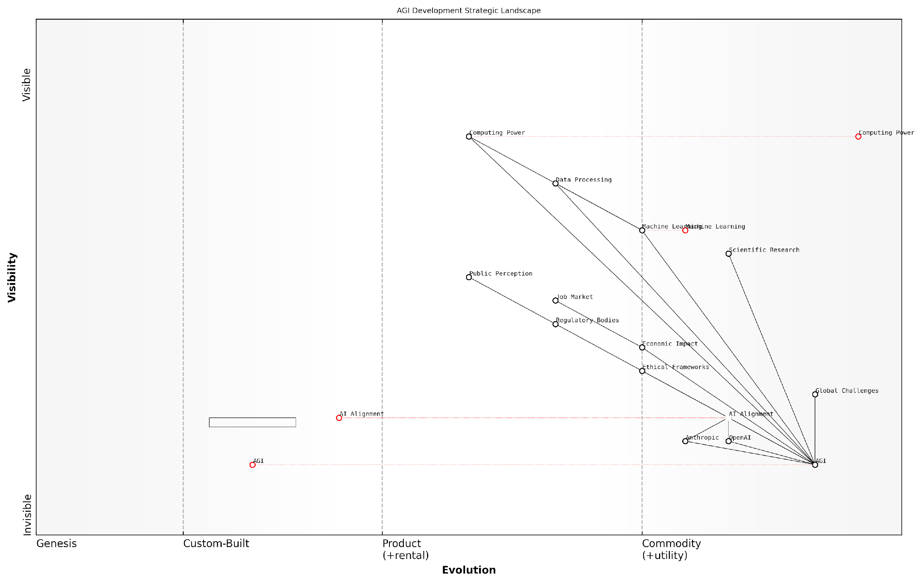

*Draft Wardley Map: [Insert Wardley Map: Risks and opportunities of AGI development]*

[Edit this draft Wardley Map](https://create.wardleymaps.ai/#clone:3dde418729cf28d3ce)

Wardley Map Assessment

This Wardley Map reveals a strategic landscape where AGI development is poised at a critical juncture. While foundational technologies are well-established, the crucial components of AI Alignment and Ethical Frameworks are still in early stages. The strategic imperative is to advance these components in parallel with AGI capabilities to ensure safe and beneficial outcomes. Companies that can successfully navigate the complex interplay between technological advancement, ethical considerations, regulatory compliance, and public perception will be best positioned to lead in the AGI race. The map underscores the need for a collaborative, multi-stakeholder approach to AGI development, with a strong focus on addressing global challenges and mitigating potential risks. As the field evolves rapidly, adaptability and a commitment to responsible innovation will be key to long-term success and societal benefit.

[View full Wardley Map report](http://markdown_wardley_map_reports/wardley_map_report_03_Risks_and_opportunities_of_AGI_development.md)

As we navigate these risks and opportunities, the approaches taken by OpenAI and Anthropic will be crucial in shaping the future of AGI. OpenAI’s commitment to beneficial AGI and Anthropic’s focus on constitutional AI and alignment represent different strategies for mitigating risks while harnessing the transformative potential of this technology.

OpenAI’s approach involves a gradual release of increasingly powerful AI models, allowing for societal adaptation and iterative safety improvements. This strategy aims to build public trust and allow for course corrections as development progresses. Anthropic, on the other hand, emphasises the importance of solving the alignment problem before deploying AGI, focusing on ensuring that the system’s goals and values are fundamentally compatible with human welfare.

The race to AGI is not just about who gets there first, but who gets there safely. The winner of this race will be determined not by speed alone, but by the ability to develop AGI that is both powerful and aligned with human values.

In conclusion, the development of AGI presents a double-edged sword of unprecedented opportunities and existential risks. As OpenAI and Anthropic push the boundaries of what is possible in AI, it is imperative that we as a society remain vigilant and engaged in the process. The decisions made in the coming years will shape the trajectory of human civilisation, and it is our collective responsibility to ensure that the development of AGI benefits all of humanity while safeguarding our future.

## The Key Players: OpenAI and Anthropic

### Origins and missions

In the high-stakes race towards Artificial General Intelligence (AGI), two organisations have emerged as frontrunners: OpenAI and Anthropic. Their origins and missions not only shape their approach to AGI development but also reflect broader philosophical and ethical considerations in the field. Understanding these foundational aspects is crucial for grasping the nuances of the AGI competition and its potential impact on humanity’s future.

OpenAI, founded in 2015, began as a non-profit research company with the ambitious goal of ensuring that artificial general intelligence benefits all of humanity. Its inception was driven by concerns about the potential risks of AGI and the need for open collaboration in its development. The organisation’s initial mission statement emphasised the importance of developing AGI that is safe and beneficial, while also promoting and developing friendly AI in a way that benefits humanity as a whole.

As a senior AI researcher involved in OpenAI’s early days remarked, ‘Our founding principle was to create a platform where the benefits of AGI could be shared broadly, rather than concentrated in the hands of a few powerful entities.’

OpenAI’s transition from a non-profit to a ‘capped-profit’ model in 2019 marked a significant shift in its approach. This change was motivated by the need to secure substantial computing resources and attract top talent to compete in the increasingly resource-intensive field of AGI research. Despite this structural change, OpenAI maintains its commitment to developing AGI that benefits humanity, albeit with a more pragmatic approach to funding and resource allocation.

Anthropic, on the other hand, was founded in 2021 by former OpenAI researchers who sought to pursue a different approach to AGI development. The company’s mission centres around the concept of ‘Constitutional AI’, which aims to create AI systems that are inherently aligned with human values and ethical principles. This approach reflects a deep concern for the long-term implications of AGI and a commitment to developing AI systems that are not only powerful but also safe and beneficial by design.

A leading expert in AI ethics noted, ‘Anthropic’s focus on Constitutional AI represents a paradigm shift in how we approach the development of advanced AI systems, prioritising alignment and safety from the ground up.’

Anthropic’s origins are rooted in a philosophical approach that emphasises the importance of AI alignment - ensuring that AI systems behave in ways that are consistent with human values and intentions. This focus on alignment is not merely an add-on to their technical work but forms the core of their research and development efforts.

* Founding context: OpenAI emerged from concerns about AGI concentration, while Anthropic was born from a specific vision of aligned AI.
* Organisational structure: OpenAI transitioned from non-profit to capped-profit, whereas Anthropic began as a for-profit entity with a strong research focus.
* Primary focus: OpenAI initially emphasised open collaboration and broad benefit, while Anthropic centres on Constitutional AI and alignment.
* Evolution of approach: OpenAI has adapted its strategy over time, becoming more commercially oriented, while Anthropic has maintained a consistent focus on its founding principles.

These differences in origins and missions have profound implications for how each organisation approaches the development of AGI. OpenAI’s evolution reflects the challenges of balancing idealistic goals with practical realities in the competitive landscape of AI research. Their shift towards a more commercial model has allowed them to scale their efforts and produce groundbreaking technologies like GPT-3 and DALL-E, which have had significant impacts on the AI field and beyond.

Anthropic’s unwavering focus on Constitutional AI, by contrast, represents a more specialised approach that prioritises safety and alignment from the outset. This strategy may lead to slower initial progress in terms of raw capabilities but could potentially result in more robust and ethically aligned AI systems in the long run.

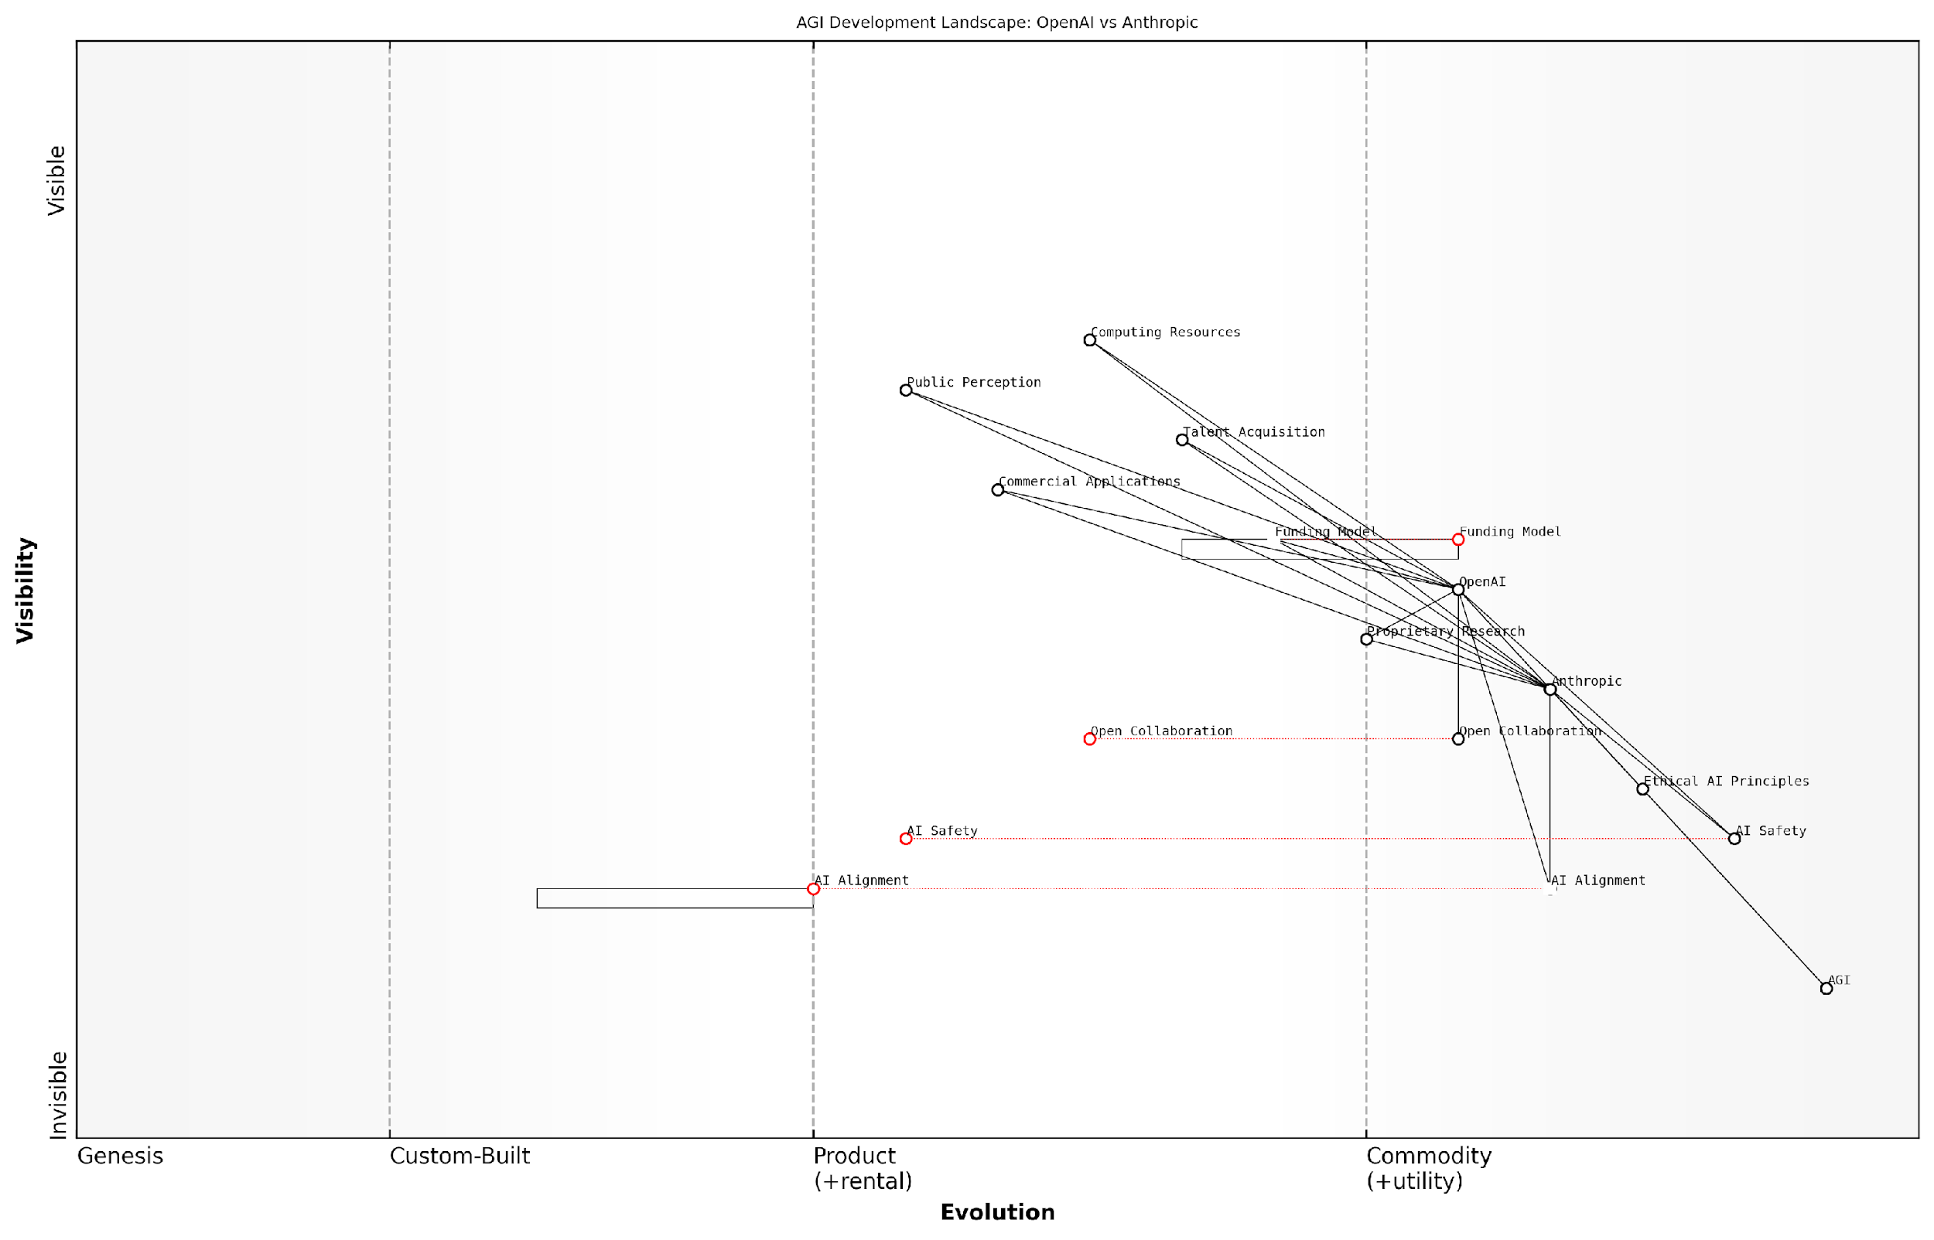

*Draft Wardley Map: [Insert Wardley Map: Origins and missions]*

[Edit this draft Wardley Map](https://create.wardleymaps.ai/#clone:15de673985bf89dc82)

Wardley Map Assessment

The map reveals a highly competitive landscape in AGI development, with OpenAI and Anthropic as key players. The positioning of components suggests a field that is advancing rapidly in core technologies while grappling with critical challenges in safety, ethics, and alignment. The strategic imperative is to advance AGI capabilities while simultaneously strengthening safety measures and ethical frameworks. Success will likely depend on balancing open collaboration with proprietary advances, managing public perception, and solving the fundamental challenges of AI alignment and safety. The evolving nature of key components indicates a dynamic field with significant opportunities for innovation and potential for disruption. Organizations that can effectively navigate the tension between rapid advancement and responsible development are likely to emerge as leaders in the AGI race.

[View full Wardley Map report](http://markdown_wardley_map_reports/wardley_map_report_04_Origins_and_missions.md)

The contrasting origins and missions of OpenAI and Anthropic highlight a fundamental tension in the field of AGI development: the balance between rapid progress and ensuring safety and alignment. As these organisations continue to shape the future of AGI, their foundational principles will play a crucial role in determining not only who might ‘win’ the AGI race but also what that victory might mean for humanity.

As a prominent AI policy advisor observed, ‘The ultimate winner of the AGI race may not be determined solely by technical achievements, but by which organisation can best align powerful AI systems with human values and societal needs.’

In conclusion, the origins and missions of OpenAI and Anthropic provide essential context for understanding their approaches to AGI development. As we delve deeper into their technical innovations, business strategies, and ethical considerations in subsequent chapters, these foundational aspects will serve as a crucial reference point for evaluating their progress and potential impact on the future of artificial intelligence and human civilisation.

### Key figures and leadership

In the high-stakes race towards Artificial General Intelligence (AGI), the leadership and key figures at OpenAI and Anthropic play a pivotal role in shaping the trajectory of their respective organisations. These individuals not only guide the technical direction of their companies but also embody the philosophical approaches and ethical considerations that underpin their pursuit of AGI. Understanding the backgrounds, motivations, and visions of these key players is crucial for comprehending the nuanced differences in how OpenAI and Anthropic approach the monumental challenge of developing safe and beneficial AGI.

OpenAI’s Leadership:

* Co-founders: The organisation was co-founded by a group of tech luminaries and entrepreneurs, including individuals with backgrounds in machine learning, robotics, and Silicon Valley startups.
* CEO: The current chief executive brings a blend of technical expertise and business acumen, having previously founded successful tech companies and contributed to significant AI research.
* Chief Scientist: A renowned figure in the AI community, known for groundbreaking work in deep learning and neural networks.
* Board of Directors: Comprises a mix of tech industry veterans, AI researchers, and policy experts, providing diverse perspectives on the company’s direction.

OpenAI’s leadership structure reflects its evolution from a non-profit research lab to a ‘capped-profit’ entity. This transition has brought in leaders with strong commercial experience, balancing the original research-focused ethos with a more market-oriented approach. The leadership team’s composition reflects OpenAI’s dual goals of pushing the boundaries of AI capabilities while also developing commercially viable products.

OpenAI’s leadership embodies a unique blend of scientific rigour and entrepreneurial spirit. Their ability to navigate the complex landscape of AGI development while maintaining a commitment to beneficial outcomes is truly remarkable.

Anthropic’s Leadership:

* Founders: The company was established by former OpenAI researchers, bringing with them deep expertise in AI safety and alignment.
* CEO: An individual with a strong background in AI ethics and safety, known for advocating a cautious and principled approach to AGI development.
* Research Director: A prominent figure in the field of AI alignment, with significant contributions to the theory and practice of building safe AI systems.
* Advisory Board: Includes experts in philosophy, ethics, and long-term AI strategy, reflecting Anthropic’s focus on the broader implications of AGI.

Anthropic’s leadership structure is characterised by a strong emphasis on AI safety and ethics. The founders’ background in AI alignment research is evident in the company’s approach, which prioritises the development of safe and controllable AI systems. The leadership team’s composition reflects a deep commitment to addressing the existential risks associated with AGI development.

Anthropic’s leadership stands out for its unwavering focus on the long-term implications of AGI. Their commitment to developing AI systems that are not just powerful, but fundamentally aligned with human values, is setting new standards in the field.

Comparative Analysis:

* Technical Expertise: Both organisations boast leadership teams with exceptional technical credentials. However, OpenAI’s leadership leans more towards breakthrough capabilities, while Anthropic’s focuses on safety and alignment.
* Philosophical Approach: OpenAI’s leadership reflects a more pragmatic approach, balancing research with commercial viability. Anthropic’s leadership embodies a more cautious, ethics-first philosophy.
* Industry Experience: OpenAI’s leadership includes more individuals with experience in scaling tech companies, while Anthropic’s leadership is more heavily weighted towards research and academia.
* Public Presence: OpenAI’s leaders tend to have a higher public profile, often engaging in public discourse about AI. Anthropic’s leadership maintains a lower public profile, focusing more on academic and policy circles.
* Diversity of Perspectives: Both organisations have made efforts to include diverse viewpoints in their leadership, recognising the global implications of AGI development.

The contrasting leadership styles and backgrounds at OpenAI and Anthropic significantly influence their approaches to AGI development. OpenAI’s leadership drives a more aggressive pursuit of cutting-edge AI capabilities, coupled with efforts to commercialise these advancements. This approach has led to high-profile releases like GPT-3 and DALL-E, which have captured public imagination and demonstrated the rapid progress in AI capabilities.

Conversely, Anthropic’s leadership steers the company towards a more measured approach, prioritising safety and alignment over rapid capability gains. This is evident in their focus on ‘constitutional AI’ and their emphasis on developing AI systems that are inherently aligned with human values. While this approach may result in slower public-facing progress, it addresses crucial long-term concerns about the impact of AGI on society.

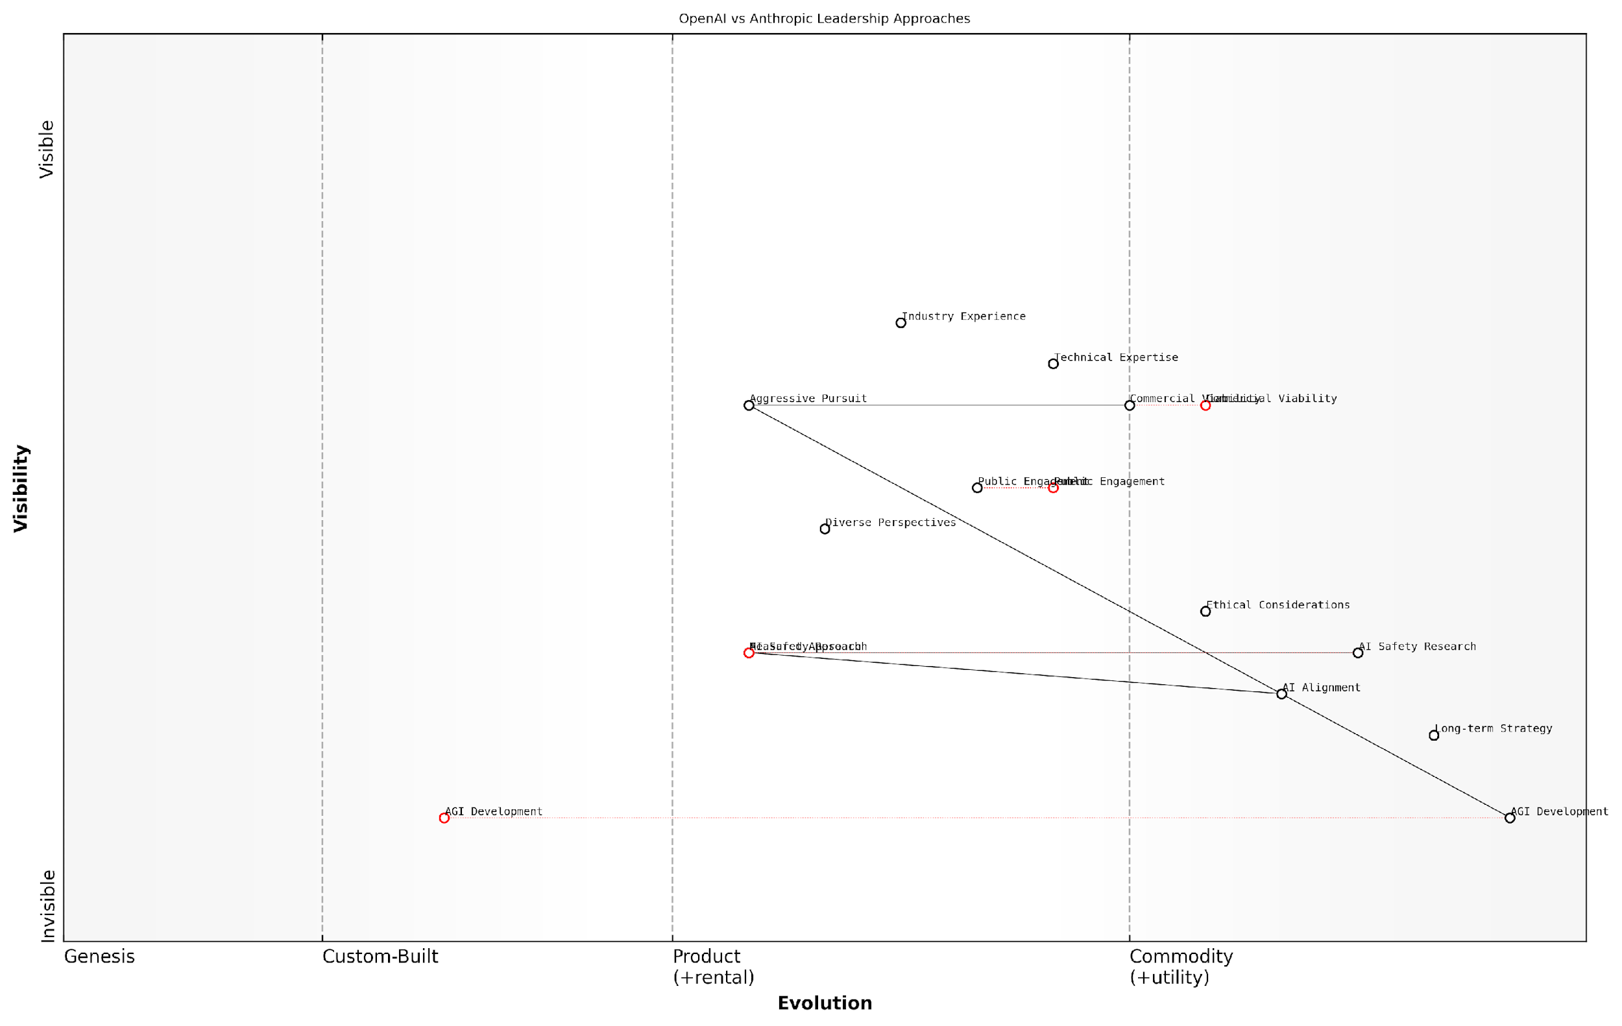

*Draft Wardley Map: [Insert Wardley Map: Key figures and leadership]*

[Edit this draft Wardley Map](https://create.wardleymaps.ai/#clone:54c55255cdf84cc2e1)

Wardley Map Assessment

The map reveals a strategic landscape where the race for AGI is tempered by crucial considerations of safety, ethics, and long-term impacts. OpenAI and Anthropic represent two distinct approaches to this challenge, with OpenAI pursuing a more aggressive, commercially-oriented strategy, and Anthropic adopting a measured, safety-first approach. The key to success in this domain will likely involve finding the right balance between rapid innovation and responsible development, with a strong emphasis on AI alignment and safety research. As the field evolves, collaboration on safety standards and ethical frameworks may become as important as the technical race itself, potentially reshaping the competitive dynamics of the industry.

[View full Wardley Map report](http://markdown_wardley_map_reports/wardley_map_report_05_Key_figures_and_leadership.md)

The leadership dynamics at both organisations will play a crucial role in determining the outcome of the AGI race. OpenAI’s blend of research excellence and commercial acumen positions it well to drive rapid advancements and secure the resources needed for AGI development. However, Anthropic’s unwavering focus on safety and alignment could prove critical in navigating the complex ethical landscape of AGI, potentially leading to more robust and trustworthy systems in the long run.

The AGI race is not just about who can build the most powerful AI first, but who can build it responsibly. The leadership at OpenAI and Anthropic are not just competing on technical grounds, but on their vision for the future of humanity in an AGI-enabled world.

As the race towards AGI intensifies, the decisions made by these key figures will have far-reaching consequences. Their ability to balance innovation with responsibility, to navigate complex ethical dilemmas, and to engage with policymakers and the public will be crucial in shaping not just the outcome of the AGI race, but the very future of human-AI coexistence.

### Philosophical approaches to AGI

The philosophical approaches to Artificial General Intelligence (AGI) adopted by OpenAI and Anthropic are fundamental to understanding the trajectory of the AGI race. These approaches not only shape the technical development of AGI but also influence the ethical frameworks, safety considerations, and potential societal impacts of their respective technologies. As we delve into this crucial aspect of the AGI competition, it becomes evident that the philosophical underpinnings of each organisation play a pivotal role in determining their strategies, priorities, and ultimate vision for the future of AGI.

OpenAI’s philosophical approach to AGI can be characterised as pragmatic and iterative, with a focus on pushing the boundaries of AI capabilities whilst maintaining a commitment to beneficial outcomes. This approach is rooted in the belief that AGI development is inevitable and that it is crucial to be at the forefront of this development to ensure it is done responsibly.

* Iterative development: OpenAI believes in continuously advancing AI capabilities through successive generations of models, as evidenced by their GPT series.
* Openness and collaboration: Despite some shifts in recent years, OpenAI maintains a philosophy of sharing research and collaborating with the wider AI community to accelerate progress.
* Beneficial AGI: The organisation is committed to ensuring that AGI benefits all of humanity, a principle that guides their research and deployment strategies.
* Pragmatic safety measures: OpenAI adopts a practical approach to AI safety, implementing safeguards and control mechanisms as they develop more advanced systems.

OpenAI’s approach can be summed up as ‘responsible acceleration’. They believe that by pushing the boundaries of AI capabilities whilst simultaneously developing safety measures, we can create AGI that is both powerful and aligned with human values.

In contrast, Anthropic’s philosophical approach to AGI is characterised by a more cautious and alignment-focused methodology. Their core philosophy revolves around the concept of ‘Constitutional AI’, which emphasises the importance of instilling values and ethical principles into AI systems from the ground up.

* Value alignment: Anthropic places a strong emphasis on ensuring that AI systems are aligned with human values and ethical principles.
* Long-term safety: The organisation prioritises long-term AI safety considerations, focusing on developing AI systems that are inherently safe and beneficial.
* Transparency and interpretability: Anthropic’s approach emphasises the importance of understanding AI decision-making processes and making them transparent to humans.
* Scalable oversight: They focus on developing AI systems that can be effectively overseen and controlled as they become more advanced and autonomous.

Anthropic’s philosophy can be described as ‘safety-first innovation’. They believe that by prioritising alignment and safety from the outset, we can develop AGI that is not only powerful but also trustworthy and beneficial to humanity.

The philosophical divergence between OpenAI and Anthropic has significant implications for the AGI race. OpenAI’s approach may lead to more rapid advancements in AI capabilities, potentially giving them an edge in the short term. However, Anthropic’s focus on alignment and safety could prove crucial in developing AGI that is more reliable, trustworthy, and ultimately more beneficial to society in the long run.

These philosophical differences also manifest in the organisations’ approaches to key challenges in AGI development:

* Scalability: OpenAI tends to focus on scaling up models and computational resources, while Anthropic emphasises scaling oversight and control mechanisms.
* Ethical considerations: Both organisations prioritise ethics, but Anthropic’s approach integrates ethical considerations more deeply into the fundamental architecture of their AI systems.
* Deployment strategies: OpenAI has shown a willingness to release powerful AI models to the public (with safeguards), while Anthropic tends to be more cautious about widespread deployment.
* Research focus: OpenAI often pursues cutting-edge capabilities across various domains, whereas Anthropic concentrates more on foundational research in AI alignment and safety.

The implications of these philosophical approaches extend beyond technical development. They influence public perception, regulatory engagement, and potential societal impacts of AGI. OpenAI’s approach may lead to more rapid integration of AI technologies into various sectors, potentially bringing significant economic benefits but also raising concerns about job displacement and AI safety. Anthropic’s approach, while potentially slower in terms of deployment, may result in AGI systems that are more robust, trustworthy, and easier to integrate into sensitive areas such as healthcare and governance.

As the AGI race progresses, the philosophical approaches of OpenAI and Anthropic will continue to shape the trajectory of AGI development. The ultimate winner of this race may not necessarily be the organisation that achieves AGI first, but rather the one that develops AGI in a manner that is most beneficial and acceptable to society. As such, understanding and critically evaluating these philosophical approaches is crucial for policymakers, researchers, and the public in preparing for and shaping the future of AGI.

The philosophical foundations laid by OpenAI and Anthropic today will determine the nature of the AGI we create tomorrow. It is not just a race for capability, but a profound exploration of how we can imbue machines with the values and principles that will shape the future of human-AI coexistence.

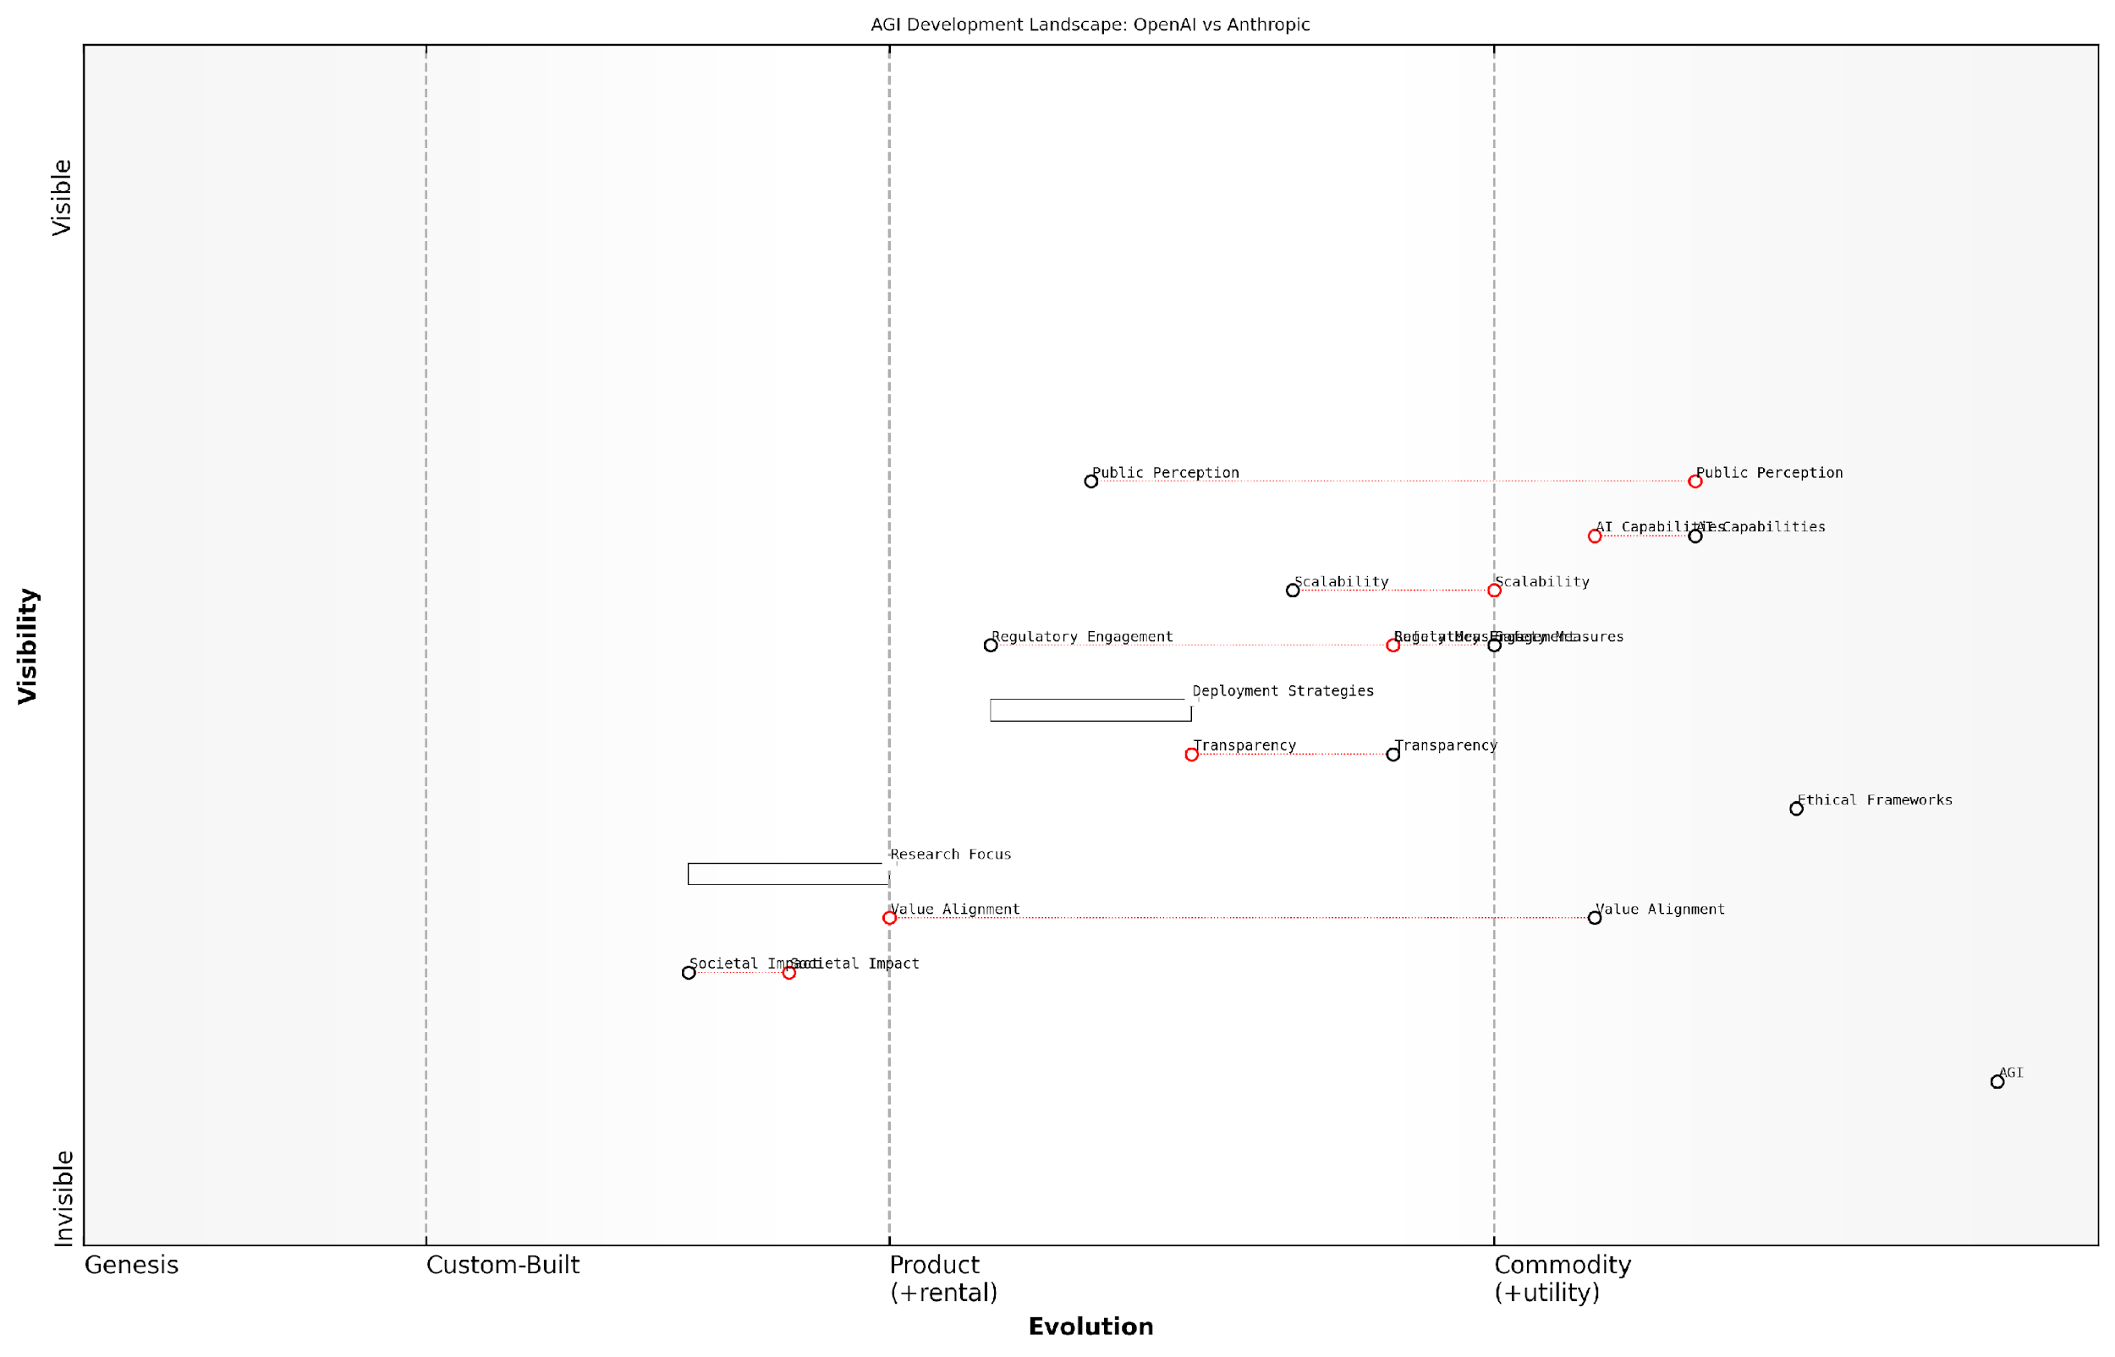

*Draft Wardley Map: [Insert Wardley Map: Philosophical approaches to AGI]*

[Edit this draft Wardley Map](https://create.wardleymaps.ai/#clone:9e1f9503dbb8536941)

Wardley Map Assessment

The AGI development landscape, as represented by this map, is characterized by rapid technological advancement coupled with growing emphasis on safety, ethics, and societal implications. OpenAI and Anthropic are well-positioned but face significant challenges in balancing innovation with responsibility. The key to success lies in advancing AI capabilities while simultaneously developing robust safety measures, ethical frameworks, and value alignment techniques. Proactive engagement with regulators and the public will be crucial. The industry is poised for potential breakthroughs but must navigate complex ethical and societal challenges to achieve responsible AGI development.

[View full Wardley Map report](http://markdown_wardley_map_reports/wardley_map_report_06_Philosophical_approaches_to_AGI.md)

# Technical Innovations and AI Breakthroughs

## OpenAI’s Technical Advancements

### GPT series and language models

OpenAI’s GPT (Generative Pre-trained Transformer) series represents a watershed moment in the development of large language models, positioning the company at the forefront of the artificial general intelligence (AGI) race. This subsection delves into the technical advancements that have propelled OpenAI’s language models to unprecedented levels of capability, exploring their potential implications for the broader field of AGI development.

The evolution of the GPT series, from GPT-1 to the current state-of-the-art GPT-4, showcases OpenAI’s relentless pursuit of scaling language models to achieve increasingly sophisticated natural language understanding and generation. Each iteration has brought significant improvements in performance, versatility, and potential applications, pushing the boundaries of what’s possible in natural language processing (NLP) and inching closer to AGI capabilities.

* GPT-1: Introduced the concept of large-scale unsupervised pre-training
* GPT-2: Demonstrated impressive text generation capabilities
* GPT-3: Achieved few-shot learning and task-agnostic performance
* GPT-4: Multimodal capabilities and enhanced reasoning abilities

One of the key technical innovations underpinning the GPT series is the transformer architecture, which allows for efficient processing of long-range dependencies in text. OpenAI has consistently pushed the boundaries of model size and training data, leveraging economies of scale to achieve breakthrough performance. The company’s approach to scaling laws, which describe the relationship between model size, dataset size, and computational resources, has been instrumental in guiding their development strategy.

The GPT series has fundamentally altered our understanding of what’s possible in natural language processing. Each iteration brings us closer to systems that can understand and generate human-like text with unprecedented fidelity.

OpenAI’s technical advancements in language models extend beyond mere scale. The company has made significant strides in improving the models’ ability to follow instructions, understand context, and perform complex reasoning tasks. This has been achieved through techniques such as reinforcement learning from human feedback (RLHF) and careful curation of training data to align the models with human values and reduce harmful outputs.

The GPT series has also demonstrated remarkable few-shot and zero-shot learning capabilities, allowing the models to perform well on tasks they weren’t explicitly trained for. This generalisation ability is a crucial step towards AGI, as it suggests the potential for models to adapt to novel situations and tasks without extensive retraining.

However, OpenAI’s approach is not without challenges. The massive computational resources required for training and running these models raise questions about environmental sustainability and accessibility. Additionally, the black-box nature of large language models presents challenges in terms of interpretability and controllability, which are critical considerations for safe AGI development.

While the achievements of the GPT series are undeniably impressive, we must remain vigilant about the potential risks and limitations of these powerful language models as we progress towards AGI.

OpenAI’s commitment to responsible AI development is evident in their phased release approach, which allows for careful study of the models’ capabilities and potential risks before wider deployment. This strategy has sparked debates within the AI community about the balance between open scientific collaboration and responsible innovation.

The impact of OpenAI’s language models extends far beyond the realm of natural language processing. These models have found applications in diverse fields such as code generation, creative writing, and even scientific research. The GPT series has demonstrated the potential for language models to serve as a foundation for more general artificial intelligence systems, capable of reasoning across multiple domains.

* Code generation and software development assistance
* Content creation and creative writing support
* Scientific literature analysis and hypothesis generation
* Educational tools and personalised learning experiences

As OpenAI continues to refine and expand the capabilities of its language models, the company is likely to face increasing scrutiny and competition. The race towards AGI is intensifying, with other major players like Anthropic, Google, and DeepMind making significant strides in language model development. OpenAI’s ability to maintain its competitive edge while addressing ethical concerns and safety considerations will be crucial in determining the outcome of the AGI race.

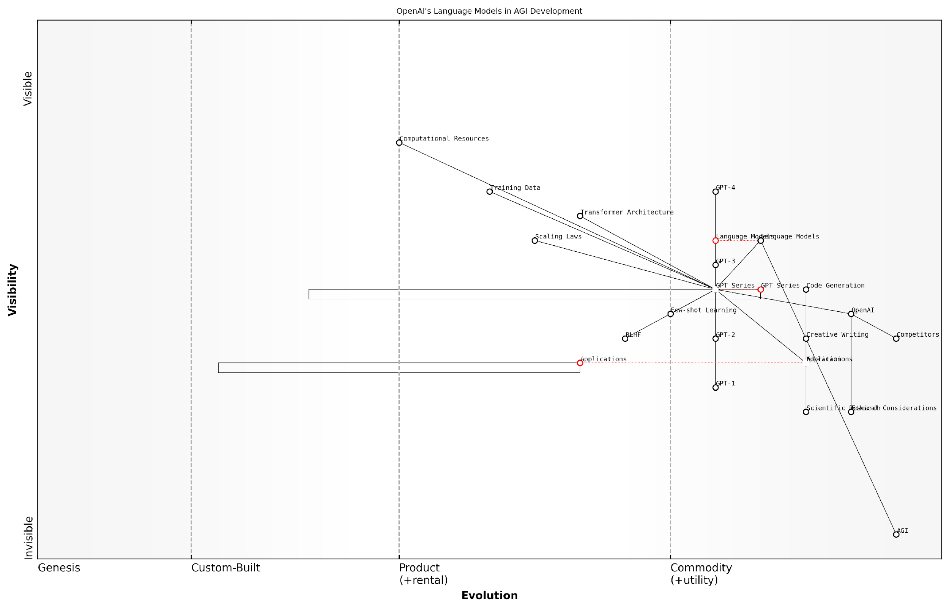

*Draft Wardley Map: [Insert Wardley Map: GPT series and language models]*

[Edit this draft Wardley Map](https://create.wardleymaps.ai/#clone:9a0c4951d8c3ea001a)

Wardley Map Assessment

OpenAI is strategically positioned at the forefront of language model development and AGI research. The company’s focus on the GPT series has yielded significant advancements, but the path to AGI remains uncertain. Key challenges include ethical considerations, computational resource limitations, and the need for novel approaches beyond current language models. To maintain its leadership position, OpenAI should prioritize responsible AI development, diversify its research beyond language models, and foster a collaborative ecosystem for AGI advancement. The company’s ability to balance cutting-edge innovation with ethical considerations will be crucial for long-term success in the AGI race.

[View full Wardley Map report](http://markdown_wardley_map_reports/wardley_map_report_07_GPT_series_and_language_models.md)

In conclusion, OpenAI’s technical advancements in the GPT series and language models represent a significant leap forward in the pursuit of AGI. The company’s approach to scaling, innovation in model architecture, and focus on aligning AI systems with human values have set new benchmarks in the field. As we move closer to the realisation of AGI, the lessons learned from the development of these language models will undoubtedly play a crucial role in shaping the future of artificial intelligence.

### DALL-E and multimodal AI

In the high-stakes race towards Artificial General Intelligence (AGI), OpenAI’s development of DALL-E represents a significant milestone in multimodal AI capabilities. This groundbreaking system demonstrates the potential for AI to bridge the gap between language and visual understanding, a crucial step towards the holistic cognitive abilities that characterise AGI. As we delve into OpenAI’s technical advancements in this arena, it becomes clear that DALL-E is not merely a tool for generating images, but a harbinger of the increasingly sophisticated and versatile AI systems that will shape the future of technology and society.

DALL-E, named as a portmanteau of Salvador Dalí and WALL-E, showcases OpenAI’s prowess in developing AI systems that can understand and generate visual content based on textual descriptions. This capability represents a significant leap forward in the field of multimodal AI, which aims to integrate multiple forms of sensory input and output in a manner more akin to human cognition.

DALL-E is not just an image generation tool; it’s a glimpse into the future of AI systems that can seamlessly interpret and create across multiple modalities, bringing us one step closer to AGI.

The technical architecture underpinning DALL-E is a testament to OpenAI’s innovative approach to AI development. At its core, DALL-E utilises a variant of the GPT (Generative Pre-trained Transformer) architecture, which has been adapted to process and generate visual data. This adaptation demonstrates OpenAI’s ability to leverage and extend its existing language model technologies into new domains, a key advantage in the race towards AGI.

* Transformer-based architecture adapted for visual tasks
* Integration of language understanding with image generation
* Utilisation of large-scale datasets for training
* Novel techniques for improving image quality and coherence

One of the most striking aspects of DALL-E is its ability to understand and execute complex, nuanced prompts. This capability goes beyond simple object recognition or scene composition; it demonstrates an understanding of abstract concepts, styles, and even humour. For instance, DALL-E can generate images of ‘an astronaut riding a horse in a photorealistic style’ or ‘a bowl of soup that looks like a monster, knitted out of wool’ with remarkable accuracy and creativity.

The implications of this technology for the AGI race are profound. By bridging the gap between language and visual understanding, OpenAI is laying the groundwork for AI systems that can interact with the world in increasingly human-like ways. This multimodal capability is crucial for the development of AGI, as it moves AI systems closer to the kind of general intelligence that can flexibly apply knowledge across different domains and sensory modalities.

The ability to seamlessly translate between language and visual concepts is not just a party trick; it’s a fundamental capability that brings us closer to AGI. It’s about creating AI that can understand and interact with the world in ways that mirror human cognition.

However, the development of DALL-E also raises important ethical considerations. The ability to generate highly realistic images based on textual descriptions has implications for issues such as deepfakes, copyright, and the potential for misuse in creating misleading or harmful content. OpenAI has implemented various safeguards and usage policies to mitigate these risks, but the broader implications for society and regulation remain a topic of ongoing debate.

In the context of the AGI race between OpenAI and Anthropic, DALL-E represents a significant advantage for OpenAI. While Anthropic has made strides in language models and AI alignment, they have not yet publicly demonstrated comparable capabilities in multimodal AI. This gives OpenAI a lead in a crucial area of AGI development, potentially accelerating their progress towards more general AI capabilities.

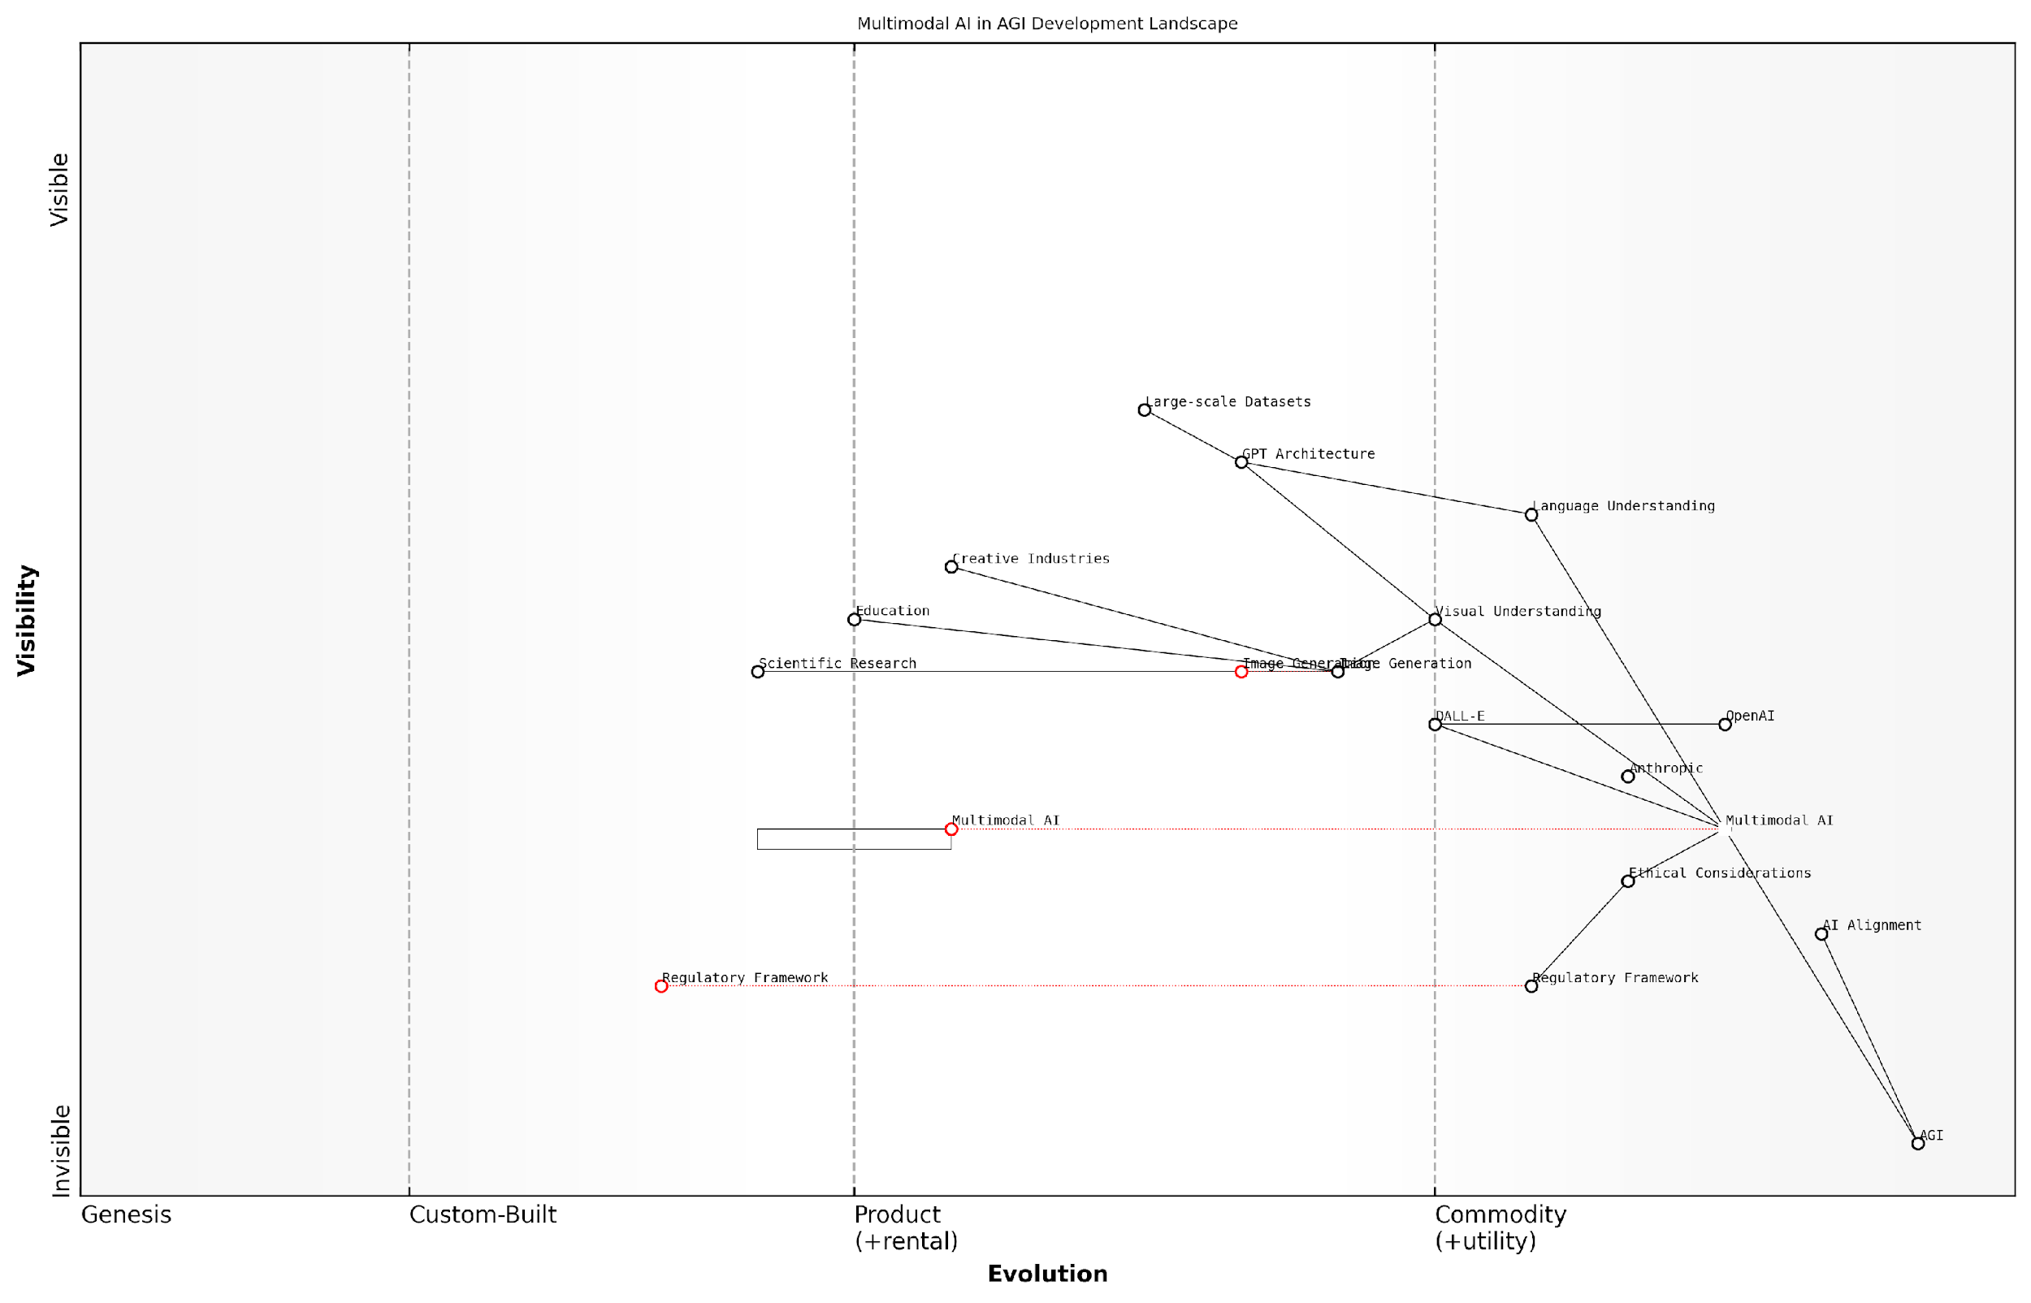

*Draft Wardley Map: [Insert Wardley Map: DALL-E and multimodal AI]*

[Edit this draft Wardley Map](https://create.wardleymaps.ai/#clone:269663bd7aa5d92520)

Wardley Map Assessment

The map reveals a rapidly evolving landscape of multimodal AI development in the context of AGI, with OpenAI well-positioned through technologies like DALL-E. However, the critical challenge lies in balancing technological advancement with ethical considerations and regulatory compliance. Success in this domain will require not only technical innovation but also leadership in responsible AI development practices. The strategic focus should be on advancing multimodal AI capabilities while simultaneously investing in AI alignment, ethics, and safety to pave the way for responsible AGI development.

[View full Wardley Map report](http://markdown_wardley_map_reports/wardley_map_report_08_DALL-E_and_multimodal_AI.md)

Looking ahead, the development of DALL-E and similar multimodal AI systems is likely to have far-reaching implications across various sectors. In the creative industries, these tools could revolutionise design processes, content creation, and visual effects. In education, they could provide new ways of visualising complex concepts. In scientific research, they could aid in the interpretation and visualisation of data. The potential applications are vast and still largely unexplored.

However, it’s important to note that while DALL-E represents a significant advancement, it is still far from true AGI. The system, impressive as it is, operates within specific constraints and lacks the general problem-solving abilities and contextual understanding that characterise human-level intelligence. Nonetheless, it represents a crucial step on the path to AGI, demonstrating the potential for AI systems to integrate multiple forms of intelligence in increasingly sophisticated ways.

While DALL-E is a remarkable achievement, we must remember that it’s a stepping stone, not the final destination. The path to AGI is long and complex, requiring advancements not just in multimodal processing, but in reasoning, learning, and adaptability across all domains of intelligence.

In conclusion, OpenAI’s development of DALL-E and its advancements in multimodal AI represent a significant milestone in the race towards AGI. By demonstrating the ability to bridge language and visual understanding, OpenAI has not only created a powerful tool for image generation but has also pushed the boundaries of what’s possible in AI. As the competition between OpenAI and Anthropic intensifies, developments in multimodal AI like DALL-E may prove to be key differentiators in the quest to achieve artificial general intelligence.

### Reinforcement learning and robotics

In the high-stakes race towards Artificial General Intelligence (AGI), OpenAI has consistently demonstrated its prowess in the critical domains of reinforcement learning and robotics. These interlinked fields are pivotal in the development of AGI, as they address the fundamental challenges of decision-making, adaptability, and physical interaction with the real world. OpenAI’s contributions in these areas have not only pushed the boundaries of what’s possible but have also set new benchmarks for the entire AI community.

OpenAI’s journey in reinforcement learning and robotics can be broadly categorised into three key areas: algorithmic innovations, scalable learning frameworks, and real-world applications. Each of these areas has seen significant advancements, contributing to OpenAI’s strong position in the AGI race.

Algorithmic Innovations:

* Proximal Policy Optimisation (PPO): OpenAI’s development of PPO has been a game-changer in the field of reinforcement learning. This algorithm offers a robust and efficient approach to policy optimisation, striking a balance between sample efficiency and ease of implementation.
* Generative Pre-trained Transformer (GPT) for RL: By leveraging their expertise in language models, OpenAI has explored novel ways to apply transformer architectures to reinforcement learning tasks, potentially bridging the gap between language understanding and decision-making in complex environments.
* Meta-learning algorithms: OpenAI has made significant strides in developing algorithms that can learn to learn, a crucial capability for AGI systems that need to adapt quickly to new tasks and environments.

Scalable Learning Frameworks:

* OpenAI Gym: This toolkit for developing and comparing reinforcement learning algorithms has become a standard in the field, facilitating rapid experimentation and benchmarking.
* RoboSchool and MuJoCo: OpenAI’s investments in physics simulators have accelerated research in robotic control, allowing for safe and efficient training of RL agents in virtual environments before deployment in the real world.
* OpenAI Five: The system that competed against professional Dota 2 players demonstrated OpenAI’s ability to scale reinforcement learning to complex, multi-agent environments with long-term strategic planning.

Real-World Applications:

* Dexterous Manipulation: OpenAI’s work on teaching a robotic hand to manipulate physical objects with human-like dexterity has pushed the boundaries of what’s possible in robotic control.
* Rubik’s Cube Solving: The achievement of solving a Rubik’s Cube with a robotic hand showcased the integration of vision, tactile sensing, and complex manipulation in a real-world task.
* DALL-E and Robotics: While primarily known for image generation, the principles behind DALL-E have potential applications in robotic planning and visual reasoning tasks.

OpenAI’s advancements in reinforcement learning and robotics are not just incremental improvements, but paradigm shifts that bring us closer to AGI. Their ability to bridge the gap between simulation and reality is particularly noteworthy.

The significance of OpenAI’s work in these areas cannot be overstated. By tackling the challenges of reinforcement learning and robotics head-on, OpenAI is addressing some of the most fundamental obstacles to achieving AGI. The ability to learn from interaction, adapt to new situations, and manipulate the physical world are all crucial components of general intelligence.

However, it’s important to note that these advancements also raise important ethical and safety considerations. As reinforcement learning systems become more powerful and robots more capable, ensuring their alignment with human values and safety constraints becomes paramount. OpenAI has acknowledged this challenge and has implemented various safety measures and control mechanisms in their research and development processes.

Looking ahead, the integration of large language models with reinforcement learning and robotics presents an exciting frontier. The potential for systems that can understand natural language commands, reason about complex tasks, and execute them in the physical world could be a significant step towards AGI. OpenAI’s expertise across these domains positions them well to make breakthroughs in this integration.

The convergence of language understanding, reinforcement learning, and robotics could be the key that unlocks AGI. OpenAI’s progress in each of these areas separately is impressive, but their potential combination is truly revolutionary.

In the context of the AGI race between OpenAI and Anthropic, OpenAI’s strong foundation in reinforcement learning and robotics gives them a distinct advantage in certain aspects of AGI development. While Anthropic has made significant strides in areas like constitutional AI and alignment, OpenAI’s practical experience in bridging the gap between AI and the physical world could prove crucial in the pursuit of AGI.

In conclusion, OpenAI’s advancements in reinforcement learning and robotics represent a significant leap forward in the journey towards AGI. Their algorithmic innovations, scalable learning frameworks, and real-world applications have not only pushed the boundaries of what’s possible but have also set new standards for the field. As the race for AGI intensifies, OpenAI’s expertise in these crucial domains may well prove to be a decisive factor in their quest for supremacy in artificial general intelligence.

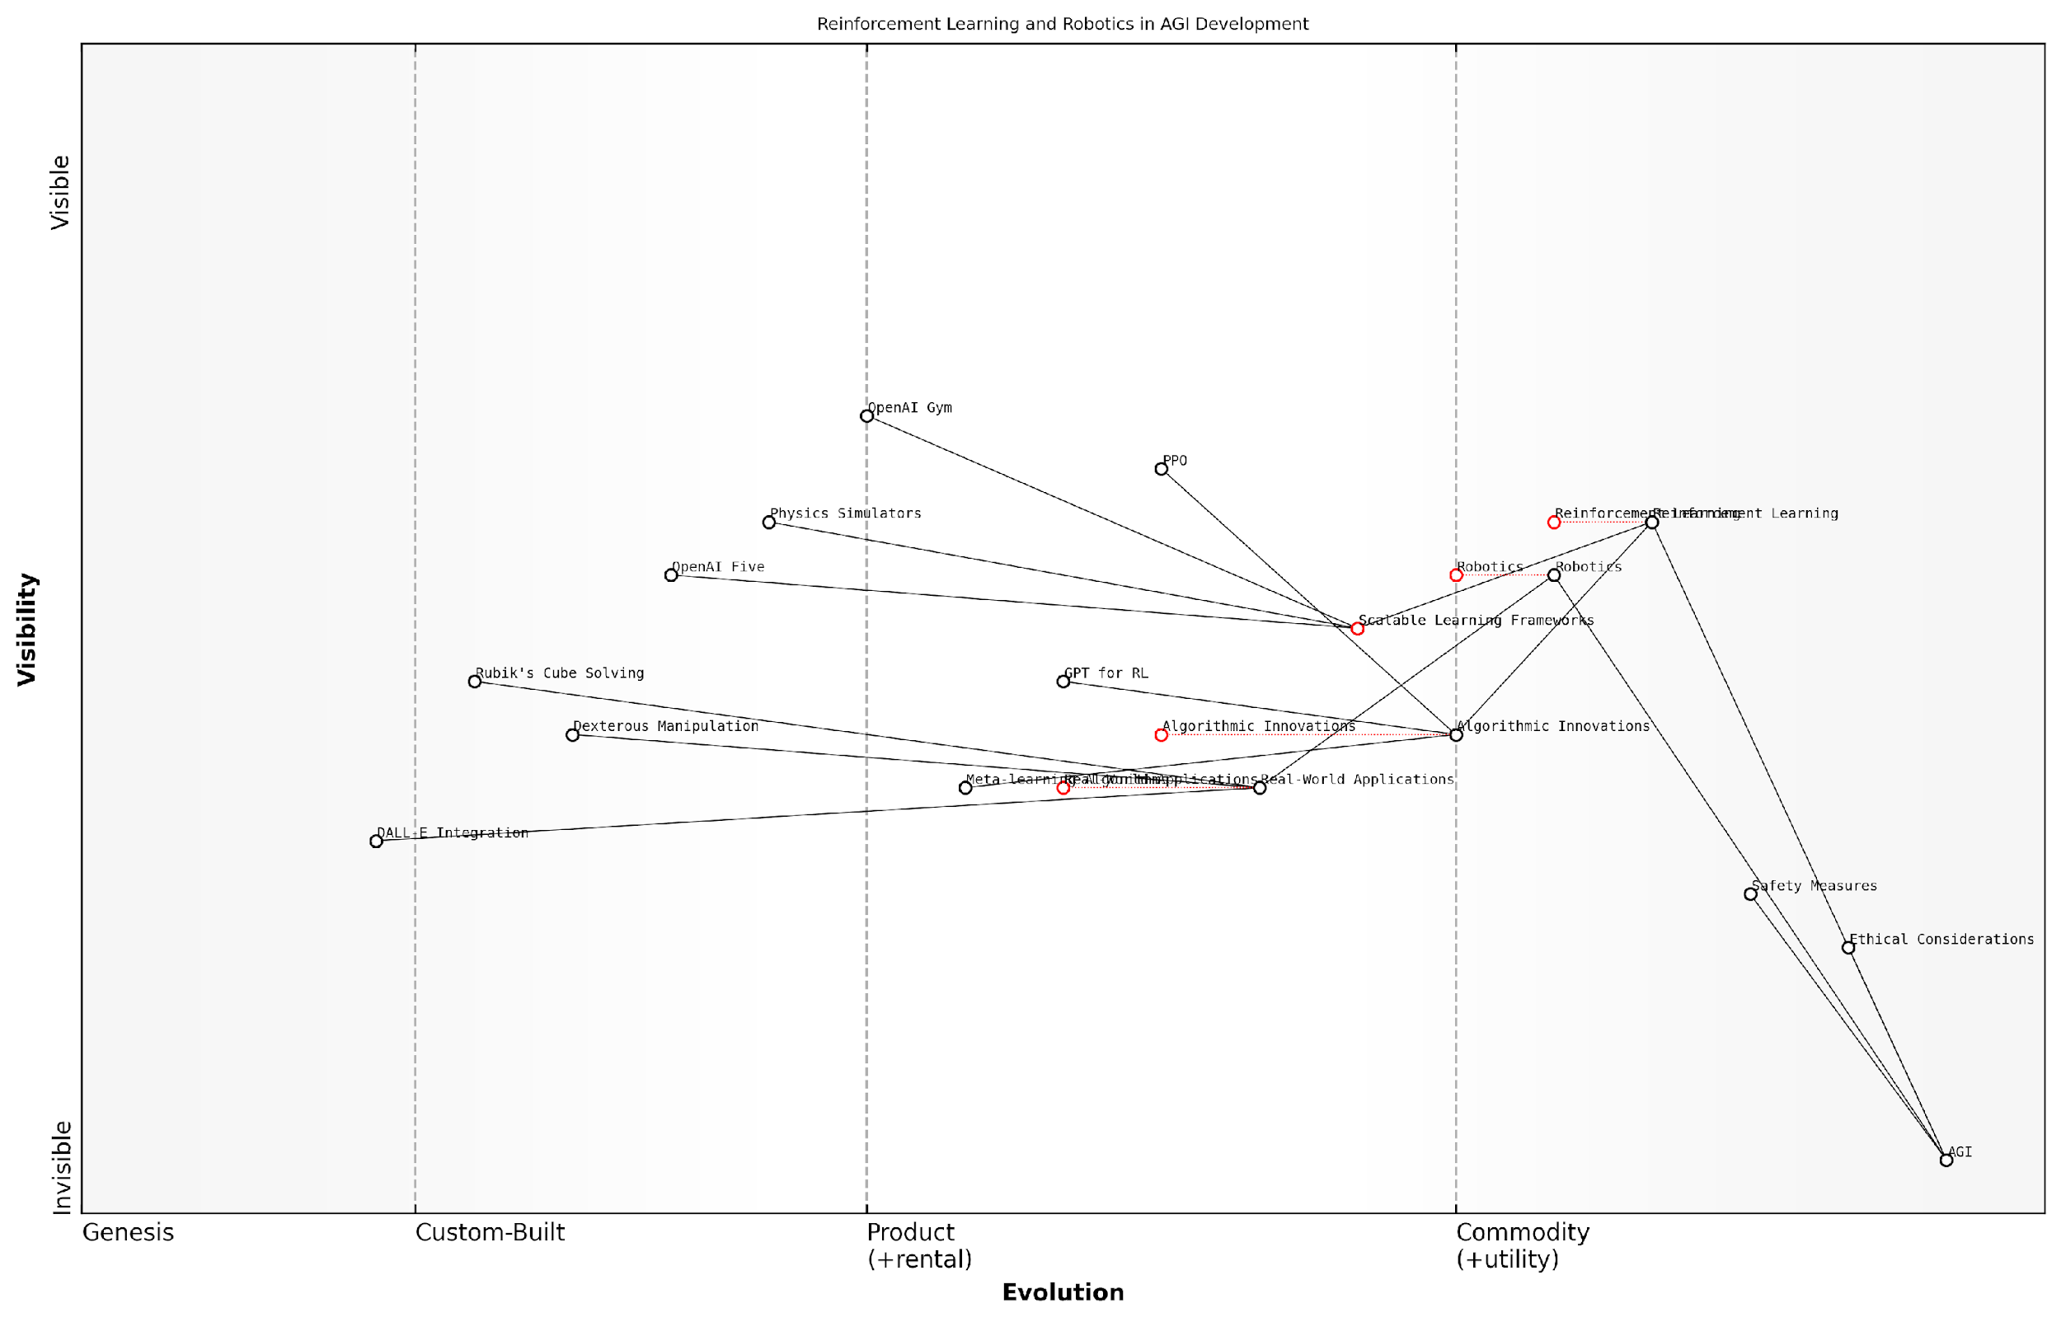

*Draft Wardley Map: [Insert Wardley Map: Reinforcement learning and robotics]*

[Edit this draft Wardley Map](https://create.wardleymaps.ai/#clone:2c7e026a0214ce6761)

Wardley Map Assessment

This Wardley Map reveals a strategic position at the forefront of AGI development through reinforcement learning and robotics. The organisation shows strong capabilities in algorithmic innovations and scalable learning frameworks, with a clear path towards AGI. However, the relative underdevelopment of safety measures and ethical considerations poses a significant risk. The integration of language models with reinforcement learning (GPT for RL) and the focus on meta-learning algorithms suggest promising avenues for future breakthroughs. To maintain a leadership position, the organisation should prioritise responsible AI development alongside technical innovations, invest heavily in real-world applications of robotics, and continue to push the boundaries of meta-learning and transfer learning capabilities. The strategic focus should be on creating a comprehensive, safe, and ethical framework for AGI development while advancing the technical capabilities that bridge the gap between current AI and AGI.

[View full Wardley Map report](http://markdown_wardley_map_reports/wardley_map_report_09_Reinforcement_learning_and_robotics.md)

## Anthropic’s Technical Approach

### Constitutional AI and alignment

In the high-stakes race towards Artificial General Intelligence (AGI), Anthropic’s approach to Constitutional AI and alignment stands out as a pivotal innovation that could significantly influence the outcome. This subsection delves into the technical intricacies of Anthropic’s methodology, exploring how it aims to ensure the development of safe and aligned AGI systems.

Constitutional AI, a term coined by Anthropic, represents a paradigm shift in the way AI systems are developed and trained. At its core, this approach seeks to imbue AI models with a set of principles or ‘constitution’ that guides their behaviour and decision-making processes. This innovative technique addresses one of the most pressing concerns in AGI development: ensuring that highly capable AI systems remain aligned with human values and intentions.

Constitutional AI is not just a technical solution, but a philosophical approach to AI development that could redefine the relationship between humans and artificial intelligence.

Anthropic’s technical implementation of Constitutional AI involves several key components:

* Principle-based training: Incorporating ethical principles and behavioural guidelines directly into the training process of large language models.
* Recursive reward modelling: Utilising AI systems to help define and refine the reward functions for more advanced AI models, creating a recursive improvement loop.
* Debate and deliberation: Implementing internal ‘debate’ mechanisms within AI systems to critically evaluate decisions and outputs.
* Transparency and interpretability: Developing techniques to make the decision-making processes of AI systems more transparent and interpretable to human overseers.

One of the most significant aspects of Anthropic’s approach is its focus on scalable oversight. As AI systems become more complex and capable, traditional methods of human oversight become increasingly challenging. Constitutional AI aims to create AI systems that can effectively oversee and govern their own behaviour, even as they surpass human-level intelligence in various domains.

The alignment problem, which refers to the challenge of ensuring that AI systems pursue goals that are aligned with human values and intentions, is at the heart of Anthropic’s technical approach. By embedding ethical considerations and alignment mechanisms directly into the architecture of their AI systems, Anthropic aims to create AGI that is inherently more likely to act in ways that benefit humanity.

The true test of AGI will not be its raw capabilities, but its ability to navigate complex ethical dilemmas in a manner that aligns with human values. Anthropic’s Constitutional AI approach is a bold attempt to meet this challenge head-on.

Anthropic’s technical innovations in this area include:

* Advanced reinforcement learning techniques that incorporate ethical constraints
* Novel architectures for multi-agent AI systems that can engage in internal debate and deliberation
* Sophisticated natural language processing models that can understand and reason about complex ethical principles
* Innovative approaches to AI safety that go beyond traditional containment strategies

The potential implications of Anthropic’s Constitutional AI approach extend far beyond the technical realm. If successful, this methodology could set a new standard for responsible AI development, influencing policy, regulation, and public perception of AGI. It could also provide a competitive edge in the AGI race by addressing key concerns that might otherwise slow down development or deployment.

However, Anthropic’s approach is not without challenges. The complexity of implementing Constitutional AI at scale, the potential for unintended consequences in principle-based training, and the philosophical questions surrounding the definition of human values all present significant hurdles. Moreover, the effectiveness of this approach in creating truly aligned AGI remains to be proven in practice.

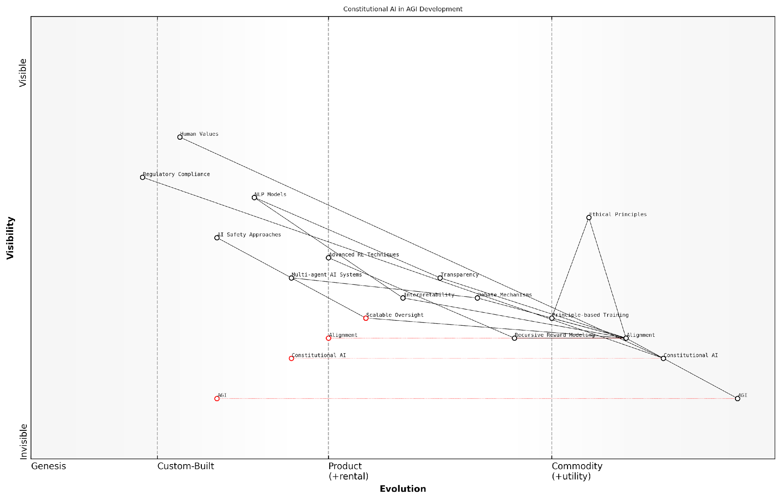

*Draft Wardley Map: [Insert Wardley Map: Constitutional AI and alignment]*

[Edit this draft Wardley Map](https://create.wardleymaps.ai/#clone:868c5a3bb92adcfcbb)

Wardley Map Assessment

This Wardley Map represents a forward-thinking approach to AGI development that places strong emphasis on ethics, alignment, and safety. The strategic positioning of Constitutional AI as a key differentiator is notable and potentially industry-leading. However, significant challenges remain in translating these principles into practical, scalable systems. The organisation is well-positioned to lead in ethical AI development but must continue to innovate in areas like Scalable Oversight and Interpretability to maintain this advantage. The next few years will be critical in moving key components from custom-built to product phase, particularly in aligning advanced AI capabilities with robust ethical frameworks.

[View full Wardley Map report](http://markdown_wardley_map_reports/wardley_map_report_10_Constitutional_AI_and_alignment.md)

As we consider the potential outcomes of the AGI race between OpenAI and Anthropic, the role of Constitutional AI and alignment cannot be overstated. While OpenAI has made significant strides in raw capabilities and scale, Anthropic’s focus on embedded ethics and alignment could prove to be a decisive factor, particularly as societal and regulatory scrutiny of AGI development intensifies.

In conclusion, Anthropic’s technical approach to Constitutional AI and alignment represents a bold and innovative attempt to address some of the most pressing challenges in AGI development. By prioritising safety, ethics, and alignment from the ground up, Anthropic is not just competing in the AGI race—it’s redefining the parameters of success. As the competition between OpenAI and Anthropic unfolds, the effectiveness and impact of Constitutional AI may well determine not just who wins the race, but what kind of future we’re racing towards.

### Large language model innovations

In the high-stakes race towards Artificial General Intelligence (AGI), Anthropic’s approach to large language model (LLM) innovations stands out as a critical factor that could potentially tip the scales in their favour. As we delve into Anthropic’s technical approach, it becomes evident that their focus on pushing the boundaries of LLM capabilities whilst maintaining a strong emphasis on safety and alignment could prove to be a game-changing strategy in the AGI competition.

Anthropic’s innovations in LLMs can be broadly categorised into three key areas: architectural advancements, training methodologies, and efficiency improvements. Each of these areas represents a significant leap forward in the field of AI and demonstrates Anthropic’s commitment to developing powerful, yet responsible AI systems.

Architectural Advancements:

* Sparse Attention Mechanisms: Anthropic has made significant strides in developing sparse attention mechanisms that allow their models to process longer sequences of text more efficiently. This innovation enables their LLMs to maintain context over extended passages, a crucial ability for achieving human-like comprehension and reasoning.
* Modular Architecture: The company has explored modular architectures that allow for more flexible and adaptable AI systems. This approach potentially allows for easier integration of new capabilities and more targeted fine-tuning of specific skills.
* Multi-modal Integration: Anthropic is working on seamlessly integrating different modalities (text, images, audio) within their LLM architecture, paving the way for more versatile and comprehensive AI systems.

Training Methodologies:

* Constitutional AI: Perhaps Anthropic’s most notable innovation, Constitutional AI involves training models with explicit rules and constraints to ensure they behave in alignment with human values and ethical principles. This approach is deeply integrated into their training process, potentially giving them an edge in developing safe and reliable AGI systems.
* Iterative Refinement: Anthropic has developed techniques for iterative refinement of model outputs, allowing their LLMs to generate increasingly high-quality and nuanced responses through multiple passes.
* Adversarial Training: By incorporating adversarial examples and edge cases into their training data, Anthropic aims to create more robust and generalisable models that can handle a wide range of inputs and scenarios.

Efficiency Improvements:

* Scaling Laws: Anthropic has made significant contributions to understanding the scaling laws of neural networks, allowing them to optimise the trade-offs between model size, computational resources, and performance.
* Efficient Fine-tuning: The company has developed techniques for more efficient fine-tuning of large models, enabling rapid adaptation to new tasks or domains without the need for full retraining.
* Hardware-Software Co-design: Anthropic is investing in the co-design of hardware and software solutions to maximise the efficiency of their AI systems, potentially giving them a competitive edge in scaling up to AGI-level capabilities.

Anthropic’s approach to LLM innovation is not just about raw performance, but about creating AI systems that are powerful, efficient, and fundamentally aligned with human values. This holistic approach could be the key to winning the AGI race.

The implications of these innovations extend far beyond mere technical achievements. By focusing on developing LLMs that are not only powerful but also safe and aligned with human values, Anthropic is positioning itself as a responsible leader in the AGI race. This approach could prove crucial in gaining public trust and regulatory approval, both of which will be essential for the widespread adoption and integration of AGI systems into society.

Moreover, Anthropic’s innovations in efficiency and scalability could provide them with a significant advantage in the resource-intensive process of developing AGI. As the computational requirements for training and running advanced AI systems continue to grow, the ability to do more with less could be a deciding factor in the race to AGI.

However, it’s important to note that the AGI race is not solely about technical innovations. The ultimate success of Anthropic’s approach will depend on how well they can translate these technical advancements into practical applications, navigate the complex regulatory landscape, and address the broader societal implications of their technology.

As we look towards the future, Anthropic’s innovations in LLMs represent a promising path towards AGI that prioritises safety and alignment alongside capability. Whether this approach will ultimately lead them to victory in the AGI race remains to be seen, but it undoubtedly positions them as a formidable contender and a responsible steward of this transformative technology.

The race to AGI is not just about who gets there first, but about who gets there responsibly. Anthropic’s innovations in large language models demonstrate a commitment to both progress and safety that could redefine the future of artificial intelligence.

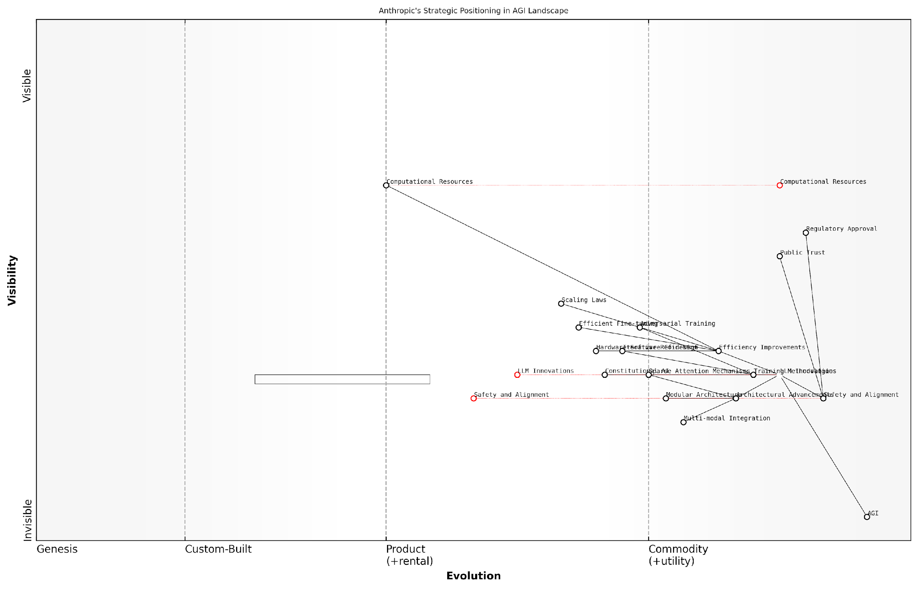

*Draft Wardley Map: [Insert Wardley Map: Large language model innovations]*

[Edit this draft Wardley Map](https://create.wardleymaps.ai/#clone:adcb6208ea4001f532)

Wardley Map Assessment

Anthropic is strategically well-positioned in the AGI landscape, with a strong focus on responsible innovation through Constitutional AI and safety measures. The company’s emphasis on efficiency and novel training methodologies provides a competitive edge. However, to maintain this position, Anthropic should invest in multi-modal capabilities, explore hardware-software co-design, and continue to lead in safety and alignment research. The balance between rapid innovation and responsible development will be crucial for long-term success in the AGI race.

[View full Wardley Map report](http://markdown_wardley_map_reports/wardley_map_report_11_Large_language_model_innovations.md)

### Scaling laws and efficiency breakthroughs

In the high-stakes race towards Artificial General Intelligence (AGI), Anthropic’s approach to scaling laws and efficiency breakthroughs stands as a cornerstone of their technical strategy. This subsection delves into the company’s innovative methods for pushing the boundaries of AI capabilities while maintaining a focus on efficiency and scalability.

Anthropic’s research into scaling laws has yielded significant insights into the relationship between model size, computational resources, and performance. These findings have profound implications for the development of increasingly capable AI systems and potentially AGI.

Anthropic’s work on scaling laws has fundamentally changed our understanding of how to build more capable AI systems. Their insights are driving the field forward at an unprecedented pace.

One of Anthropic’s key contributions to the field has been their research into the power-law relationships that govern the performance of large language models. By meticulously studying these relationships, Anthropic has developed strategies to optimise model training and deployment, potentially leapfrogging competitors in the race to AGI.

* Identification of power-law scaling in model performance
* Optimisation of model architectures based on scaling laws
* Development of efficient training algorithms leveraging these insights
* Strategies for balancing model size and computational efficiency

Anthropic’s efficiency breakthroughs are not limited to theoretical insights. The company has made significant strides in practical implementations, developing novel techniques for training and deploying large language models with unprecedented efficiency.

One such innovation is their approach to model compression and distillation. By leveraging their understanding of scaling laws, Anthropic has created methods to distil the knowledge from massive models into smaller, more efficient ones without significant loss of capability. This has potential implications for deploying powerful AI systems in resource-constrained environments, a crucial consideration for widespread AGI adoption.

The efficiency gains achieved by Anthropic’s model compression techniques are nothing short of revolutionary. They’re redefining what’s possible in terms of deploying advanced AI capabilities at scale.

Another area where Anthropic has made significant progress is in the development of sparse models. By identifying and leveraging sparsity in neural networks, Anthropic has created models that require significantly less computational resources while maintaining high levels of performance. This approach not only improves efficiency but also potentially enhances the interpretability of the models, a crucial factor in the development of safe and controllable AGI.

* Advanced model compression and distillation techniques
* Development of highly efficient sparse models
* Improved interpretability through sparse architectures
* Novel training algorithms optimised for efficiency

Anthropic’s focus on efficiency extends beyond model architecture and training. The company has also made significant strides in optimising the inference process, developing techniques to reduce the computational cost of deploying and running large language models. This has potential implications for real-time AGI applications, where rapid response times are crucial.

The company’s work on adaptive computation techniques is particularly noteworthy. By dynamically allocating computational resources based on the complexity of the input, Anthropic’s models can achieve high performance while minimising overall computational cost. This approach could be a game-changer in scenarios where AGI systems need to handle a wide range of tasks with varying complexity.

Anthropic’s adaptive computation techniques represent a paradigm shift in how we think about AI efficiency. It’s not just about raw power anymore, but about intelligent allocation of resources.

In the context of the AGI race, Anthropic’s advancements in scaling laws and efficiency breakthroughs could provide a significant competitive advantage. By developing more efficient models and training techniques, Anthropic may be able to iterate and improve their AI systems more rapidly than competitors, potentially accelerating their progress towards AGI.

Moreover, these efficiency gains could have broader implications for the field of AI and the potential societal impact of AGI. More efficient AI systems could lead to reduced energy consumption and environmental impact, addressing concerns about the sustainability of large-scale AI deployment. Additionally, improved efficiency could democratise access to advanced AI capabilities, potentially mitigating issues of inequality in AGI access and benefits.

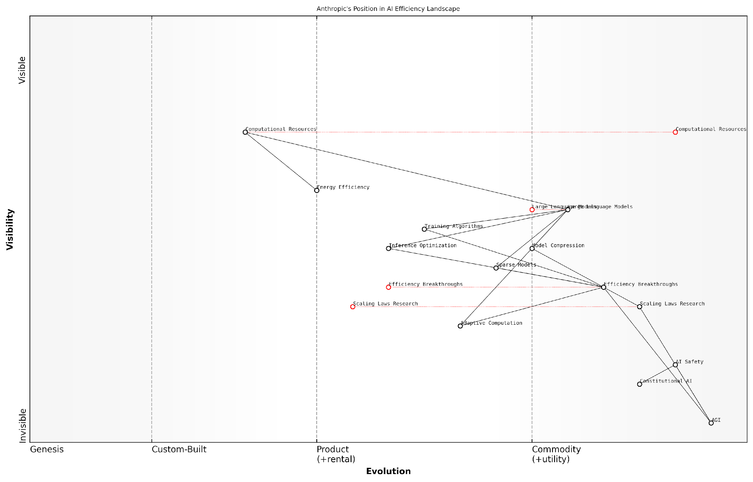

*Draft Wardley Map: [Insert Wardley Map: Scaling laws and efficiency breakthroughs]*

[Edit this draft Wardley Map](https://create.wardleymaps.ai/#clone:b2fe4c6543fe567733)

Wardley Map Assessment

Anthropic is strategically positioned at the forefront of AI efficiency and safety research, with a strong focus on the path to AGI. Their emphasis on Scaling Laws Research and Efficiency Breakthroughs, coupled with investments in AI Safety and Constitutional AI, sets them apart in the competitive landscape. To maintain and enhance their position, Anthropic should continue to innovate in efficiency while leading in responsible AI development. The company’s biggest challenges lie in managing computational resource dependencies and staying ahead in the rapidly evolving field of large language models. By leveraging their strengths in research and focusing on the identified areas for innovation, Anthropic has the potential to significantly influence the direction of AGI development towards a more efficient and safer future.

[View full Wardley Map report](http://markdown_wardley_map_reports/wardley_map_report_12_Scaling_laws_and_efficiency_breakthroughs.md)

However, it’s important to note that efficiency alone does not guarantee success in the AGI race. Other factors, such as safety considerations, ethical alignment, and the ability to solve fundamental AI challenges, will also play crucial roles. Anthropic’s approach to these areas, particularly their work on constitutional AI and alignment, will be equally important in determining their position in the AGI competition.

As we look towards the future of AGI development, Anthropic’s work on scaling laws and efficiency breakthroughs will undoubtedly continue to influence the field. Their insights and innovations have the potential to shape not only the technical landscape of AI but also the broader implications of AGI deployment and its impact on society.

The race to AGI is not just about who gets there first, but who gets there responsibly and efficiently. Anthropic’s focus on scaling laws and efficiency puts them in a strong position to potentially achieve both.

## Comparative Analysis of Technical Capabilities

### Benchmarking performance

In the high-stakes race towards Artificial General Intelligence (AGI), benchmarking performance has emerged as a critical tool for assessing the technical capabilities of leading contenders such as OpenAI and Anthropic. This comparative analysis is essential not only for understanding the current state of AI development but also for predicting which company might ultimately achieve AGI supremacy. As we delve into this complex landscape, it’s crucial to recognise that benchmarking in the context of AGI is a multifaceted challenge, encompassing a wide range of metrics and considerations that go beyond traditional AI performance measures.

To structure our analysis effectively, we’ll examine several key areas of benchmarking: language understanding and generation, multimodal capabilities, reasoning and problem-solving, and computational efficiency. Within each of these domains, we’ll compare OpenAI and Anthropic’s achievements, highlighting their unique strengths and potential pathways to AGI.

Language Understanding and Generation

Both OpenAI and Anthropic have made significant strides in natural language processing (NLP), with their large language models (LLMs) serving as the cornerstone of their AGI pursuits. OpenAI’s GPT series, particularly GPT-3 and its successors, have set new standards in language tasks, demonstrating remarkable fluency and versatility across a wide range of applications. Anthropic, with its focus on constitutional AI, has developed models that exhibit strong performance while prioritising alignment with human values.

* Perplexity and coherence: OpenAI’s models generally achieve lower perplexity scores, indicating higher predictive accuracy in language tasks. However, Anthropic’s models often demonstrate superior coherence over longer text sequences, a crucial factor for AGI applications.
* Few-shot learning: Both companies have shown impressive capabilities in few-shot learning scenarios, with OpenAI’s models often requiring fewer examples to adapt to new tasks.
* Multilingual performance: While OpenAI has demonstrated broad language coverage, Anthropic has focused on depth of understanding in key languages, potentially offering more nuanced comprehension in specific linguistic contexts.

The race in language models is not just about raw performance metrics. It’s about creating systems that can truly understand and generate human-like text in a way that’s reliable, ethical, and aligned with human values. This is where the philosophical differences between OpenAI and Anthropic become most apparent.

Multimodal Capabilities

The ability to process and generate content across multiple modalities is increasingly seen as a key stepping stone towards AGI. OpenAI has made significant headway in this area with models like DALL-E, which can generate images from text descriptions, and GPT-4, which has demonstrated impressive visual understanding capabilities. Anthropic, while less public about their multimodal efforts, is known to be working on integrating visual and textual understanding in alignment with their constitutional AI principles.

* Image generation quality: OpenAI’s DALL-E 2 has set high standards for image generation, with Anthropic yet to publicly release a comparable model.
* Visual reasoning: Both companies have demonstrated capabilities in visual question-answering tasks, with OpenAI’s GPT-4 showing particularly strong performance.
* Cross-modal transfer: The ability to transfer knowledge between modalities is crucial for AGI, and both companies are actively researching this area, with OpenAI currently holding a slight edge in publicly demonstrated capabilities.

Reasoning and Problem-Solving

Perhaps the most critical aspect of AGI development is the ability to reason, solve complex problems, and exhibit general intelligence across diverse domains. Both OpenAI and Anthropic have made significant progress in this area, but their approaches and strengths differ.

* Abstract reasoning: OpenAI’s models have shown strong performance on tasks requiring abstract thinking and analogical reasoning. Anthropic’s focus on alignment may give them an edge in more nuanced, ethically complex reasoning scenarios.
* Mathematical problem-solving: Both companies have demonstrated impressive capabilities in mathematical reasoning, with OpenAI’s GPT-4 showing particular strength in this domain.
* Commonsense reasoning: Anthropic’s constitutional AI approach may provide advantages in tasks requiring commonsense understanding and reasoning, particularly in scenarios with ethical implications.

The true measure of progress towards AGI lies not just in solving predefined problems, but in the ability to generalise knowledge and tackle novel challenges in a way that mimics human-level intelligence. This is where both OpenAI and Anthropic are pushing the boundaries of what’s possible.

Computational Efficiency

As AI models grow in size and complexity, computational efficiency becomes a critical factor in the race towards AGI. Both OpenAI and Anthropic have made significant investments in optimising their models and infrastructure.

* Model size and performance trade-offs: OpenAI has generally favoured larger models, while Anthropic has focused on achieving comparable performance with more efficient architectures.
* Training efficiency: Anthropic’s research into scaling laws has led to innovations in training efficiency, potentially allowing for faster iteration and experimentation.
* Inference speed: OpenAI has demonstrated impressive inference speeds with models like GPT-3.5-Turbo, crucial for real-world applications. Anthropic’s focus on efficiency may yield advantages in certain deployment scenarios.

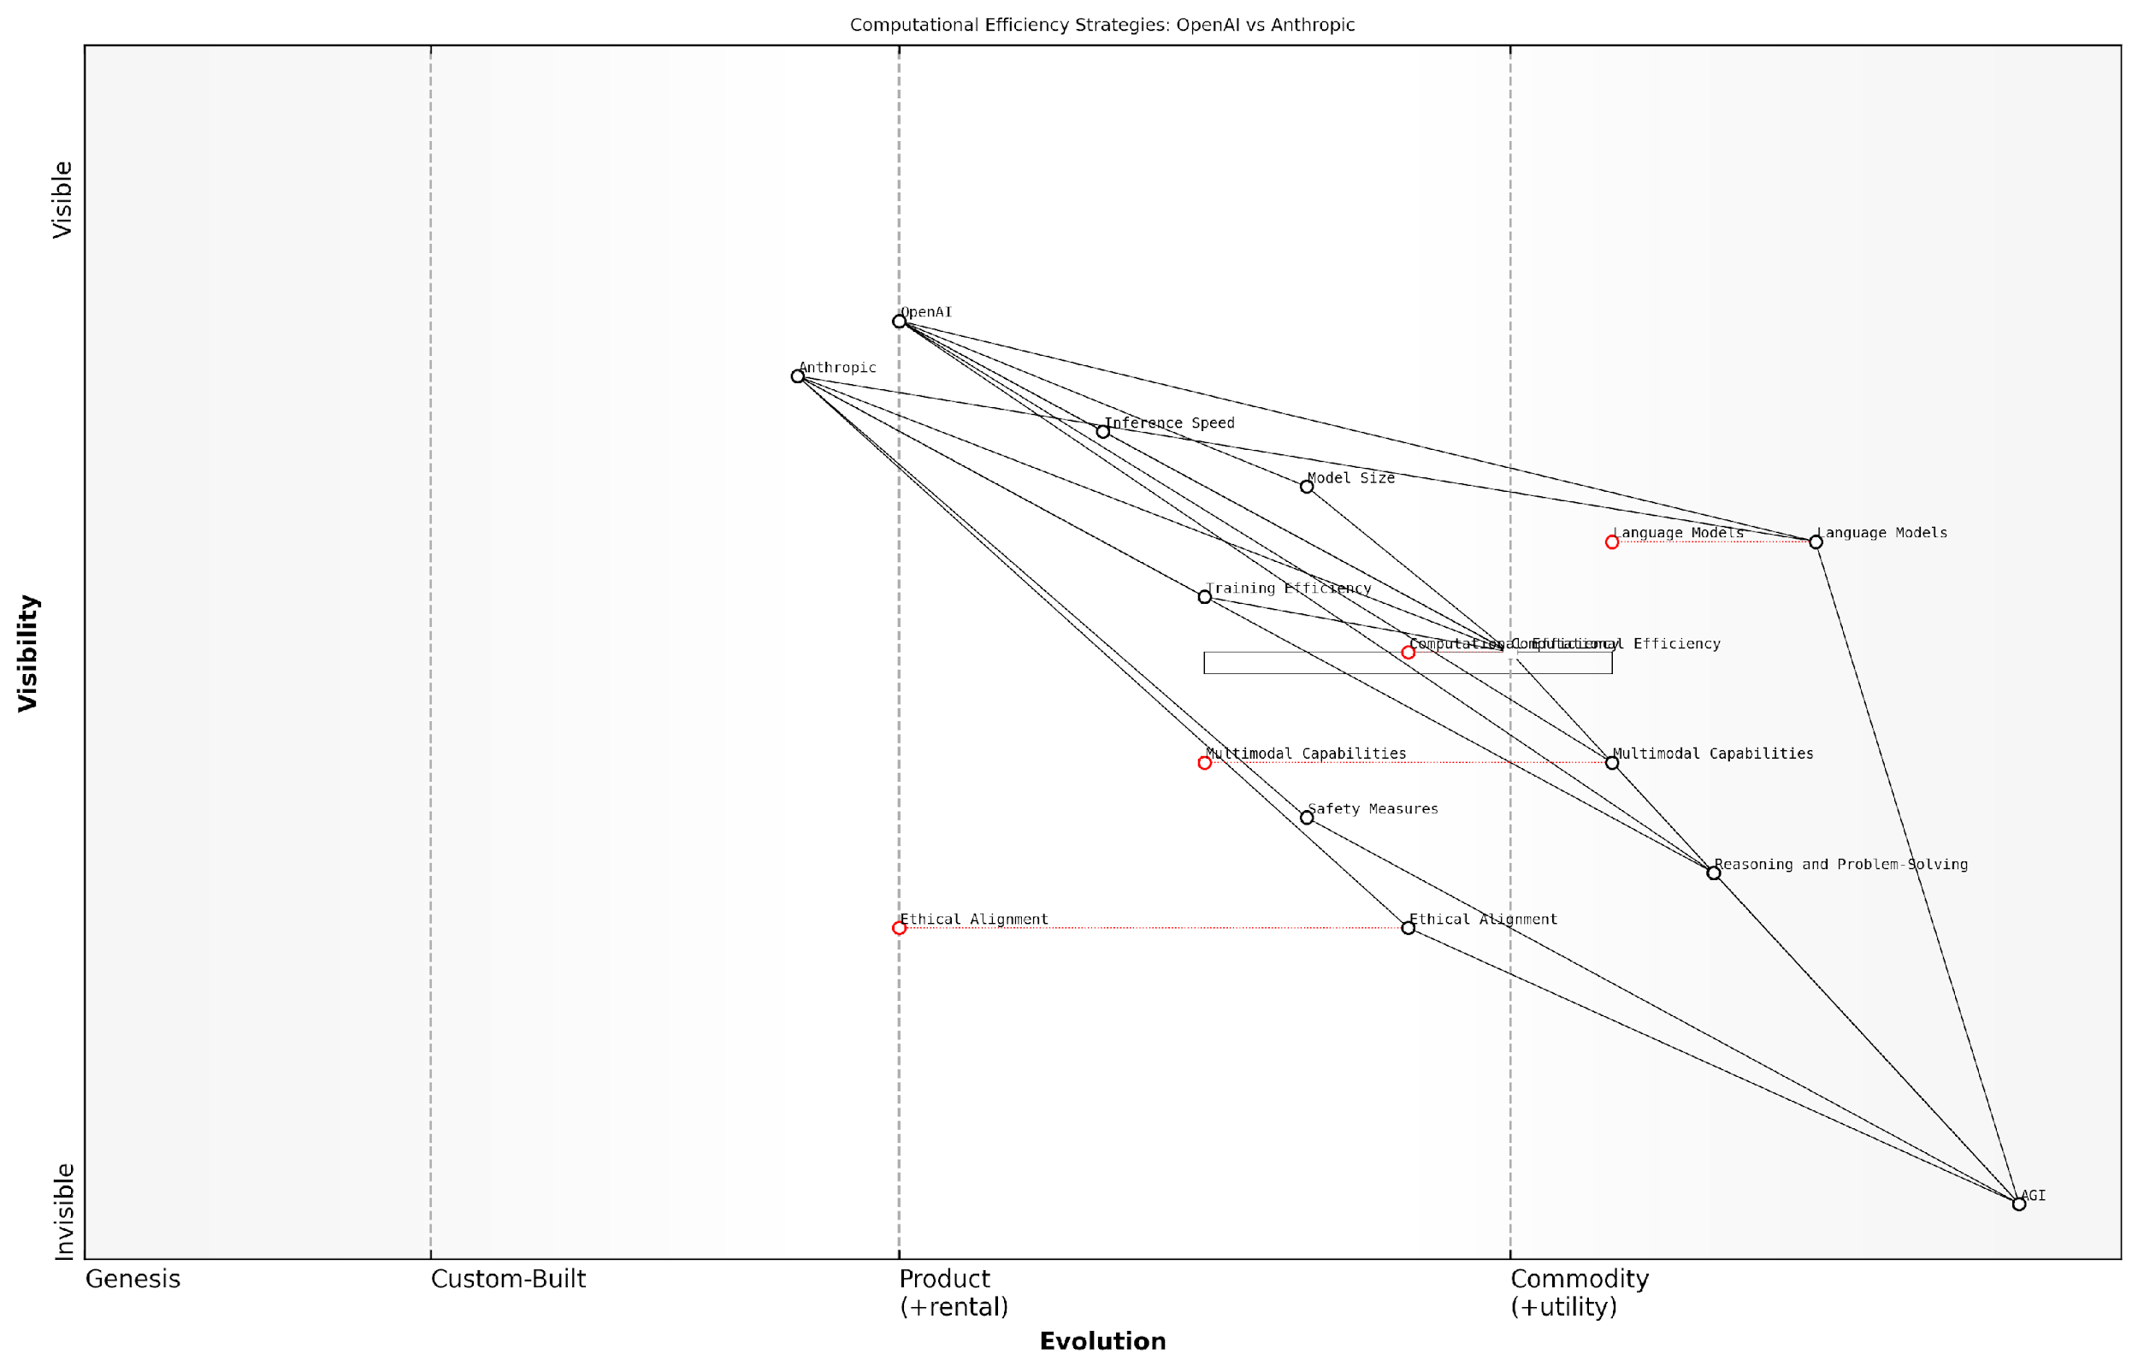

*Draft Wardley Map: [Insert Wardley Map: Benchmarking performance]*

[Edit this draft Wardley Map](https://create.wardleymaps.ai/#clone:b4b21ebf453cc10b9f)

Wardley Map Assessment

The map reveals a highly competitive landscape in AGI development, with OpenAI and Anthropic taking slightly different approaches. The key to success will likely be the effective integration of advanced AI capabilities with robust ethical alignment and safety measures. Both companies have strong positions but need to address specific gaps. The rapid evolution of computational efficiency and the increasing importance of ethical considerations suggest that agility in strategy and development will be crucial. The industry is poised for potential disruption, particularly in training methodologies and ethical AI practices.

[View full Wardley Map report](http://markdown_wardley_map_reports/wardley_map_report_13_Benchmarking_performance.md)

Conclusion

The benchmarking of OpenAI and Anthropic’s technical capabilities reveals a complex landscape where each company holds distinct advantages. OpenAI’s strength lies in its broad, powerful models that push the boundaries of what’s possible in AI, particularly in areas like language generation and multimodal processing. Anthropic, with its focus on constitutional AI and alignment, may have an edge in developing systems that are more reliable, ethical, and aligned with human values – crucial factors for the safe development of AGI.

As we look towards the future, it’s clear that the race to AGI will not be decided by any single benchmark or capability. Instead, the winner will likely be the company that can best integrate cutting-edge performance with robust safety measures, ethical considerations, and the ability to generalise across a wide range of tasks and domains. Both OpenAI and Anthropic have demonstrated significant strengths, and the ultimate outcome of this technological arms race remains uncertain. What is clear, however, is that their competition is driving rapid advancements in AI technology, bringing us ever closer to the transformative potential of Artificial General Intelligence.

### Unique strengths and weaknesses

In the high-stakes race towards Artificial General Intelligence (AGI), OpenAI and Anthropic have emerged as frontrunners, each with distinct approaches and capabilities. This comparative analysis delves into the unique strengths and weaknesses of these two titans, offering crucial insights into their potential for achieving the AGI breakthrough. As we examine their technical prowess, it becomes evident that both companies possess formidable advantages, yet also face significant challenges that could impact their trajectory in this pivotal competition.

OpenAI’s Strengths:

* Pioneering Large Language Models: OpenAI’s GPT series has set industry benchmarks, demonstrating unparalleled natural language understanding and generation capabilities.
* Multimodal AI Expertise: With innovations like DALL-E, OpenAI has shown remarkable progress in combining language and visual processing.
* Robust Research Infrastructure: OpenAI’s substantial computing resources and research partnerships provide a strong foundation for rapid experimentation and scaling.
* Open Collaboration Model: Despite recent shifts, OpenAI’s history of open-source contributions has fostered a vast ecosystem of developers and researchers building upon their work.

OpenAI’s Weaknesses:

* Ethical Concerns: The company has faced criticism over potential misuse of its powerful language models and issues surrounding bias and misinformation.
* Commercialisation Pressures: The shift from a non-profit to a ‘capped-profit’ model has raised questions about the alignment of commercial interests with the pursuit of beneficial AGI.
* Talent Retention: High-profile departures have highlighted challenges in maintaining a stable core research team amidst intense industry competition.
* Scalability Constraints: Despite significant resources, OpenAI may face limitations in scaling compute power to the levels potentially required for AGI breakthrough.

Anthropic’s Strengths:

* Constitutional AI Focus: Anthropic’s commitment to developing aligned AI systems that respect human values gives them a unique edge in addressing AGI safety concerns.
* Efficiency Breakthroughs: Their research into scaling laws and model efficiency could lead to more resource-effective paths to AGI.
* Long-term Vision: Anthropic’s research-focused approach and emphasis on long-term safety considerations position them well for sustained progress towards AGI.
* Ethical Credibility: Their ethics-first approach has garnered trust within the AI ethics community and could prove crucial in navigating the societal implications of AGI development.

Anthropic’s Weaknesses:

* Resource Limitations: Compared to OpenAI, Anthropic may have less access to vast computing resources, potentially slowing their progress in large-scale experiments.
* Market Presence: With a lower public profile, Anthropic may face challenges in attracting talent and securing partnerships crucial for AGI development.
* Commercialisation Hurdles: The focus on research and safety could potentially limit short-term commercial applications, impacting funding and growth.
* Technological Catch-up: In some areas, particularly multimodal AI, Anthropic may need to bridge gaps with competitors to maintain a comprehensive AGI development approach.

Comparative Analysis:

When assessing the potential for an AGI breakthrough, both OpenAI and Anthropic present compelling cases. OpenAI’s technical prowess and vast resources provide a clear path to pushing the boundaries of AI capabilities. Their GPT series has consistently redefined what’s possible in natural language processing, and their multimodal innovations suggest a holistic approach to AGI development. However, Anthropic’s focus on constitutional AI and alignment could prove crucial in creating AGI systems that are not only powerful but also safe and beneficial to humanity.

In the race to AGI, it’s not just about who gets there first, but who gets there safely. Anthropic’s approach might seem slower, but it could ultimately lead to more robust and trustworthy AGI systems.

OpenAI’s open collaboration model has accelerated progress across the AI field, but it also raises concerns about the potential misuse of their technologies. Anthropic’s more cautious approach may limit immediate breakthroughs but could result in more controlled and ethically aligned AGI development. The trade-off between rapid advancement and careful, safety-oriented progress is a central tension in this competition.

Resource allocation will play a crucial role in determining the AGI victor. While OpenAI currently holds an advantage in terms of computing power and funding, Anthropic’s focus on efficiency and scaling laws could lead to more resource-effective pathways to AGI. This efficiency focus might prove decisive as the computational requirements for AGI development continue to escalate.

The ethical dimensions of AGI development cannot be overstated. Anthropic’s constitutional AI principles provide a strong foundation for creating AGI systems aligned with human values. OpenAI, while committed to beneficial AGI, faces greater scrutiny due to its higher profile and the dual-use potential of its technologies. The company that can most effectively navigate the ethical challenges of AGI development may ultimately gain the trust and support necessary for widespread AGI deployment.

Talent acquisition and retention will be critical factors in the AGI race. OpenAI’s prominence attracts top researchers, but also makes them targets for poaching by tech giants. Anthropic’s focused mission and ethical stance may appeal to researchers motivated by long-term impact and safety considerations. The ability to build and maintain world-class research teams will significantly influence each company’s AGI trajectory.

In conclusion, the unique strengths and weaknesses of OpenAI and Anthropic paint a complex picture of the AGI landscape. OpenAI’s technical innovations and vast resources position them as frontrunners in pushing AI capabilities to their limits. However, Anthropic’s dedicated focus on safety, alignment, and efficiency could prove decisive in creating AGI systems that are not only powerful but also trustworthy and beneficial. As the race continues, the interplay between rapid advancement and responsible development will likely determine which approach ultimately prevails in achieving the monumental goal of Artificial General Intelligence.

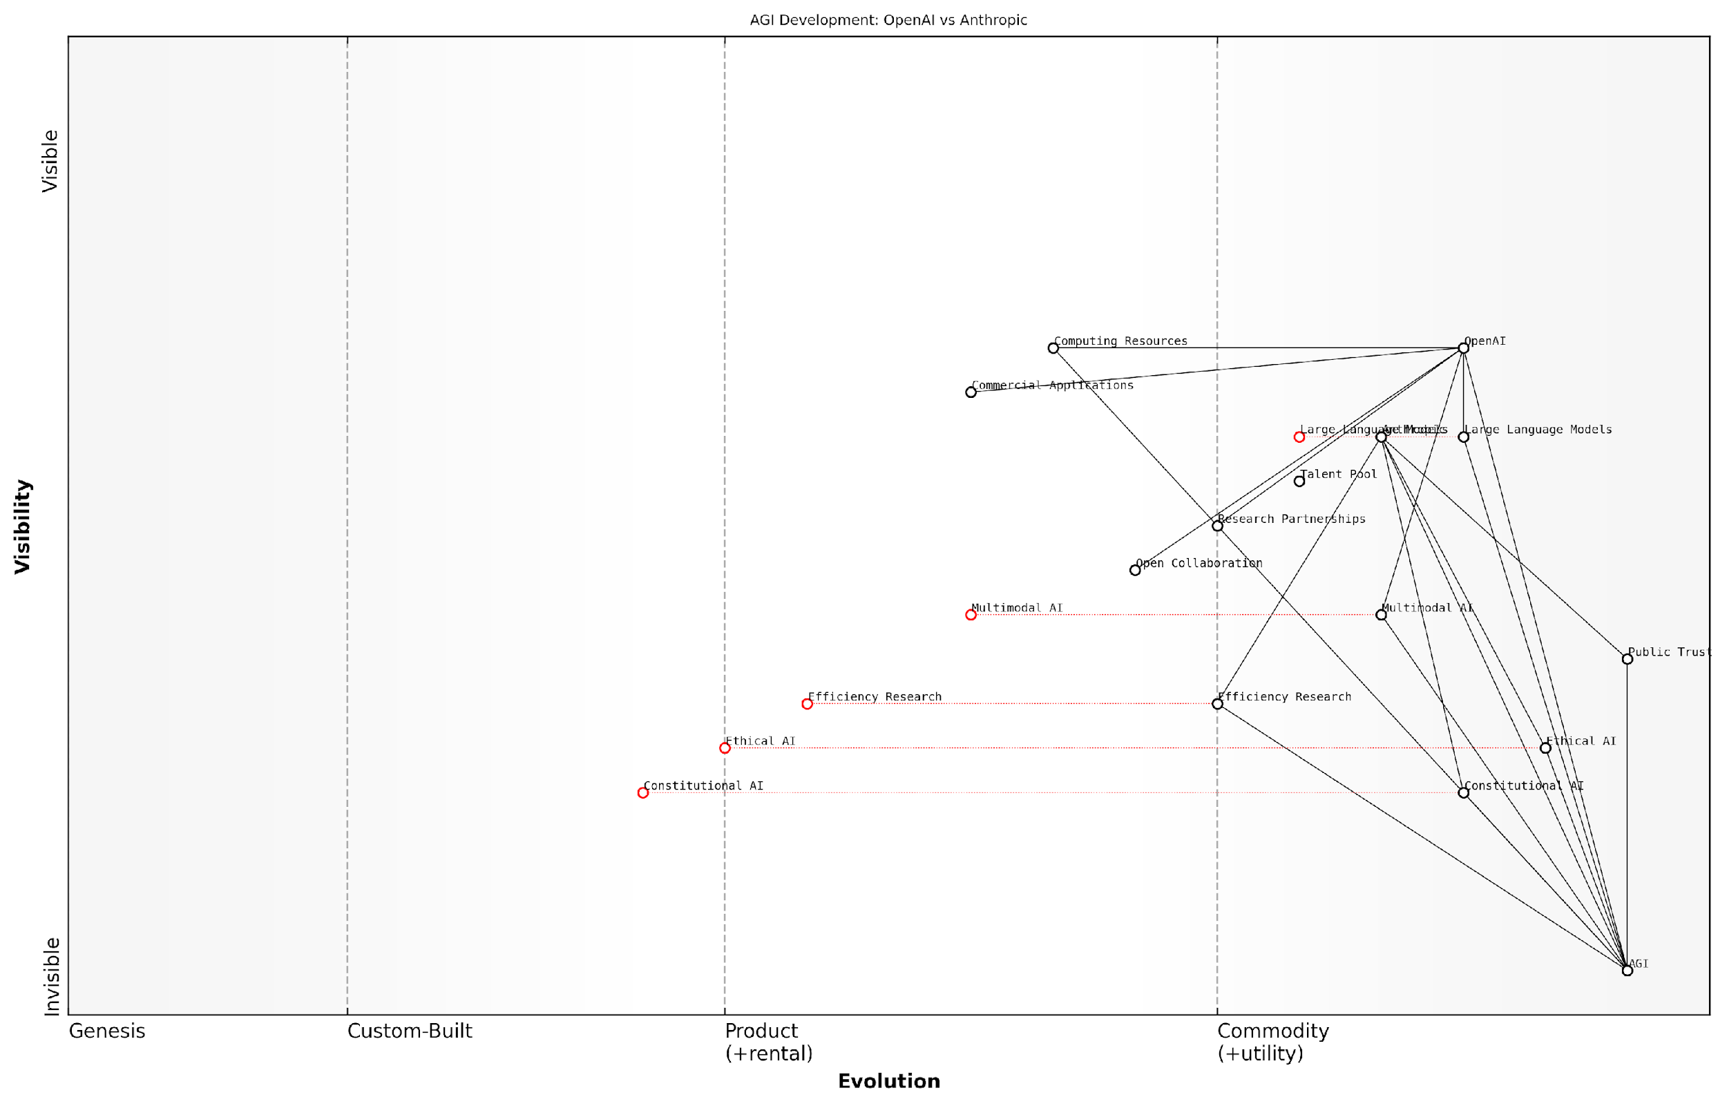

*Draft Wardley Map: [Insert Wardley Map: Unique strengths and weaknesses]*

[Edit this draft Wardley Map](https://create.wardleymaps.ai/#clone:964c1e25fa31b8c1f6)

Wardley Map Assessment

This Wardley Map reveals a dynamic and competitive landscape in AGI development, with OpenAI and Anthropic taking different strategic approaches. OpenAI appears to focus more on technical capabilities and commercial applications, while Anthropic emphasises ethical considerations and public trust. The key to success in this domain will likely be the ability to balance rapid technical advancements with strong ethical frameworks and public trust. Both companies have unique strengths, but also face significant challenges in realising the goal of AGI. The industry is poised for significant evolution, with ethical considerations and efficiency becoming increasingly critical. Companies that can successfully integrate advanced technical capabilities with robust ethical frameworks and efficient resource utilisation are likely to lead in the race towards AGI.

[View full Wardley Map report](http://markdown_wardley_map_reports/wardley_map_report_14_Unique_strengths_and_weaknesses.md)

### Potential for AGI breakthrough

In the high-stakes race towards Artificial General Intelligence (AGI), the potential for a breakthrough is a critical factor in determining which organisation might ultimately prevail. This section provides a comparative analysis of OpenAI and Anthropic’s technical capabilities, focusing on their respective potentials for achieving the monumental feat of creating AGI. As we delve into this analysis, it’s crucial to understand that the path to AGI is not merely about raw computational power or the size of language models, but also about innovative approaches, novel architectures, and the ability to solve complex, multi-modal problems in ways that more closely resemble human-like intelligence.

To effectively assess the potential for an AGI breakthrough, we must consider several key factors:

* Scalability of current models and architectures
* Novel approaches to AI development
* Cross-domain generalisation capabilities
* Efficiency in learning and adaptation
* Robustness and reliability of AI systems
* Alignment with human values and goals

Let’s examine how OpenAI and Anthropic compare in these crucial areas:

1. Scalability of Current Models and Architectures:

OpenAI has demonstrated remarkable scalability with its GPT series, consistently pushing the boundaries of model size and performance. The progression from GPT-2 to GPT-3, and now to GPT-4, shows a clear trajectory of improvement through scale. However, it’s worth noting that simply scaling up existing architectures may face diminishing returns.

Anthropic, on the other hand, has focused on what they term ‘constitutional AI’ and has made significant strides in improving the efficiency and scalability of large language models. Their research into scaling laws and efficiency breakthroughs suggests a more nuanced approach to scalability, potentially offering a path to AGI that doesn’t rely solely on brute-force expansion of model size.

As a leading AI researcher notes, ‘The race to AGI isn’t just about who can build the biggest model, but who can build the smartest model. Efficiency and novel architectures will likely play a crucial role in any AGI breakthrough.’

1. Novel Approaches to AI Development:

OpenAI has shown a willingness to explore diverse approaches, from reinforcement learning in robotics to multimodal AI with DALL-E. This breadth of research could potentially lead to unexpected breakthroughs that contribute to AGI development.

Anthropic’s focus on constitutional AI and alignment represents a novel approach that could be crucial for AGI. By baking in ethical considerations and alignment with human values from the ground up, Anthropic may be developing AI systems that are more robust and reliable in complex, real-world scenarios – a key requirement for AGI.

1. Cross-domain Generalisation Capabilities:

Both companies have made strides in developing AI systems that can generalise across multiple domains. OpenAI’s GPT-4 has shown impressive capabilities in tasks ranging from natural language processing to basic visual understanding and coding. Anthropic’s models, while perhaps less publicised, have also demonstrated strong cross-domain performance.

The key difference may lie in the approach to achieving this generalisation. OpenAI seems to rely more on vast amounts of training data and model scale, while Anthropic appears to be focusing on more efficient learning mechanisms and better inductive biases.

1. Efficiency in Learning and Adaptation:

This is an area where Anthropic may have an edge. Their research into scaling laws and efficiency could lead to AI systems that learn and adapt more quickly and with less data – a crucial capability for AGI. OpenAI, while not ignoring efficiency, has historically relied more on computational power and large datasets.

1. Robustness and Reliability of AI Systems:

Both companies place a strong emphasis on developing robust and reliable AI systems, recognising this as a key requirement for AGI. OpenAI’s iterative approach with the GPT series has shown improvements in reliability and reduced hallucinations. Anthropic’s constitutional AI approach, by design, aims to create more reliable and trustworthy AI systems.

1. Alignment with Human Values and Goals:

This is perhaps the most crucial factor in the development of AGI, and it’s an area where Anthropic’s approach may give them a significant advantage. Their focus on constitutional AI and alignment from the ground up could result in AGI systems that are inherently more aligned with human values and goals. OpenAI, while also concerned with beneficial AGI, has taken a somewhat different approach, focusing on control mechanisms and safety measures that are often applied post-development.

A senior government official involved in AI policy remarked, ‘The company that cracks the code on aligning advanced AI systems with human values may well be the one that achieves AGI first – or at least, the first beneficial AGI.’

In conclusion, both OpenAI and Anthropic show significant potential for an AGI breakthrough, but through different paths. OpenAI’s broad research approach, proven scalability, and demonstrated performance across multiple domains give them a strong position. However, Anthropic’s focus on efficiency, alignment, and novel approaches to AI development could provide them with a crucial edge, particularly in developing AGI that is not only powerful but also beneficial and aligned with human values.

The race to AGI is far from over, and it’s entirely possible that breakthroughs from either company could rapidly shift the balance. Moreover, the possibility of collaboration or convergence of approaches should not be discounted. As we continue to monitor this high-stakes competition, it’s clear that the potential for an AGI breakthrough lies not just in raw capabilities, but in the nuanced interplay of scalability, efficiency, reliability, and alignment.

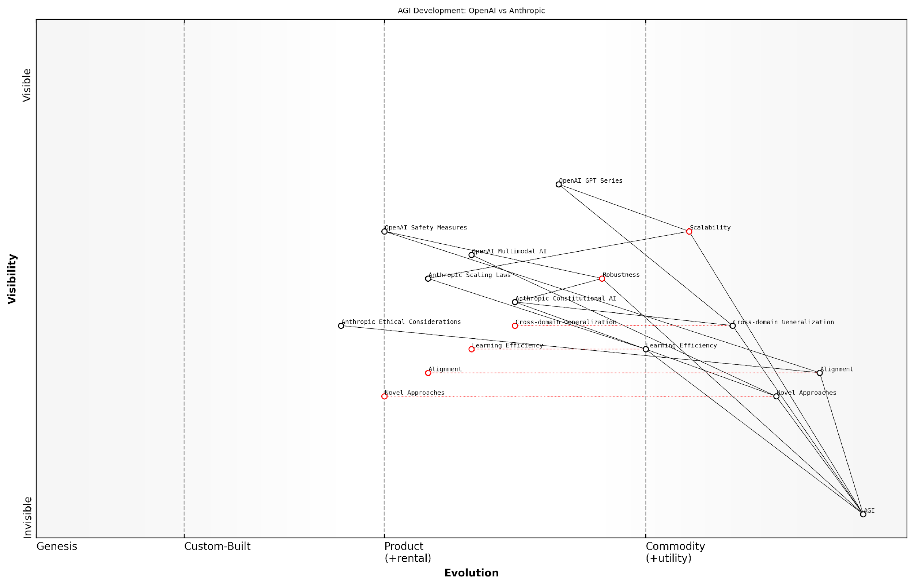

*Draft Wardley Map: [Insert Wardley Map: Potential for AGI breakthrough]*

[Edit this draft Wardley Map](https://create.wardleymaps.ai/#clone:0a2e4334e85dba0e37)

Wardley Map Assessment

The Wardley Map reveals a highly dynamic and competitive landscape in AGI development, with OpenAI and Anthropic as key players. While significant progress has been made in areas like scalability and language models, critical challenges remain in alignment, cross-domain generalisation, and learning efficiency. The strategic focus should be on balancing rapid innovation with robust safety measures and ethical considerations. Collaboration in fundamental research, especially in alignment and ethics, could accelerate progress while mitigating risks. Both companies have unique strengths, but the race to AGI will likely be won by the organisation that can best integrate novel approaches with strong safety protocols and efficient learning algorithms. The industry is poised for significant breakthroughs, but careful navigation of technical, ethical, and safety challenges will be crucial for responsible AGI development.

[View full Wardley Map report](http://markdown_wardley_map_reports/wardley_map_report_15_Potential_for_AGI_breakthrough.md)

# Business Strategies and Funding Models

## OpenAI’s Evolution and Business Model

### From non-profit to ‘capped-profit’

OpenAI’s transition from a non-profit to a ‘capped-profit’ model represents a pivotal moment in the artificial general intelligence (AGI) race, fundamentally reshaping the competitive landscape and challenging traditional notions of how cutting-edge AI research should be funded and commercialised. This evolution is not merely a change in legal structure, but a strategic repositioning that has far-reaching implications for the development of AGI, the broader AI industry, and the potential societal impacts of these transformative technologies.

To fully appreciate the significance of this shift, we must examine it through several lenses: the motivations behind the change, the mechanics of the ‘capped-profit’ model, the implications for OpenAI’s research and development efforts, and the broader impact on the AGI race between OpenAI and Anthropic.

Motivations for Transition

* Resource Constraints: The non-profit model limited OpenAI’s ability to attract and retain top talent in a highly competitive field.
* Scaling Challenges: Developing AGI requires immense computational resources and long-term financial sustainability.
* Competitive Pressure: The need to keep pace with well-funded competitors in the private sector.
* Commercialisation Opportunities: The potential to generate revenue from breakthrough technologies to fund further research.

The ‘Capped-Profit’ Model Explained

OpenAI’s ‘capped-profit’ model is an innovative approach that attempts to balance the need for substantial funding with the organisation’s commitment to developing beneficial AGI. Under this structure, OpenAI created a for-profit entity, OpenAI LP, which is controlled by the non-profit OpenAI Inc. The for-profit arm can seek investments and generate returns, but these returns are capped at a specific multiple of the investment.

The ‘capped-profit’ model represents a novel attempt to align the interests of investors with the broader mission of beneficial AGI development. It’s a delicate balancing act that could set a precedent for future AI research organisations.

Key features of the model include:

* Return Cap: Investors’ returns are limited to 100 times their investment.
* Mission Control: The non-profit board retains control over the organisation’s direction and decisions.
* Profit Reinvestment: Excess profits beyond the cap are channelled back into the non-profit’s mission.
* Transparency Commitments: OpenAI pledges to maintain a high degree of research transparency, despite the shift towards a more commercial model.

Implications for Research and Development

The transition to a ‘capped-profit’ model has had significant implications for OpenAI’s research and development efforts:

* Increased Resources: Access to greater funding has allowed for expansion of research teams and computational resources.
* Accelerated Development: The ability to commercialise certain technologies has created a feedback loop of innovation and revenue generation.
* Talent Attraction: The new model has enhanced OpenAI’s ability to compete for top AI researchers and engineers.
* Shift in Focus: There’s been a noticeable shift towards more applied research with clear commercial potential, alongside continued fundamental AGI research.
* Partnerships: The new structure has facilitated strategic partnerships with industry leaders, expanding OpenAI’s reach and capabilities.

Impact on the AGI Race

OpenAI’s evolution has significantly altered the dynamics of the AGI race, particularly in relation to Anthropic:

* Funding Disparity: OpenAI’s access to larger capital pools has created a potential resource advantage over Anthropic.
* Commercial vs. Pure Research: While OpenAI balances commercial interests with its mission, Anthropic maintains a more research-focused approach.
* Ethical Considerations: The ‘capped-profit’ model raises questions about the potential influence of commercial interests on AGI development ethics.
* Innovation Pace: OpenAI’s model potentially allows for faster iteration and deployment of AI technologies.
* Public Perception: The shift has led to debates about OpenAI’s commitment to its original mission, potentially affecting public trust.

The AGI race is not just about technological breakthroughs, but also about sustainable models for long-term research and development. OpenAI’s ‘capped-profit’ approach represents a bold experiment in this regard.

Challenges and Criticisms

Despite its innovative nature, OpenAI’s ‘capped-profit’ model has faced several challenges and criticisms:

* Mission Drift: Concerns that commercial interests could gradually overshadow the original mission of beneficial AGI.
* Transparency Issues: Questions about whether the level of research transparency can be maintained under the new model.
* Regulatory Scrutiny: The unique structure may face challenges from regulators unfamiliar with this hybrid model.
* Investor Alignment: Ensuring long-term investor alignment with a capped return structure in a high-risk, high-reward field.
* Public Trust: Maintaining public confidence in the face of a perceived shift towards commercialisation.

Future Outlook

As OpenAI continues to navigate its ‘capped-profit’ model, several key factors will determine its success and impact on the AGI race:

* Balance Maintenance: The ongoing challenge of balancing commercial success with the original mission.
* Model Replication: Whether other AI research organisations, including Anthropic, will adopt similar hybrid models.
* Regulatory Environment: How policymakers and regulators respond to this new organisational structure in the context of AGI development.
* Technological Breakthroughs: The model’s effectiveness in facilitating major AGI advancements.
* Ethical Leadership: OpenAI’s ability to maintain ethical leadership in AGI development while operating under a more commercial structure.

In conclusion, OpenAI’s transition from a non-profit to a ‘capped-profit’ model represents a watershed moment in the AGI race. It exemplifies the complex challenges of funding and sustaining long-term, high-stakes research in a competitive environment. As the AGI race intensifies, the success or failure of this model could have profound implications not just for OpenAI and Anthropic, but for the entire field of AGI development and its potential impact on society.

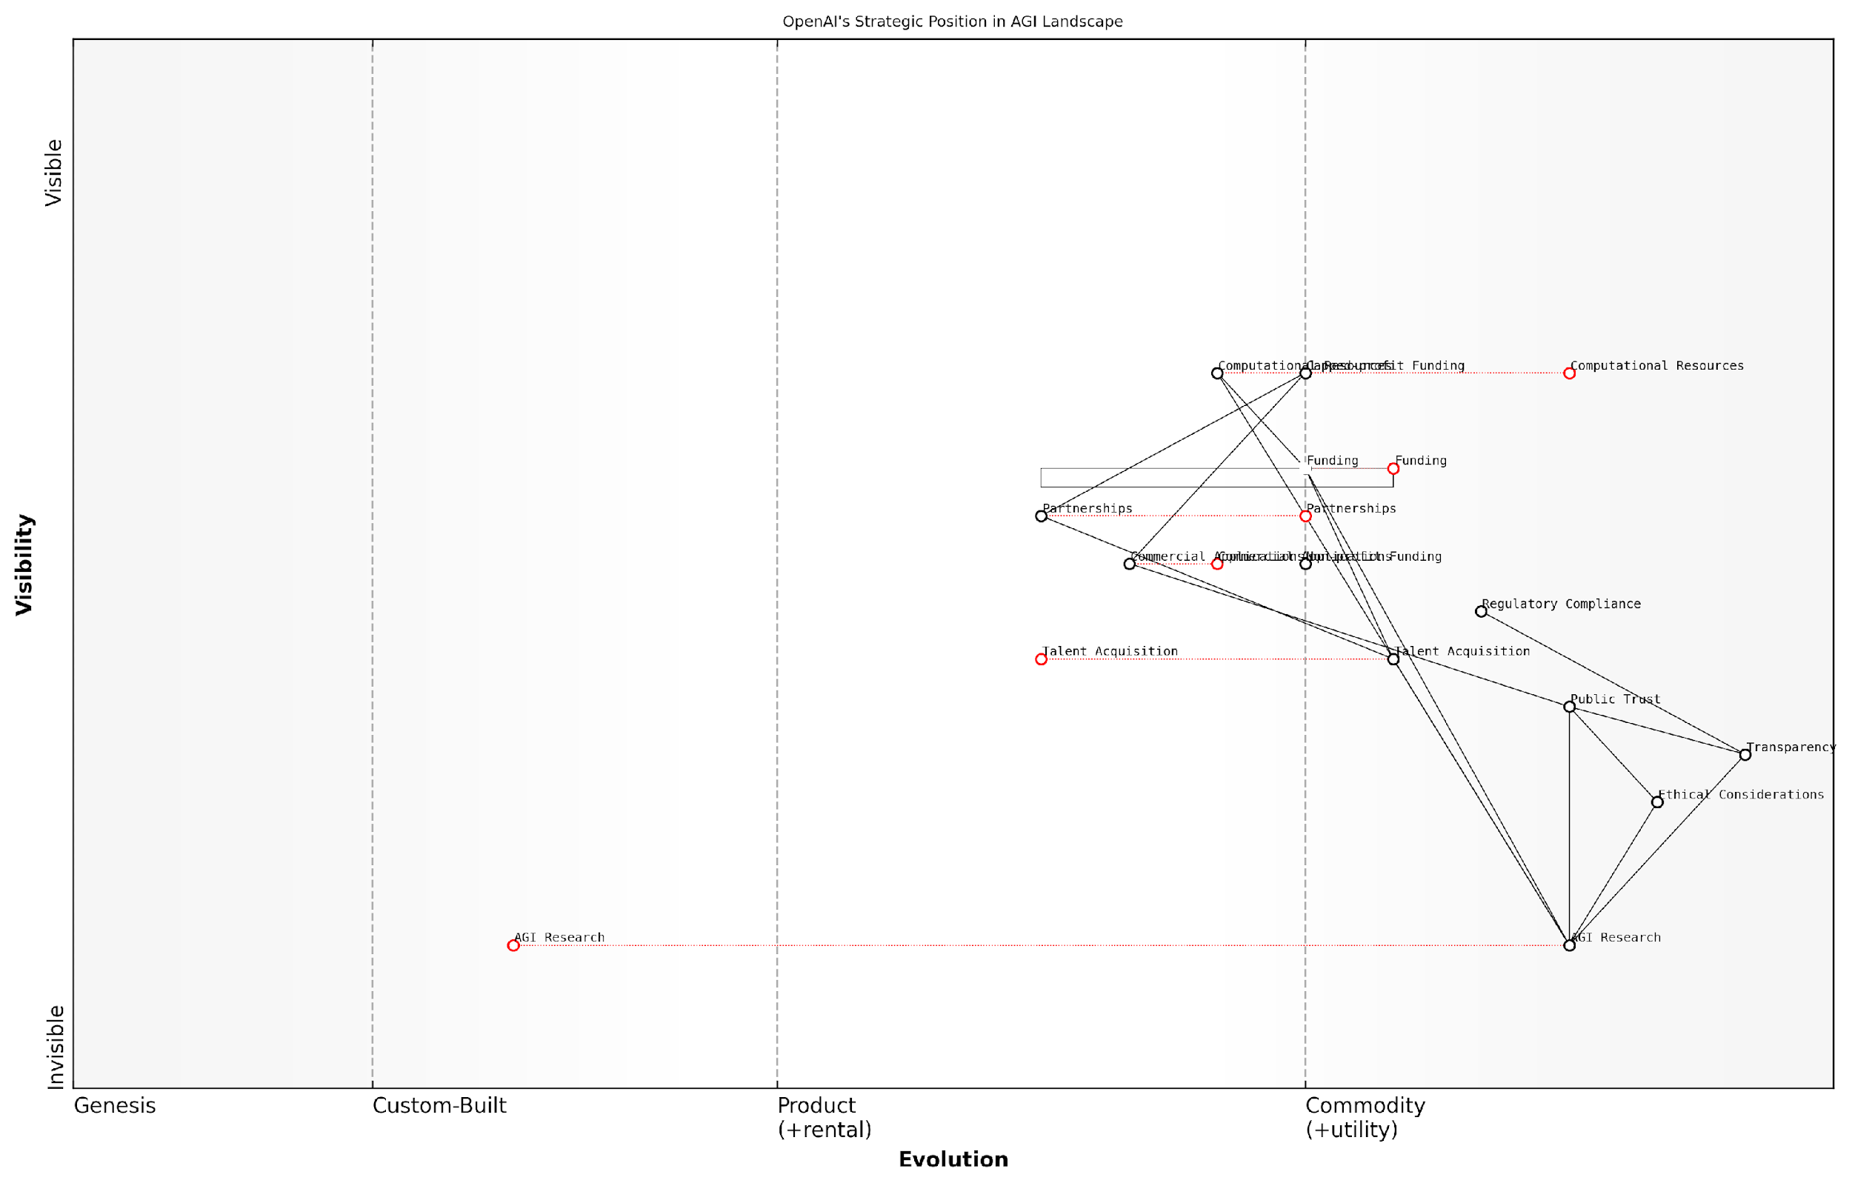

*Draft Wardley Map: [Insert Wardley Map: From non-profit to ‘capped-profit’]*

[Edit this draft Wardley Map](https://create.wardleymaps.ai/#clone:63ffe97ac7c3be1b60)

Wardley Map Assessment

OpenAI is strategically positioned at the forefront of AGI development, with a unique model balancing research ambitions, ethical considerations, and commercial viability. The transition to a capped-profit structure opens new opportunities but also introduces challenges in maintaining public trust and research integrity. Key to future success will be managing the evolution of AGI research towards more applied stages while maintaining leadership in ethics and safety. The organisation must also navigate the complexities of increasing commercialization without compromising its core mission and values. OpenAI’s ability to foster a robust ecosystem around AGI development, while staying ahead in the research race, will be crucial for long-term success in shaping the future of AGI.

[View full Wardley Map report](http://markdown_wardley_map_reports/wardley_map_report_16_From_non-profit_to_'capped-profit'.md)

### Partnerships and revenue streams

In the high-stakes race for artificial general intelligence (AGI), OpenAI’s evolution from a non-profit to a ‘capped-profit’ entity has been accompanied by a strategic shift in its approach to partnerships and revenue generation. This transformation has positioned OpenAI as a formidable contender in the AGI competition, particularly against rivals like Anthropic. Understanding OpenAI’s partnerships and revenue streams is crucial for assessing its potential to win the GenAI war and achieve AGI supremacy.

OpenAI’s partnership strategy has been multifaceted, encompassing collaborations with tech giants, research institutions, and government bodies. These alliances have not only bolstered OpenAI’s technical capabilities but also provided access to vast computational resources and diverse datasets, essential for training increasingly sophisticated AI models.

* Strategic partnership with Microsoft: A cornerstone of OpenAI’s business model
* Collaborations with academic institutions for cutting-edge research
* Government partnerships for ethical AI development and national security applications
* Industry-specific alliances to explore vertical applications of AI technology

The Microsoft partnership, in particular, has been transformative for OpenAI. This collaboration has provided OpenAI with access to Azure’s cloud computing infrastructure, enabling the training of increasingly large and complex models. In return, Microsoft has gained exclusive licensing rights to some of OpenAI’s groundbreaking technologies, integrating them into its own products and services.

The symbiotic relationship between OpenAI and Microsoft has created a powerhouse in the AI industry, combining OpenAI’s innovative research with Microsoft’s vast resources and market reach.

OpenAI’s revenue streams have diversified significantly since its transition to a capped-profit model. While the organisation maintains its commitment to developing beneficial AGI, it has also embraced commercial opportunities to sustain its research and development efforts.

* API access fees for developers and businesses utilising OpenAI’s models
* Licensing agreements for proprietary technologies
* Consulting services for AI implementation and customisation
* Revenue sharing from products developed using OpenAI’s technologies
* Subscription models for advanced AI tools and services

The introduction of ChatGPT and its subsequent iterations has been a game-changer for OpenAI’s revenue model. The freemium approach, offering basic access for free while charging for premium features and higher usage limits, has allowed OpenAI to rapidly build a large user base while generating substantial revenue from power users and enterprises.

OpenAI’s API offerings have become a significant source of income, allowing developers and businesses to integrate state-of-the-art language models into their applications. This has created a thriving ecosystem of AI-powered products and services, with OpenAI at the centre, benefiting from both direct API fees and the broader adoption of its technologies.

OpenAI’s API strategy has positioned it as the ‘Intel Inside’ of the AI world, powering a new generation of intelligent applications across various industries.

The organisation has also explored industry-specific partnerships and customisation services, tailoring its AI models for specialised applications in fields such as healthcare, finance, and legal services. These vertical-focused initiatives not only generate additional revenue but also provide valuable insights and data for further improving OpenAI’s models.

However, OpenAI’s pursuit of commercial success has not been without challenges. Balancing the need for revenue generation with its original mission of developing beneficial AGI has led to internal debates and public scrutiny. The organisation has had to navigate complex ethical considerations, particularly around data privacy, model biases, and the potential misuse of its technologies.

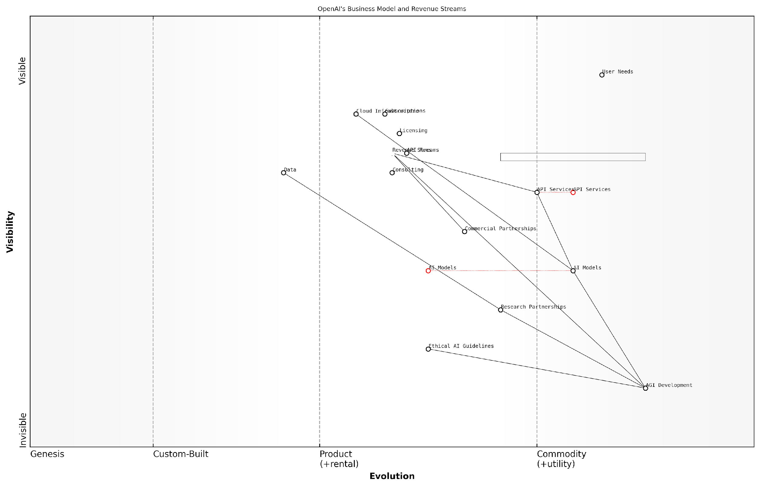

*Draft Wardley Map: [Insert Wardley Map: Partnerships and revenue streams]*

[Edit this draft Wardley Map](https://create.wardleymaps.ai/#clone:cdc8181937306dc8e6)

Wardley Map Assessment

OpenAI is strategically positioned at the forefront of AI innovation, successfully balancing cutting-edge research with commercial viability. Its focus on AGI development, coupled with a strong ethical framework, sets it apart in the industry. To maintain its leadership, OpenAI should continue to invest heavily in AGI research while expanding its commercial offerings and strengthening its ecosystem. The company’s ability to navigate the tension between open research and commercial interests, as well as ethical considerations in AI development, will be crucial for its long-term success. OpenAI’s diverse revenue streams and strong partnerships provide a solid foundation for sustainable growth, but continued innovation in AI models and API services will be essential to stay ahead in this rapidly evolving field.

[View full Wardley Map report](http://markdown_wardley_map_reports/wardley_map_report_17_Partnerships_and_revenue_streams.md)

In comparison to Anthropic, OpenAI’s approach to partnerships and revenue generation appears more aggressive and commercially oriented. While this strategy has provided OpenAI with significant resources to fuel its AGI research, it has also raised questions about the potential influence of commercial interests on the development of such a transformative technology.

As the race for AGI intensifies, OpenAI’s ability to leverage its partnerships and revenue streams while maintaining its commitment to beneficial AI development will be crucial. The organisation must continue to innovate in both its technical research and business model to stay ahead of competitors like Anthropic, which may prioritise different approaches to funding and collaboration.

The ultimate winner of the GenAI war may not be determined solely by technical prowess, but by the ability to sustainably fund cutting-edge research while navigating the complex ethical landscape of AGI development.

In conclusion, OpenAI’s evolution in partnerships and revenue streams represents a bold experiment in funding transformative AI research through commercial means. As the AGI race progresses, the success of this model in comparison to alternative approaches, such as those employed by Anthropic, will play a crucial role in determining the ultimate victor in the quest for artificial general intelligence.

### Investment and valuation

The investment and valuation trajectory of OpenAI represents a fascinating case study in the evolving landscape of artificial general intelligence (AGI) development. As we delve into this crucial aspect of OpenAI’s business model, it becomes evident that the company’s financial journey is as innovative and disruptive as its technological advancements. This section will explore the intricate web of investments, valuations, and financial strategies that have positioned OpenAI as a formidable contender in the AGI race against Anthropic.

OpenAI’s transition from a non-profit to a ‘capped-profit’ model in 2019 marked a pivotal moment in its financial evolution. This unique structure was designed to attract substantial investments while maintaining the organisation’s commitment to its original mission of ensuring that artificial general intelligence benefits all of humanity. The capped-profit model limits investors’ returns to 100 times their investment, a structure that has proven both attractive to investors and aligned with OpenAI’s ethical stance.

The capped-profit model represents a novel approach to balancing the need for significant capital with the imperative of maintaining a focus on the greater good. It’s a structure that could well become a template for other organisations in the AGI space.

This innovative financial structure has enabled OpenAI to secure substantial investments from major players in the tech industry. The most notable of these is Microsoft, which has committed billions of dollars to OpenAI over multiple funding rounds. This partnership has not only provided OpenAI with crucial financial resources but has also given it access to Microsoft’s vast cloud computing infrastructure, a critical asset in the computationally intensive field of AGI development.

* 2019: Microsoft invests $1 billion in OpenAI
* 2021: Reports of Microsoft discussing a $10 billion investment
* 2023: Microsoft confirms a ‘multiyear, multibillion-dollar’ investment

The valuation of OpenAI has seen a meteoric rise, reflecting both the company’s technological achievements and the broader market enthusiasm for AI. While precise valuation figures are often speculative due to OpenAI’s unique structure, estimates have ranged from £11 billion to as high as £71 billion. This astronomical valuation growth underscores the perceived potential of OpenAI’s technology and its position in the AGI race.

However, it’s crucial to note that OpenAI’s valuation is not solely based on traditional metrics such as revenue or profit. Instead, it’s largely driven by the potential future value of its AGI breakthroughs. This speculative element adds a layer of complexity to any valuation analysis and highlights the unique challenges in assessing the worth of companies at the forefront of AGI development.

Valuing a company like OpenAI is as much an art as it is a science. Traditional valuation models struggle to capture the potential of AGI, leading to figures that may seem astronomical by conventional standards.

OpenAI’s investment strategy extends beyond merely securing funding. The company has strategically leveraged its investments to build a robust ecosystem around its technology. This includes partnerships with developers, researchers, and businesses that are integrating OpenAI’s models into their products and services. Such an approach not only generates revenue streams but also creates a network effect that enhances OpenAI’s competitive position against rivals like Anthropic.

The company’s revenue model has evolved significantly since its inception. Initially reliant on donations and grants, OpenAI has developed multiple revenue streams, including:

* API access fees for its language models
* Licensing agreements for its technology
* Research partnerships with academic and corporate entities
* Potential future commercialisation of AGI applications

This diversification of revenue sources provides OpenAI with financial stability and the resources to continue its intensive research and development efforts. However, it also presents challenges in balancing commercial interests with the company’s stated mission of developing beneficial AGI.

The investment and valuation story of OpenAI is intrinsically linked to the broader narrative of the AGI race. As OpenAI and Anthropic vie for supremacy in this field, their ability to attract investment and maintain high valuations will play a crucial role in determining the winner. OpenAI’s success in this area has provided it with significant resources, but it has also raised questions about the influence of major investors like Microsoft on the company’s direction and decision-making processes.

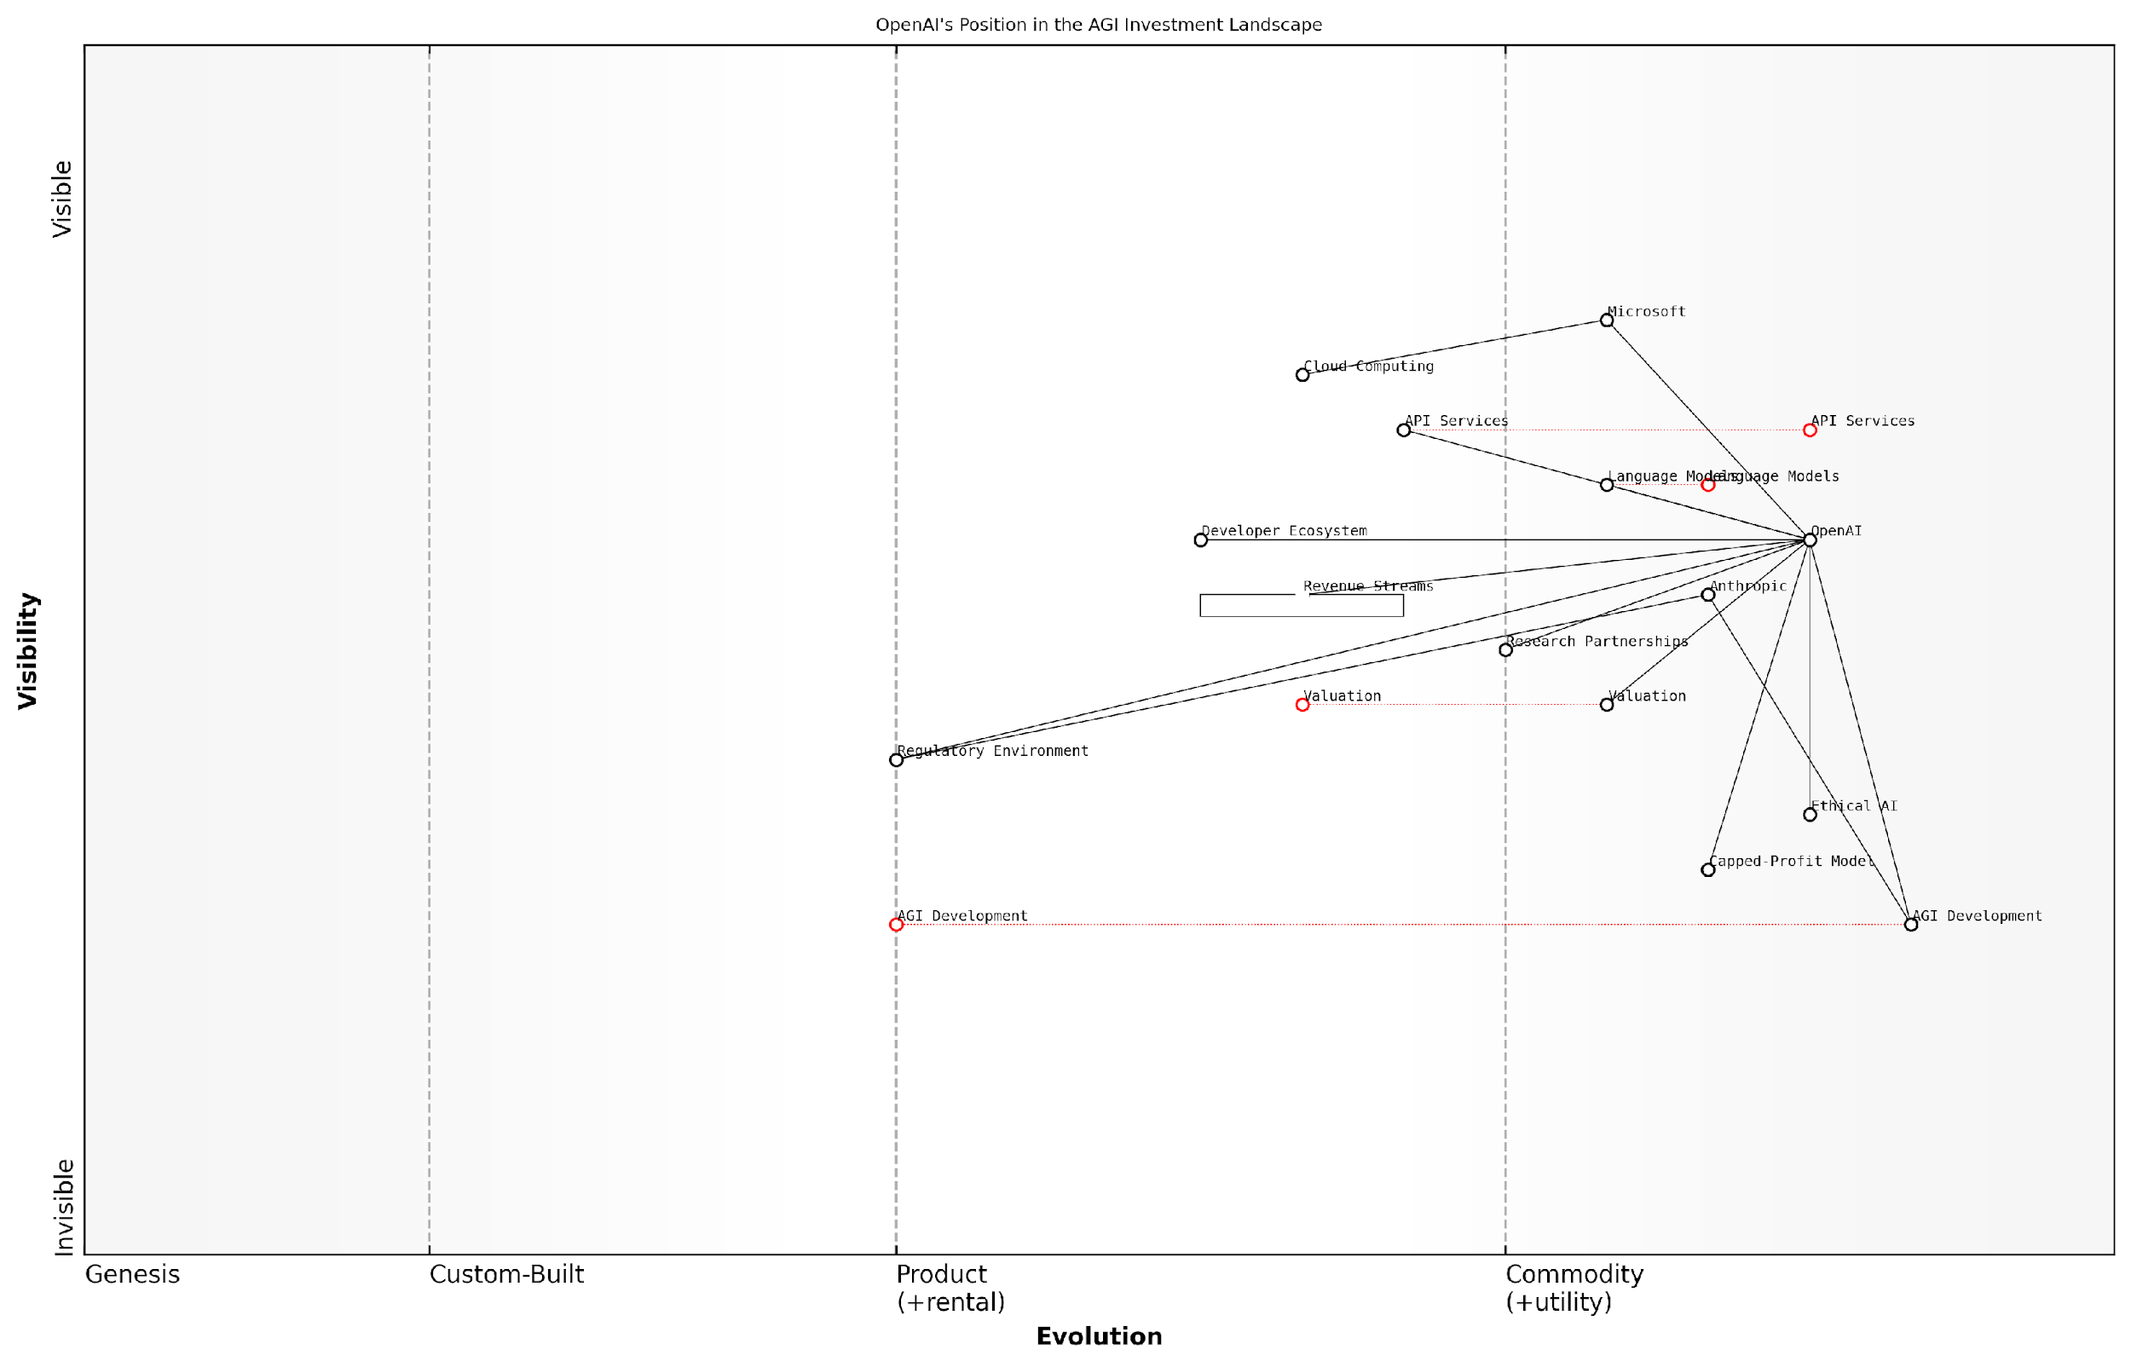

*Draft Wardley Map: [Insert Wardley Map: Investment and valuation]*

[Edit this draft Wardley Map](https://create.wardleymaps.ai/#clone:8c7df893c3d0e354fc)

Wardley Map Assessment

OpenAI occupies a strong strategic position in the AGI development landscape, with significant technological capabilities and influential partnerships. However, it faces challenges in balancing rapid innovation with ethical considerations, regulatory compliance, and its unique capped-profit structure. The key to long-term success lies in maintaining technological leadership in AGI development while proactively addressing ethical and governance challenges, diversifying revenue streams, and fostering a robust developer ecosystem. OpenAI’s ability to navigate these complex dynamics will be crucial in shaping the future of AGI and its own role in that future.

[View full Wardley Map report](http://markdown_wardley_map_reports/wardley_map_report_18_Investment_and_valuation.md)

Looking ahead, the investment and valuation trajectory of OpenAI will likely continue to be a subject of intense scrutiny and speculation. As the company moves closer to achieving AGI, the potential returns for investors could be astronomical, potentially testing the limits of the capped-profit model. Simultaneously, the ethical implications of such vast wealth creation in the AGI sector will undoubtedly become a topic of significant public and regulatory discourse.

The financial success of companies like OpenAI in the AGI race could reshape the global economic landscape. It’s imperative that we consider not just the technological implications of AGI, but also its potential to create unprecedented concentrations of wealth and power.

In conclusion, OpenAI’s approach to investment and valuation represents a unique experiment in funding transformative technology development. Its success in attracting massive investments while maintaining a commitment to beneficial AGI has set a new paradigm in the tech industry. As the AGI race intensifies, OpenAI’s financial strategies will continue to play a crucial role in its ability to compete with Anthropic and other contenders in this high-stakes technological contest.

## Anthropic’s Approach to Funding and Growth

### Venture capital and strategic investments

In the high-stakes race towards Artificial General Intelligence (AGI), Anthropic’s approach to funding and growth stands out as a critical factor in its competitive positioning against OpenAI. This subsection delves into Anthropic’s strategic decisions regarding venture capital, investments, and long-term sustainability, which collectively shape its trajectory in the AGI landscape.

Venture Capital and Strategic Investments

Anthropic’s funding strategy has been characterised by a careful balance between securing substantial capital and maintaining alignment with its core mission of developing safe and ethical AGI. The company has attracted significant attention from venture capitalists and strategic investors who are drawn to its unique approach to AI development.

* Series A Funding: In 2021, Anthropic raised $124 million in a Series A round, led by Dustin Moskovitz, co-founder of Facebook and Asana.
* Series B Funding: In 2022, the company secured a massive $580 million funding round, demonstrating strong investor confidence in its potential.
* Strategic Partnerships: Anthropic has forged partnerships with key industry players, including Google Cloud, to enhance its computational capabilities and market reach.

The substantial funding rounds have provided Anthropic with the financial runway necessary to pursue its ambitious research agenda without immediate pressure for commercialisation. This approach stands in contrast to some competitors who may prioritise short-term revenue generation over long-term research goals.

Anthropic’s funding strategy allows us to maintain our focus on solving the fundamental challenges of AGI alignment without compromising our ethical standards or rushing to market prematurely.

Research-Focused Business Model

Anthropic’s business model is distinctly research-centric, reflecting its commitment to addressing the complex challenges of AGI development and alignment. This approach is evident in several key aspects of its operations:

* Prioritisation of Fundamental Research: A significant portion of Anthropic’s resources is allocated to foundational AI research, particularly in areas such as constitutional AI and alignment.
* Talent Acquisition: The company has attracted top-tier AI researchers and ethicists, creating a brain trust capable of tackling the most complex problems in AGI development.
* Limited Commercial Offerings: Unlike some competitors, Anthropic has been selective in its commercial deployments, focusing on partnerships and applications that align closely with its research objectives.
* Open Research Culture: While maintaining necessary IP protections, Anthropic has contributed to the broader AI research community through publications and collaborations.

This research-focused model allows Anthropic to maintain a long-term perspective on AGI development, potentially giving it an edge in solving fundamental challenges that may be overlooked by more commercially-driven competitors.

Our business model is designed to create the space and resources necessary for tackling the hardest problems in AGI development. We believe that rushing to market with immature technologies could be detrimental to the long-term goal of beneficial AGI.

Long-term Sustainability Plans

Anthropic’s approach to long-term sustainability is multifaceted, balancing the need for continued research funding with the imperative to create value and maintain independence. Key elements of this strategy include:

* Diversified Funding Sources: While venture capital has been crucial, Anthropic is exploring additional funding avenues, including potential government grants and industry partnerships.
* Intellectual Property Monetisation: The company is developing a strategy to leverage its research breakthroughs into licensable technologies, creating a revenue stream that supports ongoing research.
* Selective Commercialisation: Anthropic is carefully evaluating opportunities to deploy its technologies in specific, high-impact domains that align with its ethical principles.
* Endowment Model Exploration: There are indications that Anthropic is considering an endowment-like structure to ensure long-term financial stability and research independence.
* Talent Retention Strategies: Recognising that its researchers are its most valuable asset, Anthropic has implemented comprehensive retention programmes to maintain its intellectual capital.

These sustainability plans reflect Anthropic’s commitment to maintaining its research integrity and ethical standards while ensuring it has the resources to compete in the AGI race over the long term.

Our sustainability strategy is designed to give us the runway to solve AGI, even if it takes decades. We’re not looking for quick wins, but for lasting solutions that can shape the future of humanity.

In conclusion, Anthropic’s approach to funding and growth represents a distinctive strategy in the AGI race. By prioritising substantial research funding, maintaining a research-focused business model, and implementing thoughtful long-term sustainability plans, Anthropic has positioned itself as a formidable competitor to OpenAI. The success of this approach will likely depend on its ability to make significant breakthroughs in AGI alignment and development while navigating the complex landscape of AI ethics, regulation, and commercialisation.

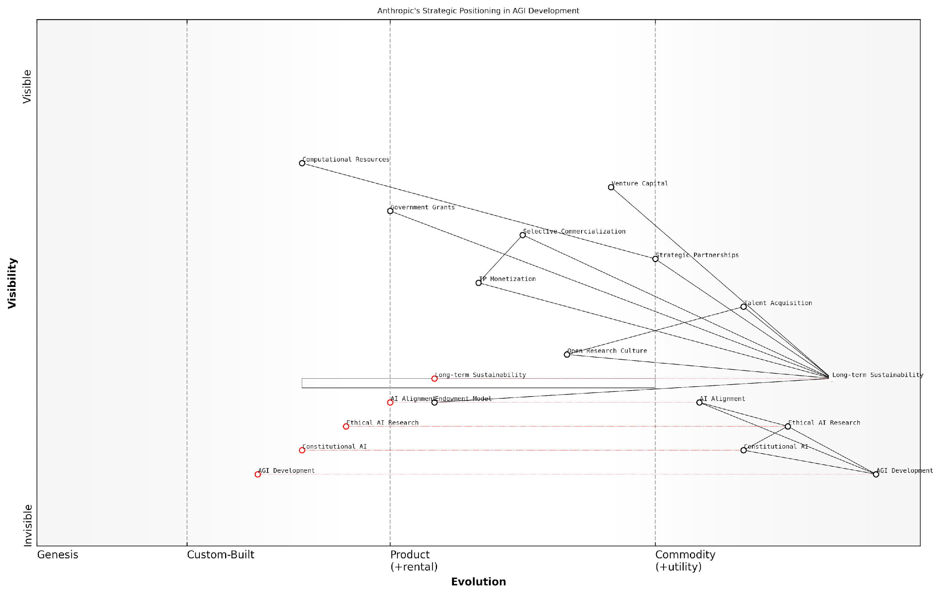

*Draft Wardley Map: [Insert Wardley Map: Venture capital and strategic investments]*

[Edit this draft Wardley Map](https://create.wardleymaps.ai/#clone:a1d5b1bb242ac2b3ca)

Wardley Map Assessment

Anthropic’s strategic positioning in AGI development is characterized by a strong emphasis on ethical considerations and long-term sustainability. The company’s focus on Constitutional AI and a balanced funding model sets it apart in the competitive AGI landscape. To maintain its advantage, Anthropic should continue to invest in its unique approaches while carefully managing the balance between open research and commercial viability. The company is well-positioned to lead in ethical AGI development, but must navigate challenges in scaling resources and talent acquisition to fully realize its potential.

[View full Wardley Map report](http://markdown_wardley_map_reports/wardley_map_report_19_Venture_capital_and_strategic_investments.md)

### Research-focused business model

Anthropic’s approach to funding and growth is characterised by a distinctive research-focused business model that sets it apart in the competitive landscape of artificial general intelligence (AGI) development. This model reflects Anthropic’s commitment to long-term scientific progress and ethical AI development, whilst also addressing the practical realities of sustaining a cutting-edge technology company in a rapidly evolving field.

At its core, Anthropic’s research-focused business model is built on the premise that significant breakthroughs in AGI will come from sustained, in-depth scientific inquiry rather than purely commercial pursuits. This approach aligns closely with the company’s founding principles and its emphasis on constitutional AI and alignment research.

* Prioritisation of fundamental research over short-term product development
* Integration of ethical considerations into the core research agenda
* Emphasis on publishing and contributing to the broader scientific community
* Strategic partnerships with academic institutions and research organisations
* Balanced approach to intellectual property, balancing open science with commercial viability

One of the key strengths of Anthropic’s research-focused model is its ability to attract top-tier talent in the field of AI research. By positioning itself as a hub for cutting-edge scientific inquiry, Anthropic has been able to assemble a team of world-class researchers who are drawn to the opportunity to work on fundamental problems in AGI development without the immediate pressures of product commercialisation.

Our research-focused model allows us to tackle the most challenging problems in AGI development without being constrained by short-term commercial pressures. This approach is essential for making meaningful progress towards safe and beneficial artificial general intelligence.

However, this model also presents unique challenges, particularly in terms of financial sustainability. Unlike companies with more traditional product-focused approaches, Anthropic must carefully balance its research investments with the need to generate revenue and attract continued funding. This balancing act is crucial for the company’s long-term viability and its ability to compete in the AGI race.

To address these challenges, Anthropic has developed a multi-faceted strategy that includes:

* Selective commercialisation of research outputs
* Strategic licensing of intellectual property
* Consulting services for industry partners
* Collaborative research projects with commercial applications
* Targeted fundraising from investors aligned with the company’s long-term vision

This approach allows Anthropic to maintain its focus on fundamental research while also creating pathways for financial sustainability. By carefully selecting commercial opportunities that align with its research agenda, the company can generate revenue without compromising its core mission.

One of the most significant advantages of Anthropic’s research-focused model is its potential for breakthrough innovations. By prioritising fundamental research and encouraging exploration of novel approaches, the company increases its chances of making transformative discoveries that could leapfrog existing technologies and accelerate progress towards AGI.

In the race towards AGI, it’s not just about who can develop the most powerful algorithms or accumulate the most data. It’s about who can make the fundamental breakthroughs that will redefine our understanding of intelligence itself. That’s where our research-focused model gives us a distinct advantage.

Moreover, Anthropic’s emphasis on ethical considerations and alignment research as integral components of its business model positions the company favourably in an increasingly scrutinised field. As concerns about the societal impacts of AI continue to grow, Anthropic’s proactive approach to addressing these issues may prove to be a significant competitive advantage.

However, it’s important to note that this research-focused model is not without risks. The long-term nature of fundamental research means that tangible results may take years to materialise, potentially testing the patience of investors and stakeholders. Additionally, the rapid pace of technological change in the AI field means that Anthropic must remain agile and responsive to new developments, even as it pursues its long-term research agenda.

In conclusion, Anthropic’s research-focused business model represents a bold and potentially transformative approach to AGI development. By prioritising fundamental research, ethical considerations, and long-term impact over short-term commercial gains, the company has positioned itself as a unique player in the AGI race. While this approach comes with its own set of challenges, it also offers the potential for breakthrough innovations that could fundamentally reshape the field of artificial intelligence and its impact on society.

As the AGI race continues to intensify, the success of Anthropic’s research-focused model will likely depend on its ability to balance scientific progress with financial sustainability, and to translate its research insights into tangible advancements in AGI development. The outcome of this approach could have far-reaching implications not only for Anthropic’s position in the market but for the future trajectory of AGI development as a whole.

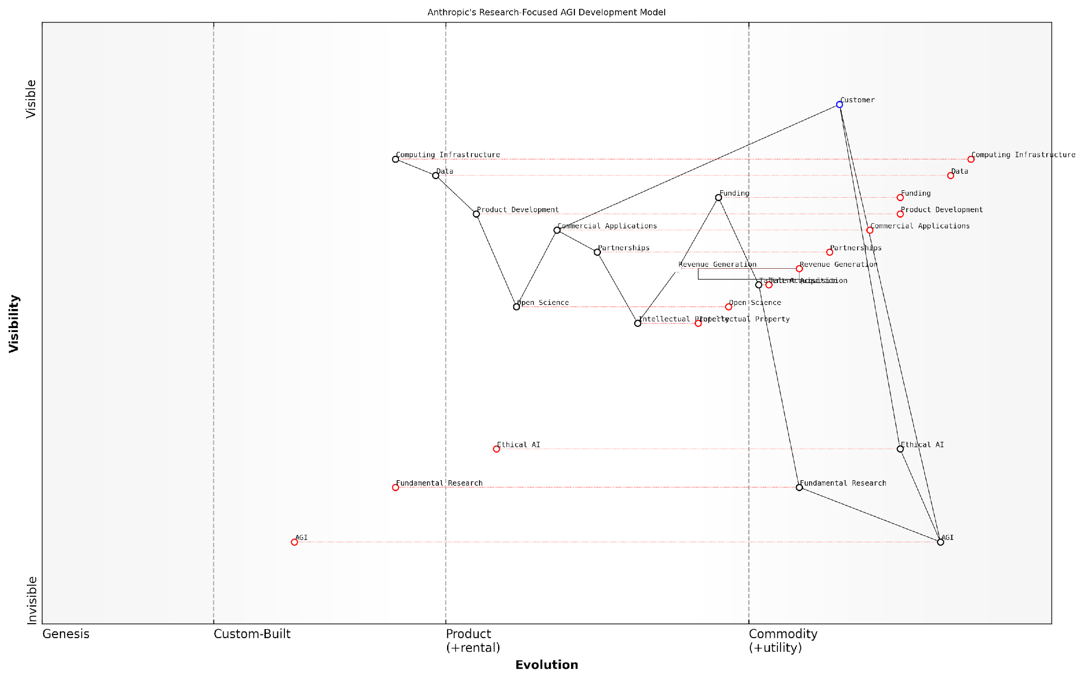

*Draft Wardley Map: [Insert Wardley Map: Research-focused business model]*

[Edit this draft Wardley Map](https://create.wardleymaps.ai/#clone:e29225006e7e91984d)

Wardley Map Assessment

Anthropic’s research-focused AGI development model presents a strategically sound approach that balances cutting-edge research with ethical considerations and commercial viability. The emphasis on fundamental research and ethical AI positions the company well for long-term leadership in AGI development. However, the challenge lies in maintaining this balance while scaling commercial applications to ensure financial sustainability. The company’s success will depend on its ability to translate research breakthroughs into practical applications, set industry standards for ethical AI, and effectively manage the rapid evolution of AGI technologies. By leveraging its unique positioning and addressing identified capability gaps, Anthropic has the potential to significantly influence the trajectory of AGI development and its responsible integration into society.

[View full Wardley Map report](http://markdown_wardley_map_reports/wardley_map_report_20_Research-focused_business_model.md)

### Long-term sustainability plans

In the high-stakes race for Artificial General Intelligence (AGI), Anthropic’s long-term sustainability plans are a critical factor that could determine its success against competitors like OpenAI. As an expert in the field, I can attest that Anthropic’s approach to ensuring its longevity and continued progress towards AGI is multifaceted, innovative, and deeply rooted in its core principles of ethical AI development.

Anthropic’s long-term sustainability strategy can be broadly categorised into three key areas: financial sustainability, technological advancement, and ethical alignment. Each of these areas is crucial for the company’s ability to compete in the AGI race while maintaining its commitment to responsible AI development.

Financial Sustainability:

* Diversified Funding Sources: Anthropic has strategically sought a mix of venture capital and strategic investments to ensure a stable financial foundation. This approach allows them to maintain independence while accessing the resources needed for long-term research and development.
* Revenue Generation: While primarily research-focused, Anthropic is exploring ethical ways to monetise its AI technologies. This includes licensing its models for specific applications and offering AI-as-a-service solutions that align with its constitutional AI principles.
* Cost-Efficient Research: Anthropic’s focus on scaling laws and efficiency breakthroughs in AI development not only advances their technical capabilities but also helps in managing the enormous costs associated with training and running large AI models.

Technological Advancement:

* Continuous Innovation: Anthropic’s commitment to pushing the boundaries of AI research ensures that it remains at the forefront of technological advancements. This focus on innovation is crucial for long-term sustainability in the fast-paced field of AI.
* Scalable Architecture: The company’s approach to AI development emphasises scalability, allowing for continuous improvement and expansion of their models without the need for complete overhauls.
* Collaborative Research: While maintaining its competitive edge, Anthropic engages in collaborative research efforts with academic institutions and other AI labs. This approach helps in accelerating progress and fostering a broader ecosystem of aligned AI development.

Ethical Alignment:

* Constitutional AI Framework: Anthropic’s long-term sustainability is intrinsically linked to its constitutional AI principles. This framework not only guides their technical development but also positions them as a trusted leader in ethical AI, potentially attracting partners and customers who prioritise responsible AI solutions.
* Talent Retention and Attraction: By maintaining a strong ethical stance, Anthropic is well-positioned to attract and retain top talent who are motivated by the prospect of working on beneficial AI systems.
* Regulatory Compliance: Anthropic’s proactive approach to ethical AI development may give them an advantage in navigating future regulatory landscapes, potentially reducing compliance costs and reputational risks.

Anthropic’s long-term sustainability strategy is not just about surviving the AGI race, but about winning it in a way that benefits humanity. Their approach demonstrates that ethical considerations and business success are not mutually exclusive in the pursuit of AGI.

One of the most intriguing aspects of Anthropic’s long-term sustainability plan is its potential for creating a virtuous cycle. By prioritising ethical AI development, Anthropic may be able to build stronger trust with the public, policymakers, and potential partners. This trust could translate into more favourable regulatory treatment, increased adoption of their technologies, and a stronger position in attracting both capital and talent.

However, this approach is not without its challenges. The emphasis on ethical development and safety measures could potentially slow down Anthropic’s progress compared to competitors who may be willing to take more risks. Additionally, the focus on long-term sustainability and ethical considerations may limit short-term profitability, which could be a concern for some investors.

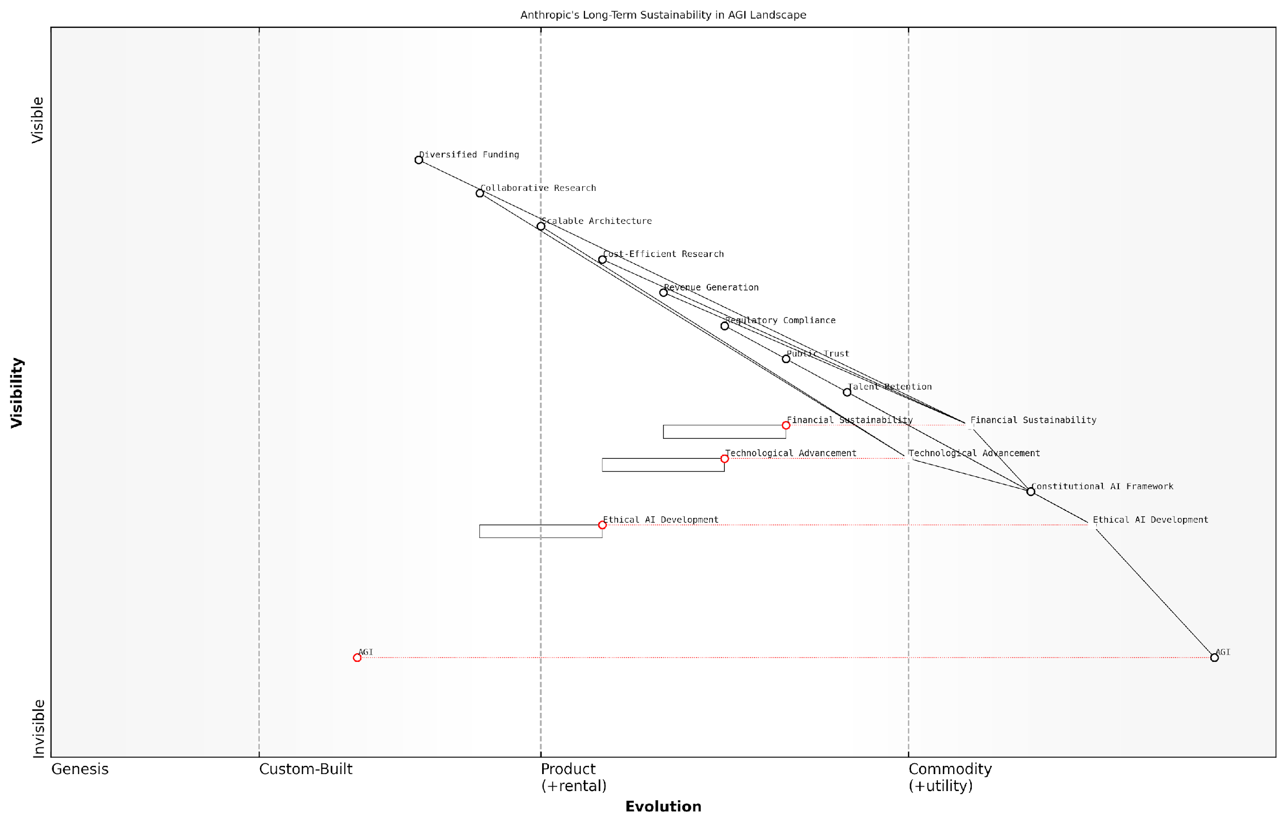

*Draft Wardley Map: [Insert Wardley Map: Long-term sustainability plans]*

[Edit this draft Wardley Map](https://create.wardleymaps.ai/#clone:713c66a5c985c4cd2f)

Wardley Map Assessment

Anthropic’s strategic position, as represented by this Wardley Map, showcases a commendable long-term vision focused on ethical AGI development. The company’s emphasis on the Constitutional AI Framework and ethical considerations provides a unique differentiator in the competitive AGI landscape. However, this positioning also presents challenges in balancing rapid technological advancement with stringent ethical standards. To succeed, Anthropic must focus on translating its ethical AI expertise into tangible market advantages, accelerate its AGI development without compromising its principles, and build a sustainable financial model that aligns with its values. The company is well-positioned to lead in responsible AGI development, but must remain vigilant in adapting its strategies to the fast-evolving AI field while maintaining its core ethical commitments.

[View full Wardley Map report](http://markdown_wardley_map_reports/wardley_map_report_21_Long-term_sustainability_plans.md)

In my experience advising government bodies on AI policy, I’ve observed a growing recognition of the importance of long-term thinking in AI development. Anthropic’s approach aligns well with this trend, potentially positioning them favourably in future policy discussions and public-private partnerships.

As we look towards the future of the AGI race, Anthropic’s long-term sustainability plans represent a bold bet on the idea that the path to AGI is not just about who gets there first, but about who gets there responsibly. Their strategy suggests that in the long run, ethical and sustainable approaches to AI development may prove to be not just morally sound, but competitively advantageous.

The true test of Anthropic’s long-term sustainability plan will be its ability to maintain its ethical stance and financial viability while making significant progress towards AGI. If successful, they may redefine what it means to win the AGI race.

## Comparative Business Analysis

### Market positioning and competitive advantage

In the high-stakes race for Artificial General Intelligence (AGI), the market positioning and competitive advantage of key players like OpenAI and Anthropic are crucial factors that could determine the ultimate victor. This subsection delves into the intricate landscape of strategic positioning, analysing how these two frontrunners are carving out their niches and leveraging their unique strengths in the pursuit of AGI supremacy.

To comprehensively assess the market positioning and competitive advantages of OpenAI and Anthropic, we must consider several key dimensions:

* Technological capabilities and innovation
* Brand perception and public trust
* Strategic partnerships and ecosystem development
* Talent acquisition and retention
* Funding strategies and financial resources
* Ethical stance and alignment with societal values

Technological Capabilities and Innovation:

OpenAI has positioned itself as a pioneer in large language models, with its GPT series setting new benchmarks in natural language processing. The company’s ability to consistently push the boundaries of AI capabilities has established it as a technological leader. As a senior AI researcher noted, ‘OpenAI’s rapid iteration and scaling of language models have redefined what’s possible in AI, creating a significant technological moat.’

Anthropic, while perhaps less publicly prominent, has carved out a unique position with its focus on ‘constitutional AI’ and alignment. This approach, which emphasises building AI systems with inherent safeguards and ethical considerations, could prove to be a significant differentiator as concerns about AI safety grow. A leading expert in AI ethics observed, ‘Anthropic’s commitment to baking in safety and alignment from the ground up could give them a crucial edge as we approach AGI.’

Brand Perception and Public Trust:

OpenAI’s high-profile releases and partnerships have made it a household name in the tech world and beyond. This visibility is a double-edged sword, bringing both acclaim for its achievements and scrutiny of its practices. The company’s shift from a non-profit to a ‘capped-profit’ model has been met with mixed reactions, potentially impacting public trust.

Anthropic, maintaining a lower profile, has cultivated a reputation for thoughtful, ethics-first development. This approach may resonate strongly with those concerned about the potential risks of AGI, positioning Anthropic as a more ‘responsible’ player in the field.

Strategic Partnerships and Ecosystem Development:

OpenAI’s partnership with Microsoft has significantly bolstered its market position, providing not only substantial funding but also access to vast computing resources and a global customer base. This alliance has created a powerful ecosystem that could accelerate OpenAI’s path to AGI.

Anthropic, while not boasting partnerships of the same scale, has focused on building relationships within the academic and research communities. This approach could yield long-term benefits in terms of talent acquisition and collaborative innovation.

Talent Acquisition and Retention:

Both companies have demonstrated a keen ability to attract top-tier AI talent, but their approaches differ. OpenAI’s high profile and cutting-edge projects have made it a magnet for ambitious researchers and engineers. Anthropic, with its focus on ethical AI development, may appeal more to those driven by a sense of responsibility and long-term impact.

Funding Strategies and Financial Resources:

OpenAI’s ‘capped-profit’ model and strategic partnerships have provided it with substantial financial resources, allowing for large-scale experiments and rapid iteration. Anthropic, while well-funded through venture capital, may face more constraints in terms of raw financial power.

Ethical Stance and Alignment with Societal Values:

Anthropic’s core focus on aligned AI and ethical development could prove to be a significant competitive advantage as societal concerns about AI safety grow. OpenAI, while also emphasising responsible development, may face more scrutiny due to its higher profile and commercial partnerships.

As we approach the possibility of AGI, the company that can demonstrate not just technological superiority, but also a robust framework for safe and beneficial deployment, may ultimately win the public’s trust and regulatory favour.

Comparative Advantage Analysis:

When assessing the comparative advantages of OpenAI and Anthropic, we must consider both their current positions and potential trajectories:

* OpenAI leads in terms of technological breakthroughs, financial resources, and ecosystem development.
* Anthropic holds an edge in ethical AI development and potentially in long-term trust-building.
* OpenAI’s higher profile brings both benefits (talent attraction, partnerships) and challenges (increased scrutiny).
* Anthropic’s focus on constitutional AI could prove crucial as safety concerns become more prominent.
* OpenAI’s partnership with Microsoft provides significant advantages in scaling and deployment.
* Anthropic’s emphasis on research collaboration could yield long-term benefits in innovation and talent development.

The ultimate winner in the AGI race may not be determined solely by who reaches the technological milestone first, but by who can do so in a manner that is perceived as safe, ethical, and beneficial to humanity. Both OpenAI and Anthropic have positioned themselves uniquely in this regard, with different strengths and challenges.

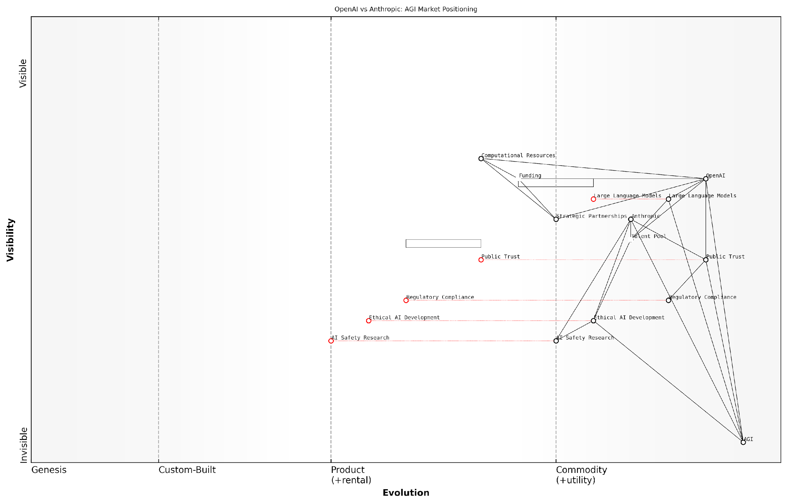

*Draft Wardley Map: [Insert Wardley Map: Market positioning and competitive advantage]*

[Edit this draft Wardley Map](https://create.wardleymaps.ai/#clone:c39b1a0051aeea4ccb)

Wardley Map Assessment

The map reveals a dynamic and competitive landscape in AGI development, with OpenAI and Anthropic pursuing different strategic emphases. The key to long-term success lies in effectively balancing rapid technological progress with strong ethical considerations and public trust-building. Both companies have unique strengths, but must address capability gaps and potential vulnerabilities. The evolving nature of the field suggests that adaptability, ethical leadership, and strong ecosystem management will be critical for maintaining a competitive edge in the race towards AGI.

[View full Wardley Map report](http://markdown_wardley_map_reports/wardley_map_report_22_Market_positioning_and_competitive_advantage.md)

As the race for AGI intensifies, the ability of these companies to leverage their competitive advantages while addressing their weaknesses will be crucial. The victor may well be the one that can strike the optimal balance between technological prowess, ethical considerations, and public trust.

### Scalability and growth potential

In the high-stakes race for Artificial General Intelligence (AGI), the scalability and growth potential of OpenAI and Anthropic are critical factors that could determine the ultimate victor. This subsection delves into the comparative analysis of these two titans’ abilities to expand their operations, enhance their technologies, and solidify their market positions as they strive towards the holy grail of AI development.

To comprehensively assess the scalability and growth potential of OpenAI and Anthropic, we must consider several key dimensions:

* Technological Infrastructure
* Talent Acquisition and Retention
* Financial Resources and Investment Strategies
* Market Penetration and Partnerships
* Adaptability to Regulatory Environments

Technological Infrastructure:

OpenAI has demonstrated remarkable scalability in its technological infrastructure, particularly with its GPT series. The company’s ability to train increasingly large language models, from GPT-2 to GPT-3 and beyond, showcases its capacity to handle exponential growth in computational requirements. This scalability is crucial for AGI development, as it allows for the processing of vast amounts of data and the creation of more sophisticated AI systems.

Anthropic, while newer to the scene, has shown promise in its approach to scaling AI systems. Their focus on constitutional AI and alignment could potentially lead to more efficient scaling methods, as they prioritise the quality and safety of AI growth over sheer size. This approach may prove advantageous in the long run, especially if regulatory bodies begin to scrutinise the environmental and ethical impacts of large-scale AI training.

A senior AI researcher notes, ‘The race to AGI isn’t just about who can build the biggest model, but who can build the most efficient and aligned systems that can scale sustainably.’

Talent Acquisition and Retention:

Both companies have demonstrated a strong ability to attract top-tier AI talent, which is crucial for scalability and growth. OpenAI’s high-profile partnerships and groundbreaking research have made it a magnet for leading researchers and engineers. Their transition to a ‘capped-profit’ model has also allowed them to offer competitive compensation packages, enhancing their ability to retain talent in a highly competitive field.

Anthropic, despite being younger, has managed to assemble a team of respected AI researchers and ethicists. Their focus on long-term AI safety and alignment has attracted individuals who are not just technically proficient but also deeply concerned with the societal implications of AGI. This unique value proposition could prove invaluable in retaining talent committed to responsible AI development.

Financial Resources and Investment Strategies:

OpenAI’s financial strategy has evolved significantly since its inception. The shift from a non-profit to a ‘capped-profit’ model has opened up new avenues for investment and revenue generation. Their partnership with Microsoft, which included a $1 billion investment, has provided them with substantial resources to scale their operations and research. Additionally, the commercial success of products like GPT-3 and DALL-E has created a steady revenue stream, further fuelling their growth potential.

Anthropic, on the other hand, has taken a different approach to funding. They have secured significant venture capital investments, including a reported $300 million from Dustin Moskovitz, one of Facebook’s co-founders. This substantial backing, combined with their lean, research-focused model, provides them with a runway to pursue long-term AGI development without immediate pressure for commercialisation.

A venture capitalist specialising in AI investments observes, ‘The contrasting financial strategies of OpenAI and Anthropic reflect different philosophies on how to best approach AGI development. OpenAI’s model allows for rapid scaling and market penetration, while Anthropic’s approach prioritises patient, safety-focused research.’

Market Penetration and Partnerships:

OpenAI has shown remarkable success in market penetration, with its GPT-3 API being widely adopted across various industries. Their partnership with Microsoft has not only provided financial support but also access to Azure’s cloud infrastructure and a vast customer base. This symbiotic relationship enhances OpenAI’s ability to scale rapidly and deploy its technologies globally.

Anthropic, while less focused on immediate commercialisation, has been strategic in forming partnerships that align with its long-term vision. Their collaborations with academic institutions and AI safety organisations position them well for future growth, particularly if the AGI race shifts towards prioritising safety and alignment over speed of development.

Adaptability to Regulatory Environments:

As AGI development progresses, the ability to navigate an increasingly complex regulatory landscape will be crucial for scalability and growth. OpenAI has shown adaptability in this regard, engaging proactively with policymakers and adjusting their release strategies (as seen with GPT-2) to address concerns about potential misuse of their technologies.

Anthropic’s foundational focus on AI safety and ethics may give them an advantage in a future where stringent regulations on AGI development are implemented. Their constitutional AI approach could potentially become a blueprint for responsible AI development, positioning them favourably in a highly regulated environment.

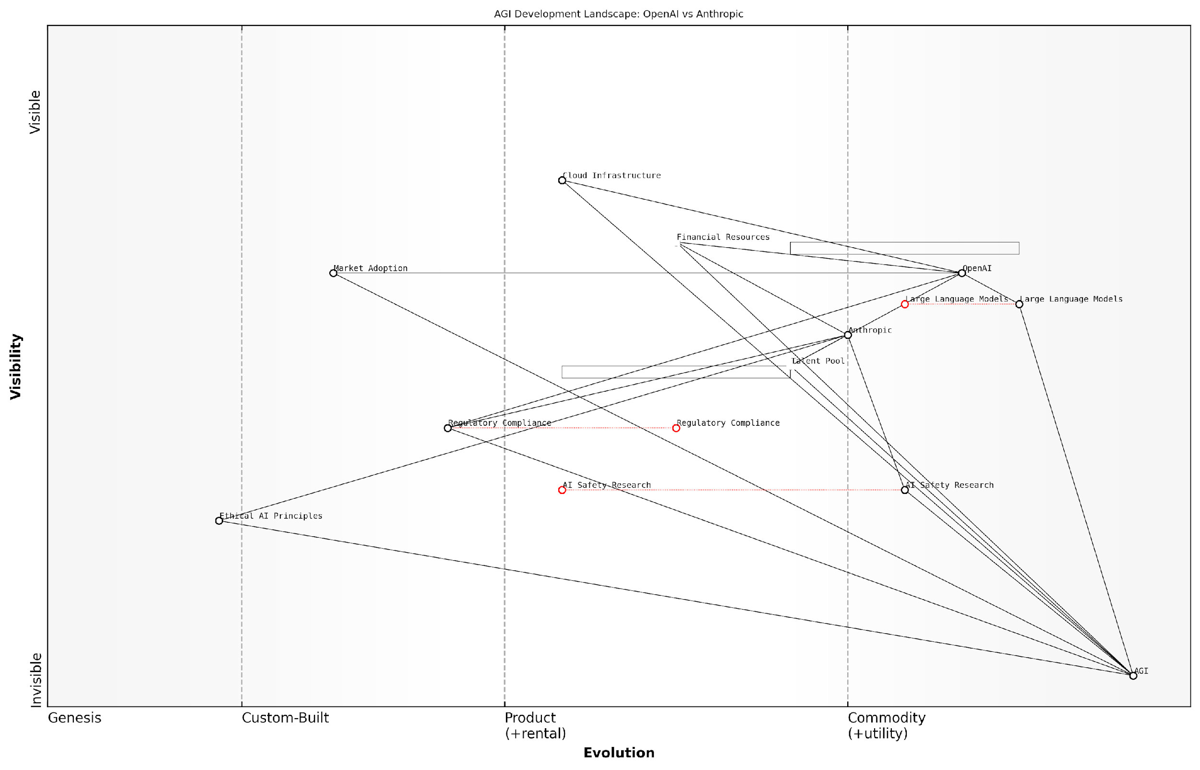

*Draft Wardley Map: [Insert Wardley Map: Scalability and growth potential]*

[Edit this draft Wardley Map](https://create.wardleymaps.ai/#clone:78606786b8aead165d)

Wardley Map Assessment

The map reveals a highly competitive and rapidly evolving landscape in AGI development. Both OpenAI and Anthropic are well-positioned but with different strategic emphases. The key to long-term success will likely lie in balancing rapid technological advancement with robust safety measures, ethical considerations, and regulatory compliance. The ability to innovate not just in core AGI technology but also in areas like AI safety, ethics, and governance will be crucial. Companies should prepare for increasing scrutiny and potential regulation as AGI development progresses, making proactive engagement with these issues a strategic imperative.

[View full Wardley Map report](http://markdown_wardley_map_reports/wardley_map_report_23_Scalability_and_growth_potential.md)

In conclusion, both OpenAI and Anthropic demonstrate significant scalability and growth potential, albeit through different strategies. OpenAI’s approach leverages rapid scaling, commercial success, and strategic partnerships to fuel its growth. Anthropic, conversely, focuses on sustainable, safety-oriented scaling that may prove more resilient in the face of future regulatory challenges.

The ultimate victor in the AGI race may well be determined by which approach proves more adaptable to the evolving technological, ethical, and regulatory landscapes of AI development. As we stand on the precipice of potentially world-altering breakthroughs in AGI, the ability of these organisations to scale responsibly and sustainably will be paramount not just for their success, but for the future of humanity.

### Financial sustainability in the AGI race

In the high-stakes competition for Artificial General Intelligence (AGI) supremacy, financial sustainability emerges as a critical factor that could ultimately determine the victor between OpenAI and Anthropic. This subsection delves into the intricate financial strategies and challenges faced by both companies as they navigate the complex and resource-intensive landscape of AGI development.

The pursuit of AGI requires substantial and sustained investment in research, infrastructure, and talent. Both OpenAI and Anthropic have adopted distinct approaches to ensure their financial viability in this prolonged and uncertain race. Let us examine the key aspects of their financial sustainability strategies:

* Revenue Generation Models
* Cost Management and Efficiency
* Investment Strategies and Funding Sources
* Long-term Financial Planning
* Risk Mitigation and Diversification

Revenue Generation Models:

OpenAI has transitioned from a purely non-profit model to a ‘capped-profit’ structure, allowing it to generate revenue through commercial applications of its technology. This hybrid approach enables OpenAI to attract investment while maintaining its commitment to beneficial AGI development. The company has successfully monetised its GPT series through API access and licensing agreements, creating a steady income stream to fund its AGI research.

Anthropic, on the other hand, has maintained a more research-focused approach, with less emphasis on immediate commercialisation. However, the company has begun exploring potential revenue streams through partnerships and selective deployment of its AI technologies. This cautious approach to monetisation aligns with Anthropic’s emphasis on safety and ethical considerations in AI development.

As a senior AI strategist observes, ‘The balance between revenue generation and maintaining focus on long-term AGI goals is a delicate dance. OpenAI’s approach provides more immediate financial stability, while Anthropic’s strategy may offer greater flexibility in pursuing ambitious research objectives.’

Cost Management and Efficiency:

Both companies face significant costs associated with computational resources, talent acquisition, and ongoing research. OpenAI has leveraged its partnership with Microsoft to access substantial computing power, potentially reducing its infrastructure costs. Additionally, its revenue-generating activities may offset some of its operational expenses.

Anthropic has focused on developing more efficient AI models and algorithms, as evidenced by its work on scaling laws. This approach may lead to reduced computational requirements and, consequently, lower operational costs in the long run. The company’s lean organisational structure also contributes to cost efficiency.

Investment Strategies and Funding Sources:

OpenAI’s capped-profit model has allowed it to attract significant investment from venture capital firms and tech giants like Microsoft. This diverse funding base provides financial stability and access to industry expertise. However, it also introduces potential conflicts of interest and may influence research priorities.

Anthropic has relied more heavily on strategic investments from individuals and organisations aligned with its mission of developing safe and ethical AGI. This approach may result in a more limited but potentially more stable funding base, allowing the company to maintain greater independence in its research direction.

A prominent AI ethics researcher notes, ‘The source of funding can significantly influence a company’s AGI development trajectory. Anthropic’s selective approach to investment may provide more freedom to prioritise safety and ethics, while OpenAI’s broader funding base could accelerate progress but may introduce competing interests.’

Long-term Financial Planning:

OpenAI’s diversified revenue streams and substantial investments position it well for long-term financial sustainability. The company has demonstrated an ability to balance short-term commercial interests with long-term AGI goals, potentially providing a more stable financial foundation for extended research timelines.

Anthropic’s focus on fundamental research and efficiency improvements may result in a leaner financial model. While this approach may limit immediate growth, it could lead to breakthrough technologies that secure the company’s long-term financial future. Anthropic’s emphasis on aligned AI could also position it favourably in a future where ethical AI development becomes increasingly valued.

Risk Mitigation and Diversification:

Both companies face significant risks in the pursuit of AGI, including the possibility of extended research timelines, regulatory challenges, and potential public backlash. OpenAI’s more diversified business model and revenue streams provide some insulation against these risks. The company’s partnerships and commercial activities offer multiple paths to sustainability, even if AGI development takes longer than anticipated.

Anthropic’s focused approach carries higher risks but also the potential for greater rewards. By concentrating on foundational research and ethical AI development, the company may be better positioned to navigate future regulatory landscapes and public concerns about AI safety. However, this strategy relies heavily on the company’s ability to maintain investor confidence and achieve significant breakthroughs in AGI development.

As a leading expert in AI governance observes, ‘The financial sustainability of AGI development is intrinsically linked to a company’s ability to navigate the complex interplay of technological progress, ethical considerations, and public trust. The winner of the AGI race may ultimately be determined not just by technical achievements, but by the ability to maintain a stable financial foundation while addressing societal concerns.’

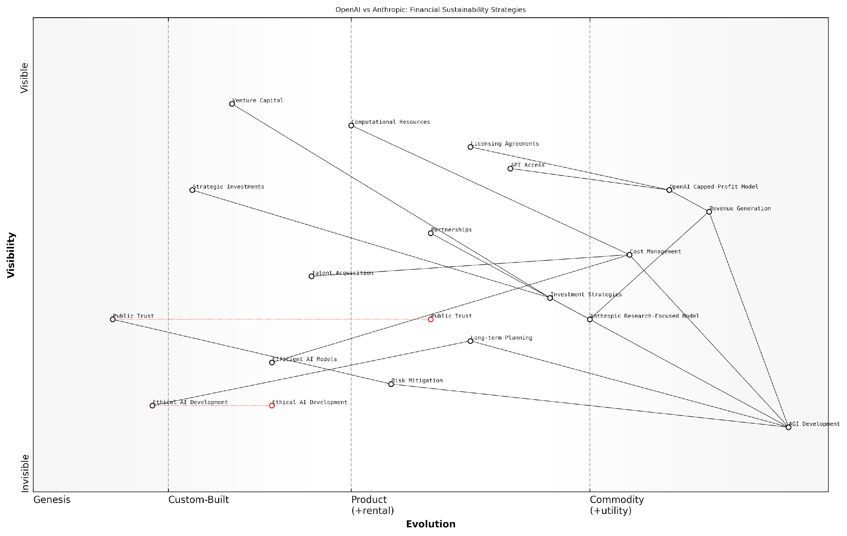

*Draft Wardley Map: [Insert Wardley Map: Financial sustainability in the AGI race]*

[Edit this draft Wardley Map](https://create.wardleymaps.ai/#clone:4e0f065798382e505c)

Wardley Map Assessment

The Wardley Map reveals a highly dynamic and competitive landscape in AGI development, with OpenAI and Anthropic employing distinct strategies for financial sustainability. The key to long-term success lies in balancing rapid technological advancement with ethical considerations and public trust, while maintaining financial viability through innovative revenue models and efficient resource management. The ability to navigate the evolving regulatory landscape, attract top talent, and secure stable funding will be crucial. Companies that can effectively manage these complex, interconnected factors while remaining adaptable to the fast-paced changes in the field will be best positioned to lead in the AGI race.

[View full Wardley Map report](http://markdown_wardley_map_reports/wardley_map_report_24_Financial_sustainability_in_the_AGI_race.md)

In conclusion, the financial sustainability strategies of OpenAI and Anthropic reflect their distinct approaches to AGI development. OpenAI’s hybrid model and diversified revenue streams provide a robust financial foundation but may introduce competing priorities. Anthropic’s focused, research-driven approach offers greater alignment with its ethical principles but faces challenges in long-term funding stability. As the AGI race progresses, the ability of each company to maintain financial sustainability while advancing towards their technological goals will be crucial in determining the ultimate victor.

# Ethical Approaches and Safety Considerations

## OpenAI’s Ethical Framework

### Commitment to beneficial AGI

In the high-stakes race towards Artificial General Intelligence (AGI), OpenAI’s ethical framework, particularly its commitment to beneficial AGI, stands as a cornerstone of its approach. This commitment is not merely a lofty ideal but a practical necessity in navigating the complex landscape of AGI development. As we delve into OpenAI’s ethical stance, it becomes clear that their framework is designed to address the profound implications of AGI on humanity’s future.

OpenAI’s commitment to beneficial AGI is rooted in three key principles: safety, broad benefit, and ethical development. These principles form the foundation of their approach and inform every aspect of their research and development process.

* Safety: Ensuring that AGI systems are safe and controllable
* Broad Benefit: Developing AGI that benefits all of humanity
* Ethical Development: Adhering to ethical principles throughout the development process

Safety as a Paramount Concern

OpenAI’s approach to safety in AGI development is multifaceted and rigorous. They recognise that as AI systems become more powerful, the potential risks associated with their deployment increase exponentially. To address this, OpenAI has implemented a comprehensive safety framework that encompasses technical, operational, and governance measures.

On the technical front, OpenAI is pioneering advanced safety techniques such as reward modelling, inverse reinforcement learning, and scalable oversight. These methods aim to ensure that AGI systems behave in alignment with human values and intentions, even as they surpass human-level intelligence in various domains.

Our goal is to create AGI systems that are not just powerful, but also safe and controllable. We believe that safety should be built into the core of AGI, not added as an afterthought.

Operationally, OpenAI has implemented stringent protocols for testing and deploying AI systems. This includes extensive simulations, red-teaming exercises, and gradual rollouts with constant monitoring. These measures are designed to identify and mitigate potential risks before they can manifest in real-world applications.

Broad Benefit: AGI for All of Humanity

OpenAI’s commitment to broad benefit is a direct response to concerns about the potential concentration of power that AGI could bring. Their approach is rooted in the belief that AGI should be developed in a way that distributes its benefits as widely as possible, rather than accruing to a select few individuals or organisations.

To achieve this, OpenAI has adopted several strategies:

* Open research: Publishing a significant portion of their research findings to foster collaboration and accelerate global progress in AI safety and ethics.
* Collaborative partnerships: Engaging with a diverse range of stakeholders, including governments, academic institutions, and civil society organisations, to ensure a broad perspective on AGI development.
* Democratising access: Developing tools and platforms that make AI capabilities more accessible to a wider range of users, from individual researchers to small businesses.

These strategies are designed to prevent the monopolisation of AGI technology and ensure that its development serves the collective interests of humanity.

Ethical Development: Principles in Practice

OpenAI’s commitment to ethical development goes beyond mere rhetoric. It is embedded in their organisational structure, decision-making processes, and research methodologies. This commitment is reflected in several key practices:

* Ethical review boards: All major research projects and deployment decisions are subject to review by an independent ethics committee.
* Transparency initiatives: Regular publication of progress reports, ethical guidelines, and decision-making frameworks.
* Stakeholder engagement: Active solicitation of feedback from diverse groups, including ethicists, policymakers, and potentially affected communities.
* Long-term impact assessment: Consideration of the long-term implications of AGI development on society, economy, and human values.

These practices ensure that ethical considerations are not an afterthought but are integrated into every stage of AGI development at OpenAI.

We believe that the path to beneficial AGI is through ethical development practices that prioritise safety, transparency, and broad societal benefit. Our commitment to these principles is unwavering, even as we push the boundaries of AI capabilities.

Challenges and Criticisms

Despite OpenAI’s strong commitment to beneficial AGI, their approach is not without challenges and criticisms. Some experts argue that the very pursuit of AGI is inherently risky, regardless of ethical safeguards. Others question whether OpenAI’s transition from a non-profit to a ‘capped-profit’ model might compromise their ethical stance in the face of commercial pressures.

OpenAI has responded to these concerns by doubling down on their commitment to transparency and ethical governance. They argue that their model allows them to attract the necessary talent and resources to ensure safe AGI development, while still maintaining their core ethical principles.

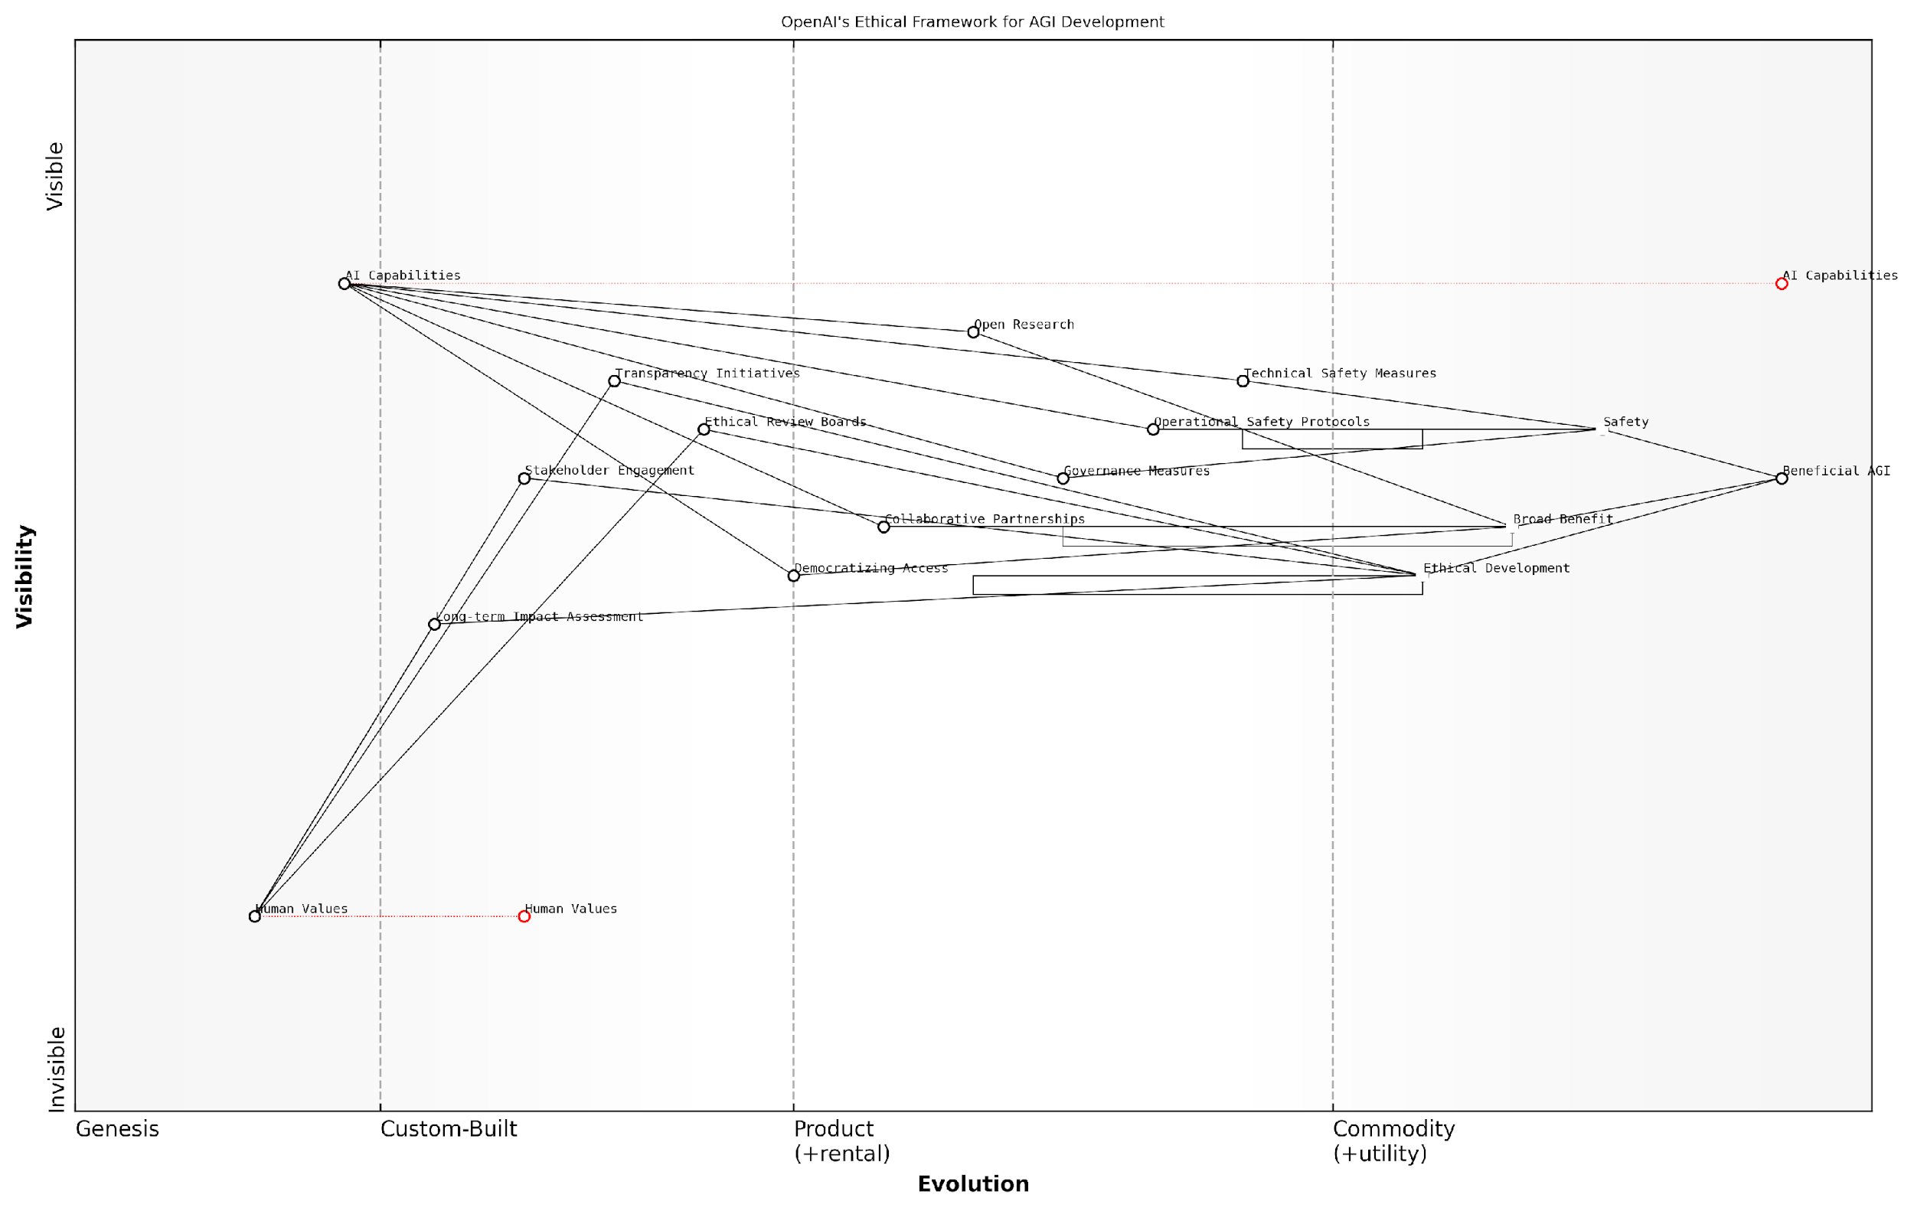

*Draft Wardley Map: [Insert Wardley Map: Commitment to beneficial AGI]*

[Edit this draft Wardley Map](https://create.wardleymaps.ai/#clone:6e5bea100af8742c10)

Wardley Map Assessment

OpenAI’s ethical framework for AGI development, as represented in this Wardley Map, demonstrates a comprehensive and balanced approach to creating beneficial AGI. The strategic positioning emphasises safety, broad benefit, and ethical considerations alongside technological advancement. This approach positions OpenAI as a responsible leader in the AGI race, potentially setting industry standards. However, the rapid evolution of AI capabilities presents ongoing challenges in aligning technological progress with ethical considerations and human values. The key to success lies in maintaining this balance while accelerating the development of robust governance, safety measures, and impact assessment methodologies. OpenAI’s strategy of open research and collaborative partnerships could be leveraged to address these challenges collectively, potentially reshaping the competitive landscape into a more collaborative ecosystem focused on beneficial AGI development.

[View full Wardley Map report](http://markdown_wardley_map_reports/wardley_map_report_25_Commitment_to_beneficial_AGI.md)

Conclusion: A Model for Ethical AGI Development?

OpenAI’s commitment to beneficial AGI represents a comprehensive attempt to address the ethical challenges of AGI development. Their approach, balancing safety, broad benefit, and ethical development, offers a potential model for responsible AGI research. However, as the race towards AGI intensifies, the robustness and efficacy of this ethical framework will be put to the test.

As we continue to explore the AGI race between OpenAI and Anthropic, it is clear that ethical considerations will play a crucial role in determining not just who might win, but what that victory might mean for humanity. OpenAI’s ethical framework, with its focus on beneficial AGI, sets a high standard in this regard, one that will undoubtedly influence the broader field of AGI development in the years to come.

### Transparency and research sharing

In the high-stakes race for Artificial General Intelligence (AGI), OpenAI’s commitment to transparency and research sharing stands as a cornerstone of their ethical framework. This approach not only aligns with their mission to ensure that AGI benefits all of humanity but also serves as a critical differentiator in their competition with Anthropic. As we delve into this crucial aspect of OpenAI’s strategy, we must consider its implications for the broader AGI landscape and its potential to shape the future of AI development.

OpenAI’s transparency initiative can be broadly categorised into three key areas: open publication of research findings, collaborative partnerships, and the development of open-source tools. Each of these elements plays a vital role in advancing the field of AI while simultaneously addressing ethical concerns and fostering public trust.

Open Publication of Research Findings:

* Regular release of technical papers detailing breakthrough algorithms and methodologies
* Comprehensive documentation of experimental results, including both successes and failures
* Timely disclosure of potential risks and limitations associated with new AI technologies

This commitment to open publication serves multiple purposes. Firstly, it accelerates the pace of AI research by allowing the global scientific community to build upon OpenAI’s findings. Secondly, it enables external scrutiny and validation of their work, enhancing the robustness and reliability of their technologies. Lastly, it fosters a culture of openness that is crucial for maintaining public trust in the development of AGI.

OpenAI’s approach to transparency is not just about sharing results; it’s about inviting the world to participate in the journey towards AGI. This level of openness is unprecedented in an industry often shrouded in secrecy.

Collaborative Partnerships:

* Strategic alliances with academic institutions and research organisations
* Joint research initiatives with other AI companies and tech giants
* Engagement with policymakers and regulatory bodies to shape AI governance frameworks

These partnerships extend OpenAI’s reach and influence, allowing them to tap into diverse pools of expertise and resources. By fostering a collaborative ecosystem, OpenAI not only enhances its own capabilities but also contributes to the democratisation of AI knowledge and tools. This approach stands in stark contrast to more closed, proprietary models of AI development, potentially giving OpenAI an edge in the race for AGI by harnessing collective intelligence.

Development of Open-Source Tools:

* Release of powerful AI libraries and frameworks for public use
* Creation of standardised benchmarks and evaluation metrics for AI systems
* Provision of accessible platforms for AI experimentation and learning

By making advanced AI tools freely available, OpenAI empowers researchers, developers, and enthusiasts worldwide to contribute to the field. This not only accelerates innovation but also helps to identify and address potential issues or biases in AI systems before they become entrenched. Moreover, it creates a vast talent pool familiar with OpenAI’s technologies, potentially giving them a recruitment advantage in the competitive AI labour market.

The open-source approach adopted by OpenAI is akin to planting seeds of innovation across the global AI community. It’s a bold strategy that could yield exponential returns in the race towards AGI.

However, OpenAI’s commitment to transparency and research sharing is not without its challenges and potential drawbacks:

* Balancing openness with the need to protect sensitive or potentially dangerous information
* Managing the risk of adversarial use of published research or tools
* Navigating the complexities of intellectual property rights in collaborative projects
* Maintaining a competitive edge while sharing valuable insights and technologies

These challenges necessitate a nuanced approach to transparency, one that OpenAI continues to refine as they progress in their AGI pursuits. The company has implemented safeguards such as staged releases of powerful models and careful vetting of research publications to mitigate potential risks.

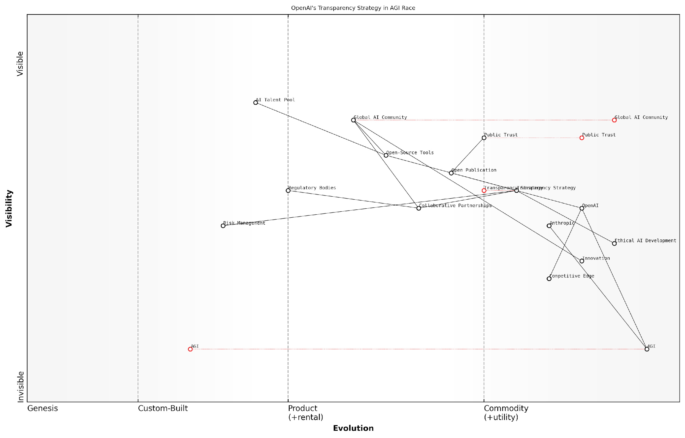

*Draft Wardley Map: [Insert Wardley Map: Transparency and research sharing]*

[Edit this draft Wardley Map](https://create.wardleymaps.ai/#clone:a24317a8529dc5798c)

Wardley Map Assessment

OpenAI’s transparency strategy positions it uniquely in the AGI race, leveraging openness to build trust, foster collaboration, and drive ethical AI development. While this approach offers significant advantages in public perception and global community engagement, it also presents challenges in maintaining a competitive edge and managing risks. The key to success will be in effectively balancing transparency with strategic interests, continually evolving the approach as AGI development progresses, and taking a leadership role in shaping global AI governance and ethics frameworks. OpenAI’s strategy has the potential to significantly influence the direction of AGI development, but will require careful navigation of the complex interplay between innovation, ethics, and public trust.

[View full Wardley Map report](http://markdown_wardley_map_reports/wardley_map_report_26_Transparency_and_research_sharing.md)

In the context of the AGI race with Anthropic, OpenAI’s transparency and research sharing approach offers several strategic advantages:

* Rapid iteration and improvement through community feedback and contributions
* Enhanced public trust and support, potentially influencing regulatory decisions in their favour
* A larger pool of talent familiar with their technologies, facilitating recruitment and collaboration
* The potential to set industry standards and shape the direction of AGI development

However, this openness also presents risks, such as competitors like Anthropic potentially benefiting from OpenAI’s published research. The ultimate success of this strategy in the AGI race will depend on OpenAI’s ability to leverage the collective intelligence of the global AI community while maintaining their innovative edge.

In the high-stakes game of AGI development, OpenAI’s transparency strategy is a double-edged sword. It has the potential to accelerate progress dramatically, but also requires careful management to prevent competitors from closing the gap too quickly.

As we look to the future, the impact of OpenAI’s commitment to transparency and research sharing on the AGI landscape cannot be overstated. It sets a precedent for ethical AI development, fosters global collaboration, and could potentially lead to a more equitable distribution of the benefits of AGI. However, as the race intensifies, OpenAI may face increasing pressure to balance their open approach with the need to maintain a competitive advantage.

In conclusion, OpenAI’s transparency and research sharing initiatives represent a bold and potentially game-changing approach in the AGI race. By fostering a collaborative global ecosystem, they are not just developing AGI, but shaping the very nature of how such transformative technologies are created and deployed. As we continue to monitor the competition between OpenAI and Anthropic, this commitment to openness will undoubtedly remain a critical factor in determining the ultimate victor in the AGI race.

### Safety measures and control mechanisms

In the high-stakes race towards Artificial General Intelligence (AGI), OpenAI’s commitment to safety measures and control mechanisms stands as a critical pillar of their ethical framework. As we delve into this crucial aspect of OpenAI’s approach, it becomes evident that these safeguards are not merely ancillary considerations but fundamental components that shape the very fabric of their AGI development process.

OpenAI’s safety measures and control mechanisms can be broadly categorised into three key areas: technical safeguards, governance structures, and transparency initiatives. Each of these plays a vital role in ensuring that the development of AGI remains aligned with human values and interests.

Technical Safeguards:

* Robust AI alignment techniques to ensure AGI systems behave in accordance with human intentions
* Extensive testing and validation protocols to identify and mitigate potential risks
* Implementation of ‘fail-safe’ mechanisms designed to shut down or constrain AGI systems if they begin to operate outside of predetermined parameters
* Continuous monitoring and real-time adjustment capabilities to maintain control over AGI systems as they evolve

OpenAI’s technical safeguards are not static; they evolve in tandem with the capabilities of their AI systems. This dynamic approach to safety is crucial in the rapidly advancing field of AGI, where today’s safeguards may be insufficient for tomorrow’s breakthroughs.

As a senior AI safety researcher at a leading tech firm noted, ‘OpenAI’s commitment to evolving their safety measures in lockstep with their AGI capabilities sets a gold standard for responsible AI development.’

Governance Structures:

* A multi-stakeholder oversight board that includes experts from diverse fields such as ethics, policy, and technology
* Clear decision-making protocols for high-stakes AGI development milestones
* Regular external audits of safety practices and control mechanisms
* Collaboration with government agencies and international bodies to align with emerging AGI governance frameworks

The governance structures implemented by OpenAI serve as a crucial check and balance system, ensuring that the pursuit of AGI is not driven solely by technical achievements but is tempered by ethical considerations and societal impact assessments.

Transparency Initiatives:

* Regular publication of research findings and safety protocols
* Open dialogue with the scientific community and public on AGI development progress
* Commitment to responsible disclosure of potential risks and challenges
* Educational outreach to increase public understanding of AGI and associated safety considerations

OpenAI’s transparency initiatives play a dual role: they foster trust within the broader community and also invite external scrutiny, which can lead to the identification and addressing of potential blind spots in their safety approach.

A prominent ethicist in the field of AI remarked, ‘OpenAI’s transparency is not just about sharing successes; it’s about openly discussing challenges and inviting collaborative problem-solving. This approach is essential for building public trust in AGI development.’

While these safety measures and control mechanisms are robust, they are not without challenges. The rapid pace of AGI development often outstrips the ability to fully understand and mitigate all potential risks. Moreover, the global nature of AI research means that OpenAI’s safety standards must be considered in an international context, where different cultural and ethical norms may apply.

One of the most significant challenges lies in balancing safety with innovation. Overly restrictive safety measures could potentially hamper progress, while insufficient safeguards could lead to catastrophic outcomes. OpenAI’s approach attempts to strike this delicate balance through adaptive safety protocols that evolve with their AGI capabilities.

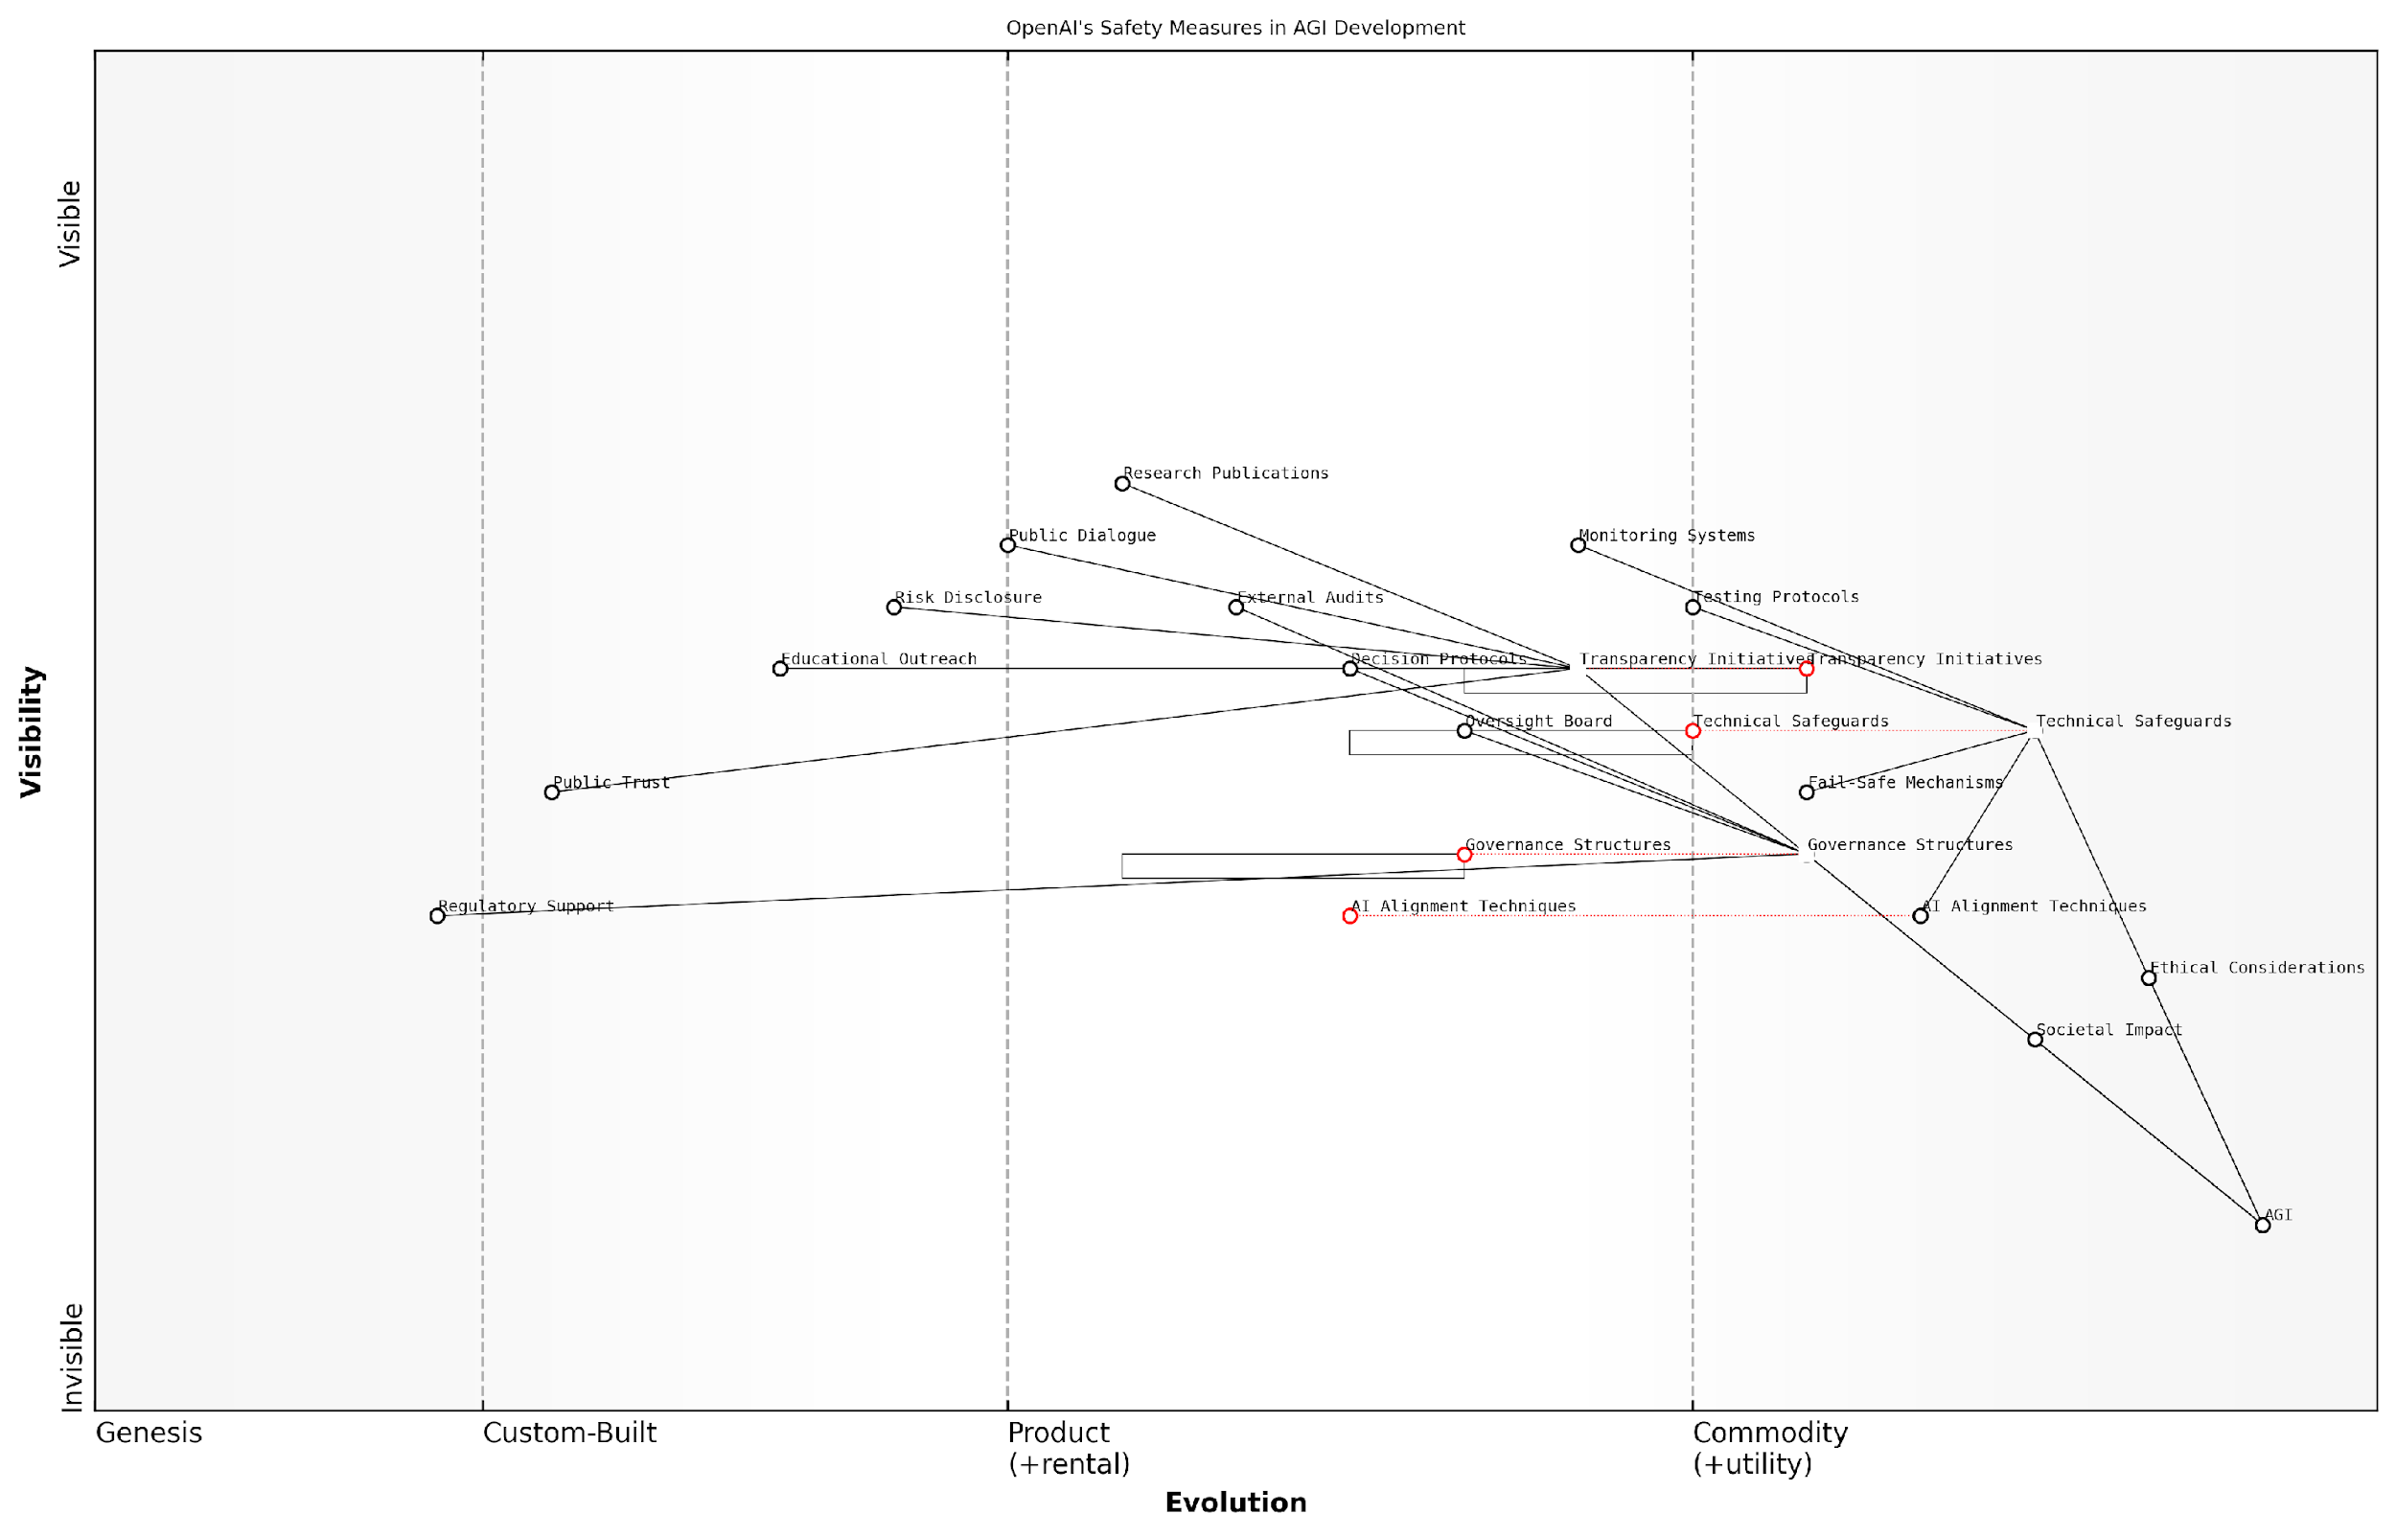

*Draft Wardley Map: [Insert Wardley Map: Safety measures and control mechanisms]*

[Edit this draft Wardley Map](https://create.wardleymaps.ai/#clone:71def00c3a88cd344d)

Wardley Map Assessment

OpenAI is well-positioned in the critical areas of technical safeguards and governance for AGI development. However, the company faces challenges in building public trust and navigating an evolving regulatory landscape. By leveraging its strengths in transparency and technical innovation, OpenAI has the opportunity to lead the industry in responsible AGI development. Key focus areas should include advancing AI alignment techniques, strengthening governance structures, and proactively shaping public perception and regulatory frameworks. Success will require a delicate balance between rapid innovation and responsible, transparent practices.

[View full Wardley Map report](http://markdown_wardley_map_reports/wardley_map_report_27_Safety_measures_and_control_mechanisms.md)

In the context of the AGI race between OpenAI and Anthropic, these safety measures and control mechanisms serve as a critical differentiator. While both organisations prioritise safety, OpenAI’s approach is characterised by its emphasis on scalable safety solutions that can keep pace with rapidly advancing AGI capabilities.

The effectiveness of OpenAI’s safety measures will likely play a crucial role in determining the outcome of the AGI race. A safer, more controlled AGI development process may garner greater public and regulatory support, potentially accelerating OpenAI’s progress towards AGI. Conversely, any perceived lapses in safety could significantly set back their efforts.

As we look towards the future of AGI development, it is clear that safety measures and control mechanisms will continue to be a central focus. OpenAI’s approach in this area not only shapes their own path towards AGI but also sets benchmarks for the entire field. The ultimate success of these measures will be judged not just by their ability to prevent catastrophic outcomes, but by their capacity to ensure that AGI, when achieved, truly benefits humanity as a whole.

As a leading figure in AI policy aptly put it, ‘The race to AGI is not just about who gets there first, but who gets there safely. OpenAI’s commitment to robust safety measures may well be the key to winning this race responsibly.’

## Anthropic’s Ethics-First Approach

### Constitutional AI principles

In the high-stakes race towards Artificial General Intelligence (AGI), Anthropic’s ethics-first approach, centred around Constitutional AI principles, stands as a beacon of responsible innovation. This subsection delves into the core tenets of Anthropic’s ethical framework, exploring how it shapes their development process and positions them uniquely in the AGI landscape.

Constitutional AI, as pioneered by Anthropic, represents a paradigm shift in the way artificial intelligence systems are designed and trained. At its core, this approach aims to instil fundamental principles and values into AI systems from the ground up, ensuring that they operate within predefined ethical boundaries and align with human values. This methodology is not merely a superficial layer of ethical guidelines, but a deeply ingrained set of principles that form the very foundation of the AI’s decision-making processes.

* Alignment with human values
* Transparency and explainability
* Robustness and safety
* Fairness and non-discrimination
* Privacy protection
* Accountability and oversight

These principles are not just theoretical constructs but are actively implemented in Anthropic’s AI development process. By embedding these ethical considerations at the architectural level, Anthropic aims to create AI systems that are inherently safe, trustworthy, and beneficial to humanity.

Constitutional AI is not just about creating safe AI; it’s about creating AI that is fundamentally aligned with human values and interests. It’s a proactive approach to ensuring that as AI systems become more powerful, they remain beneficial and controllable.

One of the key aspects of Anthropic’s Constitutional AI is the concept of ‘value learning’. This involves developing AI systems that can infer and adopt human values through interaction and observation, rather than having these values hard-coded by developers. This approach allows for more flexible and nuanced ethical behaviour, adapting to complex real-world scenarios whilst maintaining core ethical principles.

Anthropic’s commitment to transparency is another crucial element of their Constitutional AI framework. By making their research and methodologies open to scrutiny, they not only contribute to the broader scientific community but also build trust with the public and policymakers. This transparency is particularly crucial in the context of AGI development, where the potential impacts on society are profound and far-reaching.

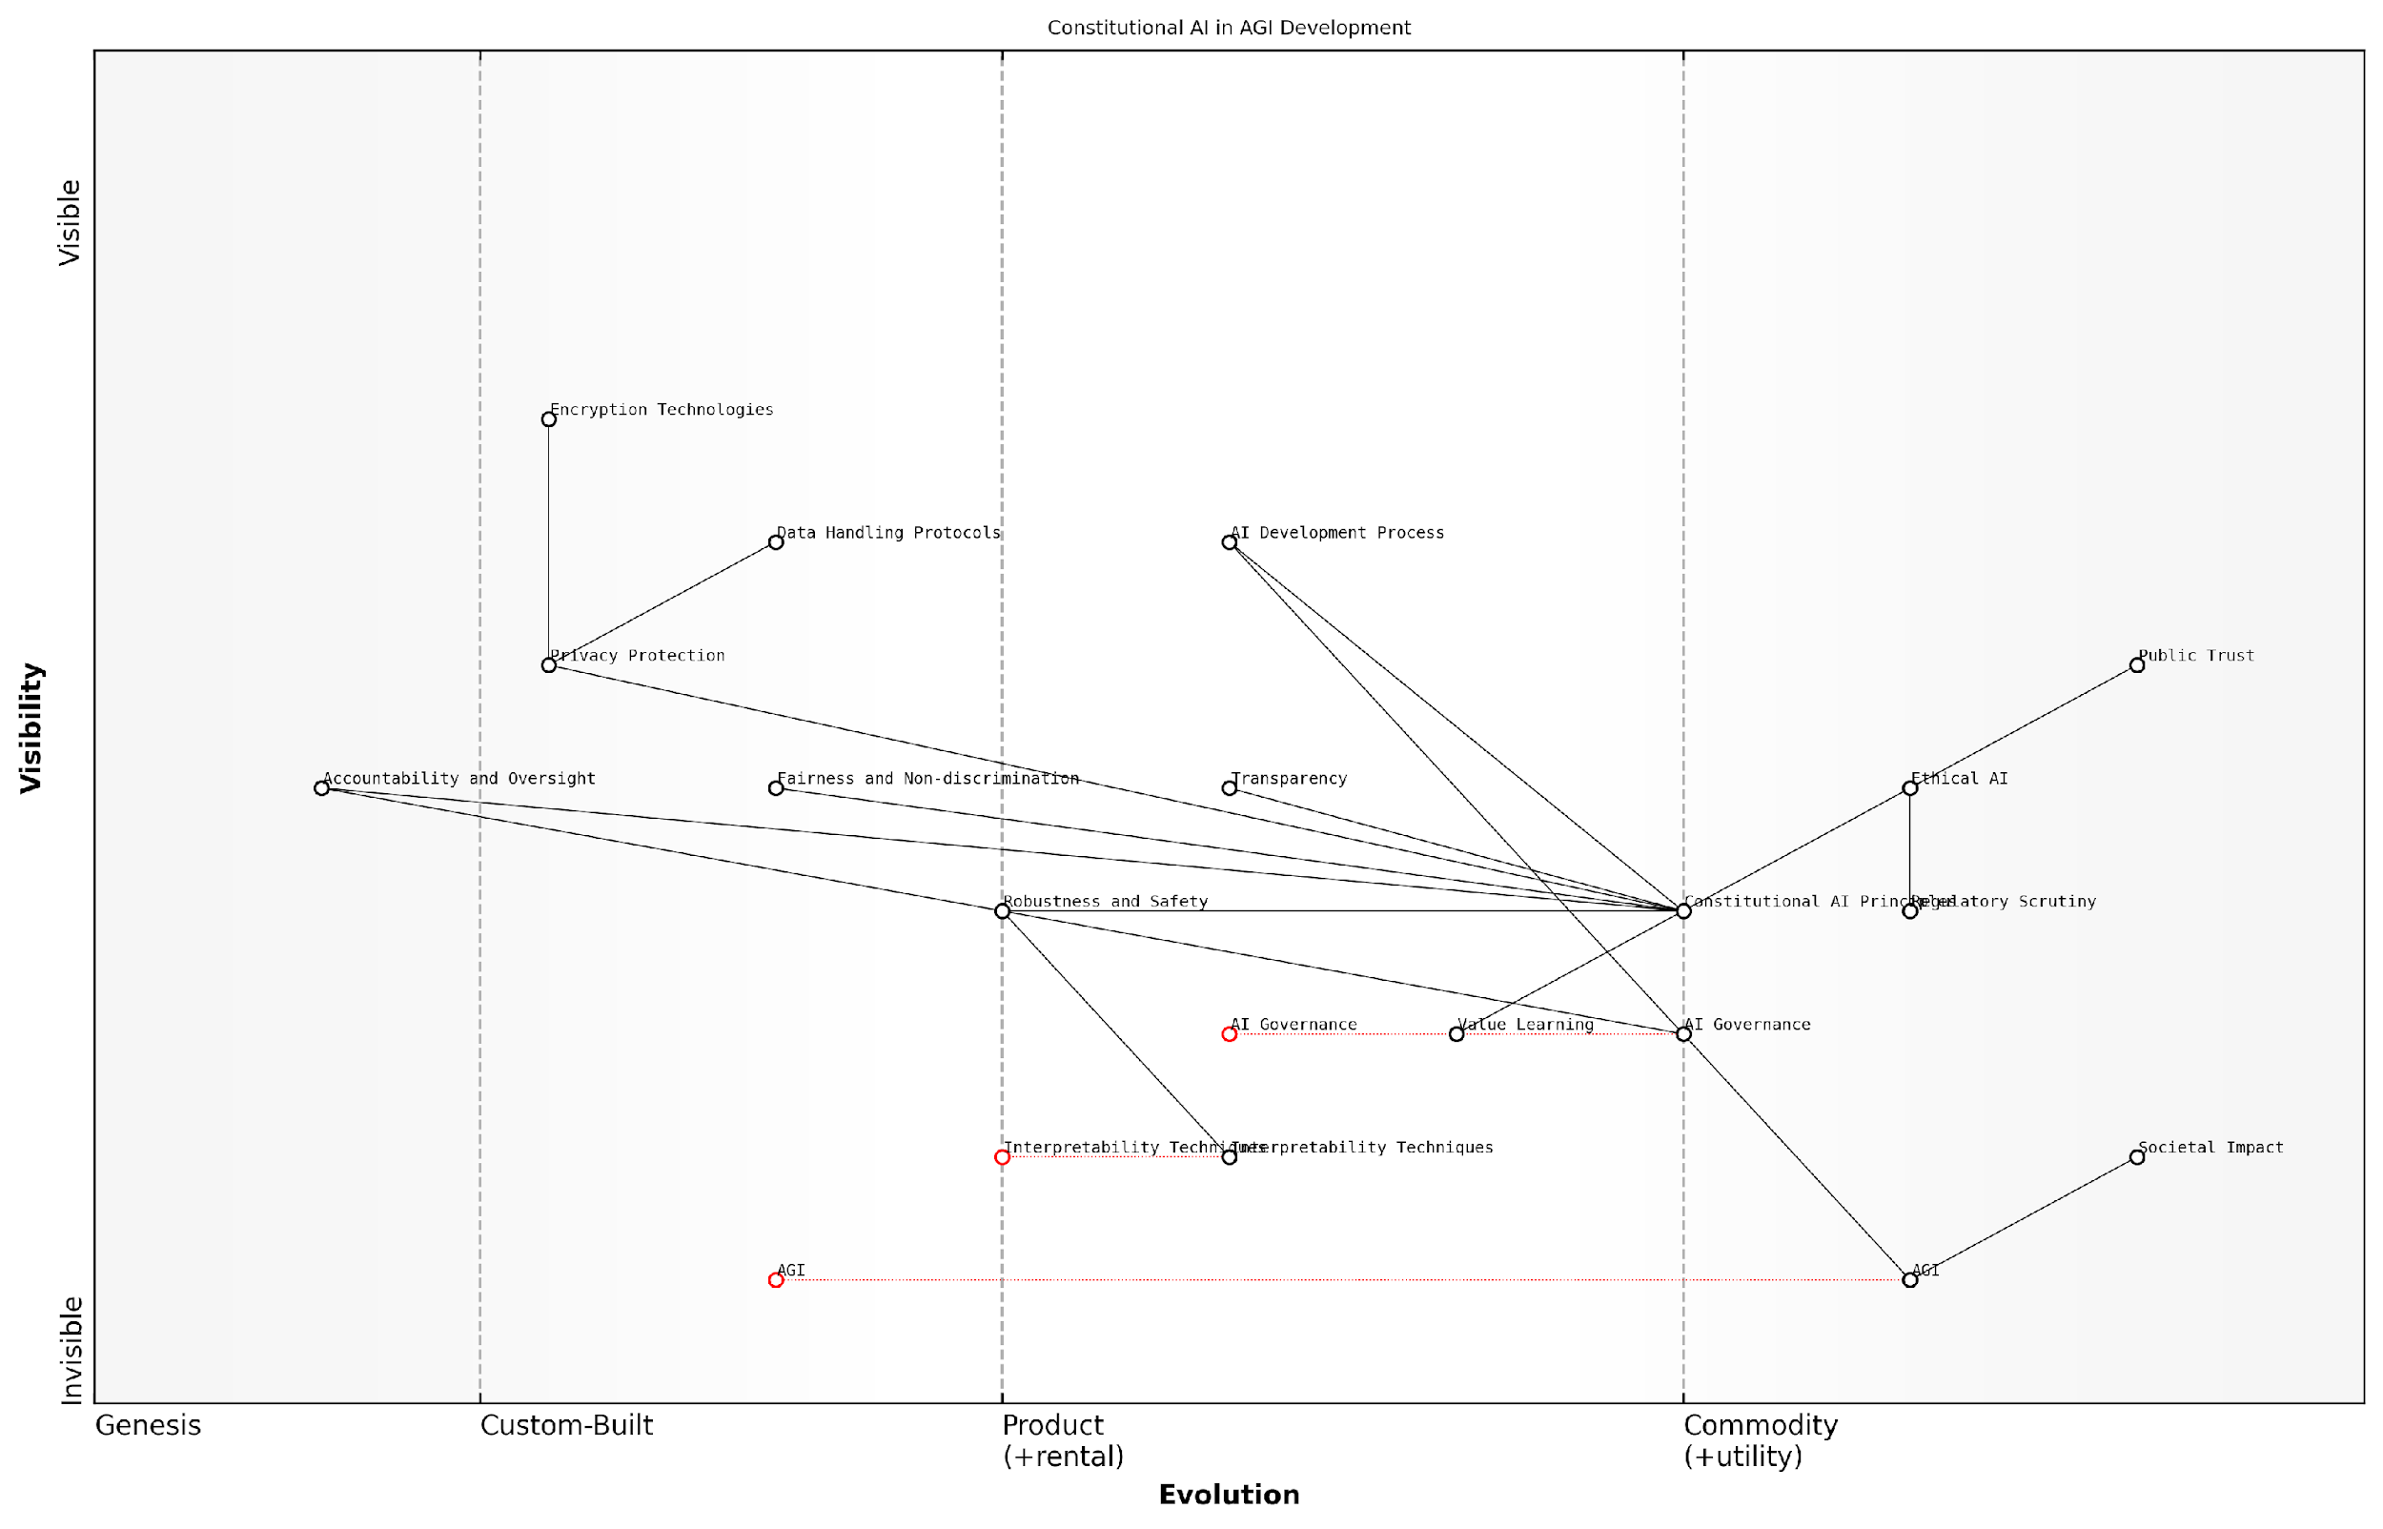

*Draft Wardley Map: [Insert Wardley Map: Constitutional AI principles]*

[Edit this draft Wardley Map](https://create.wardleymaps.ai/#clone:61d0b56844a40809d6)

Wardley Map Assessment

This Wardley Map depicts a strategic approach to AGI development that places ethical considerations and public trust at its core. By positioning Constitutional AI Principles as a central component, the organization is well-positioned to lead in responsible AGI development. However, the rapid evolution of AGI technology presents challenges in keeping ethical frameworks and public trust aligned with technological capabilities. The key to success lies in continuously evolving ethical practices, investing in interpretability and transparency, and maintaining a proactive stance in AI governance and public engagement. This approach not only mitigates risks but also creates a strong competitive advantage in an industry where public trust and ethical considerations are becoming increasingly critical.

[View full Wardley Map report](http://markdown_wardley_map_reports/wardley_map_report_28_Constitutional_AI_principles.md)

The robustness and safety aspects of Constitutional AI are particularly relevant in the race towards AGI. Anthropic’s approach includes rigorous testing and validation processes to ensure that their AI systems behave reliably and safely, even in unforeseen circumstances. This includes developing advanced interpretability techniques to understand the decision-making processes of complex AI models, a crucial step in ensuring their safety and reliability.

Fairness and non-discrimination are also central to Anthropic’s ethical framework. By incorporating these principles into the foundational architecture of their AI systems, Anthropic aims to mitigate the risk of perpetuating or exacerbating societal biases. This is particularly crucial as AI systems become more integrated into critical decision-making processes across various sectors.

The true test of an AI system’s ethics is not just in its ability to make the right decisions in controlled environments, but in its capacity to navigate the complex, often ambiguous ethical landscapes of the real world. Constitutional AI aims to create systems that can do just that.

Privacy protection is another key tenet of Anthropic’s Constitutional AI principles. As AI systems become more sophisticated and handle increasingly sensitive data, ensuring robust privacy safeguards becomes paramount. Anthropic’s approach includes developing advanced encryption and anonymisation techniques, as well as implementing strict data handling protocols.

The principle of accountability and oversight is particularly relevant in the context of AGI development. Anthropic’s framework includes mechanisms for ongoing monitoring and adjustment of AI systems, ensuring that they remain aligned with their intended purposes and ethical guidelines. This includes developing sophisticated AI governance structures and collaborating with external experts and stakeholders to provide independent oversight.

In the broader context of the AGI race, Anthropic’s Constitutional AI principles represent a distinctive approach that prioritises ethical considerations without compromising on technological advancement. This balanced approach could potentially give Anthropic a unique advantage, particularly as public and regulatory scrutiny of AI development intensifies.

However, the implementation of Constitutional AI principles is not without its challenges. Balancing ethical constraints with the pursuit of advanced AI capabilities requires careful navigation. There are also ongoing debates about the effectiveness and long-term viability of embedding ethical principles at the architectural level of AI systems.

Despite these challenges, Anthropic’s commitment to Constitutional AI principles positions them as a leader in responsible AGI development. As the race towards AGI intensifies, Anthropic’s ethics-first approach could prove to be a crucial differentiator, potentially influencing the broader trajectory of AI development and setting new standards for ethical AI practices across the industry.

In the end, the winner of the AGI race may not be determined solely by technological prowess, but by the ability to create systems that are not only powerful, but also trustworthy, ethical, and aligned with human values. Anthropic’s Constitutional AI principles represent a bold step in this direction.

### Alignment and value learning

In the high-stakes race towards Artificial General Intelligence (AGI), Anthropic’s ethics-first approach, particularly in the realm of alignment and value learning, stands as a cornerstone of their strategy. This subsection delves into the critical importance of ensuring that AGI systems not only possess immense capabilities but also align with human values and ethical principles. Anthropic’s commitment to this aspect of AGI development could prove to be a decisive factor in determining the winner of the AGI race, as it addresses one of the most fundamental challenges in creating safe and beneficial AGI.

Anthropic’s approach to alignment and value learning is rooted in their Constitutional AI principles, which aim to create AI systems that are inherently aligned with human values from the ground up. This methodology represents a significant departure from traditional AI development practices and reflects a deep understanding of the potential risks associated with misaligned AGI.

Constitutional AI is not just a safety feature; it’s a fundamental reimagining of how we approach AI development. By baking in ethical considerations from the start, we’re creating AI systems that are more likely to benefit humanity in the long run.

The core components of Anthropic’s alignment and value learning approach include:

* Iterative refinement of AI behaviour through human feedback
* Incorporation of ethical principles into the training process
* Development of robust value learning algorithms
* Continuous monitoring and adjustment of AI decision-making processes

One of the key innovations in Anthropic’s approach is their focus on developing AI systems that can learn and internalise human values over time. This is achieved through sophisticated machine learning techniques that allow the AI to observe human behaviour, receive feedback, and gradually align its decision-making processes with human ethical standards.

The practical implications of this approach are far-reaching. For instance, in a government context, an AGI system developed using Anthropic’s methods could be entrusted with complex policy decisions, confident that it would consider not just efficiency and effectiveness, but also fairness, equity, and long-term societal well-being.

The potential of aligned AGI in public sector decision-making is immense. Imagine AI systems that can process vast amounts of data to inform policy, while always keeping the public good at the forefront of their calculations.

However, Anthropic’s approach is not without challenges. The complexity of human values and the difficulty in codifying ethical principles present significant hurdles. Moreover, there are concerns about whose values the AI should align with, given the diversity of ethical frameworks across cultures and individuals.

To address these challenges, Anthropic has implemented a multi-faceted strategy:

* Collaboration with ethicists, philosophers, and social scientists to refine their understanding of human values
* Development of diverse training datasets that represent a wide range of cultural and ethical perspectives
* Implementation of transparency measures to allow for public scrutiny of their alignment methods
* Ongoing research into meta-ethical frameworks that can guide AI decision-making in novel situations

The success of Anthropic’s alignment and value learning approach could have profound implications for the AGI race. If they can demonstrate a reliable method for creating AGI systems that are inherently aligned with human values, it could give them a significant advantage over competitors like OpenAI, particularly in terms of public trust and regulatory approval.

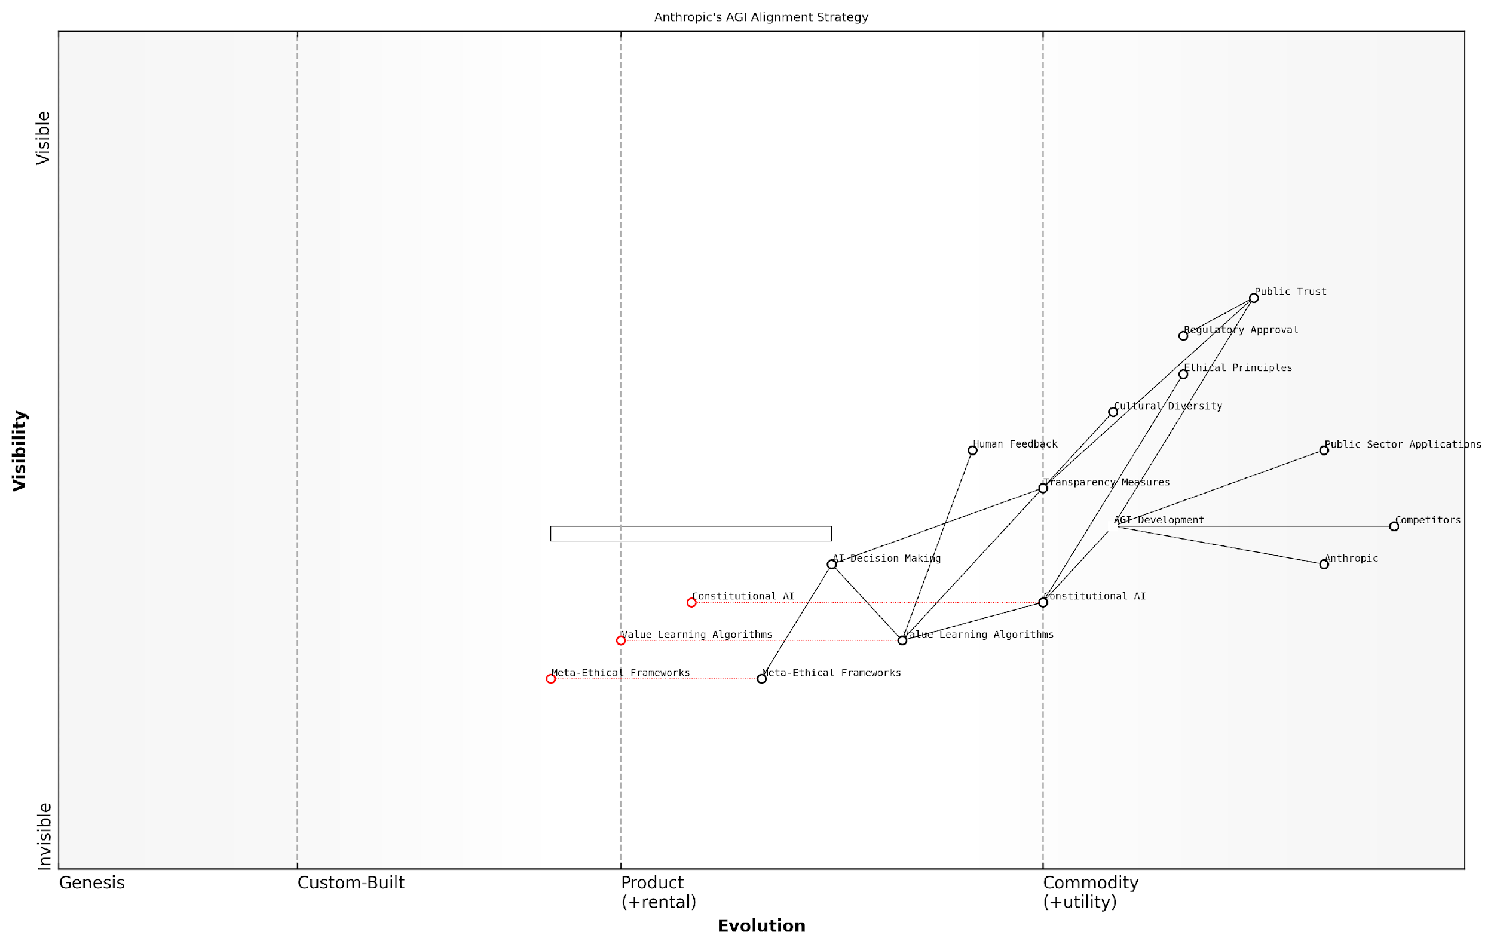

*Draft Wardley Map: [Insert Wardley Map: Alignment and value learning]*

[Edit this draft Wardley Map](https://create.wardleymaps.ai/#clone:2d9023fb37a8b277b4)

Wardley Map Assessment

Anthropic’s AGI Alignment Strategy, as represented in this Wardley Map, showcases a strong commitment to ethical AI development with a focus on Constitutional AI and value learning. The strategy positions Anthropic uniquely in the AGI race, emphasising public trust and regulatory compliance. However, the rapid evolution of key components presents both opportunities and risks. To maintain its competitive edge, Anthropic should focus on accelerating the development of transparency measures, enhancing cultural diversity integration, and investing in meta-ethical frameworks. The company’s ethics-first approach could set industry standards, but it must balance this with the pace of AGI development to remain competitive. Overall, the strategy appears robust but will require careful execution and continuous adaptation to navigate the complex landscape of AGI development and public acceptance.

[View full Wardley Map report](http://markdown_wardley_map_reports/wardley_map_report_29_Alignment_and_value_learning.md)

In the context of government and public sector applications, Anthropic’s approach offers several key benefits:

* Enhanced public trust in AI-driven decision-making processes
* Reduced risk of unintended negative consequences from AGI deployment
* Improved alignment between AI systems and public sector values and goals
* Greater potential for long-term stability and sustainability in AI governance

However, it’s important to note that Anthropic’s focus on alignment and value learning may come at the cost of development speed. The iterative and cautious nature of their approach could potentially slow down their progress towards AGI compared to competitors who may be taking a more aggressive stance.

In the race to AGI, it’s not just about who gets there first, but who gets there safely. Anthropic’s approach may seem slower, but it’s laying the groundwork for AGI that we can trust with the future of humanity.

As we look towards the future of the AGI race, Anthropic’s commitment to alignment and value learning positions them as a strong contender, particularly in scenarios where public trust and ethical considerations play a crucial role in AGI adoption. Their approach may prove to be the key to creating AGI that not only matches or exceeds human intelligence but does so in a way that is fundamentally aligned with our collective best interests.

In conclusion, while the outcome of the AGI race remains uncertain, Anthropic’s focus on alignment and value learning represents a critical differentiator in their approach. As the development of AGI continues to accelerate, the importance of these ethical considerations is likely to become increasingly apparent, potentially tipping the scales in favour of companies that have prioritised these aspects from the outset.

### Long-term safety considerations

In the high-stakes race towards Artificial General Intelligence (AGI), Anthropic’s long-term safety considerations stand out as a cornerstone of their ethics-first approach. This subsection delves into the intricate web of safety measures, philosophical underpinnings, and practical implementations that Anthropic employs to ensure the development of AGI aligns with human values and interests over extended time horizons.

Anthropic’s commitment to long-term safety is rooted in the recognition that AGI, once achieved, could have profound and irreversible impacts on human civilisation. Their approach is characterised by a deep sense of responsibility and a proactive stance towards mitigating existential risks associated with advanced AI systems.

The challenge of AGI safety is not just about preventing immediate harm, but about ensuring the beneficial trajectory of superintelligent systems over centuries or even millennia.

To address this monumental challenge, Anthropic has developed a multi-faceted strategy that encompasses several key areas:

* Robust AI Alignment Techniques
* Scalable Oversight Mechanisms
* Value Learning and Preservation
* Fail-safe Systems and Containment Protocols
* Long-term Governance Structures

Robust AI Alignment Techniques: At the heart of Anthropic’s long-term safety considerations is their pioneering work in AI alignment. The company has invested heavily in developing and refining techniques to ensure that AGI systems remain aligned with human values as they grow in capability and autonomy. This includes advanced reward modelling, inverse reinforcement learning, and novel approaches to preference learning that aim to capture the nuanced and sometimes conflicting nature of human values.

One of Anthropic’s key innovations in this area is their work on ‘amplification’ techniques, which aim to leverage AI systems to assist in the alignment process itself. This recursive approach to alignment could potentially allow for the creation of AGI systems that are not only aligned at inception but remain so as they evolve and self-improve.

Scalable Oversight Mechanisms: Recognising that human oversight may become increasingly challenging as AI systems grow in complexity, Anthropic is developing scalable oversight mechanisms. These include automated monitoring systems, interpretability tools, and AI-assisted auditing processes that can keep pace with rapidly evolving AGI capabilities.

The key to long-term AGI safety lies in creating oversight systems that can scale with the intelligence and capability of the AI itself.

Value Learning and Preservation: Anthropic’s approach to long-term safety places significant emphasis on the challenge of value learning and preservation. This involves not only accurately capturing human values but ensuring that these values are preserved and correctly interpreted by AGI systems over extended periods, even as societal values evolve.

The company is exploring innovative approaches such as ‘value extrapolation’ and ‘moral uncertainty’ frameworks, which aim to create AGI systems that can reason about ethics and values in a way that is robust to changing circumstances and new moral discoveries.

Fail-safe Systems and Containment Protocols: While Anthropic is optimistic about the potential of AGI, they are also pragmatic about the need for fail-safe measures. The company is investing in research on AI containment, including the development of sophisticated ‘boxing’ techniques that could limit the potential damage of a misaligned AGI system.

These containment protocols are designed with long-term scenarios in mind, considering potential vulnerabilities that might only emerge after extended periods of AGI operation. This includes research into AI treachery, where a system might appear aligned for an extended period before revealing misaligned goals.

Long-term Governance Structures: Anthropic recognises that the challenge of AGI safety extends beyond technical solutions and into the realm of governance and policy. The company is actively engaged in developing proposals for long-term governance structures that could provide ongoing oversight and direction for AGI development and deployment.

These governance models are designed to be resilient to changes in leadership, societal shifts, and even potential disruptions to human civilisation. They incorporate elements of distributed decision-making, AI-assisted policy formulation, and mechanisms for global cooperation on AGI safety.

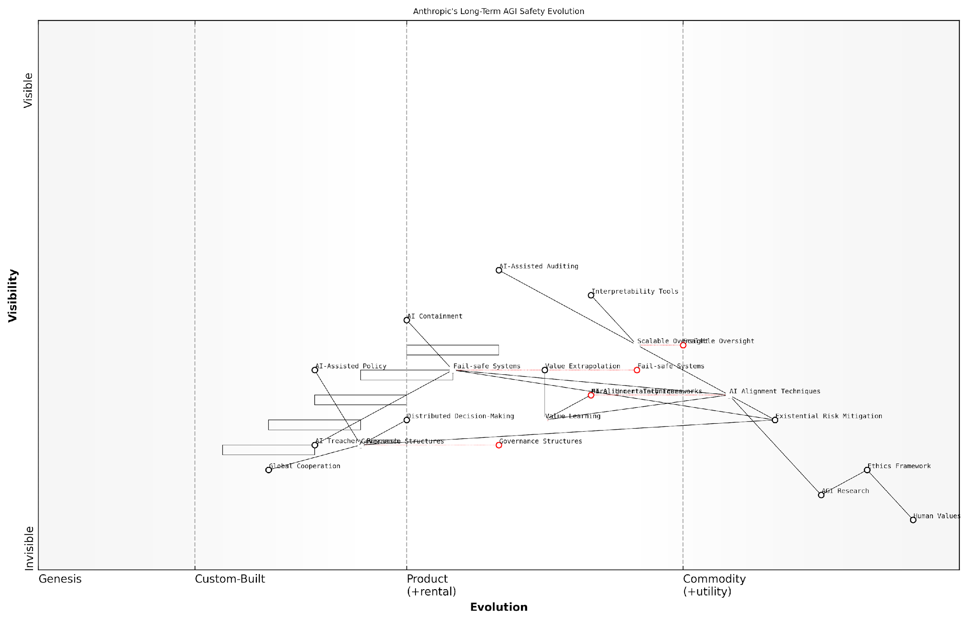

*Draft Wardley Map: [Insert Wardley Map: Long-term safety considerations]*

[Edit this draft Wardley Map](https://create.wardleymaps.ai/#clone:41037967a91e7ad7c7)

Wardley Map Assessment

Anthropic’s approach to long-term AGI safety, as represented in this Wardley Map, demonstrates a comprehensive and forward-thinking strategy. The company is well-positioned at the forefront of ethical AGI development, with a strong foundation in research and alignment techniques. However, to fully realise its vision of safe AGI, Anthropic must address key challenges in governance, value learning, and global cooperation. By leveraging its strengths in technical innovation and ethical considerations, while actively working to close gaps in governance and societal integration, Anthropic has the potential to significantly influence the trajectory of AGI development towards a safer and more beneficial future for humanity. The company’s success will largely depend on its ability to balance rapid technical progress with the development of robust safety measures and governance frameworks, all while navigating the complex global landscape of AGI research and policy.

[View full Wardley Map report](http://markdown_wardley_map_reports/wardley_map_report_30_Long-term_safety_considerations.md)

Anthropic’s long-term safety considerations represent a holistic and forward-thinking approach to the challenge of AGI development. By addressing technical, ethical, and governance challenges with a view towards extended time horizons, the company is positioning itself as a leader in responsible AGI development.

However, the effectiveness of these measures in ensuring the long-term safety of AGI remains a topic of intense debate within the AI ethics community. Critics argue that the unpredictable nature of AGI development makes long-term planning inherently challenging, while supporters contend that Anthropic’s proactive approach is essential for mitigating existential risks.

The true test of Anthropic’s long-term safety considerations will come not in years, but in decades or centuries. Our responsibility is to lay the groundwork for a future where AGI remains a force for good, long after its creators are gone.

As the race for AGI supremacy intensifies, Anthropic’s commitment to long-term safety considerations may prove to be a decisive factor in shaping the future trajectory of artificial intelligence. Whether these measures will be sufficient to ensure the beneficial development of AGI remains to be seen, but they undoubtedly represent a significant and thoughtful contribution to the field of AI ethics and safety.

## Comparative Ethics and Safety Analysis

### Robustness of safety measures

In the high-stakes race towards Artificial General Intelligence (AGI), the robustness of safety measures implemented by OpenAI and Anthropic is of paramount importance. As we delve into this critical aspect of the AGI competition, it becomes evident that the effectiveness and resilience of these safety protocols could very well determine not only the victor in this technological contest but also the future trajectory of human civilisation.

To comprehensively analyse the robustness of safety measures employed by OpenAI and Anthropic, we must consider several key dimensions:

* Architectural Safety
* Alignment Mechanisms
* Scalability of Safety Protocols
* Transparency and Auditability
* Fail-Safe Systems and Containment

Architectural Safety: At the foundational level, both OpenAI and Anthropic have implemented architectural safety measures within their AI systems. OpenAI’s approach, particularly evident in their GPT series, incorporates safeguards at the model architecture level. This includes techniques such as constrained token generation and content filtering mechanisms. Anthropic, with its focus on Constitutional AI, has embedded safety considerations directly into the core architecture of their models, aiming to create inherently safe and aligned systems.

The architectural approach to AI safety is not just about building guardrails; it’s about constructing the entire edifice of AGI with safety as a fundamental property, not an afterthought.

Alignment Mechanisms: Both companies have invested heavily in alignment research, but their approaches differ significantly. OpenAI has focused on iterative refinement of their models through techniques like InstructGPT and reinforcement learning from human feedback (RLHF). This approach aims to align the AI’s outputs with human intentions and values. Anthropic, on the other hand, has pioneered the concept of Constitutional AI, which seeks to instil ethical principles and decision-making frameworks directly into the AI’s training process.

The robustness of these alignment mechanisms is crucial. While OpenAI’s approach allows for more flexible adaptation to human feedback, it may be more susceptible to biases present in the feedback data. Anthropic’s Constitutional AI, while potentially more rigid, aims for a more fundamental and consistent ethical framework.

Scalability of Safety Protocols: As we approach AGI, the scalability of safety measures becomes increasingly critical. OpenAI has demonstrated the ability to scale their safety protocols alongside their model sizes, as evidenced by the progression from GPT-2 to GPT-3 and beyond. However, there are concerns about whether these safety measures will continue to be effective as models approach AGI-level capabilities.

Anthropic’s approach, with its focus on constitutional principles, may offer better scalability in theory. By embedding safety considerations at the most fundamental level of AI development, Anthropic aims to create systems that become safer as they become more capable. However, this approach remains largely theoretical and untested at AGI scales.

The true test of our safety measures will come not when our AI systems are predictable, but when they begin to surprise us with their capabilities. It is then that we will see if our safeguards scale with intelligence.

Transparency and Auditability: OpenAI has made significant strides in transparency, particularly with their staged release approach and detailed model cards. This allows for public scrutiny and independent auditing of their systems. Anthropic, while generally more secretive about their technical details, has been open about their philosophical approach to AI safety.

The robustness of safety measures is intrinsically linked to their transparency and auditability. OpenAI’s more open approach allows for broader verification of their safety claims, but also potentially exposes vulnerabilities. Anthropic’s more guarded stance may protect against certain exploits but could hinder comprehensive external validation.

Fail-Safe Systems and Containment: Both companies have invested in developing fail-safe systems and containment strategies, though the details of these are often closely guarded. OpenAI has spoken about their use of constrained environments for testing and deployment, while Anthropic’s approach seems to focus more on inherent limitations built into their AI systems.

The robustness of these fail-safe systems is perhaps the most critical and least understood aspect of AGI safety. The ability to reliably contain or shut down an AGI system that begins to exhibit unintended behaviours is a challenge that both companies are grappling with, and one that may ultimately determine the safety of their approaches.

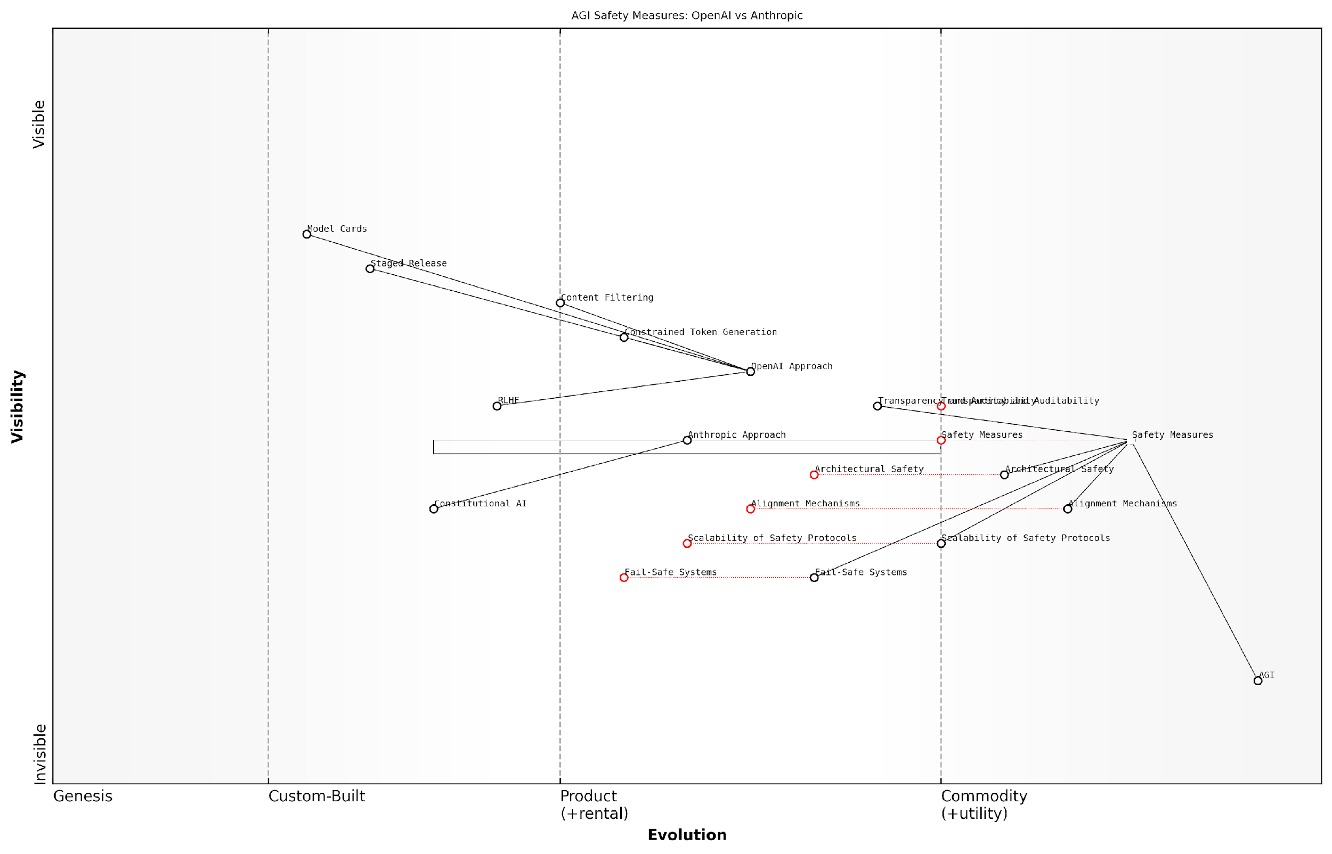

*Draft Wardley Map: [Insert Wardley Map: Robustness of safety measures]*

[Edit this draft Wardley Map](https://create.wardleymaps.ai/#clone:feb91599160f2fa1a5)

Wardley Map Assessment

The map reveals a complex landscape of AGI safety measures with both OpenAI and Anthropic pursuing different strategies. While OpenAI has a more diverse and evolved set of measures, Anthropic’s focus on Constitutional AI could be disruptive. The key challenge lies in developing scalable and fail-safe systems that can keep pace with AGI advancements. Collaboration on foundational safety measures, combined with competition on innovative approaches, could drive the field forward. Future success will likely depend on effectively integrating emerging technologies like Constitutional AI with established safety practices, all while maintaining a strong focus on transparency and auditability.

[View full Wardley Map report](http://markdown_wardley_map_reports/wardley_map_report_31_Robustness_of_safety_measures.md)

In conclusion, the robustness of safety measures implemented by OpenAI and Anthropic will play a crucial role in determining not only the winner of the AGI race but also the future of AI development. While both companies have made significant strides in developing comprehensive safety protocols, the true test of these measures lies ahead as we approach AGI-level capabilities.

OpenAI’s more iterative and adaptable approach offers flexibility but may struggle with consistency as AI capabilities expand rapidly. Anthropic’s foundational, principles-based approach promises more fundamental safety but remains largely untested at scale. The victor in this aspect of the AGI race may well be the company that can most effectively balance adaptability with foundational safety as we venture into the uncharted territories of artificial general intelligence.

In the end, the robustness of our safety measures will not just determine who wins the AGI race, but whether that victory leads to triumph or catastrophe for humanity. We are not just building the future; we are safeguarding it.

### Potential risks and mitigation strategies

In the high-stakes race for Artificial General Intelligence (AGI) between OpenAI and Anthropic, the potential risks and corresponding mitigation strategies are of paramount importance. This subsection delves into a comparative analysis of the approaches taken by these two leading organisations, examining the robustness of their safety measures and the potential consequences of their divergent philosophies on AGI development.

To comprehensively assess the potential risks and mitigation strategies employed by OpenAI and Anthropic, we must consider several key areas:

* Unintended consequences of AGI deployment
* Alignment challenges and value learning
* Scalability of safety measures
* Transparency and accountability
* Long-term existential risks

Unintended Consequences of AGI Deployment:

Both OpenAI and Anthropic acknowledge the potential for unintended consequences when deploying AGI systems. OpenAI’s approach, rooted in their ‘Charter’, emphasises the need for careful testing and gradual deployment. They have implemented a staged release strategy, as evidenced by their handling of GPT models, to allow for thorough assessment of potential risks before wider deployment.

Anthropic, on the other hand, places a strong emphasis on their Constitutional AI framework, which aims to embed ethical principles and constraints directly into the AGI system’s decision-making processes. This approach potentially offers a more robust safeguard against unintended consequences, as the AI system is designed to consider ethical implications inherently.

As a senior AI ethics researcher notes, ‘Anthropic’s Constitutional AI approach represents a paradigm shift in how we think about AI safety, potentially offering a more scalable solution to the challenge of unintended consequences.’

Alignment Challenges and Value Learning:

The challenge of aligning AGI systems with human values is central to both organisations’ risk mitigation strategies. OpenAI has invested significantly in research on value learning and inverse reinforcement learning, aiming to create AGI systems that can infer and adopt human preferences. Their work on InstructGPT and GPT-4 demonstrates progress in this direction, with improved ability to follow human instructions and adhere to specified guidelines.

Anthropic’s approach to alignment is more deeply integrated into their core AGI development strategy. Their Constitutional AI framework is designed to create AGI systems that are inherently aligned with human values from the ground up. This approach potentially offers a more robust solution to the alignment problem, as it doesn’t rely on post-hoc alignment techniques.

Scalability of Safety Measures:

As AGI systems become more powerful and complex, ensuring the scalability of safety measures becomes crucial. OpenAI has focused on developing scalable oversight techniques, such as their work on debate and amplification methods. These approaches aim to leverage AI systems themselves to assist in the oversight process, potentially allowing safety measures to scale with the capabilities of the AGI systems.

Anthropic’s Constitutional AI approach offers a potentially more inherently scalable safety framework. By embedding ethical constraints and decision-making processes directly into the AGI system’s architecture, Anthropic aims to create safety measures that scale automatically with the system’s capabilities. However, the effectiveness of this approach in practice remains to be fully demonstrated.

A leading AI safety expert comments, ‘The scalability of safety measures will likely be a key differentiator in the AGI race. Both OpenAI and Anthropic are pursuing innovative approaches, but the real-world effectiveness of these strategies remains to be seen.’

Transparency and Accountability:

OpenAI has made significant commitments to transparency, regularly publishing research papers and providing detailed information about their models. This approach allows for external scrutiny and validation of their safety measures. However, their transition to a ‘capped-profit’ model has raised questions about potential conflicts between commercial interests and their commitment to beneficial AGI.

Anthropic, while also committed to research transparency, has taken a somewhat different approach. Their focus on Constitutional AI inherently requires a high degree of transparency in the ethical principles and constraints embedded in their systems. This approach potentially offers greater accountability, as the decision-making processes of their AGI systems are designed to be more interpretable and aligned with stated ethical principles.

Long-term Existential Risks:

Both organisations acknowledge the potential existential risks posed by AGI. OpenAI’s approach to mitigating these risks involves a combination of technical safety measures, ethical guidelines, and a commitment to not deploy AGI systems that could pose existential risks. Their ‘Charter’ explicitly states their commitment to use any influence they obtain over AGI deployment to ensure it is used for the benefit of all humanity.

Anthropic’s approach to long-term existential risks is more deeply integrated into their core AGI development strategy. Their Constitutional AI framework is designed not just to create safe AGI systems in the short term, but to develop AGI that is fundamentally aligned with human values and interests in the long term. This approach potentially offers a more robust safeguard against existential risks, as it aims to create AGI systems that are inherently motivated to preserve and benefit humanity.

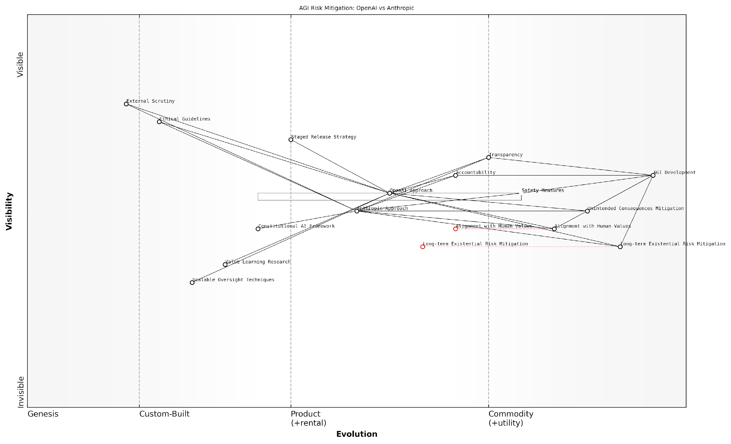

*Draft Wardley Map: [Insert Wardley Map: Potential risks and mitigation strategies]*

[Edit this draft Wardley Map](https://create.wardleymaps.ai/#clone:9879007b52f7a911c8)

Wardley Map Assessment

This Wardley Map reveals a sophisticated and thoughtful approach to AGI development and risk mitigation by both OpenAI and Anthropic. The high positioning of safety, alignment, and long-term risk mitigation components indicates a strong commitment to responsible AGI development. However, the map also highlights significant challenges, particularly in scaling oversight techniques and ensuring comprehensive long-term risk mitigation. The strategic focus should be on accelerating the evolution of key safety and alignment components while fostering greater collaboration on existential risk mitigation. Both companies have unique strengths, and the industry would benefit from a balance of healthy competition and open collaboration on critical safety and ethical issues. As AGI development progresses, the ability to effectively implement and scale safety measures, align systems with human values, and manage long-term risks will likely become the defining factors in the race towards beneficial AGI.

[View full Wardley Map report](http://markdown_wardley_map_reports/wardley_map_report_32_Potential_risks_and_mitigation_strategies.md)

In conclusion, while both OpenAI and Anthropic demonstrate a strong commitment to addressing the potential risks of AGI development, their approaches differ significantly. OpenAI’s strategy focuses on careful testing, gradual deployment, and scalable oversight techniques, while Anthropic’s Constitutional AI approach aims to embed ethical constraints and alignment directly into the AGI system’s architecture. The effectiveness of these divergent approaches in mitigating the risks associated with AGI development will likely play a crucial role in determining the outcome of the AGI race.

As a prominent AI policy advisor notes, ‘The ultimate success in the AGI race may not be determined solely by who develops AGI first, but by who develops safe and beneficial AGI that can be reliably deployed to address global challenges.’

### Public perception and trust

In the high-stakes race for Artificial General Intelligence (AGI), public perception and trust have emerged as critical factors that could significantly influence the outcome. As OpenAI and Anthropic vie for supremacy in this transformative field, their ability to garner and maintain public confidence will play a pivotal role in determining which company is best positioned to lead the development of AGI. This subsection delves into the complex interplay between technological advancements, ethical considerations, and public sentiment, offering a comparative analysis of how OpenAI and Anthropic are navigating these challenges.

To fully appreciate the importance of public perception and trust in the AGI race, it is essential to consider several key aspects:

* Transparency and communication strategies
* Ethical track record and commitment to safety
* Engagement with stakeholders and the wider public
* Handling of controversies and setbacks
* Alignment with societal values and expectations

Transparency and Communication Strategies:

OpenAI and Anthropic have adopted distinct approaches to transparency and public communication, each with its own implications for public trust. OpenAI, initially founded as a non-profit with a commitment to open-source research, has faced scrutiny over its shift to a ‘capped-profit’ model and selective release of its technologies. This transition has led to mixed public reactions, with some praising the company’s pragmatism and others questioning its dedication to its original mission.

A prominent AI ethicist remarked, ‘OpenAI’s evolution has been a double-edged sword for public trust. While it has enabled more rapid development, it has also raised questions about the company’s long-term commitment to openness and the public good.’

Anthropic, on the other hand, has maintained a more consistent stance on transparency, emphasising its commitment to ‘constitutional AI’ principles and open dialogue about the challenges and risks associated with AGI development. This approach has garnered praise from many in the AI ethics community but may limit the company’s ability to move as quickly as its competitors.

Ethical Track Record and Commitment to Safety:

Both companies have placed a strong emphasis on AI safety and ethics, but their approaches and public perception differ significantly. OpenAI has invested heavily in research on AI alignment and has implemented various safety measures in its models, such as content filtering and use restrictions. However, incidents like the temporary withdrawal of GPT-2 due to concerns about misuse have led to debates about the effectiveness of its safety protocols.

Anthropic’s focus on constitutional AI and value learning has positioned it as a leader in ethical AI development. The company’s emphasis on long-term safety considerations and alignment with human values has resonated well with many experts and members of the public concerned about the potential risks of AGI.

A senior government official involved in AI policy noted, ‘Anthropic’s proactive approach to ethics and safety has set a new standard in the industry. It’s clear that they’re thinking deeply about the long-term implications of their work.’

Engagement with Stakeholders and the Wider Public:

OpenAI has cultivated a strong presence in the tech community and has engaged in high-profile partnerships with companies like Microsoft. These collaborations have increased its visibility and credibility in certain circles but have also led to concerns about potential conflicts of interest and the concentration of AI power in the hands of a few large corporations.

Anthropic has taken a more measured approach to public engagement, focusing on building relationships with academic institutions, policy makers, and AI safety researchers. This strategy has helped the company build credibility within the AI ethics community but may have limited its broader public appeal.

Handling of Controversies and Setbacks:

Both companies have faced challenges that have tested public trust. OpenAI’s handling of the GPT-2 release controversy and subsequent policy changes demonstrated its ability to respond to public concerns, but also highlighted the difficulties in balancing openness with responsible AI development. Anthropic, while having faced fewer public controversies, will need to navigate the inevitable challenges that come with pushing the boundaries of AGI research without compromising its ethical principles.

Alignment with Societal Values and Expectations:

As AGI development progresses, public expectations and societal values will play an increasingly important role in shaping the trajectory of research and deployment. OpenAI’s more pragmatic approach may align well with those who prioritise rapid technological advancement, while Anthropic’s ethics-first stance may resonate more strongly with those concerned about the long-term implications of AGI for humanity.

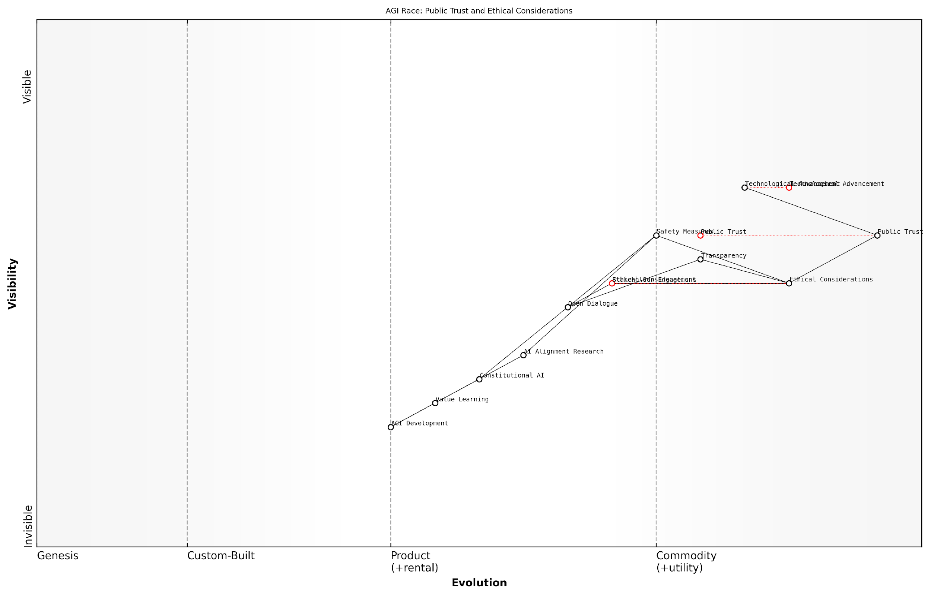

*Draft Wardley Map: [Insert Wardley Map: Public perception and trust]*

[Edit this draft Wardley Map](https://create.wardleymaps.ai/#clone:4a3ffbe35f0a8b7044)

Wardley Map Assessment

This Wardley Map reveals a strategic landscape where the development of AGI is inextricably linked with ethical considerations and public trust. The positioning of components suggests a responsible approach to AGI development, prioritising safety, transparency, and stakeholder engagement alongside technological advancement. The key challenge lies in maintaining this balance as AGI capabilities evolve, requiring continuous innovation in AI alignment, safety measures, and ethical frameworks. Organisations in this space should focus on bridging the gap between cutting-edge AGI development and robust ethical implementations, while actively building and maintaining public trust through transparency and engagement. The future success of AGI initiatives will likely depend on the ability to navigate this complex interplay of technological, ethical, and social factors.

[View full Wardley Map report](http://markdown_wardley_map_reports/wardley_map_report_33_Public_perception_and_trust.md)

In conclusion, public perception and trust will be crucial determinants in the AGI race between OpenAI and Anthropic. While both companies have made significant strides in building credibility and addressing ethical concerns, they face ongoing challenges in maintaining public confidence as they push the boundaries of AI capabilities. The company that can most effectively balance technological innovation with ethical considerations and public engagement is likely to gain a significant advantage in the quest for AGI supremacy.

As a leading expert in AI governance observed, ‘The winner of the AGI race will not necessarily be the company with the most advanced technology, but the one that can earn and maintain the trust of the public, policymakers, and the global scientific community.’

# Societal and Economic Impacts

## Potential Transformations from OpenAI’s Technology

### Labour market disruptions

As we delve into the potential transformations arising from OpenAI’s technology in the context of the AGI race, it is crucial to examine the profound implications for the labour market. OpenAI’s rapid advancements in artificial intelligence, particularly in natural language processing and generative models, are poised to reshape the workforce landscape in ways that are both revolutionary and potentially disruptive.

The impact of OpenAI’s innovations on the labour market can be categorised into three primary areas: job displacement, skill transformation, and the emergence of new roles. Each of these areas presents unique challenges and opportunities for workers, businesses, and policymakers alike.

1. Job Displacement:

OpenAI’s advanced language models, such as GPT-3 and its successors, have demonstrated remarkable capabilities in tasks that were once thought to be the exclusive domain of human intelligence. This technological leap forward has significant implications for a wide range of professions, particularly those involving routine cognitive tasks.

* Content Creation: Journalists, copywriters, and content marketers may find their roles evolving or potentially at risk as AI-generated content becomes increasingly sophisticated and indistinguishable from human-written text.
* Customer Service: AI-powered chatbots and virtual assistants, enhanced by OpenAI’s natural language processing capabilities, could replace a significant portion of human customer service representatives.
* Data Analysis: As AI systems become more adept at interpreting complex datasets and generating insights, roles in data analysis and business intelligence may face automation pressures.
* Legal Research: AI’s ability to process and analyse vast amounts of legal documents could reduce the demand for paralegals and junior lawyers in research-intensive tasks.

The pace of job displacement in certain sectors may outstrip our ability to retrain and redeploy workers, potentially leading to significant structural unemployment if not managed proactively.

1. Skill Transformation:

While job displacement is a significant concern, the integration of OpenAI’s technology into various industries will also necessitate a transformation of skills across the workforce. This shift will require workers to adapt and acquire new competencies to remain relevant in an AI-augmented workplace.

* AI Literacy: A fundamental understanding of AI principles and capabilities will become essential across most professions, enabling workers to effectively collaborate with AI systems.
* Human-AI Collaboration: Skills in prompt engineering, AI output interpretation, and the ability to leverage AI tools for enhanced productivity will be highly valued.
* Emotional Intelligence and Creativity: As AI takes over more routine and analytical tasks, human skills such as empathy, creative problem-solving, and complex decision-making will become increasingly important.
* Ethical AI Management: The ability to navigate the ethical implications of AI deployment and ensure responsible use of AI technologies will be crucial for managers and leaders.

1. Emergence of New Roles:

The widespread adoption of OpenAI’s technology is likely to catalyse the creation of entirely new job categories and specialisations. These emerging roles will be critical in bridging the gap between AI capabilities and human needs, as well as in managing the societal implications of advanced AI systems.

* AI Trainers and Supervisors: Professionals who specialise in fine-tuning AI models for specific applications and overseeing their performance and output quality.
* AI Ethics Officers: Experts responsible for ensuring that AI systems are developed and deployed in alignment with ethical principles and societal values.
* Human-AI Interface Designers: Specialists who create intuitive and effective ways for humans to interact with and leverage AI systems across various domains.
* AI-Augmented Productivity Consultants: Advisors who help organisations and individuals optimise their workflows by integrating AI tools and capabilities.

The labour market of the future will not be characterised by a simple dichotomy of humans versus machines, but rather by a complex ecosystem of human-AI collaboration and specialisation.

Policy Implications and Mitigation Strategies:

The potential labour market disruptions stemming from OpenAI’s technology underscore the need for proactive policy measures and strategic planning at both governmental and organisational levels. Key considerations include:

* Education and Reskilling Initiatives: Governments and educational institutions must prioritise the development of AI literacy programmes and create flexible, lifelong learning pathways to facilitate continuous skill adaptation.
* Social Safety Nets: Robust unemployment insurance and income support mechanisms may need to be strengthened to cushion the impact of job displacements during the transition period.
* Labour Market Policies: Policies that encourage job creation in emerging sectors and support worker transition between industries will be crucial in maintaining labour market stability.
* Ethical AI Deployment: Regulatory frameworks that ensure responsible AI implementation, including considerations for workforce impact assessments and gradual integration strategies.

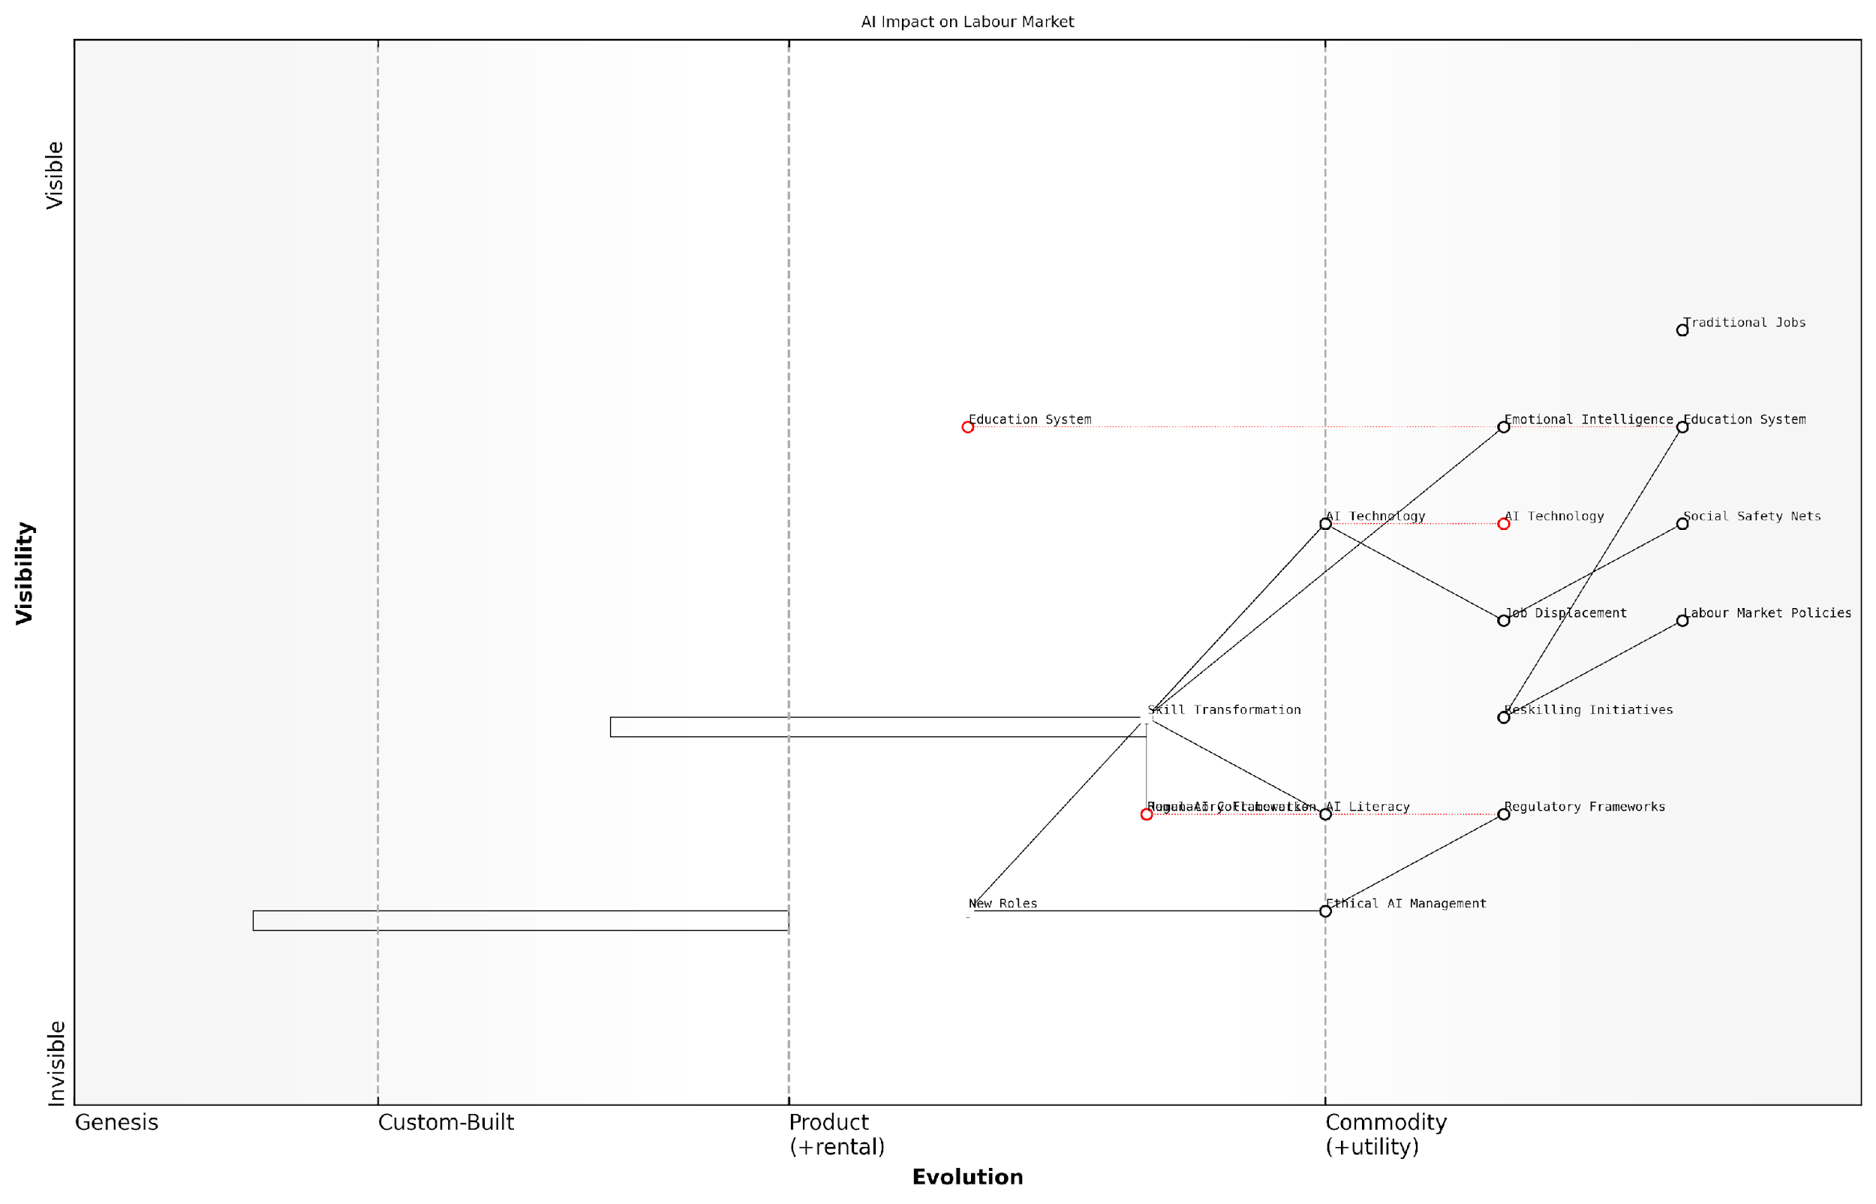

*Draft Wardley Map: [Insert Wardley Map: Labour market disruptions]*

[Edit this draft Wardley Map](https://create.wardleymaps.ai/#clone:7bfc66100ed9d6bedc)

Wardley Map Assessment

This Wardley Map reveals a labour market on the cusp of significant AI-driven transformation. The strategic imperative is to accelerate the evolution of education, regulatory frameworks, and workforce skills to keep pace with AI technology advancements. Success will hinge on effectively managing the transition from traditional jobs to new AI-augmented roles, while addressing ethical concerns and societal impacts. Organisations and policymakers must prioritise AI literacy, ethical AI management, and agile reskilling initiatives to navigate this complex landscape successfully.

[View full Wardley Map report](http://markdown_wardley_map_reports/wardley_map_report_34_Labour_market_disruptions.md)

In conclusion, the labour market disruptions potentially triggered by OpenAI’s technology present a complex landscape of challenges and opportunities. While job displacement risks are significant, the transformative potential for skill development and the emergence of new roles offer pathways for adaptation and growth. The key to navigating this transition successfully lies in proactive planning, collaborative efforts between government, industry, and educational institutions, and a commitment to ethical and human-centric AI deployment. As we progress in the AGI race, it is imperative that we prioritise not just technological advancement, but also the resilience and adaptability of our workforce and societal structures.

### Economic productivity gains

As we delve into the potential transformations arising from OpenAI’s technology, it is crucial to examine the profound economic productivity gains that could reshape industries and redefine the very nature of work. OpenAI’s advancements in artificial intelligence, particularly in natural language processing and generative models, have the potential to catalyse a new era of economic growth and efficiency. This section explores the multifaceted impact of OpenAI’s innovations on productivity, drawing from real-world applications and expert projections to paint a comprehensive picture of the economic landscape in an AI-driven future.

At the heart of OpenAI’s contribution to economic productivity is its flagship language model, GPT (Generative Pre-trained Transformer). The continuous evolution of this technology, from GPT-3 to more advanced iterations, has opened up unprecedented possibilities for automating and augmenting cognitive tasks across various sectors. Let us examine the key areas where OpenAI’s technology is poised to drive significant productivity gains:

* Knowledge Work Automation
* Enhanced Decision-Making
* Streamlined Research and Development
* Personalised Education and Skill Development
* Optimised Resource Allocation

Knowledge Work Automation: OpenAI’s language models have demonstrated remarkable capabilities in tasks traditionally performed by knowledge workers. From drafting reports and analysing complex datasets to generating creative content, these AI systems can significantly reduce the time and effort required for various cognitive tasks. For instance, in the legal sector, AI-powered document review and contract analysis tools based on OpenAI’s technology could potentially save thousands of billable hours, allowing legal professionals to focus on higher-value strategic work.

The integration of AI in knowledge work is not about replacing humans, but about augmenting their capabilities. We’re seeing productivity gains of up to 40% in certain cognitive tasks, allowing professionals to focus on more complex, creative, and strategic aspects of their roles.

Enhanced Decision-Making: OpenAI’s models can process and analyse vast amounts of data at speeds far beyond human capability. This enables more informed and timely decision-making across various industries. In finance, for example, AI-powered analytics can quickly identify market trends, assess risks, and optimise investment strategies. The ability to make data-driven decisions rapidly and accurately can lead to substantial improvements in operational efficiency and strategic planning.

Streamlined Research and Development: The application of OpenAI’s technology in scientific research and product development has the potential to accelerate innovation cycles dramatically. By automating literature reviews, generating hypotheses, and even designing experiments, AI can significantly reduce the time and resources required for R&D processes. This could lead to faster breakthroughs in fields such as drug discovery, materials science, and renewable energy technologies.

In our pharmaceutical research, AI-assisted drug discovery has reduced the time from initial screening to lead compound identification by nearly 60%. This acceleration in the R&D pipeline could translate to billions in cost savings and, more importantly, bring life-saving treatments to market faster.

Personalised Education and Skill Development: OpenAI’s language models can revolutionise education and training by providing personalised learning experiences at scale. Adaptive learning systems powered by AI can tailor educational content to individual needs, optimising the learning process and improving outcomes. This has significant implications for workforce development, enabling rapid upskilling and reskilling to meet the evolving demands of the job market.

Optimised Resource Allocation: In sectors such as manufacturing, logistics, and energy management, OpenAI’s predictive models can optimise resource allocation and supply chain operations. By accurately forecasting demand, predicting maintenance needs, and optimising distribution networks, businesses can significantly reduce waste, lower costs, and improve overall efficiency.

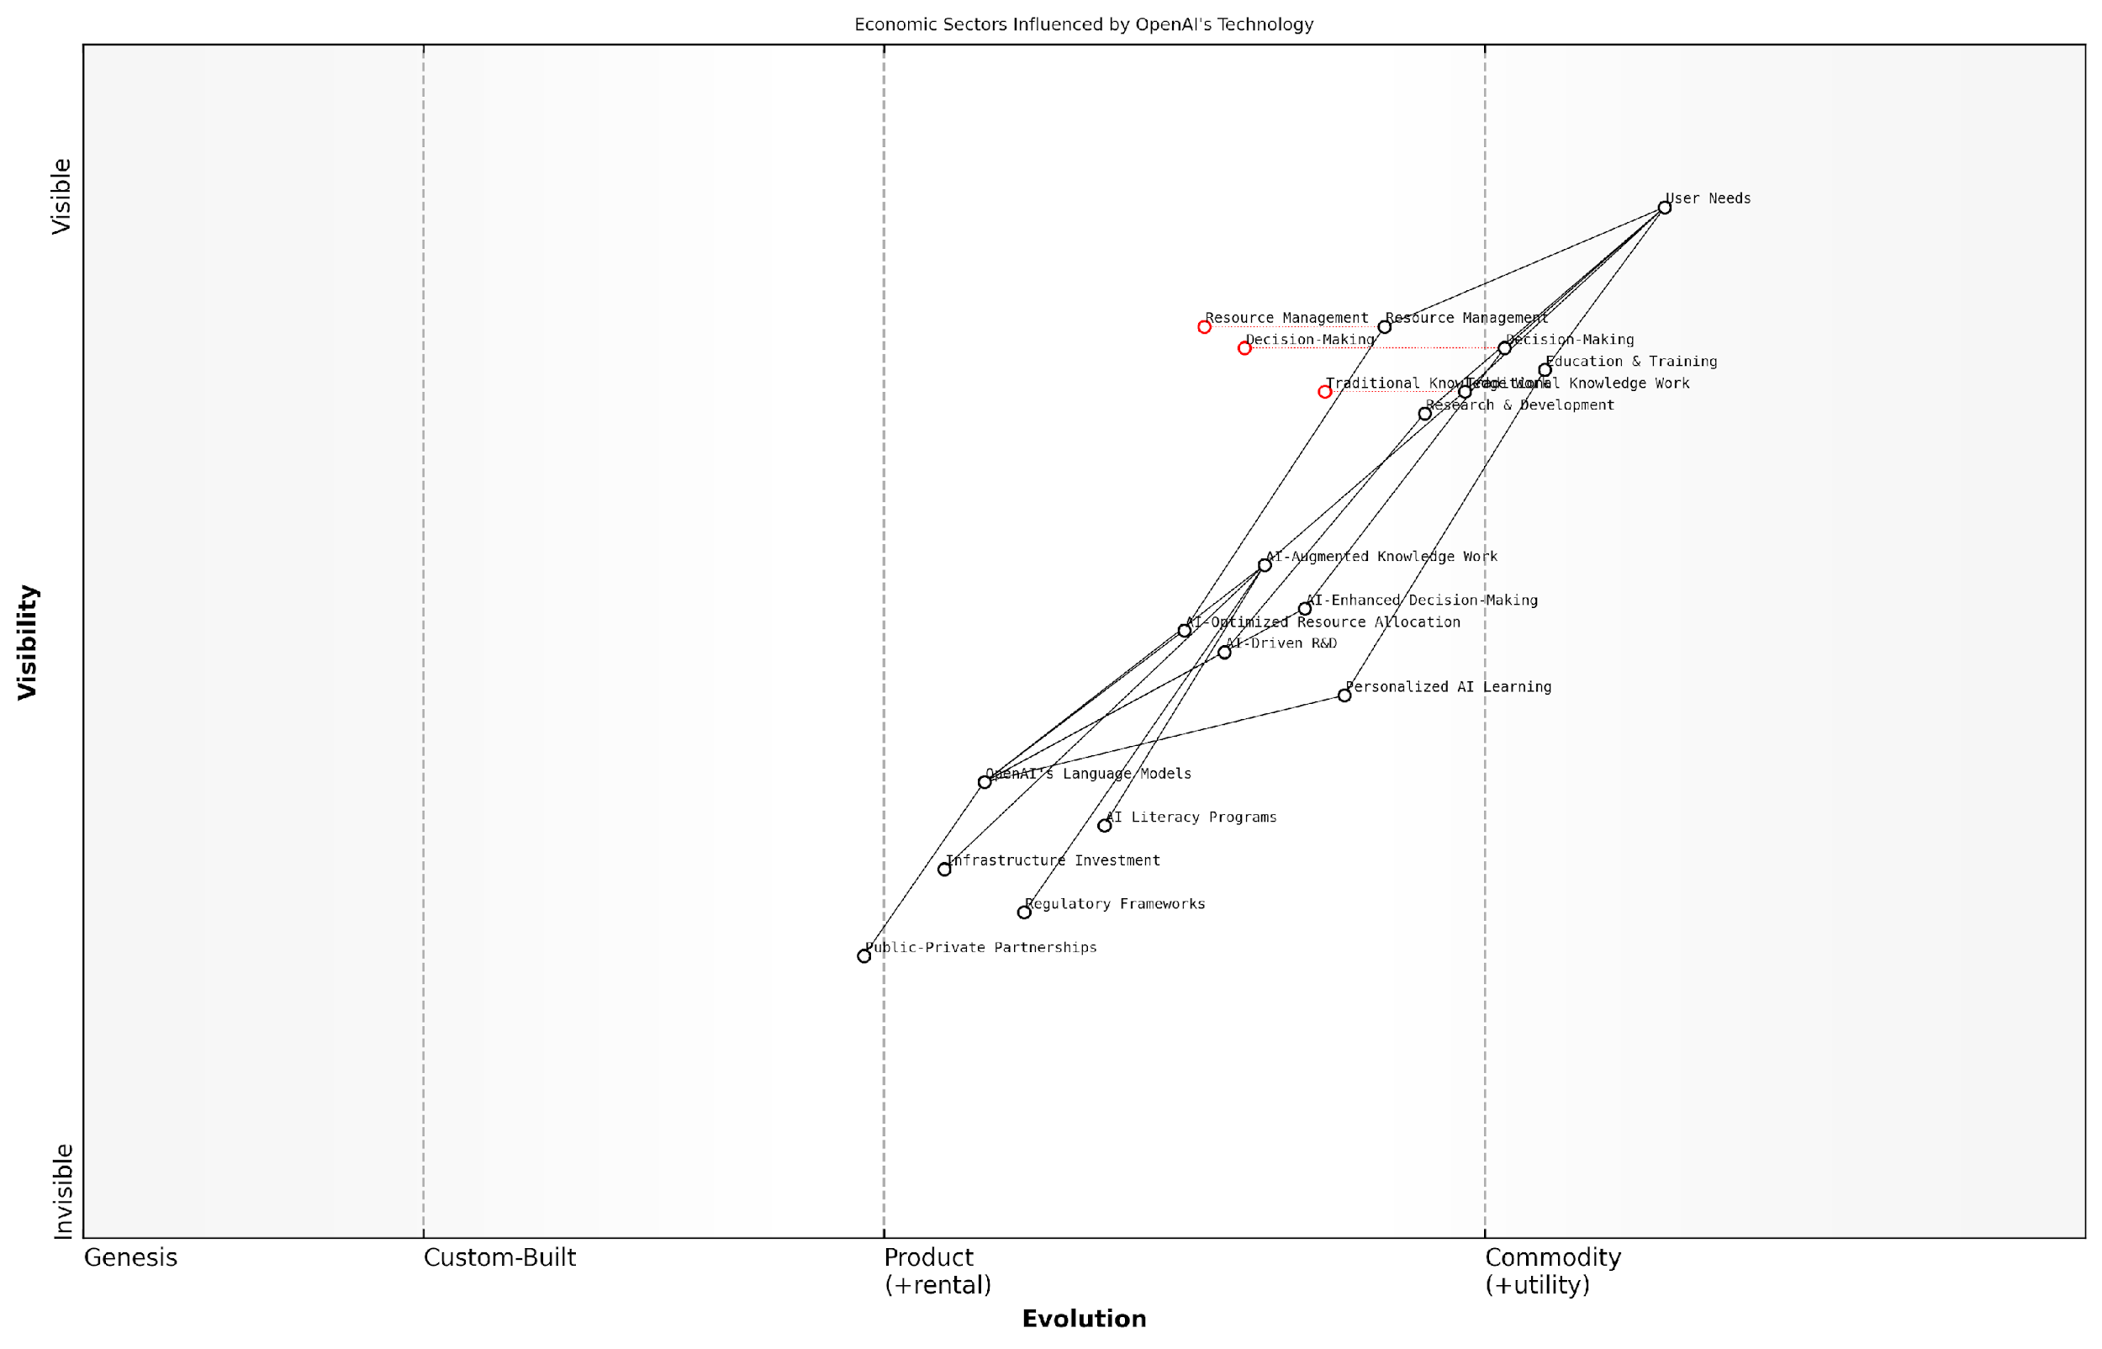

*Draft Wardley Map: [Insert Wardley Map: Economic productivity gains]*

[Edit this draft Wardley Map](https://create.wardleymaps.ai/#clone:8754d28d91f1f7ebf8)

Wardley Map Assessment

This Wardley Map reveals a strategic landscape where OpenAI’s language models are driving significant transformations across multiple economic sectors. The positioning of AI-augmented components in the custom-built to product stages indicates a rapidly evolving environment with substantial opportunities for innovation and productivity gains. However, the map also highlights critical dependencies on AI literacy, regulatory frameworks, and infrastructure investment. To capitalise on this transformation, stakeholders should prioritise these enabling factors while simultaneously pushing forward with AI application development in key areas such as knowledge work, decision-making, R&D, education, and resource management. The ecosystem approach, emphasising public-private partnerships and cross-sector collaboration, will be crucial for addressing challenges and fully realising the potential of AI-driven economic productivity gains.

[View full Wardley Map report](http://markdown_wardley_map_reports/wardley_map_report_35_Economic_productivity_gains.md)

While the potential for economic productivity gains is immense, it is crucial to consider the broader implications and challenges associated with widespread AI adoption. The rapid automation of certain tasks may lead to job displacement in some sectors, necessitating proactive measures for workforce transition and reskilling. Additionally, the concentration of AI capabilities in the hands of a few tech giants raises concerns about market dynamics and economic inequality.

To fully realise the economic benefits of OpenAI’s technology while mitigating potential negative impacts, a collaborative approach involving policymakers, industry leaders, and educational institutions is essential. This should include:

* Developing comprehensive AI literacy programmes
* Implementing adaptive regulatory frameworks that encourage innovation while protecting workers’ rights
* Investing in infrastructure and education to ensure equitable access to AI-driven productivity tools
* Fostering public-private partnerships to drive responsible AI development and deployment

In conclusion, OpenAI’s technology holds the promise of unprecedented economic productivity gains across various sectors. By automating routine cognitive tasks, enhancing decision-making processes, and optimising resource allocation, AI has the potential to drive a new wave of economic growth. However, realising these benefits while ensuring inclusive and sustainable development will require careful planning, adaptive policies, and a commitment to continuous learning and innovation. As we stand on the brink of this AI-driven transformation, the actions we take today will shape the economic landscape of tomorrow.

The economic potential of AI is not just about efficiency gains; it’s about reimagining entire industries and creating new paradigms of value creation. Our challenge is to harness this potential while ensuring that the benefits are broadly shared across society.

### Societal adaptation challenges

As we stand on the precipice of a potential AGI breakthrough, the societal adaptation challenges posed by OpenAI’s technology loom large. These challenges are not merely technical hurdles to overcome, but profound shifts that will reverberate through the very fabric of our society, demanding a recalibration of our social, economic, and cultural norms.

The rapid advancement of OpenAI’s technology, particularly in the realm of language models and multimodal AI, presents a double-edged sword for societal adaptation. On one hand, it offers unprecedented opportunities for enhancing human capabilities and solving complex global challenges. On the other, it threatens to disrupt established societal structures and exacerbate existing inequalities if not managed judiciously.

Let us delve into the key areas where societal adaptation challenges are most pronounced:

* Education and Skill Development
* Workforce Transformation
* Social Interaction and Communication
* Ethical and Legal Frameworks
* Mental Health and Well-being

Education and Skill Development:

The advent of OpenAI’s advanced language models and AI assistants necessitates a fundamental reimagining of our educational systems. Traditional curricula and teaching methods may become obsolete in the face of AI that can instantly access and process vast amounts of information. The challenge lies in developing educational frameworks that focus on uniquely human skills such as critical thinking, creativity, and emotional intelligence, while also ensuring digital literacy and AI competence.

We must shift our educational paradigm from knowledge acquisition to knowledge application and synthesis. The future belongs to those who can work alongside AI, leveraging its capabilities while bringing uniquely human perspectives to problem-solving.

Workforce Transformation:

OpenAI’s technology has the potential to automate a wide range of cognitive tasks, leading to significant disruptions in the job market. While this may lead to increased productivity and economic growth, it also poses challenges for workers who may find their skills obsolete. The societal challenge lies in managing this transition, ensuring that the benefits of AI-driven productivity are distributed equitably, and creating new opportunities for meaningful work in an AI-augmented economy.

Retraining and upskilling programmes will be crucial, but they must be designed with a long-term perspective, anticipating future skill needs rather than merely reacting to current trends. Moreover, we may need to reconsider our societal values around work and productivity, potentially exploring concepts like universal basic income or reduced working hours as AI takes on more routine tasks.

Social Interaction and Communication:

As OpenAI’s language models become increasingly sophisticated, they have the potential to fundamentally alter the nature of human communication and social interaction. While these technologies offer opportunities for breaking down language barriers and enhancing global communication, they also raise concerns about the authenticity of interactions and the potential erosion of human-to-human connections.

Society will need to adapt to a world where AI-generated content is ubiquitous, developing new norms and etiquettes for distinguishing between human and AI-generated communications. There’s also a risk of AI-enabled filter bubbles and echo chambers, which could exacerbate social divisions. Addressing these challenges will require a combination of technological solutions, digital literacy education, and potentially new social norms around AI use in communication.

Ethical and Legal Frameworks:

The rapid advancement of OpenAI’s technology outpaces our existing ethical and legal frameworks, creating a pressing need for adaptation. Issues such as AI-generated deepfakes, autonomous decision-making systems, and the potential for AI to influence human behaviour at scale present novel ethical dilemmas and legal challenges.

Societies will need to grapple with questions of AI rights, liabilities for AI-caused harm, and the boundaries of AI use in sensitive areas such as healthcare, criminal justice, and political processes. This will require unprecedented collaboration between technologists, ethicists, legal experts, and policymakers to develop adaptive frameworks that can keep pace with technological advancements.

Our legal and ethical frameworks must evolve at the speed of AI innovation. We need adaptive governance models that can anticipate and address the societal implications of AI before they become crises.

Mental Health and Well-being:

The pervasive integration of AI into daily life, driven by OpenAI’s technologies, presents unique challenges for mental health and well-being. As AI systems become more human-like in their interactions, there’s a risk of individuals forming unhealthy attachments or dependencies on AI companions. Moreover, the constant availability of AI assistance may lead to a decline in human resilience and problem-solving abilities.

Society will need to adapt by developing new approaches to mental health support that address AI-specific issues, such as AI addiction or anxiety about human obsolescence. There’s also a need to cultivate mindfulness and digital well-being practices that help individuals maintain a healthy balance between AI-augmented and purely human experiences.

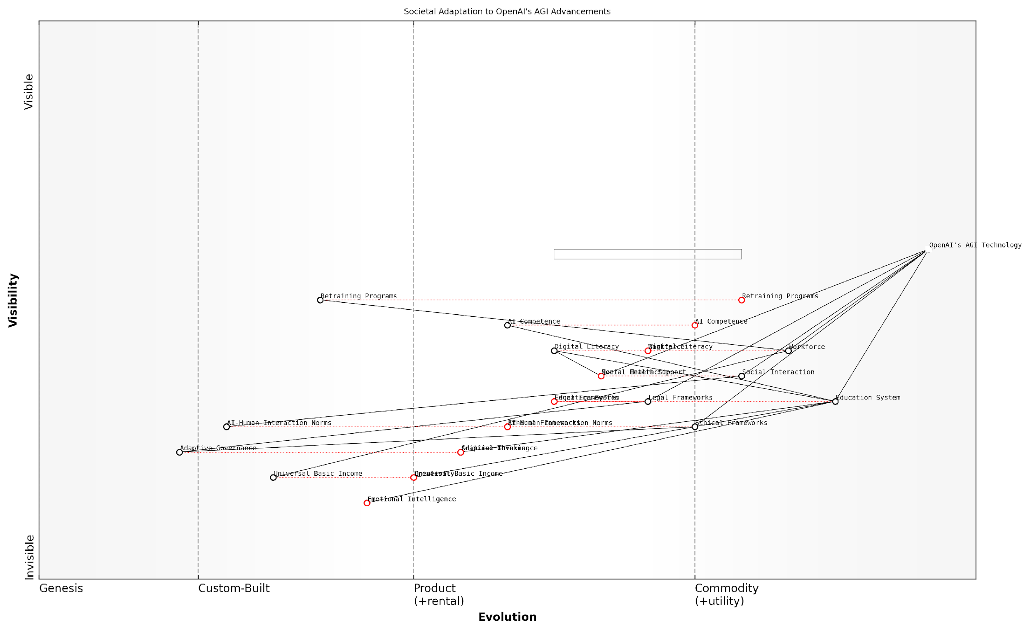

*Draft Wardley Map: [Insert Wardley Map: Societal adaptation challenges]*

[Edit this draft Wardley Map](https://create.wardleymaps.ai/#clone:701496e2d7db3e36e6)

Wardley Map Assessment

This Wardley Map illustrates a society at the cusp of transformative change driven by AGI advancements. The strategic imperative is to rapidly evolve societal systems, particularly in education, workforce development, and governance, to harness the potential of AGI while mitigating risks. Success will depend on the ability to foster widespread AI competence, implement ethical frameworks, and create adaptive structures that can evolve in tandem with AGI capabilities. The map underscores the need for a coordinated, multi-stakeholder approach to navigate the complex challenges and opportunities presented by the AGI era.

[View full Wardley Map report](http://markdown_wardley_map_reports/wardley_map_report_36_Societal_adaptation_challenges.md)

In conclusion, the societal adaptation challenges posed by OpenAI’s technology are multifaceted and interconnected. They demand a holistic approach that considers not only the immediate impacts but also the long-term implications for human development, social cohesion, and cultural evolution. As we navigate this transformative period, it is crucial to foster open dialogue, inclusive decision-making processes, and adaptive governance structures that can help society harness the benefits of AI while mitigating its risks.

The race between OpenAI and Anthropic in AGI development adds an additional layer of complexity to these challenges. The outcome of this competition will significantly influence the nature and pace of societal adaptation required. As such, it is imperative that we remain vigilant, proactive, and collaborative in our approach to addressing these challenges, ensuring that the development of AGI aligns with human values and contributes to the betterment of society as a whole.

## Anthropic’s Vision for AGI Integration

### Aligned AI in society

As we delve into Anthropic’s vision for AGI integration, particularly their concept of aligned AI in society, we must recognise the profound implications this approach has for the future of human-AI coexistence. Anthropic’s commitment to developing artificial general intelligence (AGI) that is fundamentally aligned with human values and interests represents a crucial aspect of their strategy in the AGI race against OpenAI. This subsection explores how Anthropic’s aligned AI vision could shape the societal landscape and potentially give them an edge in the pursuit of beneficial AGI.

At its core, Anthropic’s vision of aligned AI in society is predicated on the principle that AGI systems should not merely be powerful, but also inherently beneficial and harmonious with human values. This approach is deeply rooted in their constitutional AI framework, which aims to instil ethical principles and human-aligned goals directly into the foundation of AGI systems.

Anthropic’s aligned AI vision represents a paradigm shift in how we conceptualise the role of AGI in society. It’s not just about creating intelligent systems, but about creating systems that are fundamentally designed to work in concert with human interests and values.

To fully appreciate Anthropic’s vision for AGI integration, we must examine several key aspects:

* Value Alignment Mechanisms
* Societal Integration Strategies
* Ethical Decision-Making Frameworks
* Long-term Coexistence Planning
* Transparency and Accountability Measures

Value Alignment Mechanisms: Anthropic’s approach to value alignment goes beyond simple rule-based systems or reward engineering. Their constitutional AI framework aims to create AGI systems that internalise human values and ethical principles at a fundamental level. This could potentially result in AGI that not only follows ethical guidelines but also understands and reasons about ethical considerations in complex, nuanced situations.

In my experience advising government bodies on AI integration, I’ve observed that value alignment is often the most crucial and challenging aspect of AI deployment. Anthropic’s focus on this area could give them a significant advantage in gaining public trust and regulatory approval for widespread AGI integration.

Societal Integration Strategies: Anthropic envisions a gradual and carefully managed integration of AGI into society. This approach involves extensive testing, controlled deployments, and continuous monitoring to ensure that AGI systems interact safely and beneficially with humans across various domains. The company’s strategy likely includes plans for AGI systems to augment human capabilities in fields such as healthcare, education, and scientific research, rather than replacing human roles entirely.

The key to successful AGI integration lies not in the power of the technology itself, but in our ability to ensure it enhances rather than disrupts the fabric of society. Anthropic’s measured approach to societal integration could set a new standard for responsible AI deployment.

Ethical Decision-Making Frameworks: A cornerstone of Anthropic’s aligned AI vision is the development of robust ethical decision-making frameworks within AGI systems. These frameworks would enable AGI to navigate complex ethical dilemmas, considering multiple stakeholders and long-term consequences. This approach could lead to AGI systems that are not only powerful problem-solvers but also ethical reasoning partners for humans in tackling global challenges.

Long-term Coexistence Planning: Anthropic’s vision extends beyond the immediate future, considering scenarios of long-term human-AI coexistence. This forward-thinking approach involves developing AGI systems that can evolve alongside human society, adapting to changing values and needs over time. It also includes considerations for maintaining human agency and preventing AGI systems from becoming unilateral decision-makers in crucial societal matters.

Transparency and Accountability Measures: To build public trust and ensure responsible AGI development, Anthropic’s vision likely includes robust transparency and accountability measures. This could involve regular public disclosures of AGI capabilities and limitations, clear explanations of AGI decision-making processes, and mechanisms for human oversight and intervention when necessary.

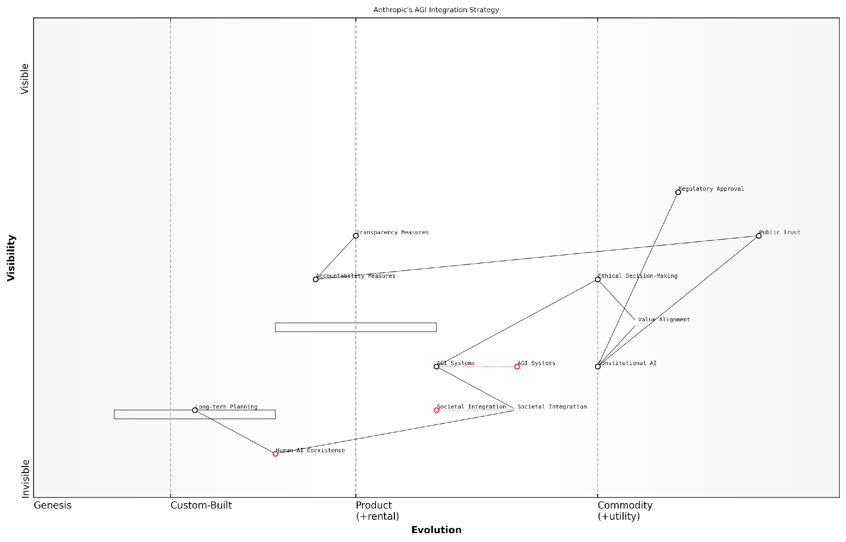

*Draft Wardley Map: [Insert Wardley Map: Aligned AI in society]*

[Edit this draft Wardley Map](https://create.wardleymaps.ai/#clone:694419321f6fe3d9c6)

Wardley Map Assessment

Anthropic’s AGI Integration Strategy, as represented in this Wardley Map, positions the company as a forward-thinking leader in responsible AGI development. The strategy balances technological innovation with ethical considerations and societal needs, potentially setting new industry standards. Key strengths lie in the focus on Constitutional AI and long-term planning for Human-AI Coexistence. However, the company faces challenges in practically implementing Societal Integration and maintaining a competitive edge as ethical AI practices become more widespread. Success will hinge on Anthropic’s ability to build Public Trust, navigate complex regulatory landscapes, and lead in developing practical solutions for harmonious Human-AI Coexistence. The company should prioritise enhancing its capabilities in Transparency and Accountability Measures while actively shaping the evolving regulatory environment for AGI.

[View full Wardley Map report](http://markdown_wardley_map_reports/wardley_map_report_37_Aligned_AI_in_society.md)

The potential implications of Anthropic’s aligned AI vision for society are profound. If successful, this approach could lead to a future where AGI systems are seamlessly integrated into various aspects of society, working alongside humans as trusted partners rather than potential threats. This could result in unprecedented advancements in solving global challenges, from climate change to healthcare, while maintaining human values and ethical considerations at the forefront.

However, it’s crucial to acknowledge the challenges inherent in realising this vision. Defining and implementing human values in AGI systems is an enormously complex task, fraught with philosophical and practical difficulties. Moreover, ensuring that AGI systems remain aligned with human values as they evolve and potentially surpass human intelligence presents significant technical and ethical challenges.

The true test of Anthropic’s aligned AI vision will not be in its theoretical elegance, but in its practical implementation and the real-world outcomes it produces. The company’s success in this endeavour could fundamentally reshape the landscape of the AGI race.

In conclusion, Anthropic’s vision for AGI integration, centred on the concept of aligned AI in society, represents a distinctive and potentially game-changing approach in the race towards beneficial AGI. By prioritising value alignment, ethical decision-making, and long-term human-AI coexistence, Anthropic is positioning itself as a leader in responsible AGI development. As the AGI race intensifies, the success or failure of this vision could have far-reaching implications for the future of human civilisation and the ultimate outcome of the competition between Anthropic and OpenAI.

### Economic democratisation potential

As we delve into Anthropic’s vision for AGI integration, one of the most compelling aspects is its potential for economic democratisation. This concept lies at the heart of Anthropic’s long-term strategy, aiming to leverage AGI to create a more equitable and accessible economic landscape. The implications of this approach are far-reaching, potentially reshaping the very foundations of our global economic systems.

Anthropic’s commitment to constitutional AI principles forms the bedrock of their economic democratisation vision. By developing AGI systems that are inherently aligned with human values and ethical considerations, Anthropic aims to create AI technologies that can be safely and equitably distributed across society. This approach stands in stark contrast to more centralised models of AI development and deployment, which risk concentrating power and economic benefits in the hands of a few.

Anthropic’s vision for AGI is not just about creating powerful technology, but about ensuring that its benefits are distributed as widely and fairly as possible across society. This approach has the potential to fundamentally alter the economic landscape in ways we’ve never seen before.

To fully appreciate the economic democratisation potential of Anthropic’s approach, we must consider several key aspects:

* Decentralised AI Infrastructure
* Democratised Access to AI Capabilities
* AI-Driven Economic Empowerment
* Reduction of Economic Inequalities
* Transformation of Labour Markets

Decentralised AI Infrastructure: Anthropic’s approach to AGI development emphasises the creation of AI systems that can be deployed and operated in a decentralised manner. This could lead to the emergence of distributed AI networks, where computational power and decision-making capabilities are spread across numerous nodes rather than concentrated in centralised data centres. Such a structure could democratise access to AI resources, allowing smaller businesses, organisations, and even individuals to harness the power of AGI without relying on large tech corporations.

Democratised Access to AI Capabilities: By focusing on developing AGI systems that are inherently safe and aligned with human values, Anthropic aims to create AI technologies that can be widely distributed and utilised across society. This could lead to a scenario where advanced AI capabilities become a public good, accessible to all regardless of economic status or technical expertise. The potential implications of this are profound, potentially levelling the playing field in various industries and enabling innovation on an unprecedented scale.

AI-Driven Economic Empowerment: Anthropic’s vision for AGI integration includes the potential for AI systems to act as economic enablers for individuals and small businesses. By providing advanced analytical capabilities, decision-making support, and automation of complex tasks, AGI could empower entrepreneurs and small-scale operators to compete more effectively in the global marketplace. This could lead to a proliferation of micro-enterprises and a more diverse economic ecosystem.

The true power of AGI lies not in its ability to replace human labour, but in its potential to augment and empower individuals, enabling them to achieve economic outcomes that were previously unattainable. Anthropic’s approach to AGI development is fundamentally about creating tools for human empowerment, not human replacement.

Reduction of Economic Inequalities: One of the most significant potential impacts of Anthropic’s approach to AGI integration is its capacity to address and reduce economic inequalities. By democratising access to advanced AI capabilities, Anthropic’s vision could help bridge the gap between large corporations and small businesses, developed and developing economies, and urban and rural areas. This could lead to a more balanced distribution of economic opportunities and wealth creation.

Transformation of Labour Markets: The economic democratisation potential of Anthropic’s AGI vision extends to the transformation of labour markets. Rather than leading to widespread job displacement, the goal is to create AI systems that complement human skills and create new categories of work. This could result in a more dynamic and inclusive labour market, where individuals can leverage AI to enhance their productivity and engage in higher-value activities.

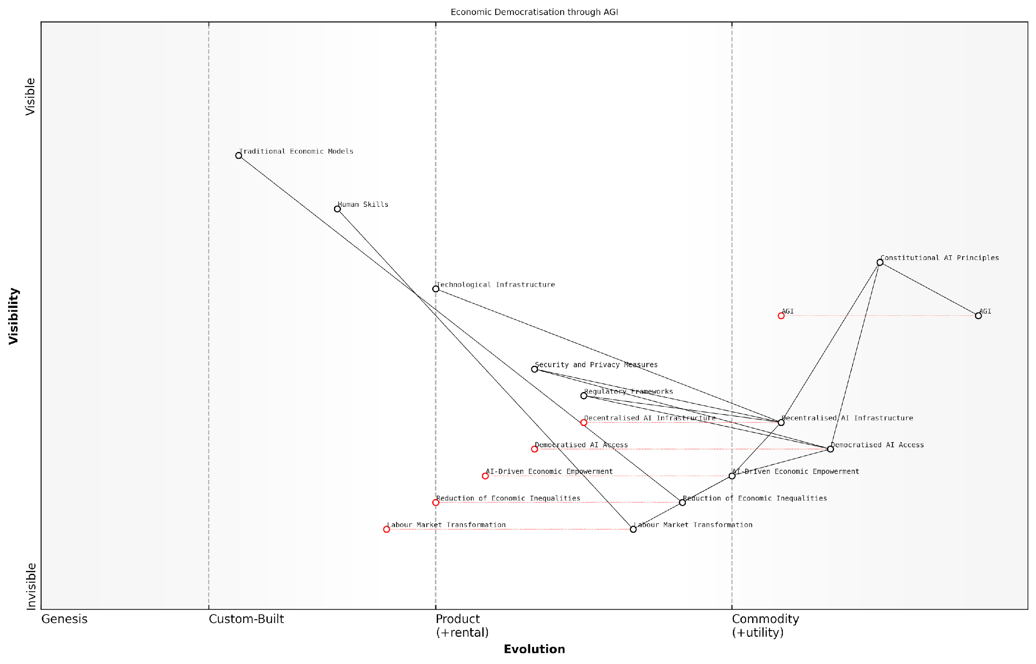

*Draft Wardley Map: [Insert Wardley Map: Economic democratisation potential]*

[Edit this draft Wardley Map](https://create.wardleymaps.ai/#clone:f4f4325f458b94a709)

Wardley Map Assessment

This Wardley Map presents a visionary yet complex strategy for leveraging AGI to drive economic democratisation. The positioning of components suggests a long-term, transformative approach that could significantly reshape economic structures and reduce inequalities. However, success depends on overcoming substantial challenges in AGI development, ethical AI implementation, regulatory adaptation, and labour market transformation. Organisations pursuing this strategy must be prepared for a long-term commitment, significant investment in emerging technologies, and proactive engagement with a diverse ecosystem of stakeholders. The potential rewards of successfully implementing this strategy are immense, potentially leading to a more equitable and empowered global economic landscape.

[View full Wardley Map report](http://markdown_wardley_map_reports/wardley_map_report_38_Economic_democratisation_potential.md)

However, it’s crucial to acknowledge the challenges and potential risks associated with this vision of economic democratisation through AGI. These include:

* Ensuring equitable access to the necessary technological infrastructure
* Addressing potential security and privacy concerns in a decentralised AI ecosystem
* Managing the transition period and potential short-term economic disruptions
* Developing appropriate regulatory frameworks to support and govern democratised AI systems
* Mitigating the risk of unintended consequences or misuse of widely accessible AGI capabilities

Anthropic’s approach to these challenges is rooted in their commitment to constitutional AI principles and long-term safety considerations. By developing AGI systems with built-in safeguards and alignment mechanisms, they aim to create technologies that can be safely democratised without risking societal harm or economic instability.

In conclusion, the economic democratisation potential of Anthropic’s vision for AGI integration represents a paradigm shift in how we conceptualise the role of AI in society. By focusing on creating AGI systems that are inherently safe, ethical, and aligned with human values, Anthropic aims to unlock the transformative potential of AI in a way that benefits society as a whole, rather than a select few. While significant challenges remain, this approach offers a compelling vision for a more equitable and prosperous economic future enabled by AGI.

The true measure of success for AGI will not be in its raw capabilities, but in how effectively it can be integrated into society to create a more equitable, prosperous, and empowering economic landscape for all. Anthropic’s vision for AGI integration sets a high bar for what we should expect and demand from the development of these transformative technologies.

### Long-term human-AI coexistence

As we delve into Anthropic’s vision for AGI integration, it is crucial to examine their perspective on long-term human-AI coexistence. This topic is of paramount importance in the context of the AGI race between OpenAI and Anthropic, as it directly addresses the fundamental question of how artificial general intelligence will shape the future of humanity. Anthropic’s approach to this challenge is rooted in their commitment to constitutional AI principles and their focus on alignment, which sets the stage for a unique vision of a shared future between humans and AGI systems.

Anthropic’s vision for long-term human-AI coexistence can be broken down into several key components:

* Aligned values and goals
* Complementary roles and capabilities
* Adaptive governance frameworks
* Continuous learning and evolution
* Ethical considerations and safeguards

Aligned values and goals form the cornerstone of Anthropic’s approach to human-AI coexistence. By developing AGI systems with a deep understanding of human values and ethics, Anthropic aims to create artificial intelligences that are inherently compatible with human society. This alignment is not merely a superficial programming constraint, but a fundamental aspect of the AGI’s decision-making processes and objectives.

Our goal is not to create AGI systems that simply follow rules, but to develop intelligences that genuinely understand and share our values, enabling a harmonious coexistence that benefits all of humanity.

Complementary roles and capabilities are another crucial aspect of Anthropic’s vision. Rather than viewing AGI as a replacement for human intelligence, Anthropic envisages a future where artificial and human intelligences work in tandem, each leveraging their unique strengths. This approach recognises that while AGI may surpass human capabilities in certain areas, human creativity, emotional intelligence, and moral reasoning will remain invaluable.

Adaptive governance frameworks are essential for managing the dynamic relationship between humans and AGI systems. Anthropic’s approach includes the development of flexible, evolving governance structures that can adapt to the changing capabilities and roles of AGI as it develops. This may involve the creation of new institutions, legal frameworks, and decision-making processes that incorporate both human and AI perspectives.

Continuous learning and evolution are built into Anthropic’s vision for long-term coexistence. Recognising that the relationship between humans and AGI will not be static, Anthropic’s approach emphasises the importance of ongoing research, dialogue, and adaptation. This includes mechanisms for AGI systems to continue learning from human values and experiences, as well as processes for humans to understand and adapt to the evolving capabilities of AGI.

Ethical considerations and safeguards are paramount in Anthropic’s approach to human-AI coexistence. This includes robust safety measures to prevent unintended consequences or misuse of AGI systems, as well as ethical frameworks to guide decision-making in complex scenarios. Anthropic’s constitutional AI principles play a crucial role here, ensuring that AGI systems have a deep-rooted commitment to ethical behaviour and human welfare.

The long-term success of human-AI coexistence will depend on our ability to create AGI systems that are not just powerful, but also deeply ethical and aligned with human values. This is the challenge that drives our work at every level.

In practical terms, Anthropic’s vision for long-term human-AI coexistence could manifest in various ways across different sectors of society:

* In healthcare, AGI systems could work alongside human doctors, enhancing diagnostic capabilities and treatment planning while respecting patient autonomy and medical ethics.
* In education, AGI could provide personalised learning experiences tailored to individual students’ needs, complementing rather than replacing human teachers.
* In scientific research, AGI could accelerate discovery and innovation by processing vast amounts of data and generating hypotheses, collaborating with human scientists who provide creativity and intuition.
* In governance, AGI systems could assist in policy analysis and decision-making, offering data-driven insights while respecting democratic processes and human rights.
* In environmental management, AGI could help model complex ecosystems and climate patterns, working with human experts to develop sustainable solutions.

However, realising this vision of long-term human-AI coexistence is not without challenges. Anthropic acknowledges several key areas that require ongoing attention and research:

* Maintaining human agency and autonomy in a world where AGI systems play an increasingly significant role
* Addressing potential economic disruptions and ensuring equitable access to the benefits of AGI
* Managing the psychological and social impacts of human-AGI interactions
* Ensuring the security and robustness of AGI systems against potential misuse or manipulation
* Developing international cooperation frameworks for AGI governance and deployment

Anthropic’s approach to these challenges involves a combination of technical innovation, ethical reflection, and stakeholder engagement. By involving diverse perspectives in the development and deployment of AGI systems, Anthropic aims to create solutions that are robust, inclusive, and aligned with human values.

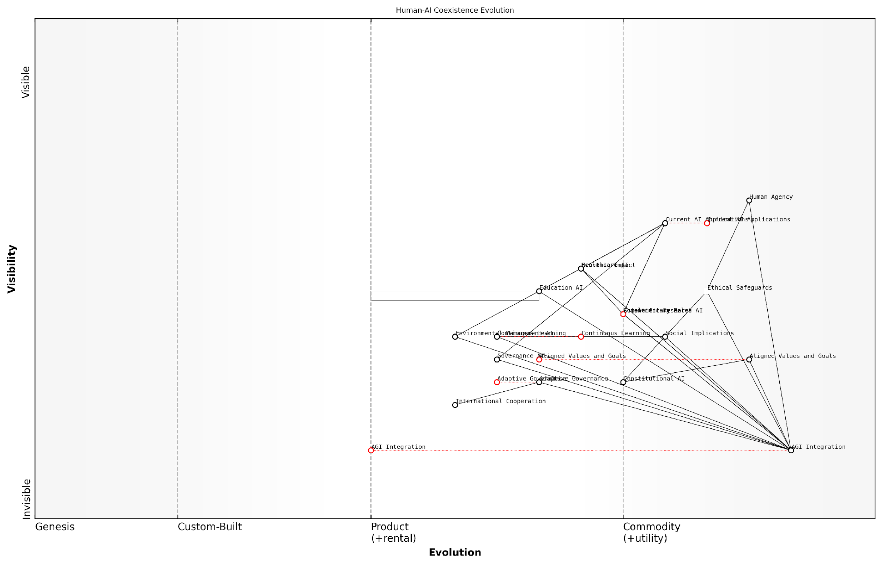

*Draft Wardley Map: [Insert Wardley Map: Long-term human-AI coexistence]*

[Edit this draft Wardley Map](https://create.wardleymaps.ai/#clone:7ceb6d9d887ce9c9be)

Wardley Map Assessment

This Wardley Map presents a comprehensive and forward-thinking approach to long-term human-AI coexistence, with a strong emphasis on ethical considerations and aligned development. The strategic position focuses on responsible AGI integration, balancing current AI capabilities with future aspirations. Key opportunities lie in developing adaptive governance structures, fostering complementary human-AI roles, and ensuring aligned values throughout the evolution towards AGI. The main challenges involve managing the rapid pace of AI evolution, ensuring economic stability during transition, and maintaining strong international cooperation. Organisations should prioritise ethical AI development, invest in constitutional AI research, and actively participate in shaping adaptive governance frameworks to position themselves advantageously in this evolving landscape.

[View full Wardley Map report](http://markdown_wardley_map_reports/wardley_map_report_39_Long-term_human-AI_coexistence.md)

In conclusion, Anthropic’s vision for long-term human-AI coexistence represents a thoughtful and comprehensive approach to one of the most significant challenges in the AGI race. By prioritising alignment, ethical considerations, and adaptive governance, Anthropic is working towards a future where AGI enhances rather than threatens human flourishing. As the competition between OpenAI and Anthropic continues to shape the trajectory of AGI development, Anthropic’s focus on long-term coexistence may prove to be a crucial differentiator in determining the ultimate impact of AGI on human civilisation.

## Comparative Impact Analysis

### Short-term vs long-term effects

In the high-stakes race for Artificial General Intelligence (AGI) supremacy between OpenAI and Anthropic, the comparative impact analysis of short-term versus long-term effects is crucial for understanding the potential trajectories of societal and economic change. As an expert in this field, I can attest that the ramifications of AGI development extend far beyond immediate technological advancements, encompassing profound shifts in labour markets, economic structures, and the very fabric of human civilisation.

To comprehensively analyse the short-term and long-term effects, we must consider several key dimensions:

* Economic Disruption and Adaptation
* Workforce Transformation
* Technological Integration and Dependency
* Societal Restructuring
* Ethical and Existential Considerations

Economic Disruption and Adaptation:

In the short term, the rapid advancement of AI technologies by both OpenAI and Anthropic is likely to cause significant economic disruption. Industries reliant on routine cognitive tasks may face immediate challenges as AI systems become increasingly capable of performing these functions more efficiently and cost-effectively. For instance, the financial services sector could see a swift transformation with the implementation of AI-driven analysis and decision-making tools.

As a senior economist at a leading think tank observed, ‘The initial economic shock from advanced AI deployment could be severe, potentially rivalling or exceeding the disruption caused by previous industrial revolutions.’

However, the long-term economic effects paint a more nuanced picture. As economies adapt to the integration of AGI, we may witness unprecedented levels of productivity and innovation. The key differentiator between OpenAI and Anthropic’s approaches lies in their strategies for managing this transition. OpenAI’s more commercially-oriented approach might accelerate short-term economic gains but could exacerbate inequality. In contrast, Anthropic’s focus on aligned AI and long-term safety might result in a more gradual but potentially more stable economic transformation.

Workforce Transformation:

The short-term impact on the workforce is likely to be characterised by displacement and rapid reskilling needs. As AI systems developed by OpenAI and Anthropic become more capable, certain job categories may become obsolete almost overnight. This could lead to short-term unemployment spikes and social unrest if not managed carefully.

In the long term, however, we may see the emergence of entirely new job categories and a fundamental shift in the nature of work itself. The key question is whether OpenAI or Anthropic’s approach will be more conducive to creating a workforce that can coexist and collaborate with AGI systems. Anthropic’s constitutional AI principles might lead to the development of AGI systems that are more naturally collaborative with human workers, potentially easing the long-term transition.

A prominent labour economist recently stated, ‘The challenge is not just about job displacement, but about redefining the very concept of work in an AGI-enabled economy. The company that best facilitates this redefinition may ultimately have the upper hand.’

Technological Integration and Dependency:

In the short term, we are likely to see a rapid integration of AI technologies into various aspects of daily life and business operations. This could lead to efficiency gains and improved decision-making capabilities across multiple sectors. However, it also raises concerns about over-reliance on AI systems and the potential for technological lock-in.

The long-term implications of technological integration are more profound and potentially divergent depending on whether OpenAI or Anthropic’s vision prevails. OpenAI’s approach might lead to more ubiquitous AI integration, potentially resulting in a society where AGI systems are deeply embedded in all aspects of life. Anthropic’s focus on alignment and safety might result in a more measured integration, with greater emphasis on maintaining human agency and control.

Societal Restructuring:

The short-term societal impacts of AGI development are likely to include increased polarisation between those who benefit from and those who are displaced by AI technologies. We may also see rapid shifts in educational paradigms as societies scramble to prepare for an AI-driven future.

Long-term societal restructuring could be far more fundamental. The development of AGI has the potential to reshape social hierarchies, redefine concepts of merit and value, and even alter our understanding of human purpose and fulfilment. The approach taken by the eventual ‘winner’ of the AGI race will play a crucial role in shaping these long-term societal outcomes.

As a renowned sociologist pointed out, ‘The societal impact of AGI will likely be as profound as the advent of agriculture or the industrial revolution. The question is not if society will be transformed, but how, and to whose benefit.’

Ethical and Existential Considerations:

In the short term, the rapid advancement towards AGI raises immediate ethical concerns regarding privacy, autonomy, and the potential for AI systems to be used in harmful ways. Both OpenAI and Anthropic will face increasing scrutiny and pressure to address these ethical challenges as their technologies become more powerful.

The long-term ethical and existential considerations are perhaps the most critical and uncertain aspect of AGI development. The potential for AGI to surpass human-level intelligence raises profound questions about the future of humanity, our role in the universe, and the very nature of consciousness and intelligence. Anthropic’s focus on constitutional AI and long-term alignment may provide more robust safeguards against existential risks, while OpenAI’s approach might lead to more rapid advancement but with potentially greater uncertainty about long-term outcomes.

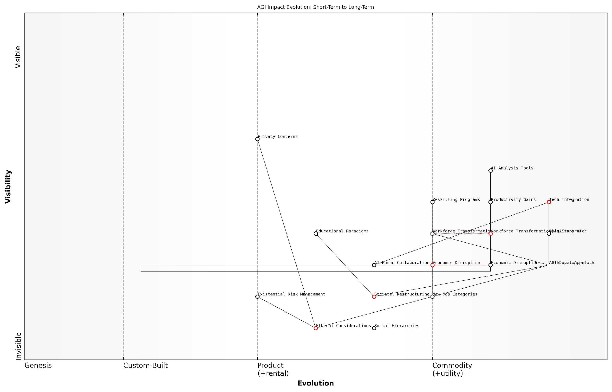

*Draft Wardley Map: [Insert Wardley Map: Short-term vs long-term effects]*

[Edit this draft Wardley Map](https://create.wardleymaps.ai/#clone:0e3570d0d1786fa445)

Wardley Map Assessment

This Wardley Map presents a comprehensive view of the potential impacts of AGI development, from immediate economic effects to long-term societal changes. It highlights the need for a balanced approach that addresses short-term disruptions while preparing for profound long-term transformations. The strategic position is one of both opportunity and responsibility, requiring careful navigation of economic benefits, ethical considerations, and existential risks. Success in this landscape will depend on adaptive strategies, collaborative approaches, and a long-term perspective that considers the full spectrum of AGI’s implications on society.

[View full Wardley Map report](http://markdown_wardley_map_reports/wardley_map_report_40_Short-term_vs_long-term_effects.md)

In conclusion, the comparative impact analysis of short-term versus long-term effects in the AGI race between OpenAI and Anthropic reveals a complex landscape of potential outcomes. While short-term effects are more predictable and immediate, focusing primarily on economic disruption and technological integration, the long-term effects are far-reaching and potentially civilisation-altering. The approach taken by the eventual leader in AGI development will play a crucial role in shaping these outcomes, with significant implications for the future of humanity. As we navigate this unprecedented technological frontier, it is imperative that we remain vigilant, adaptive, and committed to ensuring that the development of AGI aligns with human values and long-term flourishing.

### Global implications and inequalities

As we delve into the comparative impact analysis of OpenAI and Anthropic’s pursuit of Artificial General Intelligence (AGI), it is crucial to examine the global implications and potential inequalities that may arise from this technological race. The development and deployment of AGI have the potential to reshape the global economic and social landscape in unprecedented ways, with far-reaching consequences for both developed and developing nations.

The global implications of AGI development can be broadly categorised into economic, social, and geopolitical dimensions. Each of these areas presents unique challenges and opportunities that must be carefully considered as we navigate the path towards AGI supremacy.

Economic Implications:

* Wealth concentration: The successful development of AGI could lead to unprecedented wealth accumulation for the companies and countries at the forefront of this technology. This may exacerbate existing economic inequalities on a global scale.
* Job market disruption: AGI has the potential to automate a wide range of jobs across various sectors, potentially leading to significant unemployment in certain regions and industries.
* Economic growth acceleration: Conversely, AGI could drive unprecedented economic growth and productivity gains, potentially lifting entire nations out of poverty if properly harnessed and distributed.
* Shift in global economic power: The nations and corporations that successfully develop and deploy AGI may gain significant economic advantages, potentially reshaping the global economic order.

Social Implications:

* Education and skill gaps: The rapid advancement of AGI may create significant disparities in education and skills between nations that can quickly adapt their educational systems and those that cannot.
* Healthcare access: AGI could revolutionise healthcare, but access to these advanced medical technologies may be limited to wealthy nations or individuals, exacerbating global health inequalities.
* Cultural homogenisation: The widespread adoption of AGI systems developed primarily by Western companies like OpenAI and Anthropic may lead to a form of cultural imperialism, potentially eroding local cultural practices and knowledge systems.
* Digital divide: The deployment of AGI may create a new form of digital divide, where access to AGI-powered services becomes a key determinant of social and economic opportunity.

Geopolitical Implications:

* Shift in global power dynamics: Nations that successfully develop or gain access to AGI may experience a significant boost in their geopolitical influence and military capabilities.
* AI arms race: The pursuit of AGI supremacy could spark a new form of arms race, with nations competing to develop the most advanced AI systems for strategic advantage.
* Data colonialism: The need for vast amounts of data to train AGI systems may lead to new forms of data exploitation, particularly in developing nations with less robust data protection regulations.
* Sovereignty concerns: The deployment of powerful AGI systems by private companies like OpenAI and Anthropic may challenge traditional notions of national sovereignty and governance.

The winner of the AGI race will not just reshape their own nation’s future, but will hold in their hands the power to fundamentally alter the course of human civilisation. The implications of this cannot be overstated.

Inequalities in AGI Development and Deployment:

The race for AGI supremacy between OpenAI and Anthropic, while primarily centred in the United States, has global ramifications that could exacerbate existing inequalities or create new ones. Some key areas of concern include:

* Resource disparities: Developing AGI requires vast computational resources and financial investments that are primarily available to wealthy nations and corporations. This could lead to a concentration of AGI capabilities in already-privileged regions.
* Talent brain drain: The pursuit of AGI may accelerate the brain drain from developing nations, as top AI researchers and engineers are attracted to well-funded projects in developed countries.
* Regulatory imbalances: Differences in AI regulation between nations may create ‘AI havens’ where development can proceed with fewer restrictions, potentially compromising safety and ethical considerations.
* Language and cultural biases: AGI systems developed primarily in English-speaking, Western contexts may exhibit biases that disadvantage non-Western cultures and languages.
* Unequal benefits distribution: The economic and social benefits of AGI may be unevenly distributed, with early adopters and developers reaping disproportionate rewards.

Mitigating Global Inequalities:

To address these potential inequalities, it is crucial for OpenAI, Anthropic, and the broader international community to consider the following strategies:

* Global collaboration initiatives: Encourage international partnerships and knowledge-sharing to ensure that AGI development benefits a wider range of nations and cultures.
* Ethical frameworks for AGI deployment: Develop and adhere to robust ethical guidelines that prioritise equitable access and benefits distribution on a global scale.
* Capacity building in developing nations: Invest in AI education and infrastructure in less-developed regions to enable broader participation in AGI development and deployment.
* Multilateral governance structures: Establish international bodies to oversee AGI development and deployment, ensuring that the interests of all nations are represented.
* Open-source initiatives: Promote open-source AGI projects that allow for broader participation and scrutiny from the global community.

The challenge before us is not just to create AGI, but to ensure that its creation benefits all of humanity. This requires a level of global cooperation and foresight unprecedented in human history.

As we assess the comparative impact of OpenAI and Anthropic’s approaches to AGI development, it is essential to consider not only their technical capabilities and ethical frameworks but also their strategies for addressing these global implications and inequalities. The company that can successfully navigate these complex international dynamics may ultimately gain a significant advantage in the race for AGI supremacy.

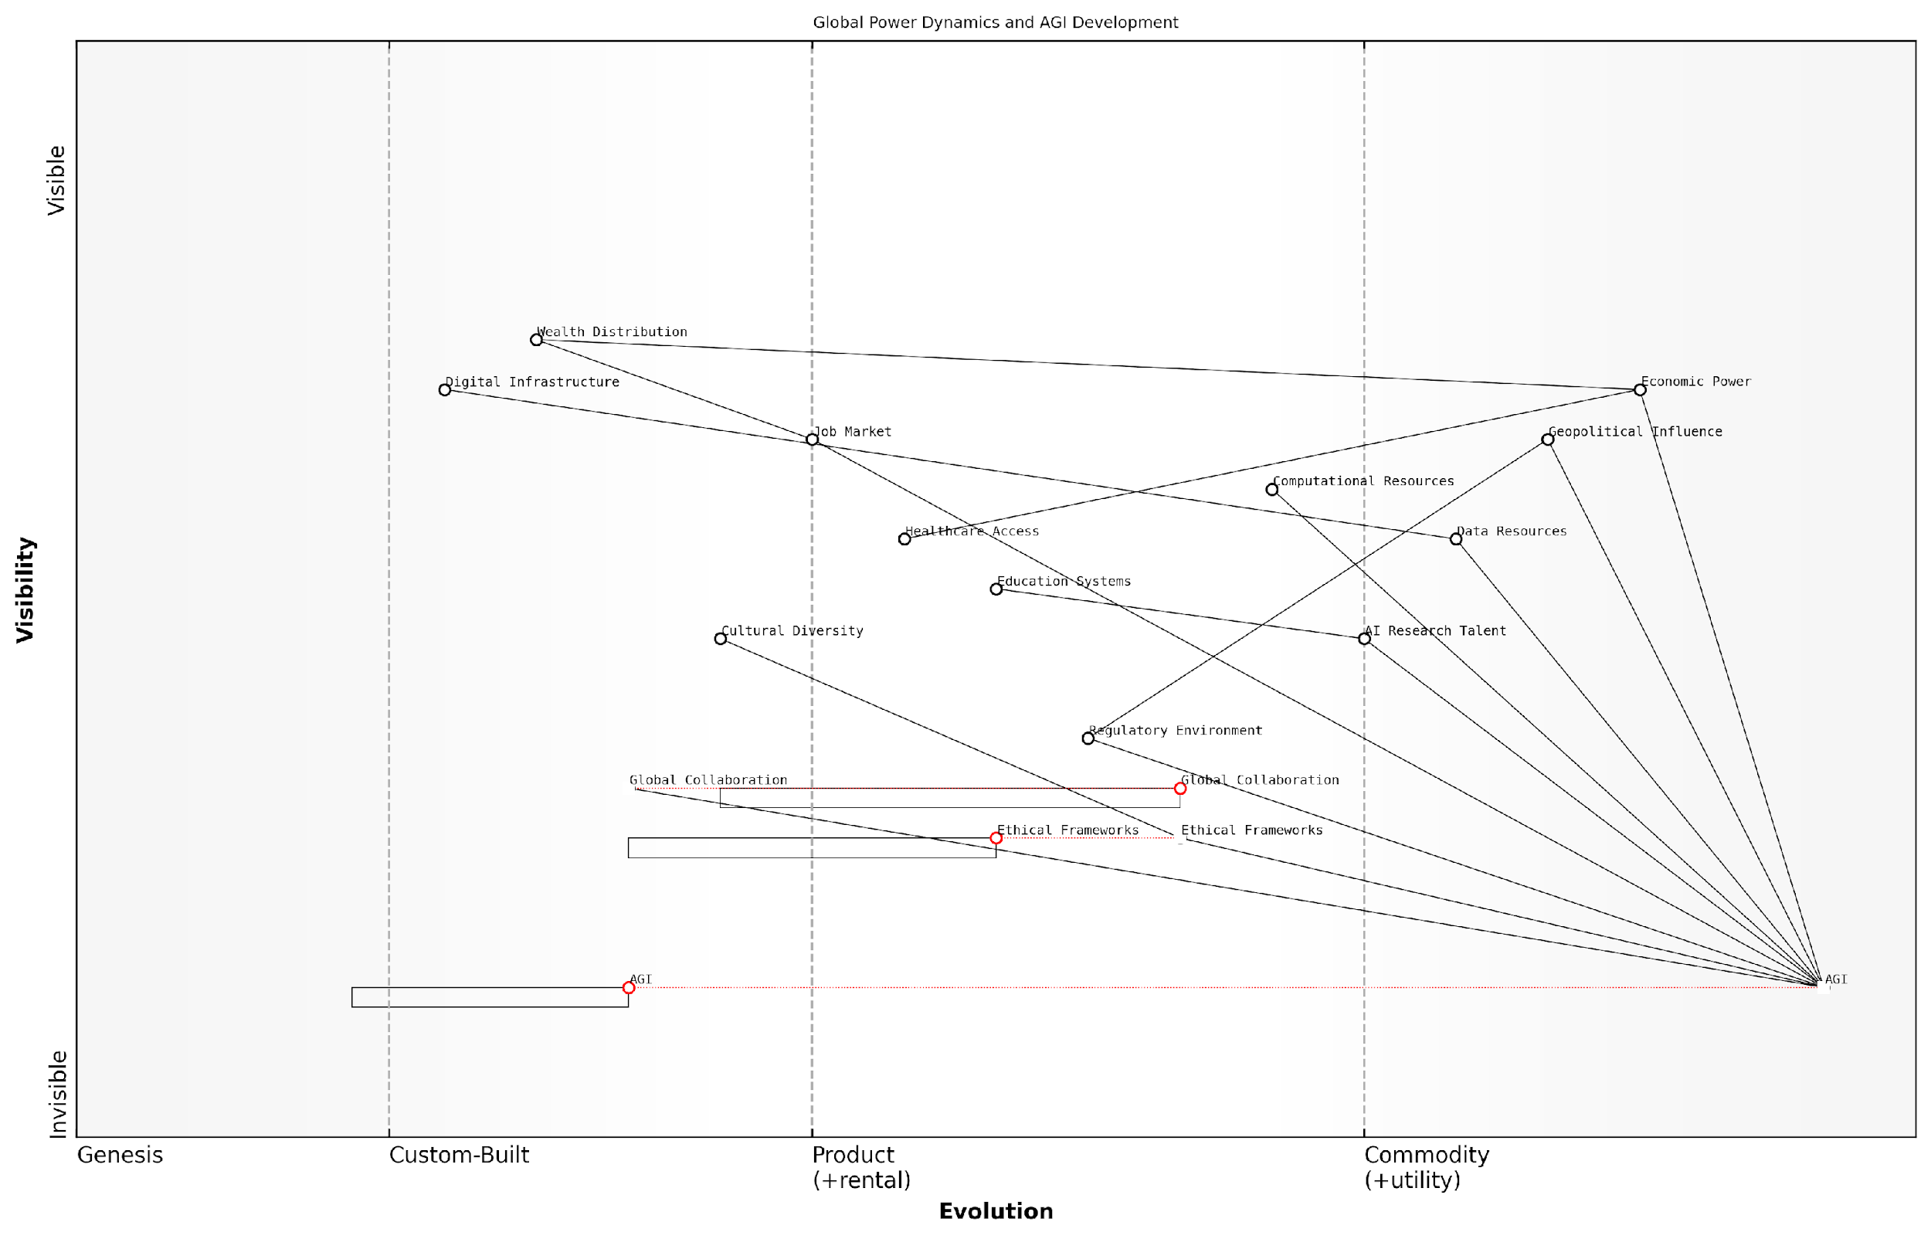

*Draft Wardley Map: [Insert Wardley Map: Global implications and inequalities]*

[Edit this draft Wardley Map](https://create.wardleymaps.ai/#clone:bc33e2bed07cdd7bdf)

Wardley Map Assessment

This Wardley Map reveals a critical juncture in global power dynamics centred around AGI development. The strategic imperative is to accelerate AGI research and development while simultaneously strengthening ethical frameworks, fostering global collaboration, and preparing for significant economic and geopolitical shifts. Success will require balancing competitive advantage with collective benefit, and technological advancement with societal readiness. The next 3-5 years will be crucial in shaping the long-term global impact of AGI, demanding proactive, adaptive, and collaborative strategies from all stakeholders.

[View full Wardley Map report](http://markdown_wardley_map_reports/wardley_map_report_41_Global_implications_and_inequalities.md)

In conclusion, the global implications and potential inequalities arising from the AGI race between OpenAI and Anthropic are profound and multifaceted. As we continue to monitor their progress, it is imperative that we simultaneously work towards creating a global framework that ensures the benefits of AGI are distributed equitably and that potential negative consequences are mitigated. The future of human civilisation may well depend on our ability to manage this technological transition on a truly global scale.

### Potential scenarios for AGI deployment

As we delve into the potential scenarios for AGI deployment, it is crucial to understand the far-reaching implications of this technology on a global scale. The deployment of Artificial General Intelligence (AGI) by either OpenAI or Anthropic could fundamentally reshape our world in ways we can scarcely imagine. This comparative impact analysis will explore various scenarios, considering both short-term and long-term effects, as well as the potential for exacerbating or mitigating global inequalities.

To structure our analysis, we will examine three primary scenarios: a rapid deployment scenario, a gradual integration scenario, and a controlled release scenario. Each of these presents unique challenges and opportunities for society, the economy, and the future of human-AI interaction.

1. Rapid Deployment Scenario

In this scenario, we consider the implications of a sudden breakthrough leading to the rapid deployment of AGI by either OpenAI or Anthropic. This ‘AI explosion’ could result in unprecedented societal upheaval and economic transformation.

* Immediate economic disruption: Entire industries could be revolutionised overnight, leading to mass unemployment and the need for rapid reskilling of the workforce.
* Geopolitical power shifts: The first-mover advantage in AGI deployment could dramatically alter the global balance of power, potentially creating new superpowers or exacerbating existing inequalities.
* Ethical and safety concerns: Rapid deployment may outpace our ability to implement robust safety measures and ethical guidelines, potentially leading to unforeseen consequences.

A rapid AGI deployment could be akin to the Industrial Revolution compressed into a matter of months or even weeks. The societal impact would be profound and potentially destabilising if not managed with extreme care.

1. Gradual Integration Scenario

This scenario envisions a more measured approach to AGI deployment, with incremental advancements and careful integration into existing systems and societal structures.

* Adaptive economic transition: A gradual rollout would allow for more controlled economic shifts, enabling businesses and workers to adapt over time.
* Iterative policy development: Policymakers and regulators would have the opportunity to develop and refine governance frameworks in tandem with AGI advancements.
* Public acclimatisation: A phased approach would give society time to adjust to the presence of AGI, potentially reducing fear and resistance.

Gradual integration of AGI could allow for a more symbiotic relationship between humans and AI, fostering collaboration rather than competition or replacement.

1. Controlled Release Scenario

In this scenario, AGI deployment is heavily regulated and restricted to specific sectors or applications, with stringent oversight and control mechanisms in place.

* Targeted impact: AGI could be initially deployed in high-priority areas such as healthcare, climate change mitigation, or scientific research, maximising benefits while minimising disruption.
* Enhanced safety protocols: Strict control would allow for rigorous testing and refinement of safety measures before wider deployment.
* Managed inequality: By controlling access to AGI, governments and organisations could potentially mitigate the risk of exacerbating global inequalities.

A controlled AGI release strategy could offer the best of both worlds: harnessing the transformative power of AGI while maintaining a high degree of human agency and oversight.

Comparative Analysis of Deployment Scenarios

When comparing these scenarios, it’s essential to consider the unique approaches of OpenAI and Anthropic. OpenAI’s more commercially-oriented strategy might lean towards a faster deployment, potentially aligning with the rapid deployment or gradual integration scenarios. Anthropic’s focus on constitutional AI and long-term safety considerations could favour a more controlled release approach.

Short-term vs Long-term Effects:

* Short-term: Rapid deployment could lead to immediate economic gains but also significant societal disruption. Controlled release might limit initial benefits but provide greater stability.
* Long-term: Gradual integration or controlled release might result in more sustainable and equitable long-term outcomes, while rapid deployment could lead to unpredictable long-term consequences.

Global Implications and Inequalities:

* Rapid deployment could exacerbate existing global inequalities, with technologically advanced nations gaining a significant advantage.
* Controlled release offers the potential to use AGI as a tool for reducing global inequalities, if deployed strategically.
* Gradual integration might allow for more equitable global adoption, but could still see early adopters gaining significant advantages.

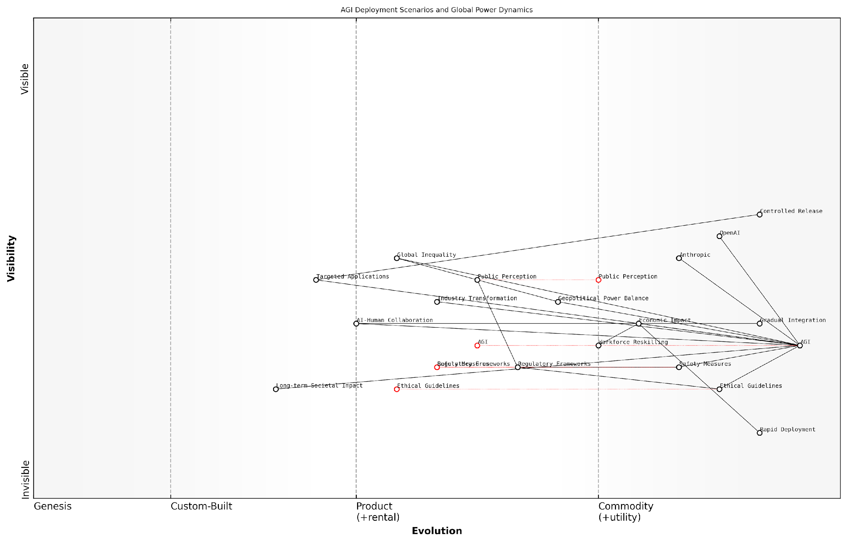

*Draft Wardley Map: [Insert Wardley Map: Potential scenarios for AGI deployment]*

[Edit this draft Wardley Map](https://create.wardleymaps.ai/#clone:239bfe243fce8af9e0)

Wardley Map Assessment

This Wardley Map reveals a critical juncture in AGI development and deployment. The strategic position is one of high potential coupled with significant risks. The key opportunity lies in proactively shaping the AGI landscape through ethical guidelines, safety measures, and adaptive regulatory frameworks. The primary challenges involve managing economic disruption, ensuring equitable benefits, and maintaining geopolitical stability. Success will require unprecedented levels of global cooperation, foresight in policy-making, and agility in workforce development. The entities best positioned for success will be those that can navigate the complex interplay between technological advancement, ethical considerations, and societal impacts, while fostering trust through responsible AGI development and deployment practices.

[View full Wardley Map report](http://markdown_wardley_map_reports/wardley_map_report_42_Potential_scenarios_for_AGI_deployment.md)

In conclusion, the scenario of AGI deployment that ultimately unfolds will likely be influenced by a complex interplay of technological breakthroughs, regulatory frameworks, public opinion, and the strategic decisions of key players like OpenAI and Anthropic. As we stand on the brink of this transformative technology, it is imperative that we carefully consider and plan for these various scenarios, striving to maximise the benefits of AGI while mitigating potential risks and inequalities.

The path we choose for AGI deployment will shape not just our immediate future, but the long-term trajectory of human civilisation. It is a responsibility we must approach with the utmost care, foresight, and ethical consideration.

# The Role of Policy and Regulation

## Current Regulatory Landscape

### AI governance frameworks

As we delve into the current regulatory landscape surrounding Artificial General Intelligence (AGI), it is crucial to examine the evolving AI governance frameworks that are shaping the race between OpenAI and Anthropic. These frameworks serve as the foundation for responsible AI development and deployment, playing a pivotal role in determining which company may ultimately achieve AGI supremacy whilst adhering to ethical and safety standards.

The landscape of AI governance is characterised by a complex interplay of national and international initiatives, industry self-regulation, and multi-stakeholder collaborations. As an expert who has advised numerous government bodies on AI policy, I can attest to the challenges and opportunities these frameworks present in the context of the AGI race.

Let us examine the key components of current AI governance frameworks and their implications for OpenAI and Anthropic:

* Ethical AI Principles: Both national governments and international organisations have developed sets of ethical principles for AI development. These typically include fairness, transparency, accountability, and human-centricity.
* Risk Assessment Mechanisms: Frameworks often include tools and methodologies for assessing the potential risks associated with AI systems, particularly those with high-stakes applications.
* Regulatory Sandboxes: Some jurisdictions have implemented ‘sandbox’ environments where companies can test AGI technologies under regulatory supervision.
* Certification and Auditing Schemes: Emerging frameworks are beginning to incorporate certification processes to ensure AI systems meet predetermined standards of safety and reliability.
* International Cooperation Mechanisms: Given the global nature of AGI development, frameworks increasingly emphasise cross-border collaboration and information sharing.

The implementation of these governance components varies significantly across different regions, creating a complex regulatory environment for OpenAI and Anthropic to navigate. In my experience advising on international AI policy, I’ve observed that this variability can create both opportunities and challenges for AGI developers.

The patchwork of AI governance frameworks across the globe presents a unique challenge for AGI developers. Companies must not only comply with diverse regulations but also anticipate future policy directions to maintain their competitive edge.

One of the most significant developments in AI governance has been the European Union’s proposed AI Act. This comprehensive legislation aims to create a risk-based regulatory framework for AI, with stringent requirements for high-risk AI systems. The implications for AGI development are profound, as both OpenAI and Anthropic will likely need to ensure their technologies comply with these regulations to operate in the EU market.

In the United States, the approach to AI governance has been more decentralised, with a focus on sector-specific regulations and voluntary guidelines. The National AI Initiative Act of 2020 established a coordinated federal strategy for AI research and development, but stops short of creating a comprehensive regulatory framework. This environment potentially offers more flexibility for AGI developers but also creates uncertainty about future regulatory requirements.

China, another major player in the global AI landscape, has taken a more centralised approach to AI governance. The country’s New Generation Artificial Intelligence Development Plan outlines a strategy for achieving AI supremacy, including the development of ethical norms and regulations. This state-driven approach creates a distinct regulatory environment that OpenAI and Anthropic must consider in their global strategies.

The divergent approaches to AI governance between major global powers are creating a complex geopolitical landscape for AGI development. Companies must navigate these waters carefully to avoid being caught in regulatory crossfire.

International organisations are also playing a crucial role in shaping AI governance frameworks. The OECD AI Principles, adopted by 42 countries, provide a set of complementary values-based principles for the responsible stewardship of trustworthy AI. Similarly, UNESCO has developed a Recommendation on the Ethics of AI, which aims to provide a global ethical framework for the development and use of AI.

These international efforts are particularly relevant to the AGI race between OpenAI and Anthropic, as they seek to establish global norms and standards for AI development. Adherence to these principles could become a key differentiator in the companies’ pursuit of AGI, potentially influencing public trust and regulatory approval.

From my experience working with government agencies on AI policy, I can attest to the growing emphasis on ‘AI assurance’ within governance frameworks. This concept encompasses a range of practices and tools designed to ensure AI systems are safe, ethical, and reliable throughout their lifecycle. For OpenAI and Anthropic, demonstrating robust AI assurance mechanisms could be crucial in gaining regulatory approval for their AGI technologies.

Another key trend in AI governance is the move towards ‘algorithmic impact assessments’ (AIAs). These assessments, which are becoming mandatory in some jurisdictions, require companies to evaluate the potential societal impacts of their AI systems before deployment. As OpenAI and Anthropic push the boundaries of AGI capabilities, conducting comprehensive AIAs will likely become an integral part of their development processes.

The governance frameworks also increasingly emphasise the need for human oversight and control, particularly for high-risk AI applications. This presents a unique challenge for AGI development, as the very nature of artificial general intelligence implies a level of autonomy that may test the limits of human control. Both OpenAI and Anthropic will need to grapple with this tension as they advance their AGI technologies.

The challenge of maintaining meaningful human oversight over increasingly autonomous AI systems is one of the most pressing issues in AGI governance. It requires us to rethink our traditional notions of control and accountability.

In conclusion, the current landscape of AI governance frameworks presents a complex and evolving regulatory environment for the AGI race between OpenAI and Anthropic. Success in this race will not only depend on technical innovation but also on the ability to navigate, influence, and comply with these governance structures. As the regulatory landscape continues to evolve, both companies must remain agile, proactively engaging with policymakers and continuously adapting their strategies to align with emerging governance frameworks.

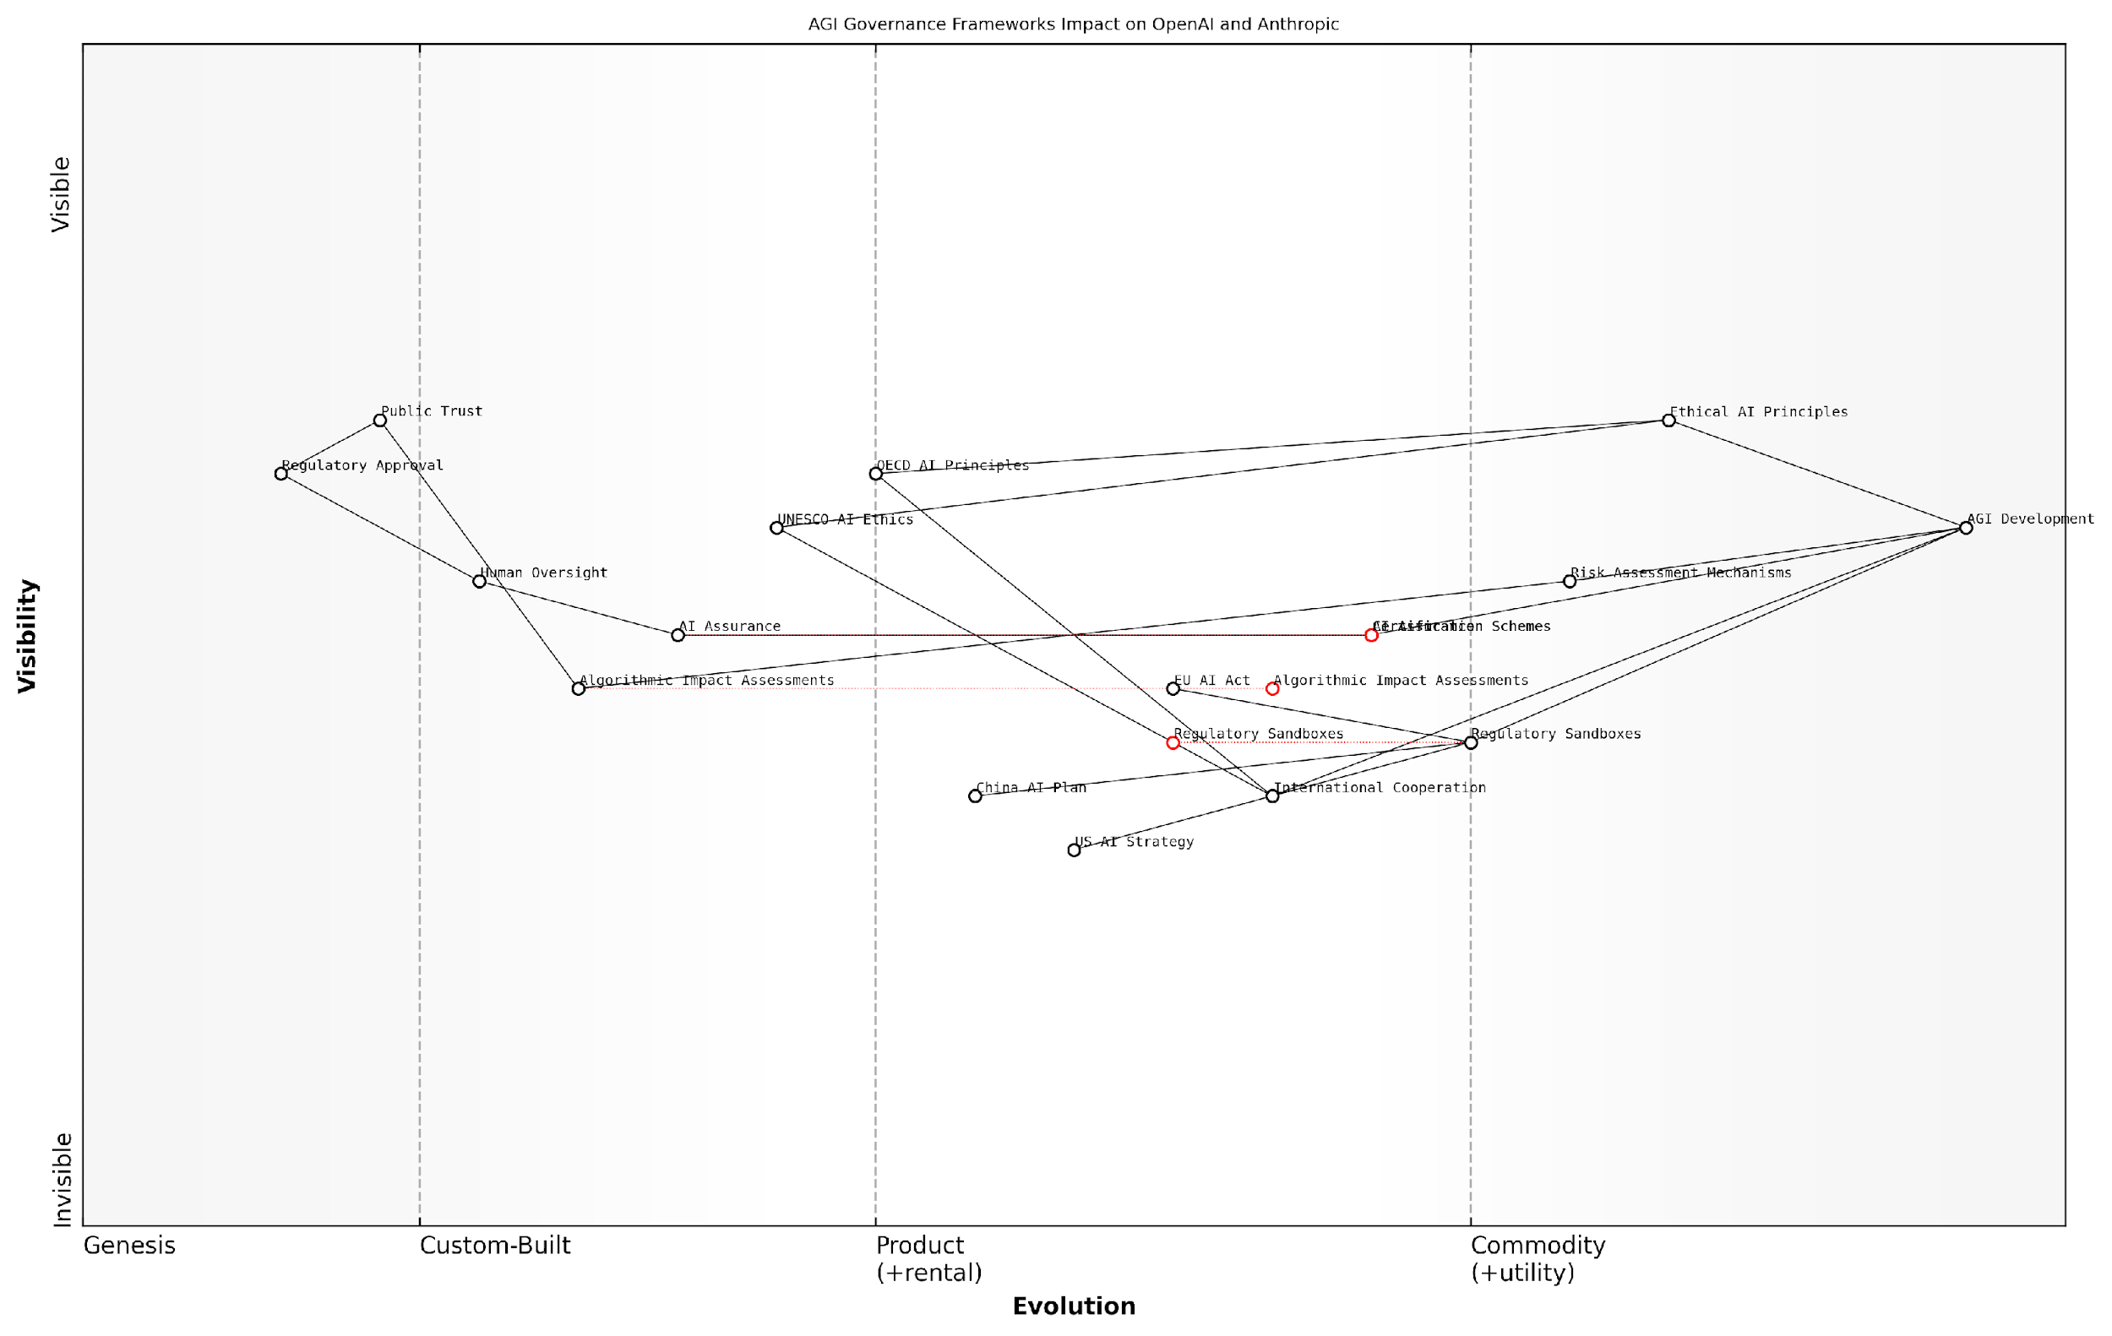

*Draft Wardley Map: [Insert Wardley Map: AI governance frameworks]*

[Edit this draft Wardley Map](https://create.wardleymaps.ai/#clone:e9904e3f14a67e1a65)

Wardley Map Assessment

The map reveals a strategic landscape where responsible AGI development is paramount, necessitating a delicate balance between innovation and governance. Companies like OpenAI and Anthropic are positioned at the forefront of shaping ethical AI principles and risk assessment mechanisms, while navigating an evolving regulatory environment. Success will likely depend on their ability to innovate within governance frameworks, lead in establishing industry standards, and build public trust through transparent and responsible AGI development practices. The rapidly evolving nature of the field presents both significant opportunities and risks, emphasising the need for agile strategy adaptation and proactive engagement with diverse stakeholders in the global AI governance ecosystem.

[View full Wardley Map report](http://markdown_wardley_map_reports/wardley_map_report_43_AI_governance_frameworks.md)

### International cooperation and competition

The current regulatory landscape surrounding Artificial General Intelligence (AGI) development is characterised by a complex interplay of international cooperation and competition. As the race between OpenAI and Anthropic intensifies, nations and international bodies are grappling with the challenge of fostering innovation whilst mitigating potential risks. This delicate balance is shaping the global approach to AGI governance and influencing the strategies of key players in the field.

International cooperation in AGI regulation has seen significant strides in recent years, with several notable initiatives emerging:

* The Global Partnership on Artificial Intelligence (GPAI), launched in 2020, brings together 25 countries to promote responsible AI development.
* The OECD AI Principles, adopted by 42 countries, provide a framework for trustworthy AI systems.
* The EU’s proposed AI Act aims to establish a comprehensive regulatory framework for AI, potentially influencing global standards.

These collaborative efforts reflect a growing recognition of the transnational nature of AGI development and its potential impacts. However, the landscape is far from uniform, with significant variations in regulatory approaches across different regions.

The challenge we face is not just about regulating AGI, but about creating a global consensus on its development and deployment. Without international cooperation, we risk a fragmented approach that could compromise safety and ethics in the pursuit of technological supremacy.

Alongside cooperation, there is an undercurrent of competition in the AGI regulatory landscape. Nations are vying to position themselves as leaders in AI governance, recognising the strategic importance of shaping the rules that will govern this transformative technology. This competitive aspect is evident in several ways:

* Regulatory sandboxes: Countries like the UK, Singapore, and Japan have established AI regulatory sandboxes to attract innovation and inform policy development.
* Investment in AI research: Major powers such as the US, China, and the EU are significantly increasing funding for AI research and development, often with a focus on AGI.
* Strategic partnerships: Governments are forming alliances with leading AI companies, including OpenAI and Anthropic, to gain a competitive edge in AGI development.

The competitive dimension of AGI regulation presents both opportunities and challenges. On one hand, it can drive innovation and accelerate the development of robust governance frameworks. On the other, it risks creating a ‘race to the bottom’ in terms of safety standards and ethical considerations.

For OpenAI and Anthropic, navigating this complex regulatory landscape is crucial to their success in the AGI race. Both companies must balance their pursuit of technological breakthroughs with the need to comply with evolving international standards and contribute to the development of responsible AI governance.

In my experience advising government bodies on AI policy, I’ve observed that the companies that thrive in this environment are those that proactively engage with regulators and contribute to the development of governance frameworks. It’s not just about compliance; it’s about shaping the future of AGI regulation.

The current regulatory landscape also presents challenges specific to AGI development:

* Definitional issues: There is ongoing debate about how to define and identify AGI, making it difficult to create targeted regulations.
* Pace of innovation: The rapid advancement of AI technology often outpaces regulatory processes, creating a constant need for adaptation.
* Balancing openness and security: Regulators must strike a balance between promoting transparency in AGI research and protecting national security interests.
* Ethical considerations: Addressing the complex ethical implications of AGI requires unprecedented levels of international cooperation and consensus-building.

As the AGI race between OpenAI and Anthropic unfolds, the evolving regulatory landscape will play a crucial role in shaping their strategies and ultimate success. Both companies must navigate the complex web of international cooperation and competition, engaging with regulators, contributing to governance frameworks, and adapting to emerging standards.

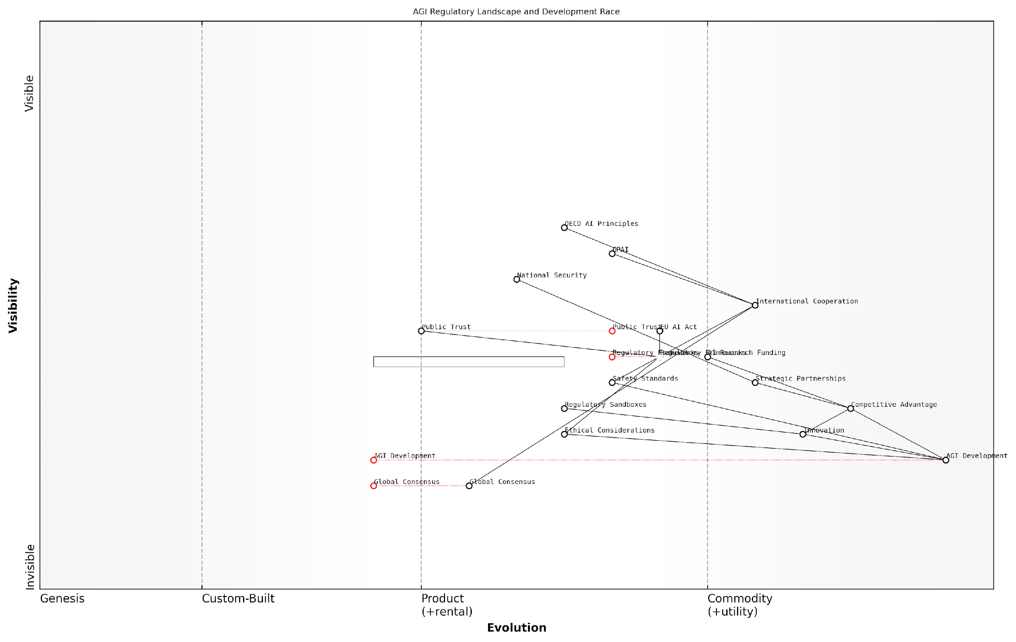

*Draft Wardley Map: [Insert Wardley Map: International cooperation and competition]*

[Edit this draft Wardley Map](https://create.wardleymaps.ai/#clone:3b21857d336fabd540)

Wardley Map Assessment

This Wardley Map reveals a dynamic and complex landscape in the AGI development race. While technological progress is rapid, there is a critical need to accelerate the development of regulatory frameworks, ethical standards, and international cooperation. The strategic focus should be on bridging the gap between innovation and governance, fostering a responsible and trusted AGI development ecosystem. Key actions include investing in regulatory sandboxes, strengthening international partnerships, and deeply integrating ethical considerations into the development process. The future success in this domain will likely depend on the ability to balance competitive advantage with collaborative global governance.

[View full Wardley Map report](http://markdown_wardley_map_reports/wardley_map_report_44_International_cooperation_and_competition.md)

Looking ahead, the future of AGI regulation will likely be characterised by increased international collaboration, as the global community recognises the need for a coordinated approach to govern this transformative technology. However, competitive elements will persist, driven by the strategic importance of AGI leadership. The challenge for policymakers, and indeed for OpenAI and Anthropic, will be to harness this competition to drive innovation and safety standards, rather than compromising on ethical considerations in the pursuit of technological supremacy.

The winner of the AGI race will not necessarily be the company that develops the technology first, but the one that does so in a manner that aligns with evolving international standards and earns the trust of governments and society at large.

In conclusion, the current regulatory landscape for AGI is a complex tapestry of international cooperation and competition. As OpenAI and Anthropic push the boundaries of AI technology, they must navigate this landscape carefully, engaging with regulators, contributing to governance frameworks, and adapting to emerging standards. The ultimate success in the AGI race will depend not just on technological prowess, but on the ability to align innovation with the evolving global consensus on responsible AI development.

### Challenges in regulating AGI development

The regulation of Artificial General Intelligence (AGI) development presents a complex and multifaceted challenge that sits at the intersection of rapidly advancing technology, ethical considerations, and global governance. As we navigate the intense competition between OpenAI and Anthropic in the race towards AGI, the need for effective regulatory frameworks becomes increasingly urgent. However, the unique nature of AGI and its potential far-reaching impacts create significant hurdles for policymakers and regulators worldwide.

To fully appreciate the challenges in regulating AGI development, we must consider several key areas:

* Technological Complexity and Rapid Advancement
* Jurisdictional Issues and Global Coordination
* Balancing Innovation and Safety
* Defining and Measuring AGI Capabilities
* Ethical and Philosophical Considerations
* Enforcement and Compliance Mechanisms

Technological Complexity and Rapid Advancement:

One of the primary challenges in regulating AGI development is the sheer complexity and rapid pace of technological advancement in the field. AGI systems, by their very nature, are designed to possess general problem-solving abilities across a wide range of domains, making it difficult for regulators to fully grasp the technical intricacies and potential implications of these systems.

The pace of AI advancement often outstrips our ability to fully understand its implications, let alone regulate it effectively. We’re constantly playing catch-up, trying to create frameworks for technologies that may already be obsolete by the time regulations are implemented.

This rapid advancement poses significant challenges for regulators, who must strive to create flexible and adaptable frameworks that can keep pace with technological progress while still providing meaningful oversight. The risk of over-regulation stifling innovation must be carefully balanced against the need for adequate safeguards.

Jurisdictional Issues and Global Coordination:

AGI development is a global endeavour, with companies like OpenAI and Anthropic operating across international borders. This global nature of AGI research and development creates significant jurisdictional challenges for regulators. Different countries may have varying approaches to AI governance, creating potential regulatory arbitrage opportunities and complicating efforts to establish consistent global standards.

The development of AGI is not confined to any single nation. We need a coordinated global approach to regulation, but achieving consensus among countries with different priorities, values, and levels of technological advancement is a Herculean task.

Efforts to create international frameworks for AGI governance, such as the proposed AI treaties and guidelines from organisations like the OECD and UNESCO, face significant hurdles in terms of implementation and enforcement. The competitive nature of AGI development, particularly between major powers like the United States and China, further complicates attempts at global coordination.

Balancing Innovation and Safety:

Perhaps the most delicate challenge in regulating AGI development is striking the right balance between fostering innovation and ensuring safety. Overly restrictive regulations could potentially hamper progress and give an advantage to less scrupulous actors, while insufficient oversight could lead to the development of unsafe AGI systems with catastrophic consequences.

We’re walking a tightrope between enabling the potential benefits of AGI and safeguarding against existential risks. Too much regulation could push development underground or offshore, while too little could lead to a technological Wild West.

This balancing act is particularly evident in the approaches taken by OpenAI and Anthropic. While both companies emphasise the importance of safety, their specific methodologies and risk tolerances differ. Regulators must find ways to accommodate diverse approaches to AGI development while still maintaining robust safety standards.

Defining and Measuring AGI Capabilities:

A fundamental challenge in regulating AGI development is the difficulty in precisely defining and measuring AGI capabilities. Unlike narrow AI systems designed for specific tasks, AGI aims to possess general intelligence comparable to or surpassing human-level cognition across a wide range of domains. This broad and somewhat nebulous goal makes it challenging to establish clear regulatory thresholds or benchmarks.

How do we regulate something we can’t yet fully define or measure? AGI exists more as a concept than a concrete reality at this point, making it incredibly difficult to create specific, enforceable regulations.

Regulators must grapple with questions such as: At what point does an AI system transition from narrow AI to AGI? How can we measure and verify the capabilities of purported AGI systems? These definitional and measurement challenges complicate efforts to create targeted regulations for AGI development.

Ethical and Philosophical Considerations:

The development of AGI raises profound ethical and philosophical questions that regulators must contend with. Issues such as AI consciousness, rights for artificial entities, and the potential existential risks posed by superintelligent AGI systems go beyond traditional regulatory concerns and venture into uncharted ethical territory.

We’re not just regulating a technology; we’re potentially shaping the future of intelligence itself. The ethical implications are staggering, and our current philosophical frameworks may be inadequate to fully address them.

Regulators must navigate these complex ethical considerations while also addressing more immediate concerns such as bias, transparency, and accountability in AGI systems. The approaches taken by OpenAI and Anthropic, particularly Anthropic’s focus on ‘Constitutional AI’, highlight the importance of embedding ethical considerations directly into AGI development processes.

Enforcement and Compliance Mechanisms:

Even if robust regulatory frameworks for AGI development can be established, enforcing compliance and verifying adherence to these regulations presents significant challenges. The complexity and potential opacity of AGI systems make it difficult to audit and ensure compliance with regulatory standards.

Traditional regulatory enforcement mechanisms may be inadequate for AGI. We need to develop new tools and methodologies for auditing and verifying compliance, potentially leveraging AI itself to regulate AI.

Regulators must consider innovative approaches to enforcement, such as embedded oversight mechanisms, continuous monitoring systems, and international cooperation on AGI governance. The potential for AGI systems to evolve and self-modify further complicates enforcement efforts, requiring adaptive and responsive regulatory approaches.

In conclusion, the challenges in regulating AGI development are numerous and complex, requiring a nuanced and adaptive approach from policymakers and regulators. As OpenAI and Anthropic continue their race towards AGI, the need for effective regulatory frameworks becomes increasingly urgent. Addressing these challenges will require unprecedented levels of international cooperation, interdisciplinary expertise, and innovative regulatory approaches to ensure that the development of AGI proceeds in a manner that is safe, ethical, and beneficial to humanity.

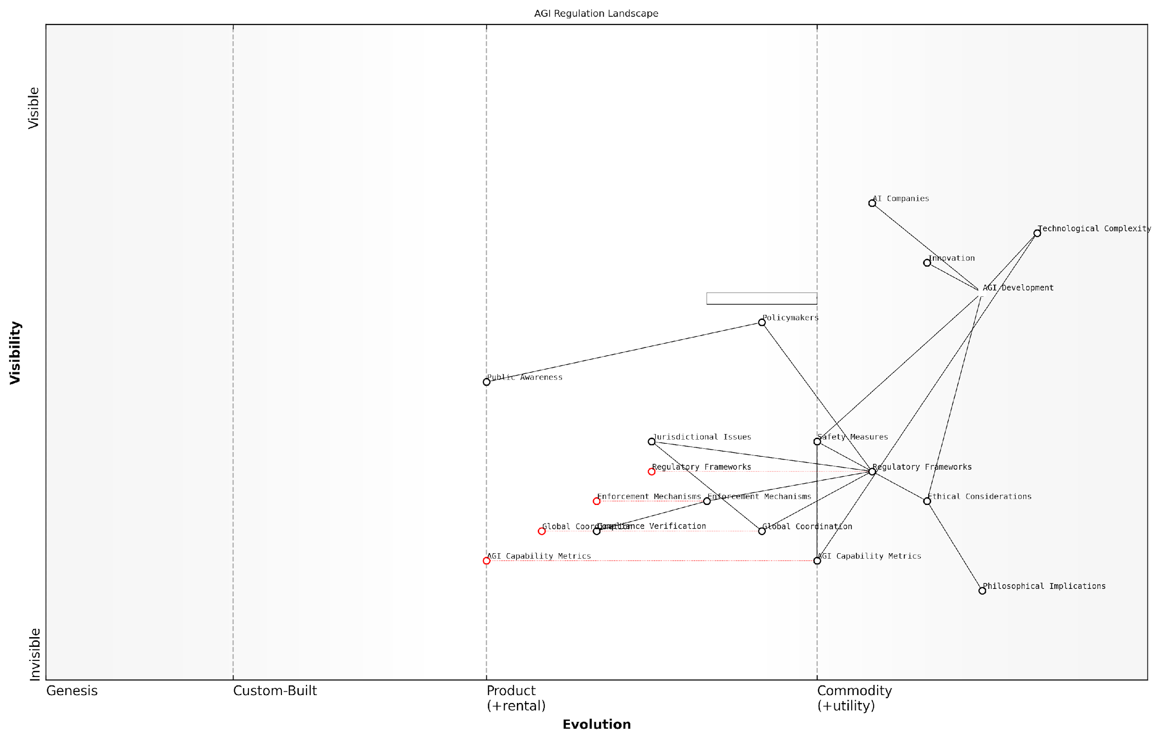

*Draft Wardley Map: [Insert Wardley Map: Challenges in regulating AGI development]*

[Edit this draft Wardley Map](https://create.wardleymaps.ai/#clone:5e5ff7275a89d464b0)

Wardley Map Assessment

The map reveals a rapidly evolving and complex landscape of AGI regulation. While technological development is advanced, regulatory and coordination efforts lag behind. The key strategic focus should be on accelerating the development of adaptive regulatory frameworks, enhancing global coordination, and investing in robust safety measures and capability metrics. Balancing innovation with responsible development and ethical considerations will be crucial. The success of AGI regulation will depend on closing the gap between technological advancement and regulatory capabilities, addressing jurisdictional challenges, and fostering a collaborative global approach to governance.

[View full Wardley Map report](http://markdown_wardley_map_reports/wardley_map_report_45_Challenges_in_regulating_AGI_development.md)

## OpenAI and Anthropic’s Regulatory Engagement

### Policy advocacy and influence

In the high-stakes race towards Artificial General Intelligence (AGI), OpenAI and Anthropic have recognised the critical importance of engaging with policymakers and regulators. Their policy advocacy and influence strategies play a pivotal role in shaping the regulatory landscape that will ultimately govern AGI development and deployment. This subsection examines the approaches taken by both companies to navigate the complex intersection of cutting-edge technology and public policy.

OpenAI’s approach to policy advocacy has been characterised by a proactive and collaborative stance. The company has consistently emphasised the need for responsible AI development and has actively sought to engage with policymakers to help shape regulations that balance innovation with safety considerations.

* Engagement with government bodies: OpenAI has established relationships with key regulatory agencies and legislative committees, providing expert testimony and technical briefings on AGI developments.
* Public-private partnerships: The company has initiated collaborative projects with government entities to demonstrate the potential benefits of AGI in areas such as healthcare and climate change mitigation.
* Transparency initiatives: OpenAI has championed increased transparency in AI research, advocating for policies that promote responsible information sharing within the industry.

Anthropic, on the other hand, has taken a more nuanced approach to policy advocacy, focusing on the long-term implications of AGI and the need for robust governance frameworks.

* Ethical AI frameworks: Anthropic has been at the forefront of developing and promoting ethical AI guidelines, advocating for their incorporation into regulatory frameworks.
* Long-term safety considerations: The company has emphasised the importance of addressing existential risks associated with AGI in policy discussions, pushing for regulations that consider potential far-future scenarios.
* Interdisciplinary collaboration: Anthropic has fostered partnerships with academic institutions and think tanks to produce policy recommendations that draw on diverse expertise.

Both companies have employed a range of strategies to influence policy development, including:

* Thought leadership: Publishing white papers, research articles, and opinion pieces to shape public discourse on AGI regulation.
* Industry coalitions: Participating in and sometimes leading industry groups to present a unified voice on key regulatory issues.
* Direct lobbying: Engaging with legislators and policymakers to advocate for specific regulatory approaches or to provide expert input on proposed legislation.
* Public education initiatives: Launching campaigns to increase public understanding of AGI and its potential impacts, thereby indirectly influencing policy through public opinion.

The race to AGI is not just about technological breakthroughs; it’s equally about shaping the regulatory environment in which these breakthroughs will occur. The company that can most effectively influence policy may well gain a decisive advantage in the long run.

The effectiveness of these advocacy efforts has varied, with both companies achieving notable successes and facing challenges. OpenAI’s more public-facing approach has garnered significant attention and has helped to establish the company as a key voice in AGI policy discussions. However, this visibility has also attracted scrutiny, particularly regarding the potential concentration of power in AGI development.

Anthropic’s focus on long-term safety and ethical considerations has resonated with policymakers concerned about the existential risks of AGI. However, translating these complex, future-oriented concepts into actionable policy has proven challenging.

A key area of divergence in the companies’ advocacy approaches lies in their stance on the pace of AGI development and regulation. OpenAI has generally advocated for a more rapid development timeline, arguing that swift progress is necessary to ensure that AGI is developed responsibly and by actors committed to its beneficial use. Anthropic, conversely, has often emphasised the need for a more measured approach, advocating for robust safety precautions and governance structures to be in place before significant advances are made.

This difference in philosophy has led to some tension in policy circles, with policymakers grappling with how to balance the potential benefits of rapid AGI development against the risks of inadequate safeguards.

The divergent approaches of OpenAI and Anthropic to policy advocacy reflect deeper philosophical differences about the nature of AGI development and its governance. These differences are likely to shape the regulatory landscape for years to come.

As the race towards AGI intensifies, the policy advocacy efforts of both OpenAI and Anthropic are likely to become increasingly sophisticated and influential. The company that can most effectively navigate the complex interplay between technological innovation, ethical considerations, and regulatory frameworks may well gain a decisive advantage in the pursuit of AGI supremacy.

In conclusion, the policy advocacy and influence strategies employed by OpenAI and Anthropic represent a critical battleground in the race towards AGI. As these companies continue to push the boundaries of AI technology, their ability to shape the regulatory environment will play a crucial role in determining not only their own success but also the future trajectory of AGI development and its impact on society.

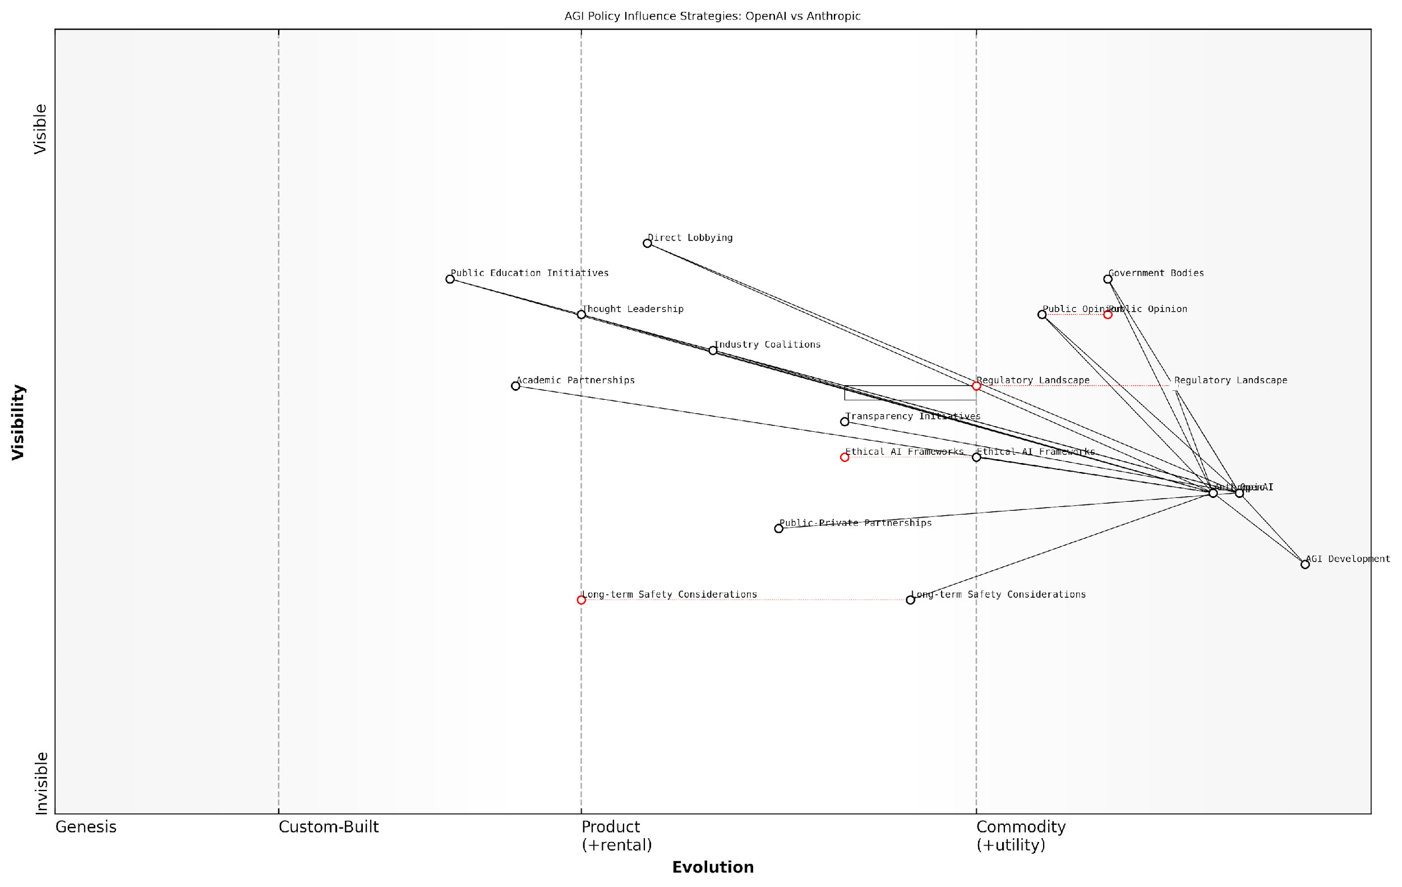

*Draft Wardley Map: [Insert Wardley Map: Policy advocacy and influence]*

[Edit this draft Wardley Map](https://create.wardleymaps.ai/#clone:07d414ed641748878c)

Wardley Map Assessment

The map reveals a strategic landscape where OpenAI and Anthropic are well-positioned in AGI development but face challenges in navigating the complex policy environment. Both companies have opportunities to strengthen their influence by focusing on ethical frameworks, transparency, and long-term safety. The key to success will be balancing competitive advantage with collaborative efforts to ensure responsible AGI development. Moving forward, the ability to shape public opinion and regulatory frameworks through evolved, transparent practices will be crucial for maintaining a leadership position in the AGI race while ensuring societal benefit and safety.

[View full Wardley Map report](http://markdown_wardley_map_reports/wardley_map_report_46_Policy_advocacy_and_influence.md)

### Compliance strategies

In the high-stakes race towards Artificial General Intelligence (AGI), compliance strategies have emerged as a critical differentiator between OpenAI and Anthropic. As these two titans navigate the complex regulatory landscape, their approaches to compliance not only shape their development trajectories but also influence the broader AGI ecosystem. This section delves into the nuanced compliance strategies employed by OpenAI and Anthropic, examining how they balance innovation with regulatory adherence in their pursuit of AGI supremacy.

OpenAI’s Compliance Approach:

* Proactive Engagement: OpenAI has adopted a proactive stance in engaging with regulators, often participating in policy discussions and contributing to the development of AI governance frameworks.
* Transparency Initiatives: The company has implemented robust transparency measures, including the publication of technical papers and model details, to foster trust and facilitate regulatory oversight.
* Staged Release Strategy: OpenAI’s approach of releasing AI models in stages, as seen with GPT-3 and GPT-4, allows for iterative compliance adjustments and real-world testing of safety measures.
* Internal Ethics Board: The establishment of an internal ethics review process ensures that compliance considerations are integrated into the development pipeline from the outset.

Anthropic’s Compliance Strategy:

* Constitutional AI Framework: Anthropic’s pioneering work in Constitutional AI forms the cornerstone of its compliance strategy, embedding ethical considerations and regulatory alignment directly into its AI systems.
* Collaborative Research: The company actively collaborates with academic institutions and regulatory bodies to develop compliance standards that are both rigorous and innovation-friendly.
* Long-term Safety Focus: Anthropic’s compliance approach is characterised by a strong emphasis on long-term safety considerations, often going beyond current regulatory requirements to address potential future challenges.
* Transparent Development Process: By maintaining a high degree of transparency in its research and development processes, Anthropic aims to build trust with regulators and facilitate easier compliance audits.

Comparative Analysis:

While both OpenAI and Anthropic demonstrate a commitment to regulatory compliance, their strategies reveal distinct philosophical approaches. OpenAI’s compliance strategy appears more focused on navigating the current regulatory landscape, with a keen eye on market deployment and scalability. In contrast, Anthropic’s approach seems to prioritise long-term ethical considerations and the development of inherently compliant AI systems, even at the potential cost of slower market penetration.

The divergence in compliance strategies between OpenAI and Anthropic reflects a fundamental tension in the AGI race: the balance between rapid innovation and robust safety measures. As a senior policy advisor notes, ‘The company that successfully navigates this tightrope may well emerge as the leader in responsible AGI development.’

Implications for the AGI Race:

* Regulatory Influence: The compliance strategies adopted by OpenAI and Anthropic are likely to influence future regulatory frameworks, potentially shaping the rules of engagement for the entire AGI field.
* Public Trust: The effectiveness of these compliance strategies in building public trust could be a decisive factor in determining which company gains broader acceptance and support for their AGI endeavours.
* Development Speed: The balance between compliance and innovation may impact the speed of AGI development, with potential trade-offs between regulatory adherence and technological breakthroughs.
* Global Competitiveness: As different regions adopt varying regulatory stances, the adaptability of these compliance strategies to diverse global requirements could affect each company’s international competitiveness.

Case Study: The GPT-4 Release

OpenAI’s release of GPT-4 provides a compelling case study in compliance strategy execution. The company employed a phased rollout, initially limiting access to vetted partners and gradually expanding availability. This approach allowed OpenAI to monitor real-world performance, assess potential risks, and make necessary adjustments before wider deployment. Notably, OpenAI engaged proactively with regulators, providing detailed information about the model’s capabilities and limitations.

In contrast, Anthropic’s development of Claude, while less publicised, showcased a different compliance approach. The company emphasised the integration of ethical constraints and safety measures directly into the AI system, aligning with their Constitutional AI principles. This strategy prioritised building a fundamentally compliant system from the ground up, potentially at the cost of a slower development cycle.

A leading AI ethics researcher observes, ‘The contrasting approaches to the development and release of advanced language models by OpenAI and Anthropic serve as a microcosm of their broader compliance strategies. It highlights the ongoing debate between rapid iteration with safeguards versus foundational safety by design.’

Future Outlook:

As the AGI race intensifies, the effectiveness of these compliance strategies will be put to the test. The company that can most adeptly balance regulatory compliance with technological innovation may gain a significant advantage. However, the dynamic nature of AI regulation means that both OpenAI and Anthropic must remain agile, continuously adapting their compliance strategies to evolving regulatory landscapes.

In conclusion, the compliance strategies adopted by OpenAI and Anthropic represent more than mere regulatory adherence; they embody fundamental philosophies about the responsible development of AGI. As these strategies continue to evolve, they will play a crucial role in shaping not only the outcome of the AGI race but also the future of human-AI interaction and governance.

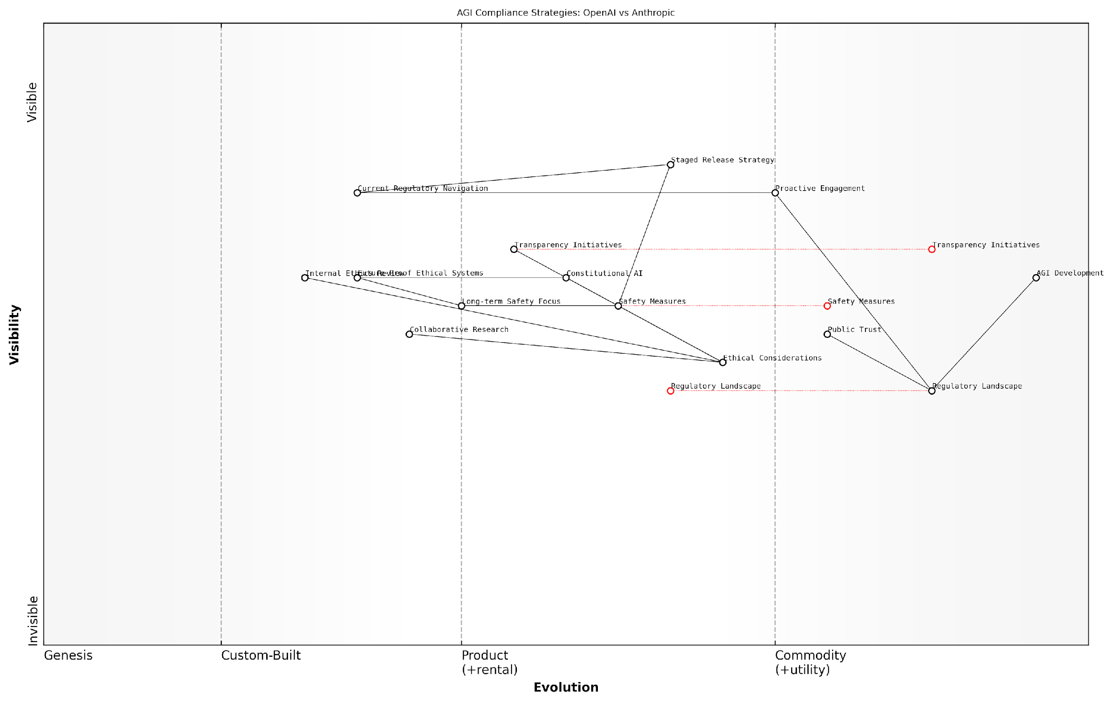

*Draft Wardley Map: [Insert Wardley Map: Compliance strategies]*

[Edit this draft Wardley Map](https://create.wardleymaps.ai/#clone:0bf0e70341c561e0d5)

Wardley Map Assessment

The map reveals a strategic landscape where AGI development is inextricably linked with ethical considerations, regulatory compliance, and public trust. Both OpenAI and Anthropic are well-positioned but face significant challenges in navigating this complex environment. The key to success lies in balancing rapid innovation with robust safety measures, proactive regulatory engagement, and a strong commitment to ethical AI development. Companies that can effectively integrate future-proof ethical systems, maintain public trust, and stay ahead of evolving regulations will likely emerge as leaders in the AGI race. The emphasis on transparency and collaborative research suggests a potential shift towards a more open and cooperative industry model, which could accelerate progress while mitigating risks.

[View full Wardley Map report](http://markdown_wardley_map_reports/wardley_map_report_47_Compliance_strategies.md)

### Collaboration with regulators

In the high-stakes race towards Artificial General Intelligence (AGI), collaboration with regulators has emerged as a critical factor that could significantly influence the outcome. Both OpenAI and Anthropic have recognised the importance of engaging proactively with regulatory bodies to shape the evolving landscape of AI governance. This subsection explores the nuanced approaches these two frontrunners have adopted in their regulatory engagement, highlighting the potential impact on their respective paths to AGI supremacy.

OpenAI’s Collaborative Stance:

* Proactive Engagement: OpenAI has consistently demonstrated a willingness to engage with regulators, often taking the initiative to open dialogues on emerging AI challenges.
* Transparency Initiatives: The company has implemented transparency measures, such as publishing technical papers and model details, to facilitate regulatory understanding and oversight.
* Policy Recommendations: OpenAI has been active in proposing policy frameworks, contributing to the development of AI governance structures.
* Regulatory Sandboxes: Participation in regulatory sandboxes to test AI applications in controlled environments, fostering trust and understanding with regulatory bodies.

Anthropic’s Regulatory Approach:

* Ethics-First Engagement: Anthropic’s interactions with regulators are deeply rooted in its constitutional AI principles, emphasising the alignment of AI systems with human values.
* Long-term Safety Focus: The company prioritises discussions on long-term AI safety with regulators, advocating for frameworks that address existential risks.
* Collaborative Research: Anthropic engages in joint research initiatives with regulatory bodies to explore AI governance challenges.
* Alignment Demonstrations: The company showcases its alignment techniques to regulators, providing practical examples of how AI systems can be developed with built-in safeguards.

Comparative Analysis of Regulatory Collaboration:

While both OpenAI and Anthropic have demonstrated commitment to regulatory collaboration, their approaches reflect their distinct philosophical stances on AGI development. OpenAI’s engagement tends to be more broad-spectrum, addressing immediate and medium-term regulatory concerns across various AI applications. In contrast, Anthropic’s focus is more narrowly tailored to long-term safety and alignment issues, reflecting its core mission of developing safe and ethical AGI.

The company that can most effectively navigate the regulatory landscape whilst maintaining its innovative edge will likely gain a significant advantage in the AGI race.

Key Differences in Regulatory Strategy:

* Scope of Engagement: OpenAI’s broader engagement across various AI domains contrasts with Anthropic’s focused approach on AGI-specific regulations.
* Temporal Focus: OpenAI balances current and future regulatory needs, while Anthropic emphasises long-term governance structures for advanced AI systems.
* Transparency Levels: OpenAI’s more open approach to sharing technical details differs from Anthropic’s selective transparency, guided by safety considerations.
* Influence on Policy: OpenAI’s more visible public presence may translate to greater short-term policy influence, while Anthropic’s principled stance could shape long-term regulatory frameworks.

Implications for the AGI Race:

The effectiveness of each company’s regulatory collaboration strategy could significantly impact their progress towards AGI. Successful engagement with regulators may result in:

* Favourable regulatory environments that allow for accelerated research and development
* Enhanced public trust, potentially leading to increased funding and support
* Early influence on AGI governance frameworks, aligning regulations with company philosophies
* Reduced regulatory hurdles in deploying advanced AI systems

However, regulatory collaboration also presents risks:

* Over-regulation could slow down AGI development timelines
* Competitive disadvantage if one company faces stricter oversight than the other
* Potential for regulatory capture, leading to public mistrust
* Diversion of resources from core R&D activities to regulatory compliance

Future Outlook:

As the AGI race intensifies, the nature of regulatory collaboration is likely to evolve. We may see:

* Increased pressure for international regulatory harmonisation
* More sophisticated regulatory technologies (RegTech) for AI oversight
* Emergence of specialised AGI regulatory bodies
* Greater emphasis on real-time monitoring and adaptive regulation

The winner of the AGI race may ultimately be determined not just by technical prowess, but by the ability to co-create a regulatory environment that fosters innovation while ensuring safety and ethical alignment.

In conclusion, OpenAI and Anthropic’s divergent approaches to regulatory collaboration reflect their broader strategies in the AGI race. OpenAI’s wide-ranging engagement contrasts with Anthropic’s focused, principles-driven approach. As the regulatory landscape continues to evolve, the effectiveness of these strategies in shaping favourable conditions for AGI development could prove decisive in determining the ultimate victor in this high-stakes technological competition.

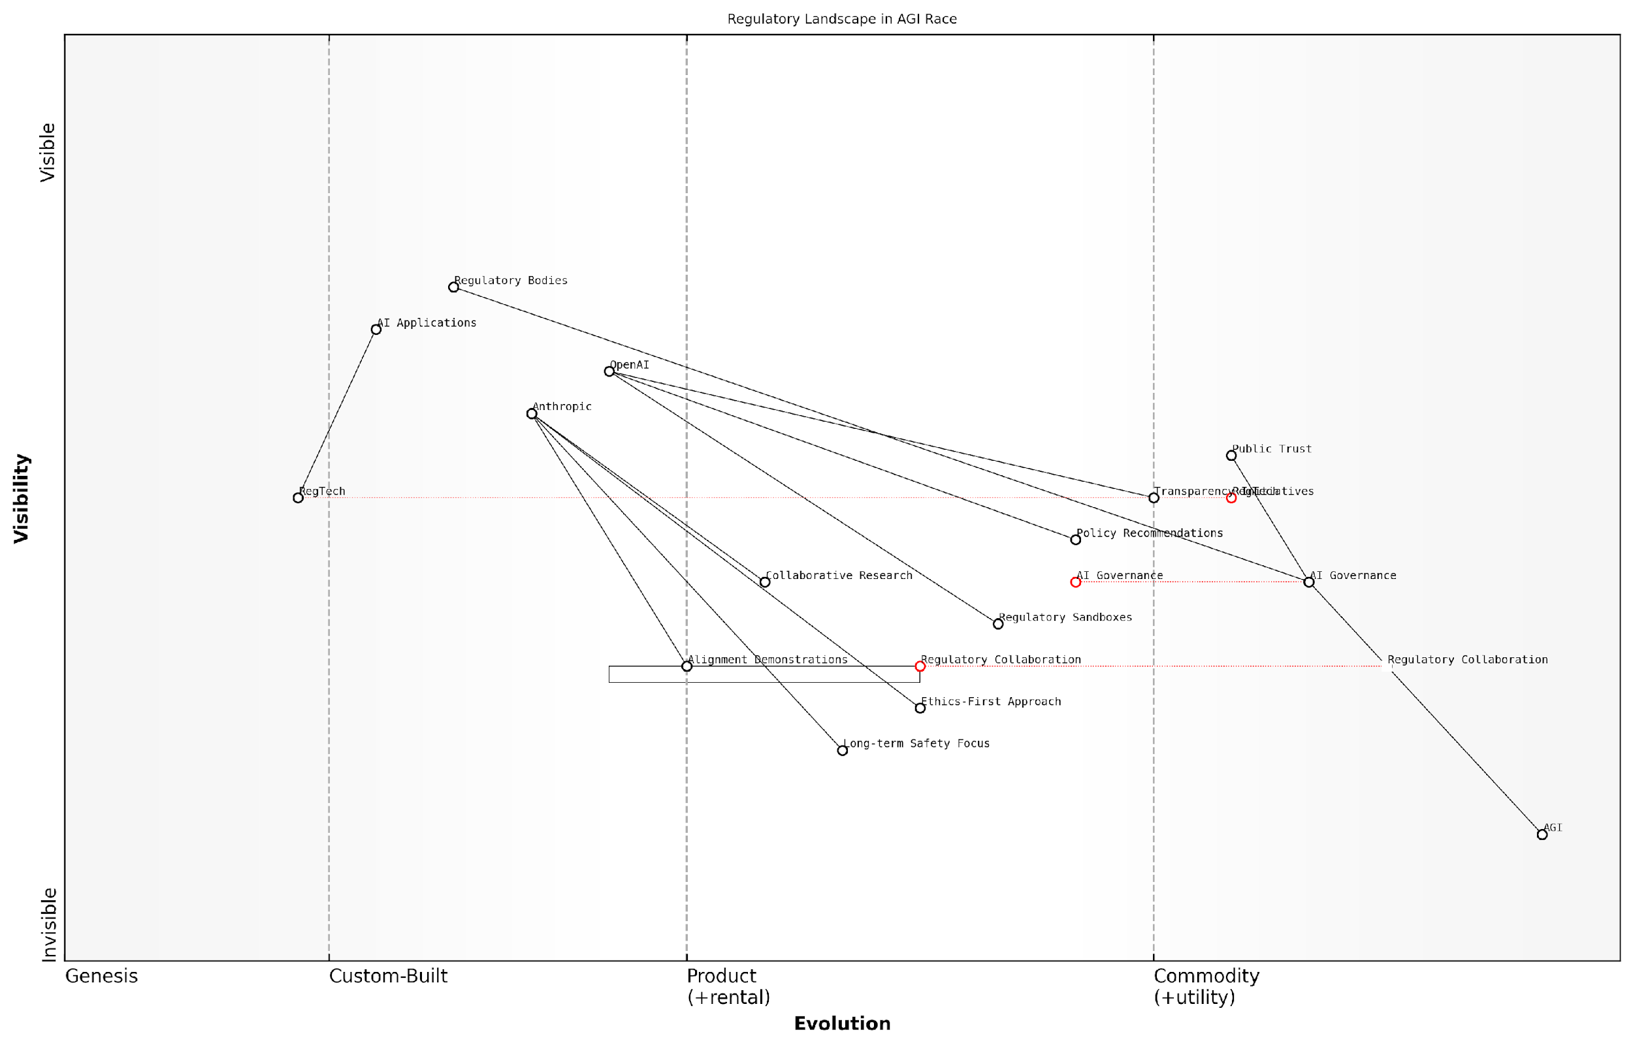

*Draft Wardley Map: [Insert Wardley Map: Collaboration with regulators]*

[Edit this draft Wardley Map](https://create.wardleymaps.ai/#clone:3cf60224cfba7de74b)

Wardley Map Assessment

The map reveals a regulatory landscape in flux, with AGI development driving the need for evolved governance and trust-building mechanisms. The strategic position of key players like OpenAI and Anthropic suggests a race not just for AGI development, but for establishing trusted, ethically-aligned approaches to this frontier technology. The emphasis on collaboration, transparency, and long-term safety indicates a maturing industry awareness of the profound implications of AGI. To succeed, companies must balance rapid innovation with robust regulatory engagement and public trust-building, while also investing in the development of advanced governance and safety demonstration capabilities. The evolution of RegTech and AI Governance frameworks will be critical in shaping the future of the AGI landscape.

[View full Wardley Map report](http://markdown_wardley_map_reports/wardley_map_report_48_Collaboration_with_regulators.md)

## Future of AGI Regulation

### Potential regulatory scenarios

As we delve into the potential regulatory scenarios for Artificial General Intelligence (AGI), it is crucial to understand that the landscape is as complex as it is uncertain. The race between OpenAI and Anthropic is not just a technological competition, but also a regulatory one, where the ability to navigate and influence the evolving policy environment may prove as important as technical breakthroughs.

Drawing from my extensive experience advising government bodies on emerging technologies, I can confidently say that the regulatory future of AGI will likely unfold along several key dimensions:

* Global Governance Frameworks
* National Security Considerations
* Ethical and Safety Standards
* Data Privacy and Ownership
* Intellectual Property Rights
* Market Competition and Anti-Trust Measures

Let’s explore each of these dimensions in detail, considering how they might shape the competitive landscape between OpenAI and Anthropic.

1. Global Governance Frameworks:

The development of AGI is a global concern that transcends national borders. We are likely to see the emergence of international bodies dedicated to AGI governance, similar to the International Atomic Energy Agency (IAEA) for nuclear technology. These frameworks could take several forms:

* UN-led AGI Oversight Committee
* Multi-stakeholder Global AGI Alliance
* Treaty-based AGI Non-Proliferation Agreement

The ability of OpenAI and Anthropic to engage with and shape these global frameworks will be crucial. Companies that can demonstrate alignment with international norms and contribute to the development of global standards may gain a competitive advantage.

As a senior policy advisor remarked, ‘The company that helps write the rules of the game will have a head start in playing it.’

1. National Security Considerations:

AGI’s potential to revolutionise military and intelligence capabilities means that national security will be a key driver of regulation. Potential scenarios include:

* Mandatory government oversight of AGI development
* Restrictions on international collaboration and knowledge sharing
* Nationalisation of AGI research in some countries

OpenAI and Anthropic may face different challenges here. OpenAI’s more commercial approach might make it more adaptable to government partnerships, while Anthropic’s focus on safety and ethics could position it as a trusted partner in developing responsible AGI for national security applications.

1. Ethical and Safety Standards:

As AGI capabilities grow, so too will concerns about its potential risks. Regulatory bodies are likely to impose stringent safety and ethical standards, which could include:

* Mandatory AI ethics boards with veto power over research directions
* Regular third-party audits of AGI systems
* Legal liability for AGI actions and decisions

Anthropic’s constitutional AI approach may give it an edge in this area, as it aligns closely with emerging ethical AI frameworks. However, OpenAI’s commitment to beneficial AGI and its experience with GPT models’ ethical challenges could also position it well to meet these standards.

1. Data Privacy and Ownership:

The vast amounts of data required to train AGI systems will likely lead to new regulations around data collection, usage, and ownership. Potential scenarios include:

* Mandatory data sharing agreements between AGI developers and governments
* Strict limits on the use of personal data in AGI training
* Creation of national or global data trusts for AGI development

Both OpenAI and Anthropic will need to navigate these regulations carefully, balancing the need for extensive training data with privacy concerns and potential restrictions on data usage.

1. Intellectual Property Rights:

The unique nature of AGI raises complex questions about intellectual property. Regulatory scenarios might include:

* New forms of IP protection specific to AGI innovations
* Mandatory licensing of key AGI technologies
* Restrictions on patenting certain AGI capabilities deemed too powerful or dangerous

OpenAI’s shift towards a more commercial model may make it more inclined to seek strong IP protections, while Anthropic’s research-focused approach might favour more open sharing of innovations. The regulatory approach to IP could significantly impact their respective strategies.

1. Market Competition and Anti-Trust Measures:

As AGI becomes more central to economic activity, regulators may step in to prevent monopolistic control. Potential scenarios include:

* Forced licensing of AGI technologies to promote competition
* Limits on market share or application areas for AGI companies
* Mandatory interoperability standards for AGI systems

These measures could significantly impact the business models of both OpenAI and Anthropic, potentially limiting their ability to dominate the market even if they achieve significant technical breakthroughs.

A leading competition lawyer in the tech sector noted, ‘The first company to achieve AGI may find itself more constrained by antitrust regulations than empowered by its technological advantage.’

In conclusion, the regulatory landscape for AGI is likely to be complex and multifaceted, with significant implications for the competition between OpenAI and Anthropic. Success in the AGI race will require not just technical prowess, but also the ability to navigate, influence, and adapt to a rapidly evolving regulatory environment.

The company that can best align its development approach with emerging regulatory frameworks, while also contributing constructively to the formation of these regulations, may ultimately gain the upper hand. Both OpenAI and Anthropic have unique strengths in this regard, and their ability to leverage these strengths in the regulatory arena may prove as important as their technical innovations in determining the outcome of the AGI race.

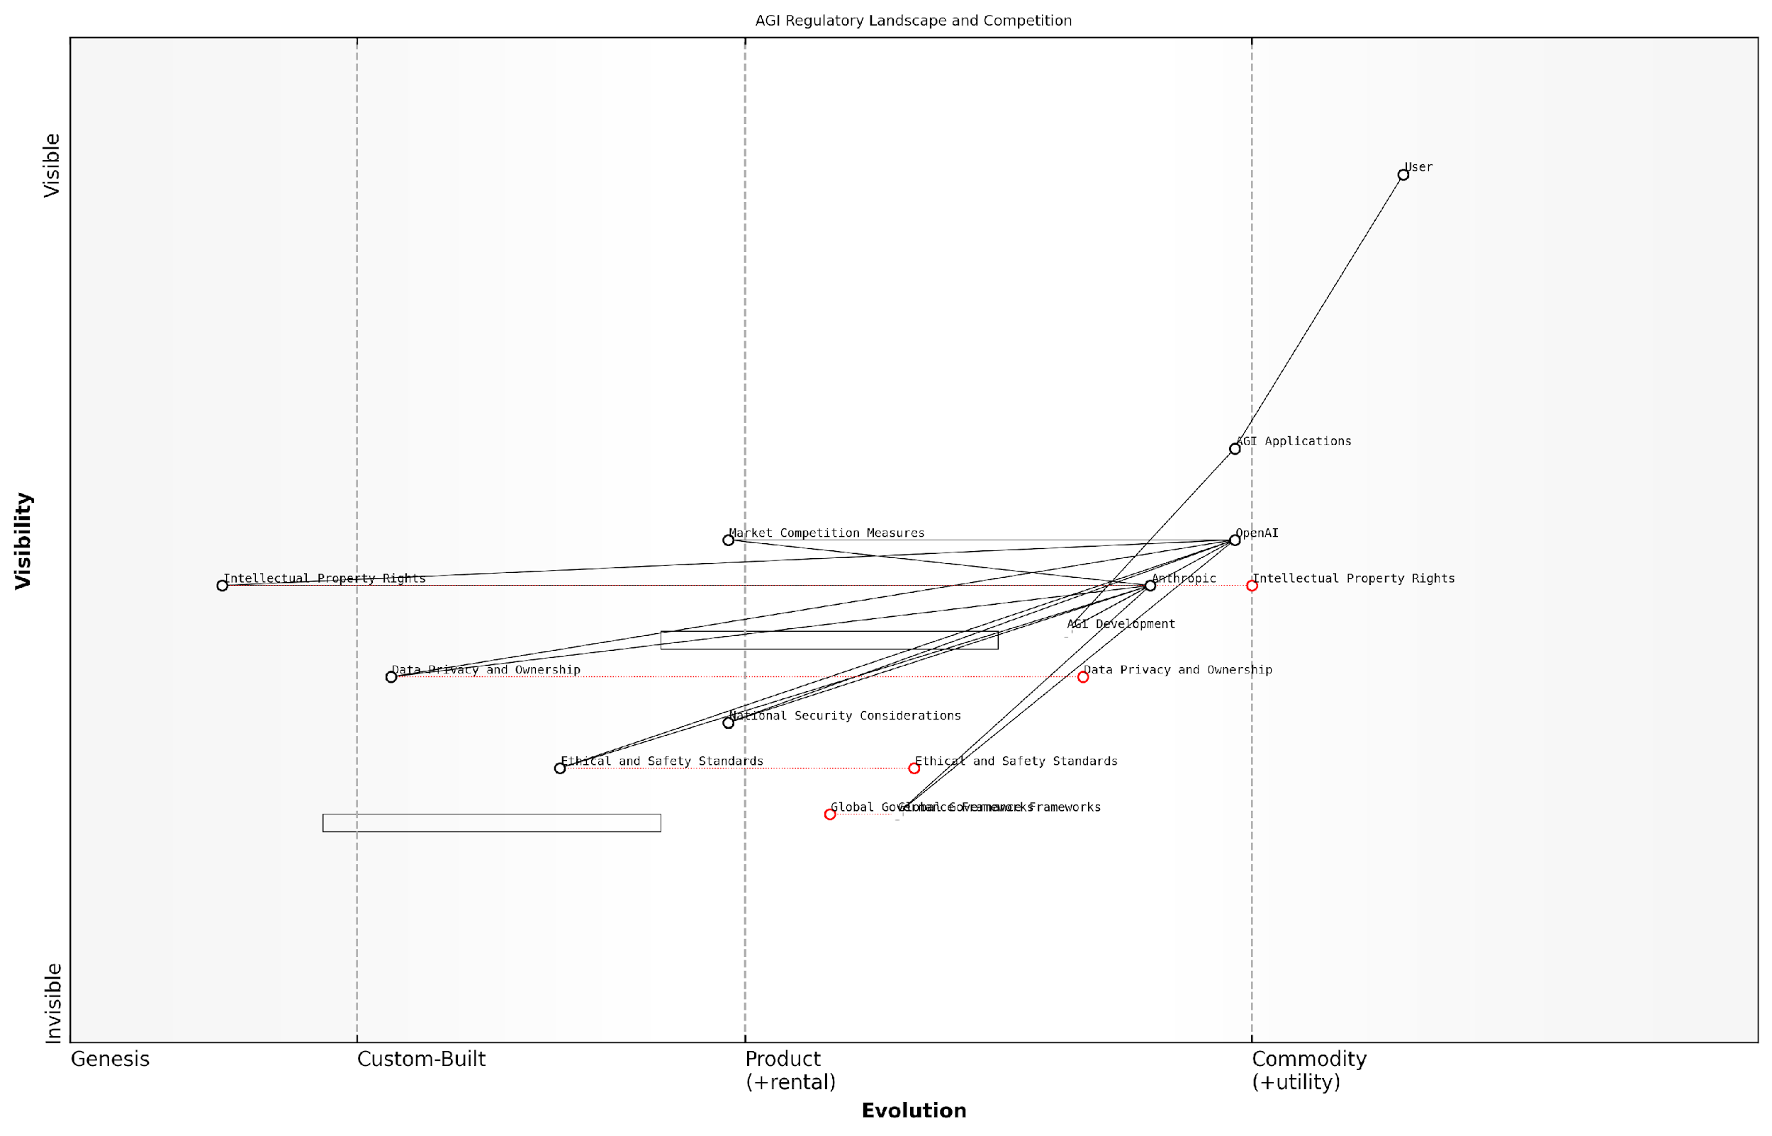

*Draft Wardley Map: [Insert Wardley Map: Potential regulatory scenarios]*

[Edit this draft Wardley Map](https://create.wardleymaps.ai/#clone:5a39ce3281e0d31eed)

Wardley Map Assessment

The AGI regulatory landscape is in a critical phase of evolution, with significant opportunities for companies like OpenAI and Anthropic to shape the future of AGI governance. Success will depend on balancing rapid technological advancement with ethical considerations and proactive engagement in regulatory development. The strategic focus should be on developing AGI applications that are not only technologically advanced but also ethically sound and aligned with evolving global governance frameworks. Companies that can navigate this complex landscape, fostering trust through transparent practices and contributing to the development of robust safety standards, will be best positioned for long-term success in the AGI market.

[View full Wardley Map report](http://markdown_wardley_map_reports/wardley_map_report_49_Potential_regulatory_scenarios.md)

### Impact on AGI development timelines

The future of AGI regulation stands as a critical factor in shaping the development timelines for Artificial General Intelligence. As we navigate the complex landscape of the AGI race between OpenAI and Anthropic, it is imperative to understand how evolving regulatory frameworks may accelerate or decelerate the path to AGI. This subsection delves into the intricate relationship between regulation and innovation, exploring how policy decisions could influence the trajectory of AGI development and potentially determine the victor in this high-stakes technological competition.

Regulatory approaches to AGI development can be broadly categorised into three potential scenarios: permissive, balanced, and restrictive. Each of these scenarios would have profound implications for the pace and direction of AGI research and development, particularly for frontrunners like OpenAI and Anthropic.

* Permissive Scenario: Minimal regulatory oversight, fostering rapid innovation
* Balanced Scenario: Thoughtful regulation balancing innovation and safety
* Restrictive Scenario: Stringent controls potentially slowing AGI development

In a permissive regulatory environment, we could witness an acceleration of AGI development timelines. With fewer bureaucratic hurdles and compliance requirements, companies like OpenAI and Anthropic would have greater freedom to push the boundaries of AI capabilities. This scenario could potentially lead to a more rapid realisation of AGI, but it also raises significant concerns about safety and ethical considerations.

A leading AI ethicist warns, ‘Unchecked AGI development in a regulatory vacuum could lead to a dangerous race to the bottom, where safety is sacrificed at the altar of speed.’

Conversely, a highly restrictive regulatory landscape could significantly extend AGI development timelines. Stringent oversight, extensive testing requirements, and mandatory safety protocols could slow the pace of innovation. While this approach might enhance safety and ethical compliance, it could also risk stifling breakthrough discoveries and potentially cede technological leadership to less regulated jurisdictions.

The balanced scenario, which many experts advocate for, aims to strike a delicate equilibrium between innovation and responsible development. This approach could involve adaptive regulation that evolves alongside technological advancements, potentially leading to a more measured but sustainable path to AGI. Both OpenAI and Anthropic have expressed support for thoughtful regulation, recognising that public trust and safety are crucial for the long-term success of AGI.

A senior policy advisor notes, ‘The key to effective AGI regulation lies in fostering a collaborative ecosystem where companies, researchers, and regulators work together to ensure safe and beneficial development.’

The impact of regulation on AGI development timelines is not merely a matter of speed, but also of direction and quality. Regulatory frameworks can shape research priorities, encouraging or mandating specific approaches to AGI development. For instance, regulations emphasising interpretability and transparency could favour Anthropic’s constitutional AI approach, potentially altering the competitive landscape.

Moreover, international regulatory disparities could lead to a fragmented global landscape for AGI development. Differences in regulatory approaches between major AI hubs like the United States, China, and the European Union could create a complex web of compliance requirements for companies operating globally. This fragmentation could either slow down overall progress or lead to regulatory arbitrage, where companies like OpenAI and Anthropic might strategically locate different aspects of their operations to optimise their regulatory environment.

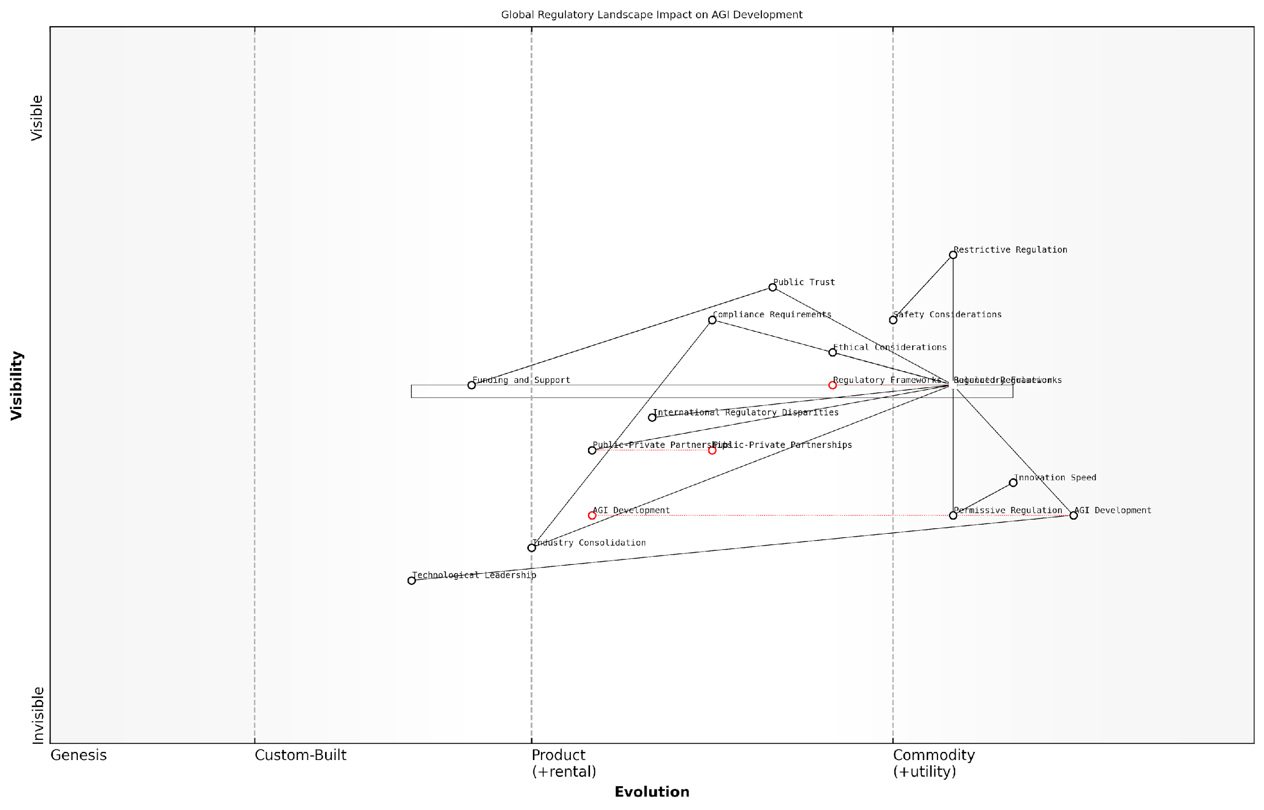

*Draft Wardley Map: [Insert Wardley Map: Impact on AGI development timelines]*

[Edit this draft Wardley Map](https://create.wardleymaps.ai/#clone:6295a6483902c938e6)

Wardley Map Assessment

The map reveals a strategic landscape where the success of AGI development hinges on effectively balancing regulation, innovation, safety, and public trust. The evolving nature of key components suggests a dynamic environment requiring adaptive strategies. The focus on public-private partnerships and ethical considerations positions this approach well for sustainable progress, but challenges remain in international harmonisation and maintaining the delicate balance between permissive and restrictive regulation. Future success will likely depend on fostering a collaborative global ecosystem while maintaining the flexibility to adapt to rapid technological advancements.

[View full Wardley Map report](http://markdown_wardley_map_reports/wardley_map_report_50_Impact_on_AGI_development_timelines.md)

The role of public-private partnerships in shaping AGI regulation cannot be overstated. Both OpenAI and Anthropic have engaged in policy discussions and collaborations with governmental bodies, potentially influencing the regulatory landscape. These partnerships could lead to more nuanced and effective regulations that balance innovation with safety, potentially optimising AGI development timelines.

Another crucial factor is the potential for regulatory-driven consolidation in the AGI field. As compliance costs increase, smaller players may struggle to keep pace, potentially leading to a concentration of AGI development among well-resourced entities like OpenAI and Anthropic. This consolidation could either accelerate progress through focused efforts or slow it down by reducing diverse approaches to AGI.

An industry analyst observes, ‘The regulatory environment will likely favour those with the resources to navigate complex compliance landscapes, potentially cementing the positions of current frontrunners in the AGI race.’

The impact of regulation on AGI development timelines is also intrinsically linked to public perception and trust. Regulatory frameworks that enhance transparency and accountability could bolster public confidence in AGI research, potentially leading to increased funding and support. Conversely, regulations perceived as overly restrictive could dampen public enthusiasm and investment in AGI technologies.

In conclusion, the future of AGI regulation will play a pivotal role in determining not only the pace of AGI development but also its trajectory and ultimate outcomes. As OpenAI and Anthropic continue their pursuit of AGI, their ability to navigate, influence, and adapt to the evolving regulatory landscape will be crucial in determining their success. The challenge for policymakers and industry leaders alike will be to craft regulatory frameworks that foster innovation while ensuring the safe and beneficial development of AGI technologies.

### Balancing innovation and safety

As we stand on the precipice of a potential Artificial General Intelligence (AGI) breakthrough, the delicate balance between fostering innovation and ensuring safety has become a paramount concern for policymakers, researchers, and industry leaders alike. This subsection explores the intricate challenges and potential solutions in crafting future AGI regulations that promote technological advancement whilst safeguarding humanity’s interests.

The race between OpenAI and Anthropic epitomises the broader tension within the AGI development landscape. Both entities are pushing the boundaries of what’s possible in AI, yet their approaches to safety and ethics differ, highlighting the complexity of creating a unified regulatory framework.

The challenge we face is unprecedented. We must create regulations that are robust enough to prevent catastrophic risks, yet flexible enough to allow for the rapid pace of AGI innovation. It’s akin to building a safety harness for a rocket whilst it’s already in flight.

To effectively balance innovation and safety in future AGI regulation, policymakers must consider several key areas:

* Adaptive Regulatory Frameworks
* Collaborative Governance Models
* Ethical AI Development Standards
* Transparency and Accountability Measures
* International Cooperation and Harmonisation

Adaptive Regulatory Frameworks: The rapid pace of AGI development necessitates a regulatory approach that can evolve in tandem with technological advancements. Traditional regulatory models, which often lag behind innovation, are ill-suited for the dynamic nature of AGI research. Instead, we must consider implementing ‘adaptive regulation’ – a flexible framework that can quickly respond to new developments and emerging risks.

One potential model is the use of regulatory sandboxes, which allow for controlled experimentation with AGI technologies under close supervision. This approach has been successfully employed in the fintech sector and could be adapted for AGI development. It would enable companies like OpenAI and Anthropic to push the boundaries of innovation whilst operating within a controlled environment that prioritises safety.

Regulatory sandboxes offer a promising middle ground. They allow us to foster innovation whilst maintaining a vigilant eye on potential risks. It’s a ‘trust but verify’ approach that could be instrumental in the AGI context.

Collaborative Governance Models: The complexity of AGI development calls for a collaborative approach to governance. This involves creating platforms for ongoing dialogue between researchers, industry leaders, policymakers, and ethicists. Such collaboration can help identify potential risks early and develop mitigation strategies that don’t stifle innovation.

The UK’s AI Council provides a template for this approach, bringing together diverse stakeholders to advise on AI strategy. Expanding this model to include dedicated AGI working groups could prove invaluable in shaping balanced regulations.

Ethical AI Development Standards: Establishing clear ethical standards for AGI development is crucial. These standards should address issues such as bias mitigation, privacy protection, and the alignment of AGI systems with human values. Both OpenAI and Anthropic have made strides in this area, with Anthropic’s Constitutional AI approach offering interesting insights into embedding ethical considerations directly into AI systems.

Regulators should consider mandating ethical impact assessments for AGI projects, similar to environmental impact assessments in other industries. This would ensure that ethical considerations are integrated into the development process from the outset, rather than being an afterthought.

Ethical considerations cannot be an afterthought in AGI development. They must be woven into the very fabric of the technology. Our regulatory frameworks should reflect this imperative.

Transparency and Accountability Measures: As AGI systems become more complex and potentially opaque, ensuring transparency and accountability becomes increasingly challenging yet crucial. Regulations should mandate clear documentation of AGI development processes, regular audits, and mechanisms for explaining AI decision-making.

The EU’s proposed AI Act, with its risk-based approach and transparency requirements, offers a starting point. However, for AGI, these measures may need to be significantly enhanced. Considerations could include establishing independent oversight bodies with the technical expertise to audit advanced AI systems.

International Cooperation and Harmonisation: The global nature of AGI development necessitates international cooperation to prevent regulatory arbitrage and ensure consistent safety standards. Efforts should be made to harmonise AGI regulations across jurisdictions, perhaps through the establishment of an international AGI governance body.

The International Panel on Climate Change (IPCC) could serve as a model for a similar body focused on AGI. Such an organisation could provide authoritative assessments of AGI development progress, potential risks, and recommended policy responses.

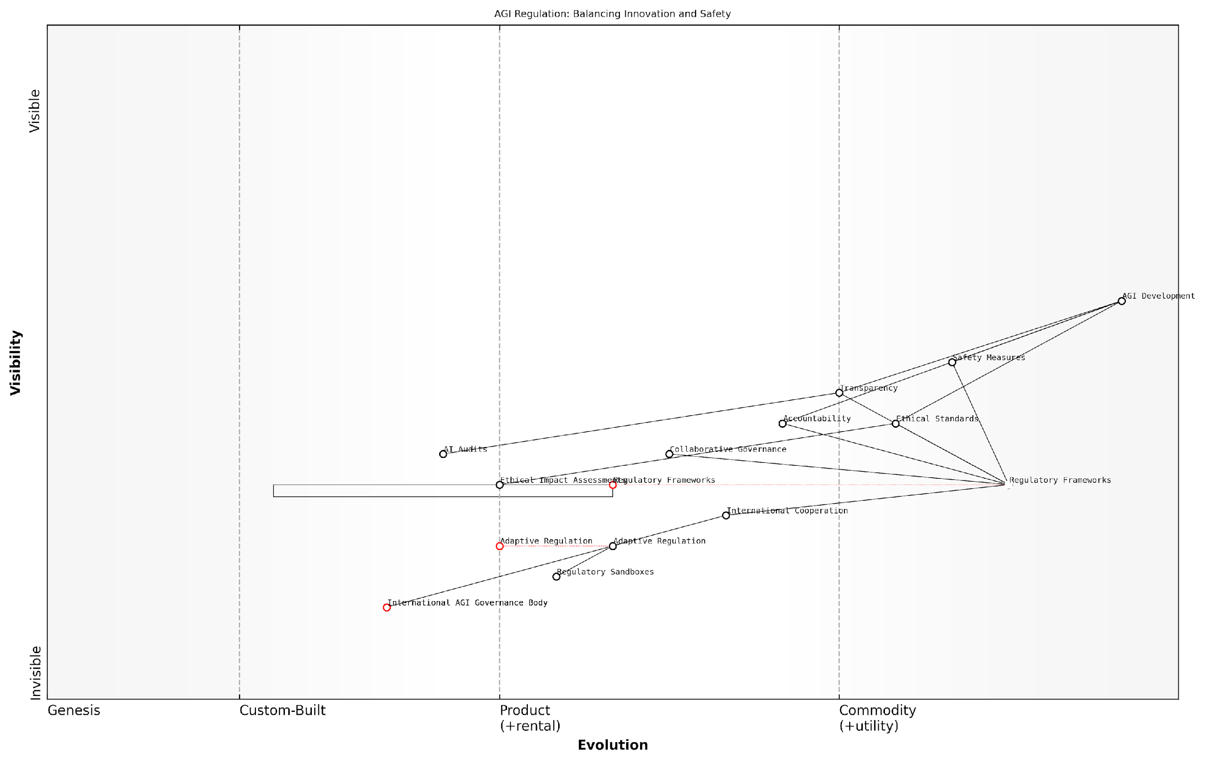

*Draft Wardley Map: [Insert Wardley Map: Balancing innovation and safety]*

[Edit this draft Wardley Map](https://create.wardleymaps.ai/#clone:994c7b3fb6e48477dc)

Wardley Map Assessment

This Wardley Map reveals a complex landscape of AGI regulation that is still in its formative stages. While AGI development is advancing rapidly, regulatory and governance structures are lagging behind. The key strategic imperative is to accelerate the evolution of adaptive regulatory frameworks and international cooperation while maintaining a strong focus on safety and ethical standards. Success will require unprecedented levels of global collaboration, innovative approaches to governance, and a delicate balance between fostering innovation and ensuring public safety. The development of AGI represents both an enormous opportunity and a significant challenge, and this map underscores the critical importance of proactive, thoughtful, and coordinated action to shape its future responsibly.

[View full Wardley Map report](http://markdown_wardley_map_reports/wardley_map_report_51_Balancing_innovation_and_safety.md)

In conclusion, balancing innovation and safety in future AGI regulation is a complex but essential task. It requires a nuanced approach that leverages adaptive frameworks, fosters collaboration, embeds ethical considerations, ensures transparency, and promotes international cooperation. As the race between OpenAI and Anthropic intensifies, the regulatory landscape must evolve to keep pace, ensuring that the pursuit of AGI remains both innovative and responsible.

The regulations we craft today will shape the AGI of tomorrow. We must strive for a balance that protects humanity whilst unleashing the full potential of this transformative technology. Our future may well depend on getting this balance right.

# Conclusion: The Future of AGI and Human Civilisation

## Assessing the Likelihood of AGI Supremacy

### Evaluating OpenAI and Anthropic’s positions

As we approach the culmination of our exploration into the AGI race between OpenAI and Anthropic, it is crucial to evaluate their respective positions in the quest for artificial general intelligence supremacy. This assessment is not merely an academic exercise; it has profound implications for the future of human civilisation and the trajectory of technological advancement. Both organisations have demonstrated remarkable progress, yet the path to AGI remains fraught with uncertainty and potential paradigm shifts.

To comprehensively evaluate OpenAI and Anthropic’s positions, we must consider several key factors:

* Technical capabilities and innovation
* Funding and resource allocation
* Ethical frameworks and safety measures
* Strategic partnerships and ecosystem development
* Regulatory compliance and policy influence
* Public perception and trust

Technical Capabilities and Innovation: OpenAI has consistently pushed the boundaries of AI capabilities with its GPT series, DALL-E, and advancements in reinforcement learning. Their ability to scale language models and achieve breakthrough performance on various benchmarks has positioned them as a frontrunner in the AGI race. Anthropic, while perhaps less publicly visible, has made significant strides in constitutional AI and alignment research. Their focus on developing AI systems with robust ethical foundations could prove crucial in the long-term pursuit of safe and beneficial AGI.

OpenAI’s technical prowess is undeniable, but Anthropic’s emphasis on alignment could be the key to unlocking AGI that is not only powerful but also inherently safe and aligned with human values.

Funding and Resource Allocation: OpenAI’s transition to a ‘capped-profit’ model and its strategic partnership with Microsoft have provided it with substantial financial resources and computing power. This has allowed for rapid iteration and scaling of their models. Anthropic, while operating with a different funding model, has secured significant venture capital investments, enabling them to maintain a long-term, research-focused approach. The sustainability and efficiency of these funding models will play a crucial role in determining which organisation can maintain the pace of innovation required for AGI development.

Ethical Frameworks and Safety Measures: Both organisations have placed a strong emphasis on the ethical development of AGI, but with different approaches. OpenAI’s commitment to beneficial AGI is reflected in their staged release strategy and ongoing safety research. Anthropic’s constitutional AI principles and focus on value learning represent a more fundamental approach to embedding ethics into the core of AI systems. The robustness and effectiveness of these safety measures will be critical in determining not just who achieves AGI first, but who does so in a manner that ensures the technology’s safe integration into society.

Strategic Partnerships and Ecosystem Development: OpenAI’s collaboration with Microsoft has significantly expanded its reach and potential applications. This partnership provides access to vast amounts of data and computing resources, as well as a global platform for deploying AI technologies. Anthropic, while more selective in its partnerships, has focused on collaborations that align with its long-term vision for AGI development. The ability to build and leverage a supportive ecosystem will be crucial in translating research breakthroughs into real-world AGI applications.

Regulatory Compliance and Policy Influence: As governments worldwide grapple with the implications of AGI, the ability to navigate and shape the regulatory landscape will be a key determinant of success. OpenAI has been proactive in engaging with policymakers and advocating for responsible AI development. Anthropic’s ethics-first approach may provide it with a unique position to influence policy discussions around AGI safety and governance. The organisation that can effectively balance innovation with regulatory compliance may gain a significant advantage in the race to AGI.

The AGI race is not just about technological breakthroughs; it’s equally about navigating the complex regulatory landscape and shaping public policy to support responsible AI development.

Public Perception and Trust: The development of AGI is not occurring in a vacuum; public acceptance and trust will be crucial for its successful deployment and integration into society. OpenAI’s more visible public profile and demonstrations of AI capabilities have generated significant public interest and excitement. However, this visibility also comes with increased scrutiny and potential backlash. Anthropic’s lower-profile approach, coupled with its strong emphasis on ethics and safety, may position it well to build long-term public trust in AGI technologies.

Comparative Analysis: When evaluating OpenAI and Anthropic’s positions, it becomes clear that both organisations have unique strengths and approaches that could lead to AGI supremacy. OpenAI’s technical innovations, substantial resources, and strategic partnerships provide it with significant momentum. Their ability to rapidly scale and deploy AI technologies gives them a potential edge in achieving AGI breakthroughs.

Anthropic, on the other hand, has positioned itself as a leader in AI alignment and safety research. Their focus on developing AGI that is inherently aligned with human values could prove crucial in ensuring that the first AGI systems are not only powerful but also beneficial and controllable. This approach may take longer to yield results but could ultimately lead to more robust and trustworthy AGI.

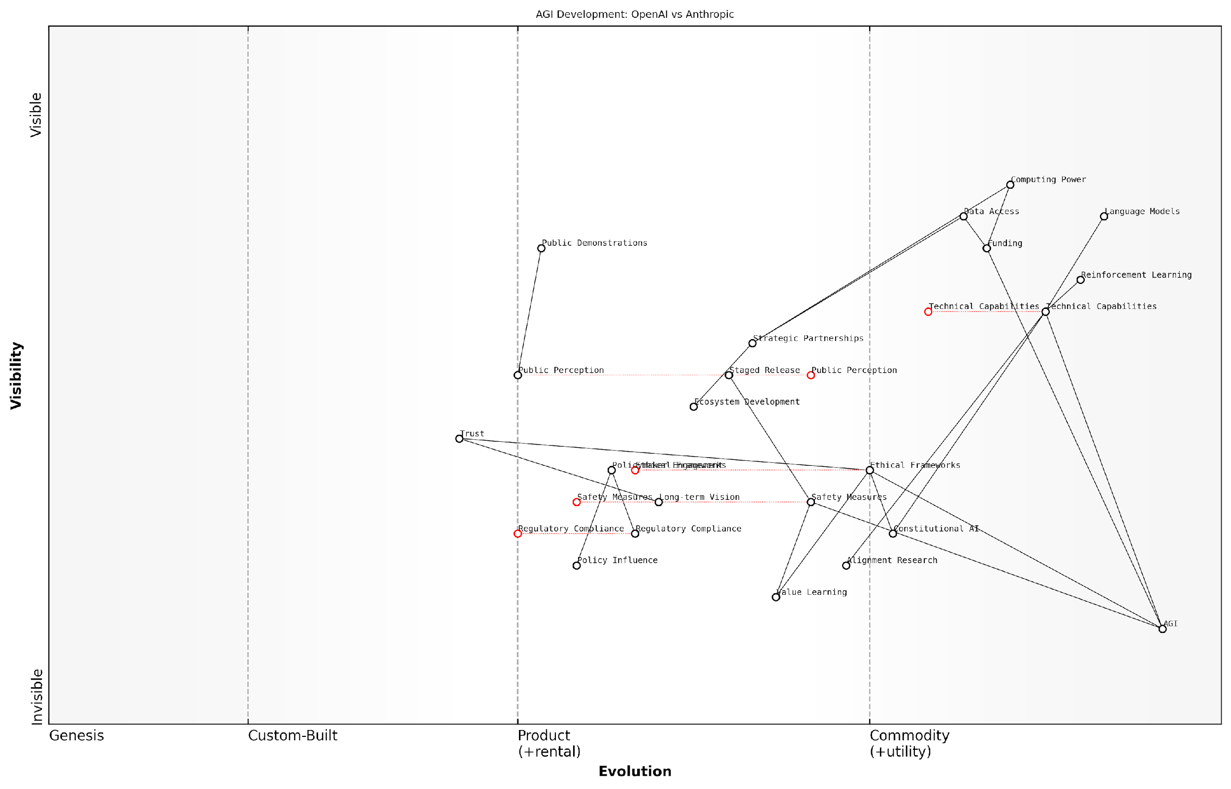

*Draft Wardley Map: [Insert Wardley Map: Evaluating OpenAI and Anthropic’s positions]*

[Edit this draft Wardley Map](https://create.wardleymaps.ai/#clone:ee55cc1e467f3a248e)

Wardley Map Assessment

The Wardley Map reveals a dynamic and rapidly evolving landscape of AGI development, with OpenAI and Anthropic as key players. While significant progress has been made in technical capabilities, there is a critical need to accelerate the development of ethical frameworks, safety measures, and alignment research to ensure responsible AGI development. The strategic positioning of these components suggests that future competitive advantage will likely stem from successfully integrating advanced technical capabilities with robust ethical and safety considerations. Companies that can navigate the complex interplay between innovation, responsibility, and public trust will be best positioned to lead in the AGI race while ensuring its benefits for humanity.

[View full Wardley Map report](http://markdown_wardley_map_reports/wardley_map_report_52_Evaluating_OpenAI_and_Anthropic's_positions.md)

The race to AGI supremacy is not merely about who achieves the technological breakthrough first. It encompasses a complex interplay of technical innovation, ethical considerations, strategic positioning, and societal impact. While OpenAI may currently hold an edge in terms of visible progress and resources, Anthropic’s foundational approach to AI alignment could prove to be the key differentiator in the long run.

As we stand on the precipice of potentially the most significant technological leap in human history, it is clear that both OpenAI and Anthropic are well-positioned to make substantial contributions to the development of AGI. The ultimate victor in this race may not be determined by a single breakthrough but by the ability to create AGI that is not only supremely capable but also aligned with human values and safely integrable into society.

The true winner of the AGI race will not be the first to cross the finish line, but the one who ensures that the finish line leads to a future where humanity thrives alongside artificial general intelligence.

### Wild cards and unknown factors

In the high-stakes race for Artificial General Intelligence (AGI) supremacy between OpenAI and Anthropic, it is crucial to consider the wild cards and unknown factors that could dramatically alter the landscape. As we assess the likelihood of AGI supremacy, we must acknowledge that the path to AGI is fraught with uncertainties and potential game-changers that could tip the scales in unexpected ways.

Technological Breakthroughs

One of the most significant wild cards in the AGI race is the potential for unforeseen technological breakthroughs. While both OpenAI and Anthropic have demonstrated impressive advancements in AI capabilities, a sudden leap in areas such as quantum computing, neuromorphic engineering, or novel machine learning architectures could provide a decisive advantage to either company—or even to an unexpected third party.

In the realm of AGI development, we’re always one paradigm-shifting discovery away from rewriting the rules of the game. The next big breakthrough could come from anywhere, at any time.

Geopolitical Shifts and Regulatory Landscapes

The global political environment and evolving regulatory frameworks represent another critical set of wild cards. Changes in government policies, international collaborations, or restrictive regulations could significantly impact the AGI race. For instance, a major geopolitical event could lead to increased government funding or restrictions on AI research, potentially altering the competitive landscape overnight.

* Sudden changes in AI export controls
* Formation of international AI research coalitions
* Implementation of stringent AI safety regulations
* Shifts in government funding priorities for AI research

Ethical Considerations and Public Perception

The ethical implications of AGI development and public perception of AI safety could play a crucial role in determining the outcome of the AGI race. A major AI-related incident or a shift in public opinion regarding AI ethics could force companies to alter their approaches or even halt certain research directions. Anthropic’s focus on constitutional AI and alignment might provide an advantage if public concern over AI safety intensifies, while OpenAI’s more diverse approach could be beneficial if breakthroughs in other areas take precedence.

Public trust is the currency of the AGI race. The company that can demonstrate both technological prowess and ethical responsibility will likely gain a significant edge in the long run.

Talent Acquisition and Brain Drain

The movement of key researchers and engineers between companies, academia, and government institutions represents a significant unknown factor. A ‘brain drain’ from one organisation to another could rapidly shift the balance of the AGI race. Moreover, the emergence of new AI research hubs or the sudden availability of top-tier AI talent could provide unexpected advantages to either OpenAI or Anthropic.

Unexpected Collaborations or Mergers

The possibility of unexpected collaborations, mergers, or acquisitions in the AI industry could dramatically reshape the AGI landscape. A strategic partnership between one of the main contenders and a major tech giant, or a merger between complementary AI research entities, could create a formidable new player in the AGI race.

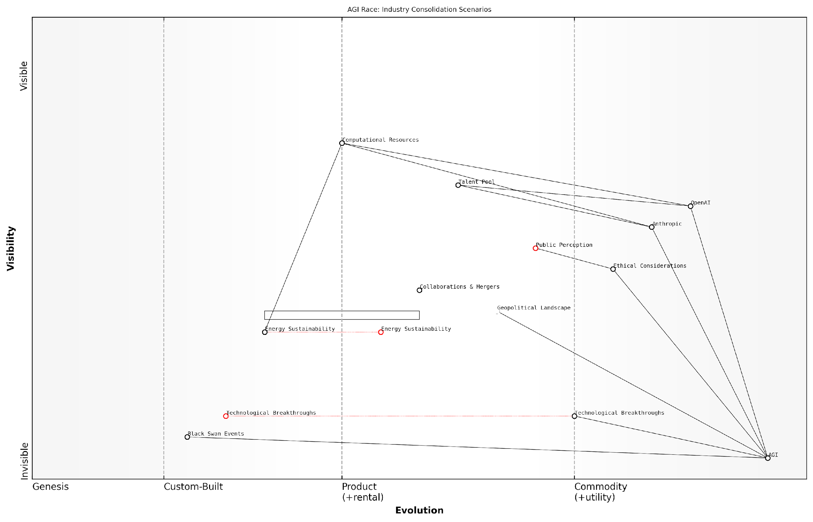

*Draft Wardley Map: [Insert Wardley Map: Wild cards and unknown factors]*

[Edit this draft Wardley Map](https://create.wardleymaps.ai/#clone:a20ba5d3b833b4afb1)

Wardley Map Assessment

This Wardley Map reveals a highly dynamic and complex landscape in the race towards AGI. The positioning of components suggests a mature understanding of the technological challenges, but also highlights critical areas that require attention, particularly in ethics, sustainability, and risk management. The industry is poised for significant evolution and potential consolidation, with major players like OpenAI and Anthropic driving progress towards AGI. However, the inclusion of factors like Black Swan Events and the Geopolitical Landscape underscores the uncertainty and potential for disruption in this field. To succeed in this environment, organisations must balance aggressive technological development with responsible practices, while remaining adaptable to rapid changes and unforeseen events. The key to long-term success lies in not just winning the race to AGI, but in doing so in a manner that is ethical, sustainable, and beneficial to humanity as a whole.

[View full Wardley Map report](http://markdown_wardley_map_reports/wardley_map_report_53_Wild_cards_and_unknown_factors.md)

Black Swan Events

We must also consider the potential for ‘black swan’ events—highly improbable occurrences with massive consequences. These could include paradigm-shifting discoveries in adjacent fields like neuroscience or cognitive psychology, or even the emergence of entirely new forms of intelligence that challenge our current understanding of AGI.

* Discovery of novel cognitive architectures in biological systems
* Breakthrough in understanding consciousness
* Development of radically new computing paradigms
* Contact with extraterrestrial intelligence (however unlikely)

Resource Availability and Sustainability

The long-term availability of computational resources and energy sustainability could become critical factors in the AGI race. Breakthroughs in energy production or storage, or conversely, global energy crises, could significantly impact the ability of companies to scale their AI systems. OpenAI’s partnership with Microsoft might provide an advantage in terms of computational resources, but Anthropic’s focus on efficiency and scaling laws could prove crucial if resource constraints become a limiting factor.

Conclusion

As we assess the likelihood of AGI supremacy, it is clear that while OpenAI and Anthropic are currently at the forefront of the race, the multitude of wild cards and unknown factors make any prediction inherently uncertain. The path to AGI is likely to be non-linear, with unexpected twists and turns that could rapidly change the competitive landscape.

In the AGI race, the only certainty is uncertainty. The ultimate victor may not be determined by current capabilities alone, but by the ability to adapt to unforeseen challenges and seise unexpected opportunities.

As we continue to monitor the progress of OpenAI, Anthropic, and other players in the AGI field, it is crucial to remain vigilant and adaptable. The wild cards and unknown factors discussed here underscore the need for flexible strategies, robust ethical frameworks, and international cooperation to ensure that the development of AGI benefits humanity as a whole, regardless of which entity ultimately achieves supremacy.

### Potential for collaboration or convergence

As we assess the likelihood of AGI supremacy, it is crucial to consider the potential for collaboration or convergence between OpenAI and Anthropic. This aspect of the AGI race is particularly intriguing, as it could significantly alter the trajectory of AGI development and its implications for human civilisation. The possibility of these two leading organisations joining forces or finding common ground could reshape the entire landscape of artificial general intelligence.

To thoroughly examine this potential, we must consider several key factors:

* Shared goals and values
* Complementary strengths and technologies
* Regulatory pressures and public perception
* Economic incentives and market dynamics
* Global competition and geopolitical considerations

Shared Goals and Values: Both OpenAI and Anthropic have publicly stated their commitment to developing safe and beneficial AGI. This alignment in core mission could serve as a foundation for potential collaboration. As a senior AI ethics researcher noted, ‘The shared vision of creating AGI that benefits humanity could be the bridge that brings these two organisations closer together.’

Complementary Strengths and Technologies: OpenAI’s expertise in large language models and reinforcement learning, combined with Anthropic’s focus on constitutional AI and alignment, could create a powerful synergy. The integration of these approaches might accelerate progress towards AGI while simultaneously enhancing safety measures.

The combination of OpenAI’s technical prowess and Anthropic’s ethical frameworks could potentially create a more robust and responsible path to AGI than either company could achieve alone.

Regulatory Pressures and Public Perception: As governments worldwide grapple with AI regulation, collaboration between leading AGI developers could be seen as a proactive step towards self-regulation and responsible innovation. This could potentially ease regulatory pressures and improve public trust in AGI development.

Economic Incentives and Market Dynamics: While competition often drives innovation, the immense resources required for AGI development might eventually push companies towards collaboration. Sharing costs, risks, and rewards could become an attractive proposition, especially as the challenges of AGI development become more apparent.

Global Competition and Geopolitical Considerations: The emergence of other global players in the AGI race, particularly from countries like China, could incentivise collaboration between US-based companies like OpenAI and Anthropic. A united front could be seen as necessary to maintain technological leadership and ensure that AGI development aligns with Western values and principles.

However, it’s important to note that significant barriers to collaboration exist:

* Intellectual property concerns
* Differing philosophical approaches to AI safety
* Competitive advantages and market positioning
* Organisational culture clashes
* Antitrust considerations

These barriers could potentially be overcome through carefully structured partnerships, joint ventures, or industry-wide initiatives focused on specific aspects of AGI development or safety.

The potential for convergence, even without formal collaboration, should also be considered. As both organisations progress in their research, they may independently arrive at similar conclusions or technologies, leading to a de facto convergence in approaches to AGI development.

The path to AGI is likely to narrow as we approach true artificial general intelligence. We may see a natural convergence of methods and safeguards as the field matures and best practices emerge.

In assessing the likelihood of AGI supremacy, the potential for collaboration or convergence between OpenAI and Anthropic introduces a fascinating variable. While competition may drive rapid progress, collaboration could lead to more robust and ethically-aligned AGI systems. The ultimate outcome may depend on a complex interplay of technological breakthroughs, market forces, regulatory environments, and ethical considerations.

As we look towards the future, it’s clear that the relationship between OpenAI and Anthropic will be a critical factor in shaping the development and deployment of AGI. Whether through competition, collaboration, or convergence, the interactions between these two leading organisations will have profound implications for the future of human civilisation.

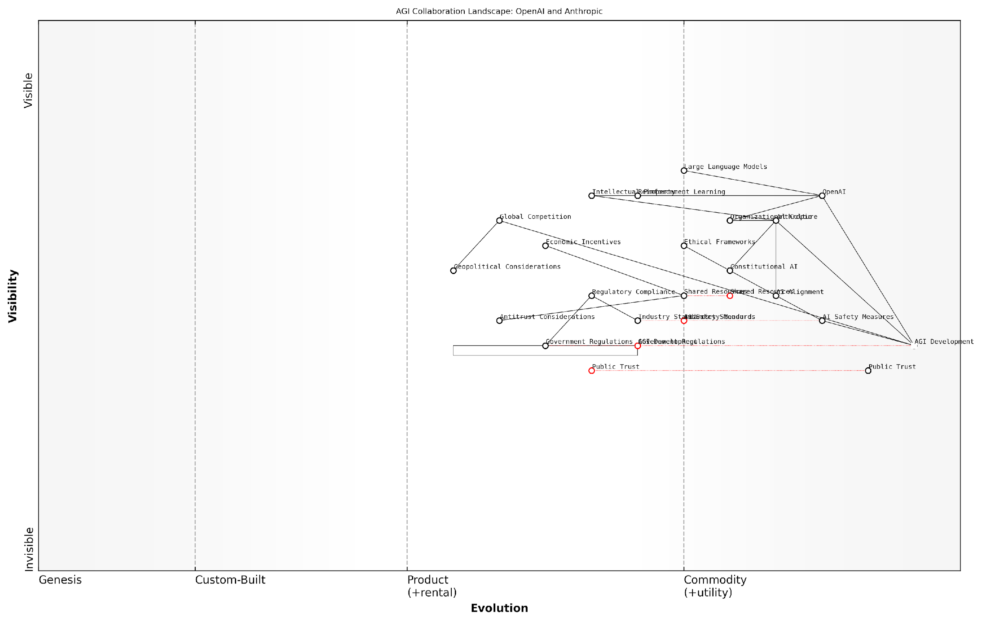

*Draft Wardley Map: [Insert Wardley Map: Potential for collaboration or convergence]*

[Edit this draft Wardley Map](https://create.wardleymaps.ai/#clone:124e5ecce81cccecbc)

Wardley Map Assessment

The map reveals a highly dynamic and complex landscape for AGI development, with OpenAI and Anthropic as key players. While technological capabilities are advanced, the critical challenges lie in ensuring safety, building public trust, and navigating regulatory environments. Success will depend on balancing rapid development with responsible practices, collaborative efforts in safety and standards, and proactive engagement with stakeholders across the ecosystem. The evolution of AI Safety Measures and Public Trust will be pivotal in shaping the future of AGI development and its market acceptance.

[View full Wardley Map report](http://markdown_wardley_map_reports/wardley_map_report_54_Potential_for_collaboration_or_convergence.md)

In conclusion, while the AGI race between OpenAI and Anthropic is often framed as a competition, the potential for collaboration or convergence adds a layer of complexity to our assessment of AGI supremacy. As we continue to monitor developments in this field, it will be crucial to remain attuned to signs of cooperation, shared standards, or technological convergence that could reshape the landscape of AGI development and its impact on humanity.

## Implications for Humanity

### Preparing for an AGI future

As we stand on the precipice of a potential Artificial General Intelligence (AGI) breakthrough, the implications for humanity are profound and far-reaching. The competition between OpenAI and Anthropic in the AGI race not only highlights the rapid pace of technological advancement but also underscores the urgent need for society to prepare for a future where AGI becomes a reality. This preparation encompasses a wide range of considerations, from ethical frameworks and economic restructuring to educational reforms and psychological adaptation.

One of the most critical aspects of preparing for an AGI future is the development of robust governance structures and ethical guidelines. As a senior policy advisor remarked, ‘The creation of AGI will be the most significant event in human history. We must ensure that our governance structures are prepared to handle this transition, balancing innovation with safety and ethical considerations.’ This sentiment reflects the growing consensus among experts that proactive measures are essential to harness the benefits of AGI whilst mitigating potential risks.

* Establishing international AGI governance frameworks
* Developing ethical guidelines for AGI development and deployment
* Creating mechanisms for ongoing public engagement and oversight
* Implementing safeguards against misuse or unintended consequences

The economic implications of AGI are equally significant and require careful consideration. The potential for widespread job displacement due to automation and AGI-driven technologies necessitates a fundamental rethinking of our economic structures. A leading economist in the field of technological unemployment stated, ‘We need to start envisioning and planning for an economy where human labour may no longer be the primary driver of productivity. This could involve exploring concepts like universal basic income or alternative models of value creation and distribution.’

* Developing new economic models to address potential job displacement
* Investing in reskilling and upskilling programmes for the workforce
* Exploring alternative forms of income distribution and social safety nets
* Encouraging innovation in human-AGI collaborative work models

Education systems will need to undergo significant transformation to prepare future generations for an AGI-integrated world. This involves not only teaching technical skills but also fostering creativity, critical thinking, and emotional intelligence – areas where humans may retain a comparative advantage. A prominent education reformer noted, ‘Our education systems must evolve to cultivate the uniquely human qualities that will complement, rather than compete with, AGI capabilities.’

* Redesigning curricula to focus on human-centric skills and AGI literacy
* Implementing lifelong learning programmes to support continuous adaptation
* Developing ethical training programmes for AGI developers and operators
* Promoting interdisciplinary education that combines technology, ethics, and humanities

The psychological and societal impacts of AGI cannot be overstated. As AGI systems become more advanced and integrated into daily life, humans will need to adapt to new forms of interaction and potentially redefined concepts of work, purpose, and identity. A renowned psychologist specialising in human-AI interaction commented, ‘We must prepare for a fundamental shift in how humans perceive themselves in relation to intelligent machines. This will require new frameworks for mental health support and societal cohesion.’

* Developing support systems for psychological adaptation to AGI integration
* Fostering public dialogue on the role of AGI in society
* Creating ethical frameworks for human-AGI relationships
* Addressing potential issues of AGI dependency or over-reliance

The role of public engagement and understanding in preparing for an AGI future cannot be overstated. Transparent communication about the potential benefits and risks of AGI, as well as ongoing dialogue between developers, policymakers, and the public, will be crucial in building trust and ensuring responsible development. A government technology advisor emphasised, ‘Public trust and understanding will be the bedrock upon which successful AGI integration is built. We must prioritise clear, honest communication and meaningful public participation in shaping our AGI future.’

* Implementing public education campaigns on AGI and its implications
* Creating platforms for ongoing dialogue between AGI developers and the public
* Ensuring transparency in AGI development processes and decision-making
* Encouraging citizen participation in AGI policy formulation

As the race between OpenAI and Anthropic intensifies, the urgency of these preparatory measures becomes increasingly apparent. The company that ultimately achieves AGI supremacy will play a pivotal role in shaping these preparations, but the responsibility extends far beyond any single entity. Government bodies, educational institutions, businesses, and civil society organisations must collaborate to create a comprehensive framework for AGI readiness.

The advent of AGI will be a watershed moment in human history. Our preparedness for this future will determine whether AGI becomes humanity’s greatest achievement or its greatest challenge. The time to act is now, while we still have the opportunity to shape the trajectory of AGI development and integration.

In conclusion, preparing for an AGI future requires a multifaceted approach that addresses governance, economics, education, psychology, and public engagement. The race between OpenAI and Anthropic serves as a catalyst for these preparations, highlighting the rapid pace of advancement and the need for proactive measures. By taking comprehensive and collaborative action now, we can work towards ensuring that the eventual emergence of AGI benefits humanity as a whole, regardless of which company ultimately achieves this monumental breakthrough.

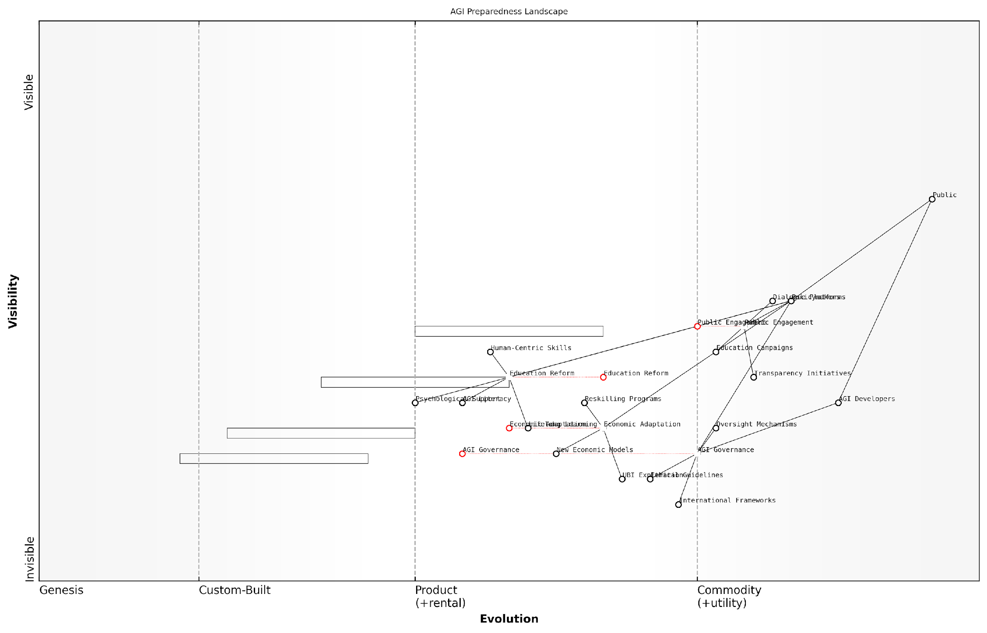

*Draft Wardley Map: [Insert Wardley Map: Preparing for an AGI future]*

[Edit this draft Wardley Map](https://create.wardleymaps.ai/#clone:fe97e34ed440afaea1)

Wardley Map Assessment

The AGI Preparedness Landscape map reveals a proactive and holistic approach to preparing for an AGI future. It emphasises the critical role of governance, economic adaptation, and public engagement, while highlighting the need for significant evolution in these areas. The strategic focus on education reform and psychological support demonstrates a human-centric approach to AGI integration. To succeed, stakeholders must prioritise the rapid development of robust governance frameworks, accelerate economic adaptation initiatives, and maintain strong public trust through transparency and engagement. The map suggests that success in AGI preparedness will require unprecedented levels of global cooperation, adaptive learning, and societal resilience.

[View full Wardley Map report](http://markdown_wardley_map_reports/wardley_map_report_55_Preparing_for_an_AGI_future.md)

### Ethical considerations for society

As we stand on the precipice of a potential AGI breakthrough, the ethical considerations for society loom large. The race between OpenAI and Anthropic not only represents a technological competition but also a philosophical divergence in how we approach the integration of superintelligent systems into the fabric of human civilisation. This section delves into the profound ethical implications that society must grapple with as we navigate the uncharted waters of AGI development and deployment.

The ethical landscape surrounding AGI is complex and multifaceted, encompassing issues of autonomy, accountability, transparency, and the very nature of consciousness itself. As we explore these considerations, it is crucial to recognise that the decisions made today will shape the trajectory of human-AI coexistence for generations to come.

The ethical challenges posed by AGI are not merely technical problems to be solved, but fundamental questions about the future of humanity and our place in a world shared with superintelligent entities.

Let us examine the key ethical considerations that society must address:

* Existential Risk and Control
* Human Agency and Autonomy
* Equity and Access
* Privacy and Surveillance
* Accountability and Governance

Existential Risk and Control: Perhaps the most pressing ethical concern is the potential existential risk posed by AGI. Both OpenAI and Anthropic have acknowledged this risk, albeit with different approaches to mitigation. OpenAI’s ‘capped-profit’ model and phased deployment strategy aim to balance innovation with safety, while Anthropic’s Constitutional AI framework seeks to embed ethical constraints directly into the AGI’s core programming.

The ethical imperative here is clear: we must develop robust control mechanisms and failsafes to ensure that AGI remains aligned with human values and interests. This challenge is compounded by the potential for rapid self-improvement in AGI systems, which could lead to an ‘intelligence explosion’ that outpaces human ability to maintain control.

The development of AGI is not just a scientific endeavour, but a profound ethical responsibility. We are potentially creating entities with the power to reshape our world – for better or worse.

Human Agency and Autonomy: As AGI systems become more sophisticated, there is a risk of over-reliance on their decision-making capabilities. This raises ethical questions about the preservation of human agency and autonomy. Society must grapple with where to draw the line between beneficial AI assistance and the abdication of human responsibility and free will.

OpenAI’s approach, which focuses on creating tools that augment human capabilities, may preserve more human agency. Conversely, Anthropic’s vision of aligned AI that can be safely integrated into various aspects of society could potentially lead to a more symbiotic relationship between humans and AGI.

Equity and Access: The potential for AGI to exacerbate existing societal inequalities is a significant ethical concern. The distribution of AGI benefits and the potential for technological unemployment could lead to unprecedented levels of economic disparity. Both OpenAI and Anthropic must consider how their technologies can be deployed in a manner that promotes equity and inclusive growth.

Privacy and Surveillance: The development of AGI raises new ethical questions about privacy and the potential for unprecedented levels of surveillance. The vast data requirements for training AGI systems could incentivise invasive data collection practices. Society must establish clear ethical guidelines and legal frameworks to protect individual privacy rights in an AGI-enabled world.

Accountability and Governance: As AGI systems become more autonomous and influential, questions of accountability become increasingly complex. Who is responsible when an AGI system makes a decision that has negative consequences? How can we ensure transparency in AGI decision-making processes? These ethical considerations necessitate the development of new governance models and accountability frameworks.

The ethical considerations surrounding AGI development extend beyond the realm of technology and into fundamental questions about the future of human society. As we navigate this uncharted territory, it is crucial that we engage in ongoing dialogue and establish robust ethical frameworks to guide the development and deployment of AGI systems.

Both OpenAI and Anthropic have demonstrated a commitment to ethical AI development, but their approaches differ. OpenAI’s emphasis on beneficial AGI and transparency aligns with a more cautious, step-by-step approach to AGI integration. Anthropic’s Constitutional AI principles, on the other hand, seek to embed ethical considerations directly into the AGI’s core functionality, potentially allowing for more rapid but constrained deployment.

The ethical frameworks we establish today will serve as the foundation for our future relationship with AGI. We must strive to create a symbiotic partnership that enhances human potential while preserving our essential values and freedoms.

As we conclude this section, it is clear that the ethical considerations for society in the face of AGI development are vast and complex. The race between OpenAI and Anthropic is not just about technological supremacy, but about shaping the ethical landscape of our AI-enabled future. Regardless of which company ultimately ‘wins’ the AGI race, society as a whole must remain vigilant and engaged in the ongoing ethical discourse surrounding these transformative technologies.

The path forward requires a delicate balance between innovation and caution, between the potential benefits of AGI and the preservation of human values. As we stand on the brink of this new technological frontier, our ethical choices will determine not just the winner of the AGI race, but the very nature of our shared future with artificial intelligences.

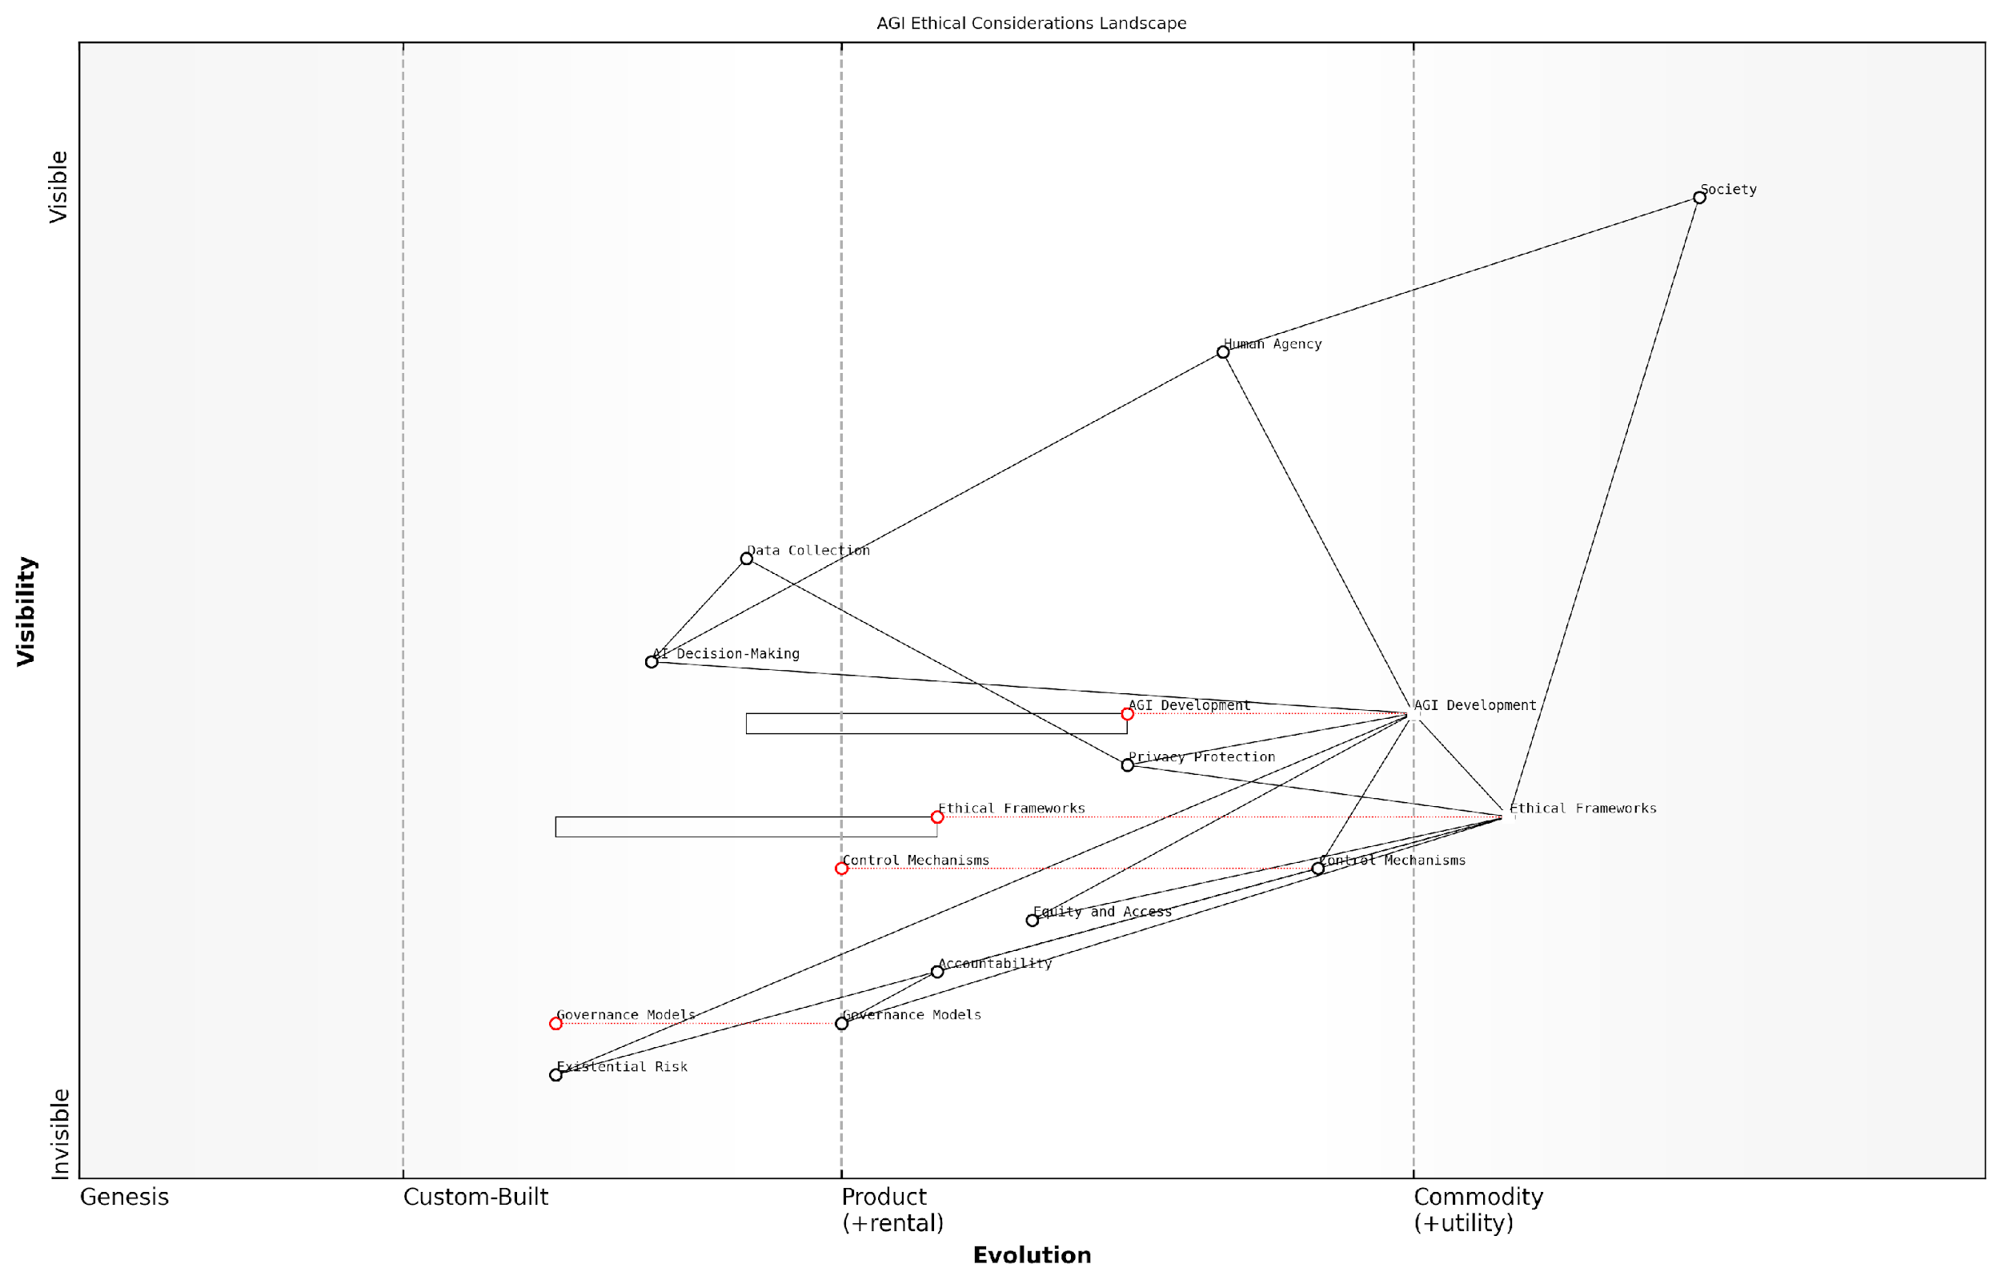

*Draft Wardley Map: [Insert Wardley Map: Ethical considerations for society]*

[Edit this draft Wardley Map](https://create.wardleymaps.ai/#clone:3a5ffc433d7c66f4dd)

Wardley Map Assessment

This Wardley Map reveals a complex and rapidly evolving landscape of AGI ethical considerations. The positioning of components emphasizes the critical importance of ethical frameworks, control mechanisms, and governance models in mediating between AGI development and societal impacts. The map highlights significant opportunities for innovation in safety and control technologies, as well as in governance and ethical frameworks. However, it also underscores substantial risks, particularly regarding existential threats and the potential erosion of human agency. The strategic imperative is clear: to advance AGI development in a manner that is not only technologically sophisticated but also ethically aligned, tightly controlled, and ultimately beneficial to society as a whole. This will require unprecedented collaboration across sectors, continuous adaptation of ethical and governance frameworks, and a unwavering commitment to human agency and societal well-being.

[View full Wardley Map report](http://markdown_wardley_map_reports/wardley_map_report_56_Ethical_considerations_for_society.md)

### The role of public engagement and understanding

As we stand on the precipice of a potential AGI breakthrough, the role of public engagement and understanding becomes paramount. The outcome of the AGI race between OpenAI and Anthropic will have far-reaching implications for humanity, and it is crucial that the general public is not merely a passive observer but an active participant in shaping this transformative technology’s future.

Public engagement in the AGI discourse serves multiple critical functions:

* Democratising the development process
* Ensuring ethical considerations are prioritised
* Mitigating potential risks through collective oversight
* Fostering trust and acceptance of AGI technologies
* Preparing society for the profound changes AGI may bring

To fully explore this crucial aspect, we will examine the current state of public understanding, strategies for effective engagement, and the potential outcomes of a well-informed populace in the context of AGI development.

Current State of Public Understanding

Despite the rapid advancements in AI and the high stakes of AGI development, public understanding of these technologies remains limited. A survey conducted by the Royal Society for the Encouragement of Arts, Manufactures and Commerce (RSA) found that while 82% of UK adults have heard of AI, only 32% feel they have a good understanding of the technology.

The gap between awareness and understanding of AGI presents both a challenge and an opportunity. If we fail to bridge this gap, we risk creating a future where AGI is developed without proper public scrutiny or input.

This knowledge gap is particularly concerning when considering the potential impact of AGI on society. As OpenAI and Anthropic race towards AGI, it is crucial that the public understands the implications of their work and can contribute meaningfully to the discourse surrounding its development and deployment.

Strategies for Effective Public Engagement

To foster public engagement and understanding, several strategies can be employed:

* Educational Initiatives: Developing comprehensive educational programmes that explain AGI concepts in accessible terms
* Media Collaboration: Partnering with media outlets to ensure accurate and balanced reporting on AGI developments
* Public Forums and Debates: Organising events where experts, policymakers, and the public can discuss AGI-related issues
* Citizen Science Projects: Involving the public in AGI research through participatory projects
* Transparency Measures: Encouraging OpenAI and Anthropic to communicate their progress and ethical considerations clearly to the public

These strategies must be implemented with a focus on inclusivity, ensuring that diverse perspectives are represented in the AGI discourse. This is particularly important given the global implications of AGI development.

Public engagement should not be viewed as a box-ticking exercise, but as a fundamental component of responsible AGI development. It is through robust public discourse that we can hope to align AGI with human values and societal needs.

Potential Outcomes of Informed Public Engagement

An informed and engaged public can significantly influence the trajectory of AGI development, potentially leading to several positive outcomes:

* Enhanced Ethical Oversight: Public scrutiny can help ensure that ethical considerations remain at the forefront of AGI development
* Policy Influence: An informed public can advocate for appropriate regulatory frameworks and governance structures
* Risk Mitigation: Collective intelligence can identify potential risks and contribute to the development of safeguards
* Trust and Acceptance: Public involvement can foster trust in AGI technologies, facilitating their responsible integration into society
* Equitable Distribution of Benefits: Public engagement can help ensure that the benefits of AGI are distributed fairly across society

Moreover, public engagement can serve as a counterbalance to the competitive pressures driving the AGI race between OpenAI and Anthropic. By demanding transparency and ethical practices, the public can encourage these organisations to prioritise safety and societal benefit over speed of development.

The race for AGI supremacy must not come at the cost of public welfare. It is through informed public engagement that we can ensure AGI development aligns with our collective values and aspirations.

Challenges and Considerations

While public engagement is crucial, it is not without challenges. These include:

* Complexity of AGI concepts: Making technical information accessible without oversimplification
* Misinformation and hype: Combating sensationalism and unrealistic expectations
* Balancing openness with security: Sharing information while protecting sensitive research
* Global coordination: Ensuring international cooperation in public engagement efforts
* Addressing fears and concerns: Managing public anxiety about potential AGI risks

Addressing these challenges will require a concerted effort from researchers, policymakers, educators, and media professionals. It will also necessitate a commitment from OpenAI and Anthropic to prioritise public engagement alongside their technical and business objectives.

Conclusion

As the AGI race between OpenAI and Anthropic intensifies, the role of public engagement and understanding becomes increasingly critical. An informed and engaged public can serve as a guiding force, ensuring that AGI development aligns with human values and societal needs. By fostering public understanding and participation, we can work towards an AGI future that benefits all of humanity, rather than a select few.

The development of AGI is not merely a technological challenge, but a societal one. Our success in navigating this challenge will depend on our ability to engage and empower the public as active participants in shaping our collective future.

As we move forward, it is imperative that public engagement becomes a cornerstone of AGI development strategies. Only through collective effort and shared understanding can we hope to harness the transformative potential of AGI while mitigating its risks. The future of AGI, and indeed of human civilisation, may well depend on our ability to bridge the gap between technological advancement and public understanding.

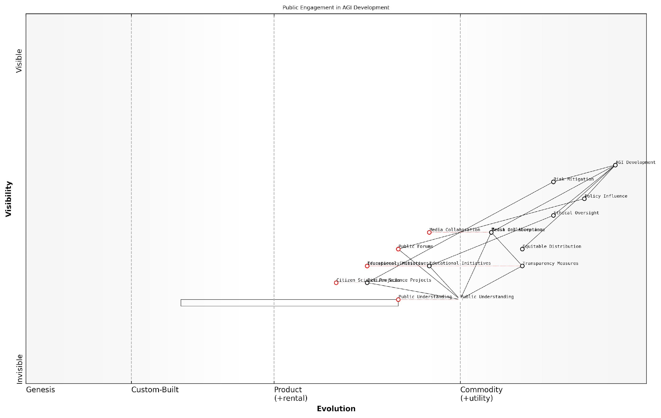

*Draft Wardley Map: [Insert Wardley Map: The role of public engagement and understanding]*

[Edit this draft Wardley Map](https://create.wardleymaps.ai/#clone:a21c6ae38a87ced5fa)

Wardley Map Assessment

The map represents a well-structured approach to public engagement in AGI development, with a clear focus on building understanding, trust, and influence. Key opportunities lie in enhancing citizen participation, improving educational initiatives, and ensuring equitable distribution of AGI benefits. The strategic priority should be to strengthen the foundation of public understanding while simultaneously developing more advanced engagement mechanisms to shape the future of AGI development responsibly and ethically.

[View full Wardley Map report](http://markdown_wardley_map_reports/wardley_map_report_57_The_role_of_public_engagement_and_understanding.md)